Lecture 9

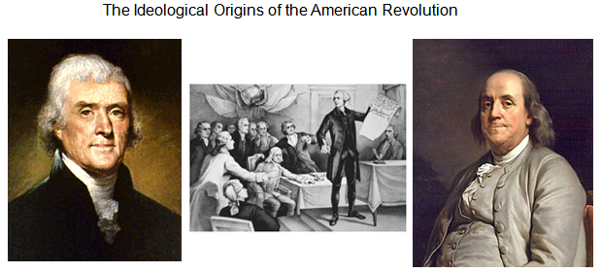

History of the Thirteen Colonies
The Thirteen Colonies were English, Dutch, Swedish, and later British colonies established on the Atlantic coast of North America between 1607 and 1733
People fleeing persecution by King Charles I and Anglican Archbishop William Laud were responsible for settling most of New England, and the Province of Maryland was founded in part to be a haven for Roman Catholics
Mercantilism was the basic policy imposed by Britain on its colonies from the 1660s. Mercantilism meant that the government and merchants based in England became partners with the goal of increasing political power and private wealth, to the exclusion of other empires and even merchants based in its own colonies.

The Thirteen Colonies
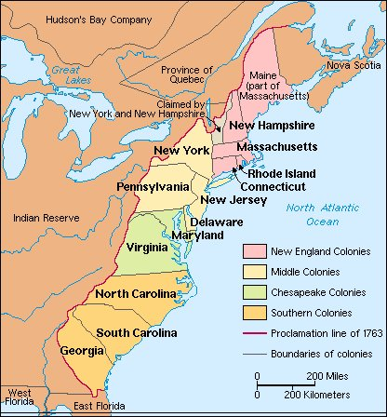
Resentment to British Rule
After the French-Indian war (1754-1763), The British Empire increased taxes (the Stamp Act)
In 1768 British troops arrived to enforce heavy taxation, which caused tension to rise.
Boston Massacre (March 5, 1770): A group of British soldiers fired into a hostile crowd, killing five colonials.
Boston Tea Party (December 6, 1773): The British Parliament passed the Tea Act which was designed to force the Colonists into importing tea from the East India Company and pay tax to the British Empire. This was strongly opposed in the Colonies. On December 6, a group boarded a ship and destroyed the tea. This act started the chain of events that led to the Revolutionary War.

Revolution
British Parliament passed the punitive “Intolerable Acts” after the Boston Tea Party
Committees of Correspondence are formed to pass communication quickly in the Colonies.
Continental Congress is formed from delegates of the colonies to oppose taxation without representation (1774).
On June 11, during the Second Continental Congress, the members of the Committee of Five were appointed. The five were tasked with drafting a document detailing
The reasons for separating from the British Empire and becoming an independent nation.

The Committee of Five
John Adams of Massachusetts
Adams gained prominence during the controversy surrounding the Stamp Act (1765) as a brilliant defender of American rights under British law.
In his Thoughts on Government (spring 1776), he wrote that the purpose of government was the "greatest quantity of human happiness," a notion which he derived from Cicero,
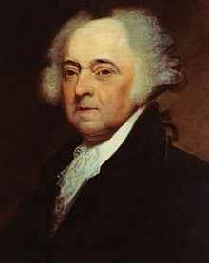

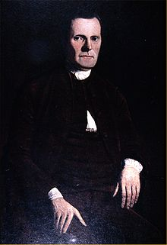
Roger Sherman of Connecticut
Roger Sherman (April 19, 1721 – July 23, 1793) was an early American lawyer and politician, as well as a founding father. He served as the first mayor of New Haven, Connecticut, He was the only person to sign all four great state papers of the U.S.: the Continental Association, the Declaration of Independence, the Articles of Confederation and the Constitution. Thomas Jefferson said of him: "That is Mr. Sherman, of Connecticut, a man who never said a foolish thing in his life."

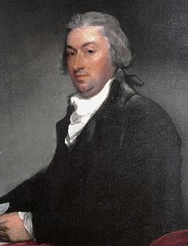

Robert Livingston of New York
Robert Livingston was born in the city of New York in 1746. He was educated at King's (now Columbia) College, where he was graduated in 1764. Livingston became politically active in the era of the Stamp Act Revolt. In 1776, as a member of the Provincial congress of New York, he was selected to attend the Continental Congress. He was the only member of the five who did NOT sign the Declaration of Independence.

Benjamin Franklin of Pennsylvania
Benjamin Franklin (1706-1790) was one of the most celebrated of America's Founding Fathers, a man who enjoyed success as an inventor, scientist, printer, politician, and diplomat.
Inspired by friend and philosopher David Hume, Franklin changed Jefferson's language in the Declaration of Independence from "we hold these truths to be sacred and undeniable" to "we hold these truths to be self-evident." The change reflected a statement grounded in reason and rooted in the principles of the scientific revolution, rather than the notion that the equality of all men was an article of religious faith.

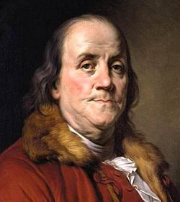

Thomas Jefferson of Virginia
Thomas Jefferson (1743-1826) is considered one of the most important Founding Fathers of the United States of America for the central role he played in drafting the Declaration of Independence. During the American Revolution, Jefferson was elected governor of Virginia and, after the war, he was appointed minister to France. He also served as the nation's first secretary of state, its second vice president, and its third president.

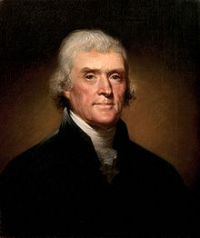

تتاا

