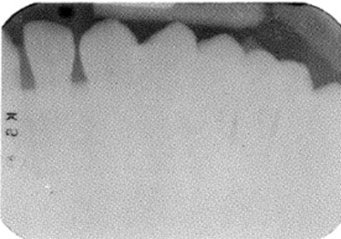
Figure 7a:underexposed intra-oral film
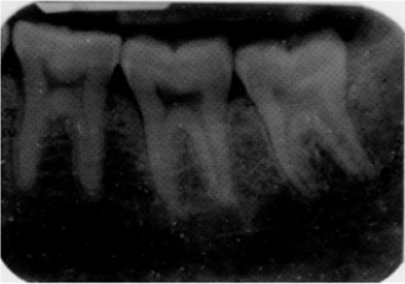
Figure 7b: overexposed intra-oral film
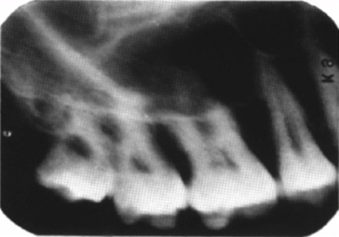
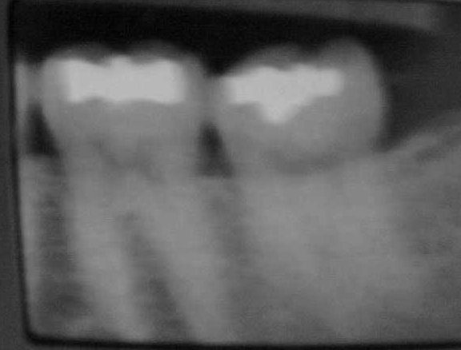

Figure 7c: blurred image
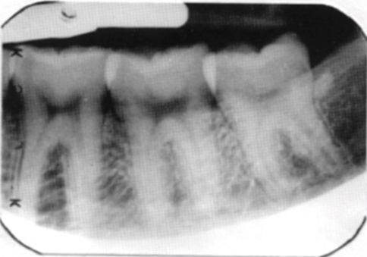
Figure 7d: partial image
For i

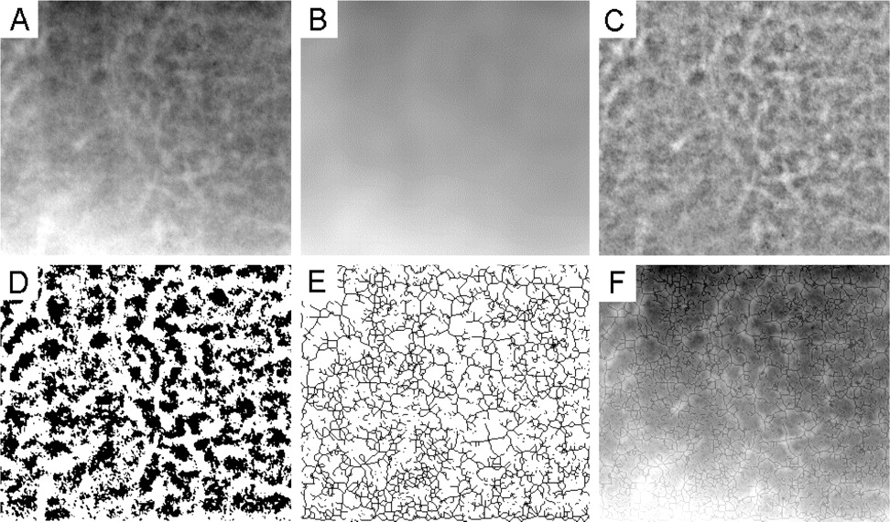
اخطاء الاشعة
http://dhonline.chattanoogastate.edu/modules/xray/exposureerrors.htm

Giant cell granuloma:

Panoramic tomography/Panagraphy
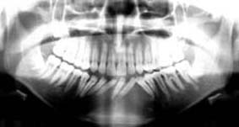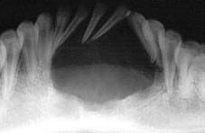

Periapical/Occlusal radiography
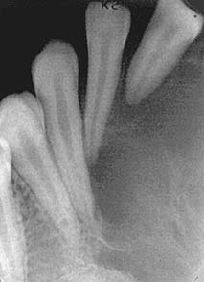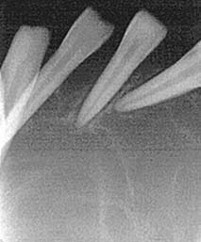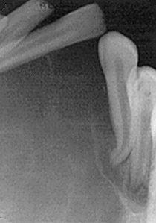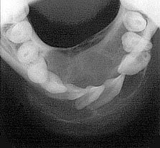
......................................................................................................................
Female patient with hyperplasia on left side

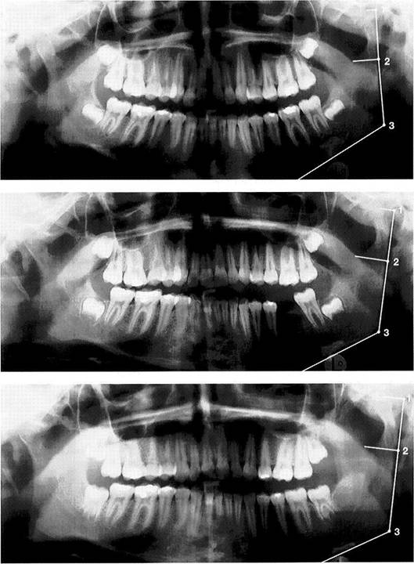
Maxillary sinus septum
(arrows pointing to thin radiopaque line extending from the floor of the maxillary sinus)
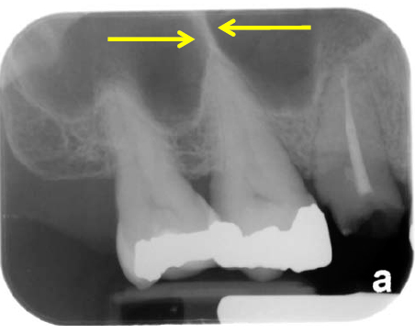
Maxillary sinus septum without arrows
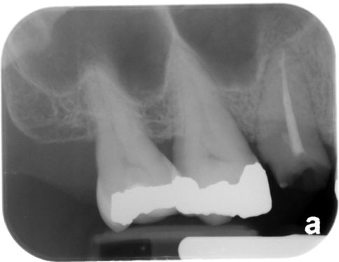
Maxillary sinus septum
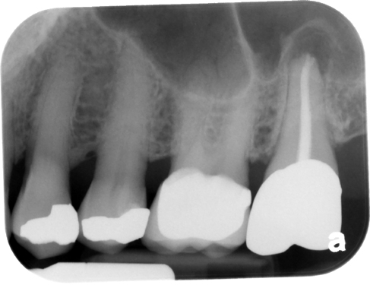

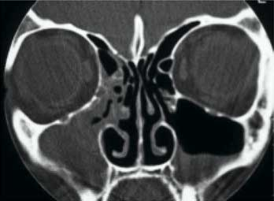
Cornal CT scan of patient with significant right maxiallry and ethmoid sinus onstruction
and air-fluid level of left maxillary sinus

