Lecture 6

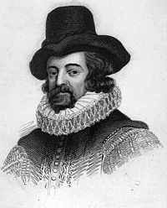
Francis Bacon
Francis Bacon has been called the father of:
  - The scientific method
  - The Enlightenment
  - Empiricism
  - Modern Science
  - Inductive Reasoning

Biography
Born 22 January 1561 Strand, London, England

Was thought to be home schooled due to poor health

Entered Trinity College at Cambridge at age 12
Met Queen Elizabeth who was impressed with his intelligence

In 1576 he entered Gray's Inn, and in the same year joined the embassy of Sir Amyas Paulet to France, where he remained until his father died in 1579

Obtained political office in 1584, eventually rose to Lord Chancillor, was accused of Corruption, and stripped of office

Timeline
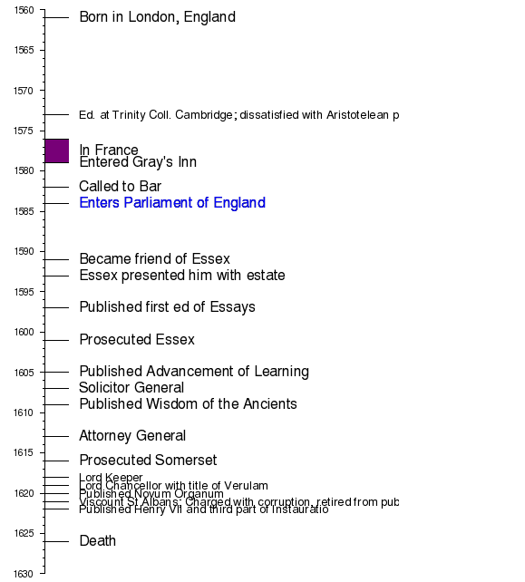

Of Studies
- 'Studies' have a three-fold purpose: 'delight', 'ornament' & 'ability'. Books may be read for attaining delight, for being ornamental in discourses, and for achieving ability.

- 'Studies' must be ratified by experience, just as experiences are trimmed by studies.

- Clever people do not like studies, for things learnt from books may be inimical to their interests. Simple men look upon reading books as a very admirable venture, for they themselves do not find a chance to read books. But only the wise men can make good use of their knowledge.

- Books are generally of three types; some are to be 'tasted' i.e. to be read in parts; some are to be 'swallowed' i.e. to be somehow read through''; some books deserve to be read in full with enough sincerity and attention.

e) Just as ailments of the body can be cured by physical exercises, ailments/shortcomings of the mind may be cured by appropriate studies.

Of Simulation and Dissimulation
— Tell a lie and find a truth.

Summary: The practice of dissimulation is followed by the weak man,
for the strong minds and hearts have the power to tell the truth.
The man of secret nature never gives a hint of what is in his heart.
The advantage of simulation and dissimulation is that they keep the
opposition guessing and unprepared and so to be easily surprised at
the proper moment. They also help us discover the intentions of the other.
The disadvantage is that they indicate a weakness of the disposition and one who uses these methods is considered unreliable.

Of Parents and Children:
— The joys of parents are secret; and so are their griefs and fears.

— Children increase the cares of life; but they mitigate the remembrance of death.

— Children sweeten labor, but they make misfortune more bitter.

Summary: Children get benefit because of their parents. Parents usually have unequal favoritism towards their children. They should give them suitable monetary allowance.
They should choose a suitable profession for their child.

Of Great Place:
— The rising onto place is laborious and by pains men come to greater pains; and it is sometimes base and by indignities men come to dignities.
— Death falls heavy upon him who dies too well known to others, but unknown to himself.

— It is a strange desire to seek power and lose liberty; or to seek power over others and to lose power over a man’s self.

— Men in great place are thrive servants: servants of the sovereign or state; servantsof fame and servants of business.

Summary: Men are servants of the state, their desires for fame and time restriction. Man should follow the good examples set in the past. There are faults of men in great place such as delays, corruption etc. We should refuse bribes. One may while rising to a position use
crooked methods and join sides but after reaching a position, one should become neutral.

