Lecture 7

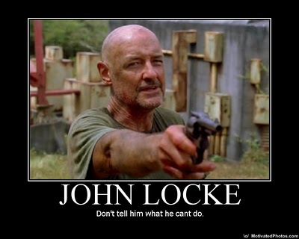

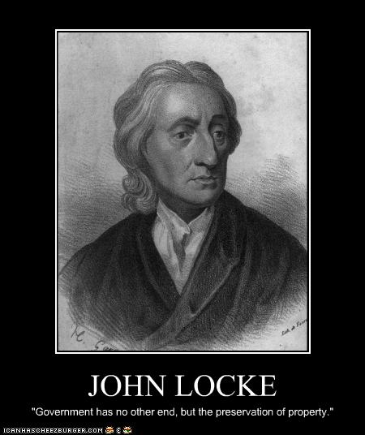

Widely known as:
- The Father of Liberalism
- One of the most influential of Enlightenment thinkers
- One of the first of the British empiricists, following the tradition of Francis Bacon

His work had a great impact upon:
- Social contract theory
- The development of epistemology and political philosophy
- Voltaire and Rousseau, many Scottish Enlightenment thinkers, as well as the American revolutionaries
- Classical republicanism and liberal theory
- American Declaration of Independence

Biography
- Born August 29, 1632 in Somersetshire
Taught at home by his father until he was 14-
- Studied moral philosophy, chemistry, meteorology and medicine at Oxford
- Entered politics in 1667 and became assistant to Lord Ashley, who eventually rose to the position of Lord Chancellor and Earl of Shaftesbury
From 1675 to 1679 he lived in France and worked on his Essay-
Left England again in 1683 after the execution of Lord Ashley-
- Returned to England after the Glorious Revolution and ascension of William and Mary
Retired from public life in 1691 and died in 1704

Philosophy
Promoted representative democracy form of government-
“Man” is the Animal the “person” is ones self-
Championed the separation of Church and State -

The Essay
- First appearing in 1690 with the printed title An Essay Concerning Humane Understanding
- Concerns the foundation of human knowledge and understanding
- Describes the mind at birth as a blank slate (tabula rasa, although he did not use those actual words) filled later through experience.
- One of the principal sources of empiricism in modern philosophy,
- Influenced many enlightenment philosophers, such as David Hume and George Berkeley and Jean-Jacques Rousseau.

Of Perception
Passive, unavoidable-
- The first step toward knowledge and the only inlet of all the materials in the mind Cannot occur without awareness.
Often comes attended by some automatic judgment, -
- Separates animals from lower forms of life.

Of Retetion (Memory)
- Locke is concerned mostly to tell us which ideas are best remembered and to name the defects of the faculty.
Locke recognizes that, given his doctrine that all mental -
- items must be conscious, there is not much room allowed for memory.
- For the sake of consistency Locke admits that by "memory" he does not literally mean a place where ideas are stored, but rather, he refers to a power of the mind to revive perceptions it once had

Of Discernment
-The ability to tell one idea apart form all others
-The faculty that determines intelligence, according to Locke.
-The stronger this faculty, the stronger one's powers of reasoning.
- Discernment makes our ideas clear and determinate, qualities that are revealed as extremely important for knowledge..

