Lecture12

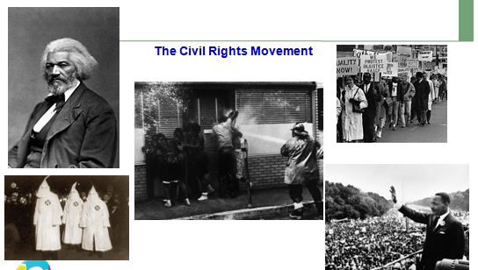

Reconstruction
The Union victory in the Civil War in 1865 may have given some 4 million slaves their freedom, but the process of rebuilding the South during the Reconstruction period (1865-1877) introduced a new set of significant challenges. Under the administration of President Andrew Johnson in 1865 and 1866, new southern state legislatures passed restrictive "black codes" to control the labor and behavior of former slaves and other African Americans. Outrage in the North over these codes eroded support for the approach known as Presidential Reconstruction and led to the triumph of the more radical wing of the Republican Party. During Radical Reconstruction, which began in 1867, newly enfranchised blacks gained a voice in government for the first time in American history, winning election to southern state legislatures and even to the U.S. Congress. In less than a decade, however,
reactionary forces–including the Ku Klux Klan–would reverse the changes wrought by Radical Reconstruction in a violent backlash that restored white supremacy in the South.

Characteristics of the post-Reconstruction period:
Racial segregation. By law, public facilities and government services such as education were divided into separate "white" and "colored" domains. Characteristically, those for colored were underfunded and of inferior quality.
Disfranchisement. When white Democrats regained power, they passed laws that made voter registration more inaccessible to blacks. Black voters were forced off the voting rolls. The number of African American voters dropped dramatically, and they no longer were able to elect representatives. From 1890 to 1908, Southern states of the former Confederacy created constitutions with provisions that disfranchised tens of thousands of African Americans.
Exploitation. Increased economic oppression of blacks, Latinos, and Asians, denial of economic opportunities, and widespread employment discrimination.
Violence. Individual, police, organizational, and mass racial violence against blacks (and Latinos in the Southwest and Asians in California).

The Ku Klux Klan
A group including many former Confederate veterans founded the first branch of the Ku Klux Klan as a social club in Pulaski, Tennessee, in 1866.
The organization of the Ku Klux Klan coincided with the beginning of the second phase the Reconstruction when Congress passed the Reconstruction Act. Under its provisions, the South was divided into five military districts, and each state was required to approve the 14th Amendment, which granted "equal protection" of the Constitution to former slaves.

The Ku Klux Klan dedicated itself to an underground campaign of violence against Republican leaders and voters (both black and white) to restore white supremacy in the South.
At least 10 percent of the black legislators elected during the 1867-1868 constitutional conventions became victims of violence during Reconstruction, including seven who were killed.
Jim Crow Laws
In the years following the end of Reconstruction, the South reestablished many of the provisions of the black codes in the form of the so-called "Jim Crow laws." These remained firmly in place for almost a century, but were finally abolished with the passage of the Civil Rights Act of 1964.
From the late 1870s, Southern state legislatures passed laws requiring the separation of whites from “persons of color” in public transportation and schools. Generally, anyone of ascertainable or strongly suspected black ancestry in any degree was for this purpose a “person of color”.
The segregation principle was extended to parks, cemeteries, theatres, and restaurants in an effort to prevent any contact between blacks and whites as equals. It was codified on local and state levels and most famously with the “separate but equal” decision of the U.S. Supreme Court in Plessy v. Ferguson (1896).

Civil Rights Leaders
Frederick Douglas (1818-95) called the father of the civil rights movement, he was a prominent American abolitionist, author and orator. Born a slave, Douglass escaped at age 20 and went on to become a world-renowned anti-slavery activist. Douglass' work as a reformer ranged from his abolitionist activities in the early 1840s to his attacks on Jim Crow and lynching in the 1890s.
Dr. Martin Luther King Jr. (1929-1968) was a Baptist minister and social activist who played a key role in the American civil rights movement from the mid-1950s until his assassination in 1968. Inspired by advocates of nonviolence such as Mahatma Gandhi, King sought equality for African Americans, the economically disadvantaged and victims of injustice through peaceful protest. He was the driving force behind watershed events such as the Montgomery Bus Boycott and the March on Washington, which helped bring about such landmark legislation as the Civil Rights Act of 1964 and the Voting Rights Act of 1965. King was awarded the Nobel Peace Prize in 1964 and is remembered each year on Martin Luther King Jr. Day, a U.S. federal holiday since 1986.
Rosa Parks
By refusing to give up her seat to a white man on a Montgomery, Alabama, city bus in 1955, black seamstress Rosa Parks (1913—2005) helped initiate the civil rights movement in the United States. The leaders of the local black community organized a bus boycott that began the day Parks was convicted of violating the segregation laws. Led by a young Rev. Dr. Martin Luther King Jr., the boycott lasted more than a year—during which Parks not coincidentally lost her job—and ended only when the U.S. Supreme Court ruled that bus segregation was unconstitutional.
Malcolm X
Born Malcolm Little, he changed his last name to X to signify his rejection of his "slave" name. Charismatic and eloquent, Malcolm became an influential leader of the Nation of Islam, which combined Islam with black nationalism and sought to encourage and enfranchise disadvantaged young blacks searching for confidence in segregated America. After Malcolm X's death in 1965, his bestselling book The Autobiography of Malcolm X popularized his ideas, particularly among black youth, and laid the foundation for the Black Power movement of the late 1960s and 1970s.
Civil Rights Organizations: National Association for the Advancement of Colored People (NAACP), Student Non-violent Coordinating Committee (SNCC), Southern Christian Leadership Conference (SCLC), The Congress of Racial Equality (CORE)
Methods of Protests included: Sit-ins, marches, Boycotts and Freedom Rides
Many locals in the deep south strongly resented attempts at desegregation and responded with heavy handed tactics including arrests, beatings, arson, murder, lynching, spying, firing, evictions, and other forms of intimidation. Sometimes the fire department was called in to use water cannons on protesters, and sometimes police dogs were let loose to attack protesters.
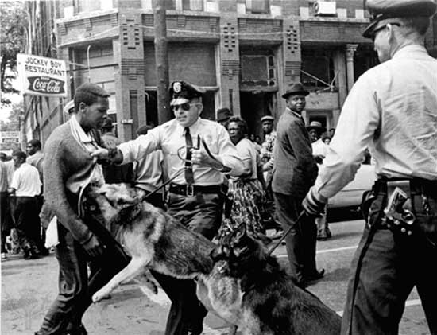
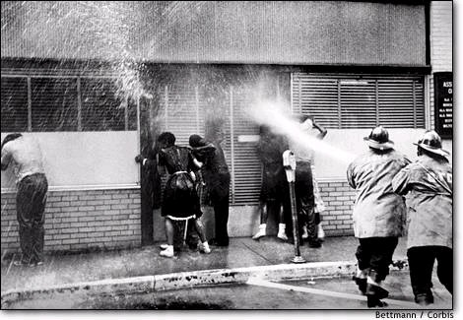

Civil Rights Accomplishments
On May 17, 1954, The Supreme Court rules on the landmark case Brown v. Board of Education of Topeka, Kans., unanimously agreeing that segregation in public schools is unconstitutional.
On December 10, 1964, Dr. Martin Luther King, Jr. was awarded the Nobel Peace Prize, the youngest man to receive the award; he was 35 years of age.
President Lyndon Johnson signed the Voting Rights Act of 1965 on August 6.
President Johnson signs the Civil Rights Act of 1964. The most sweeping civil rights legislation since Reconstruction, the Civil Rights Act prohibits discrimination of all kinds based on race, color, religion, or national origin.
In 1967, President Johnson appointed Thurgood Marshall to the Supreme Court, declaring that it was "the right thing to do, the right time to do it, the right man and the right place.“
Since 1976, every U.S. president has officially designated the month of February as Black History Month.

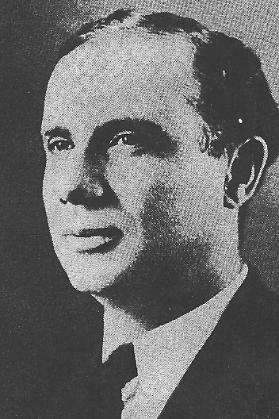
William Alfred Carroll Hughes

