بسم الله الرحمن الرحيم
lecture 11

On page 202
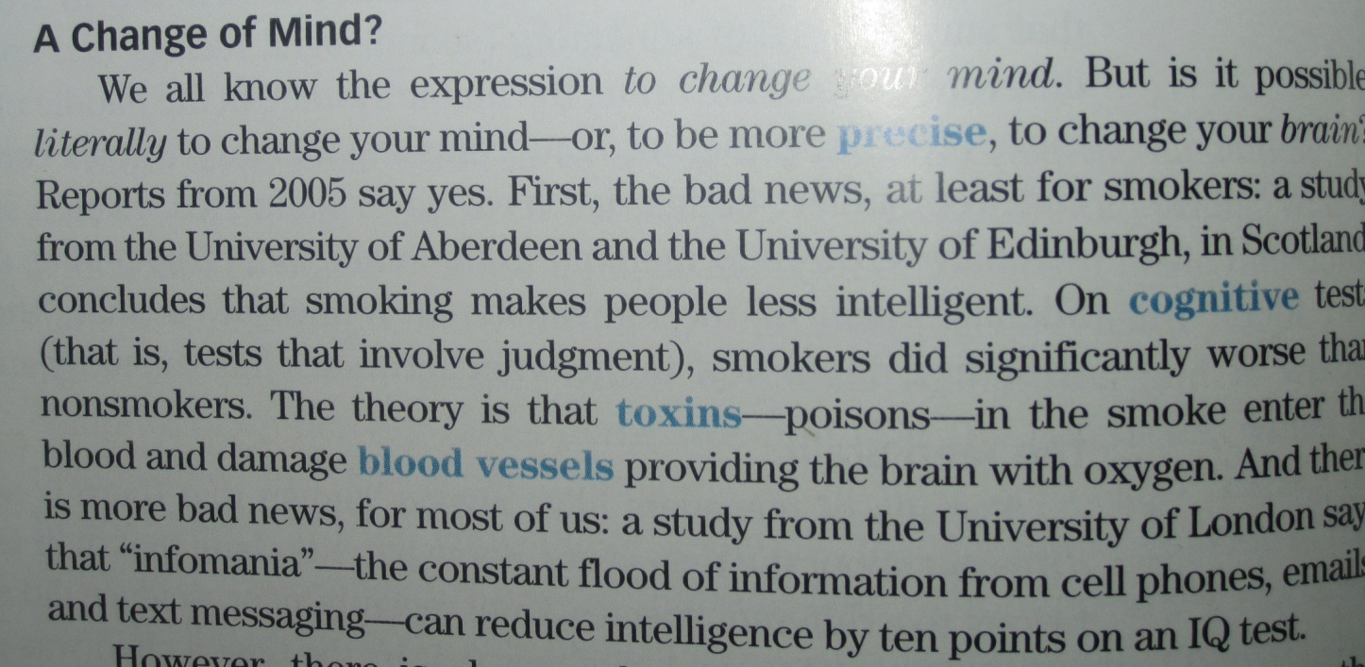
Scanning & Skimming a reading text
1. Where are the universities of Aberdeen and Edinburg located?
A. in London B. in Scotland
C. in the USA D. in Liverpool
2. The underlined word “ precise “ line 2 means___________
A. clear B. different
C. normal D. ambiguous
3. __________ is the cause of being less intelligent.
A. Sleeping B. Nonsmoking
C. Smoking D. Studying
4. The test that involves judgment is called a/an _________ test.
A. Ability B. Toxins
C. Cognitive D. Vessel
5. The underlined pronoun “ it” Line 4 refers to__________
A. the university B. Scotland
C. a study D. Edinburg
6. The underlined word “ intelligent “ line 2 means ________
A. interesting B. different
C. famous D. clever
7. What is the function of blood vessels? _________.
A. providing brain with blood B. thinking
C. providing brain with oxygen D. moving
8. The word in the paragraph which is closest in meaning to the word “ poisons” is _____
A. tests B. toxins
C. reports D. smokers
9. The constant flood of information from cell phones and emails is called_______
A. Informania B. toxin
C. intelligence D. blood vessels
10. The most appropriate TOPIC of the paragraph is____________.
A. providing brain with blood B. Smoking
PS | Words | Meaning
( adj ) | Vast | Big and wide
( V ) | Depict | Show in the form of a picture
( N ) | Merchant | tradesman
( PV ) | Sum up | conclude
( VP ) | Point out | Indicate
( Adj ) | Handsome | Looks beautiful and attractive
C. providing brain with oxygen D. Changing your mind

Previewing vocabulary
PS | Words | Meaning
( N ) | Route | way or road street
( N ) | Region | area / district
( V ) | Found | establish
( adj ) | Mature | Fully grown

Exercise
1. Our doctor always ____________ the importance of the contents of lectures in the final test.
A. fixes B. points out
C. looks D. takes
2. king Faisal University was __________________ in 1975.
A. found B. founded
C. bought D. pointed out
3. The word “______________” is closest in meaning to the word tradesman.
A. merchant B. policeman
C. district D. mature
4. The phrase “ fully grown” is closest in meaning to the word “ ________________’
A. beautiful B. ugly
C. mature D. important

الي بعده عندنا قاعده خفيفه وحلوه الي هي الـ countable and uncountable nouns
راح اسهلها ان شاء الله واخليها ع طريقه جدول
Any | Some | A little | little | A few | Few | Lots of | A lot of | Much | Many
C + Un  P  N + Q | C + Un  P  Q if we sure the answer will be yes | Un  N + A |  | C  P  A |  | The same meaning but lots of less formal  C + Un  S + P |  | Un  S  N + Q | C  P  N + Q
C – countable
S – singular
Un – uncountable P – plural
N – negative
A – affirmative
Q – question
الفرق بين few and a few – little and a little
Few + little : for negative ideas and it’s less than a little and a few
اولا كل الاربع كلمات معناها قليل بس few + little معناها اقل اكثر
مثال لما ابي اروح لمطعم وابي يكون بالاكل شوي ملح يعني تقريبا ذره اقول little salt
ثانيا تستخدم للافكار السلبيه
A little + a few : for positive ideas
تستخدم للافكار الاجابية
مثال / I have few lemons

من شوي الجدول هو الاساس عشان تعرفون كل وحده واستخدامها
نجي الحين للاشياء الزياده
- الـ countable ممكن يكون مفرد او جمع مثال / I have one rabbit – I have two rabbits
- مع الـ countable اقدر استخدم الـ articles الي هي a – an اذا كانت الكلمه مفرده مثال / I’m eating a banana
واذا كنا راح نتكلم عن المعدود المفرد لازم نستخدم هالكلمات a – this – my – an – the
مثال / I can’t find my cat – he is a doctor
- اذا كان عندنا معدود بس جمع نقدر نستخدمه لحاله مثل / sharks are dangerous
- بالنسبه لكلمه people هي اساسا جمع كلمه person مانقدر نجمع كلمه people لانه خطأ فادح
مثل / there are 3 people – this in one person
Here are some more uncountable nouns:
music, art, love, happiness , advice, information, news , furniture, luggage , rice, sugar, butter, water , electricity, gas, power , money, currency .
معلومه مهمه : دايما نعامل الكلمات الغير معدوده معامله المفرد باي حال من الاحوال
Your luggage looks heavy مثال:
الشي الثاني من المستحيل انه نستخدم الـ articles مع الغير معدود لكن فيه كلمات بديله عنها والي هم
a piece of - a bottle of - a grain of – a slice of - a bar of
مثل / a slice of cheese
A bar of chocolate
الشي الثالث عندنا انه فيه كلمات تجي للمعدود والغير المعدود لكم المعنى يختلف احيانا
Countable |  | Uncountable
There are two hairs in my coffee! | hair | I don't have much hair.
There are two lights in our bedroom. | light | Close the curtain. There's too much light!
Shhhhh! I thought I heard a noise. | noise | It's difficult to work when there is too much noise.
Have you got a paper to read? (= newspaper) | paper | I want to draw a picture. Have you got some paper?
Our house has seven rooms. | room | Is there room for me to sit here?
We had a great time at the party. | time | Have you got time for a coffee?
Macbeth is one of Shakespeare's greatest works. | work | I have no money. I need work!

اخر شي عندنا انه اغلب المشروبات غير معدوده واذا كنا نبيها معدوده راح نقول
One coffee please
والمقصود فيه انه كوب من القهوه
او
Two teas please
والمقصود كوبين من الشاهي

في المحتوى فيه بعض التمارين راح اخليها لوقت المراجعه
وبكذا خلصنا محاظرتنا واي سؤال انا بالخدمه
ودي

