
المملكة العربية السعودية
وزارة التعليم العالي
جامعة الدمام
كلية التربية بالجبيل

Data structure
Group.1
لطيفة موسى الجوير
روان القحطاني
عبير الهاجري
سمية حامد الغامدي
مريم الماص

Date:28\3\1433

Dr.Eman Ahmed Abdel Ghaffar

Task 1:
array is the development of imaginary to facilitate access to the content
of memory but in fact data stored in memory in the form of Bet tat Marts one after the other Three-dimensional array is a array within a array within a array.
The following program uses a multi-dimensional arrays (three dimensional)
We designed a program that prints the numbers from 1 to 10 and so on.
In this example we have identified two pages , 2 columns and 5 rows.
Program:
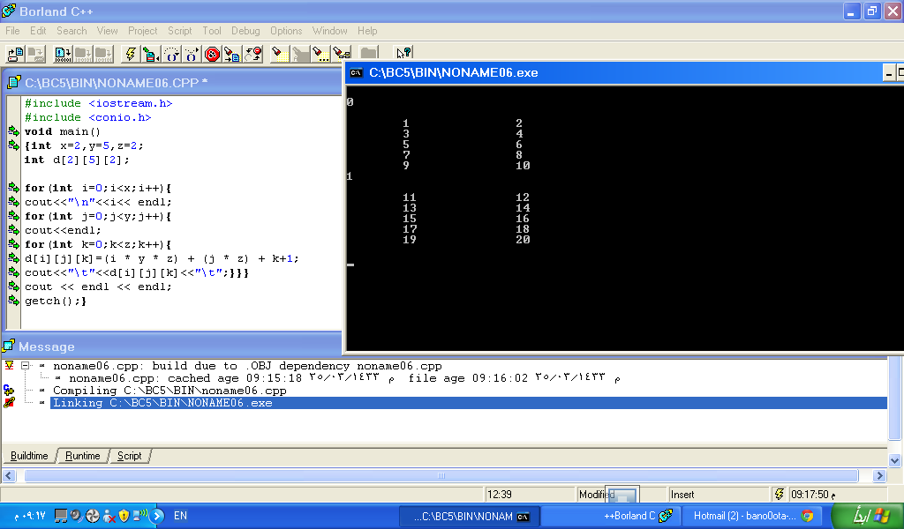
Out put:
Reference: http://mycodelog.com/2010/05/21/array3d/
+فكرة فريق العمل
