Lecture 2

The Renaissance 1485–1660
CONTEXTS AND CONDITIONS :
- At the end of the 14th century , the world changed.
Two key dates can mark the beginning of modern times:
- End of the Roses wars (between England & Franc) in 1485.
- The invention of printing, William Caxton issued the first imaginative book to be published in England – Sir Thomas Malory’s retelling of the Arthurian legends as Le Morte D’Arthur
- Christopher Columbus discovered the Americas opened the eyes of Europeans to the New World.
- At the geographical and spiritual were the keys to the Renaissance, the revival of learning and culture, which culminated in Italy in early 16 th century, and in Britain during the reign of Queen Elizabeth I
- England came out of the wars of Roses new strain in power, which each Teodorz.
- Of the greatest kings Teodorz, Henry VIII, who Astmrgmh of 1509 to 1547
- Try giving birth to Henry VIII's son to inherit the throne after him, married 6 times, and his sixth wife gave birth to him ( a boy and two daughters) and they are "King Edward " , " Queen Mary I " and " Queen Elizabeth I "

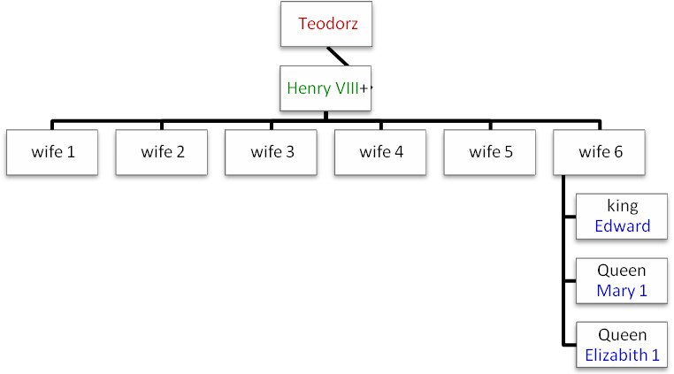

- The Catholic Church does not allow for dissolution of marriage and the need for Henry VIII to annul his marriage to Catherine disagreed with Pope Clement VII.
- Henry VIII Ended the rule of the Catholic Church in England, closed (and destroyed the wide) and monasteries, which was a repository of science, history and culture in the Renaissance from 1485 to 1660, and proclaimed himself president and head of the Church⬅ This movement, known as re-training and re-drafting
- England became a Protestant, founded by Martin Luther.

- The effects of the Reformation in the reign of Henry VIII a major crisis like this in England in the 16th century.

- England gained independence from Europe in two ways: Empire invasions + control of the seas, which had been achieved during the reign of Elizabeth I, daughter of Henry VIII.
- Henry did not consider the separation from Rome revolt isolated. Two of the European intellectuals, founded the atmosphere to make this possible:
- Dutch Erasmus: His disdain for the rigidity Catholic monasticism did not attempt to deny the authority of Alapapa, but it was a challenge to the corruption in the Catholic Church.
Erasmus did not have time to do ritual is necessary, the sale of religious and archaeological pieces, he wished to return the previous values ​​of the Christian Church
When his visit to England Aeramos became a friend of Sir Thomas Moore, who later cut off his head for the refusal to endorse Henry VIII's divorce from Catherine.

- German Martin Luther : Witnessed the decisive separation from Rome.
Luther agreed with much of what Erasmus said about corruption in the Catholic Church, but they differed in their responses, where Luther's refusal to pander or accept the authority of the Pope.

- Many historians have considered in 1517, ((when he commented Luther on the door of his church 95 Theses against the sale of papal indulgences)) starter to restructure and revive the Protestant.
- Constant opposition to Luther to the Pope led to the isolation
- Calvin French, such as Luther took it upon himself to develop the Catholic Church
- The last twenty years of the life of Calvin, Geneva became the home of Protestant power
- Moral order has become tough, such as: dress was austere, patriarchal system has taken its grip is getting stronger, and the events of daily life was held by the control, flooded the women and men were beheaded, while their adultery.
- Century after the discovery of the Americas, founded the Copernicus and Qalilio principle scientifically that the earth were not the center of the universe
- Facts approved by the Dutch philosopher Erasmus, human thinking has had a great influence on generations of writers who put him center of the universe.
- Discovered writings in the Renaissance geography of the human soul, to redefine its relationship with power, history, science and the future.
- No longer have controlled fascination and magnificence to the Christian church, but real life you need to provided explanations and facts.
- Men and used his authority, his abilities and free will, is the subject of literature of the Renaissance
- Became man is the center of attention the old assumptions no longer valid in the Renaissance, but science is clear from the facts
- Some historians say that the birth of modern science, mathematics and astronomy:

- In the fourth decade of the 16th century Copernicus replacing the system of Aristotle with the sun, instead of the ground, in the center of the universe.
- In anatomy, Harvey discovered (1628) the circulation of the blood.
- The beginning of the 17th century was the development and discovery and use of clocks and telescopes, thermometers, compasses, microscopes

- The writing in that era wider discovery of human freedom since the classical period.
- English language has become one of the richest and most diverse arts in the world literature.
- Literature in Renaissance English contains some of the biggest names in all of world literature: Shakespeare, Marlowe, Webster, Johnson, and the dramatists; Sydney, Spencer, Donne, and Milton among the poets;
Bacon, Nash, Raleigh, Brown, and Hawker in prose

Political

- Although Elizabeth's reign, which spanned 45 years, but it is a stable period, the presence of threats and conspiracies by the Protestant, except that in the reign of Elizabeth won the Spanish Armada and a fleet of King Philip of Spain.
In this way the sovereignty of England.
- London became the capital of the country depending on its size and importance
- Majority of the population did not read and write but they were going to the theater, which was a place for discussion and entertainment scene

وفيه كم شريحه من اخر المحاضره الثانيه لم يقراها الدكتور ولم يشرحها وقال اقراوها انتم لانفسكم اتوقع انها ماراح تدخل الامتحان << منقول ههههههههه

بدويه

© 2011 ملتقى جامعة الملك فيصل- اللغة الإنجليزية
المستوى الرابع

