Lecture 9
Elements of the lecture
- Skimming for the topic and main idea
- Vocabulary Previewing
- Reading Passage
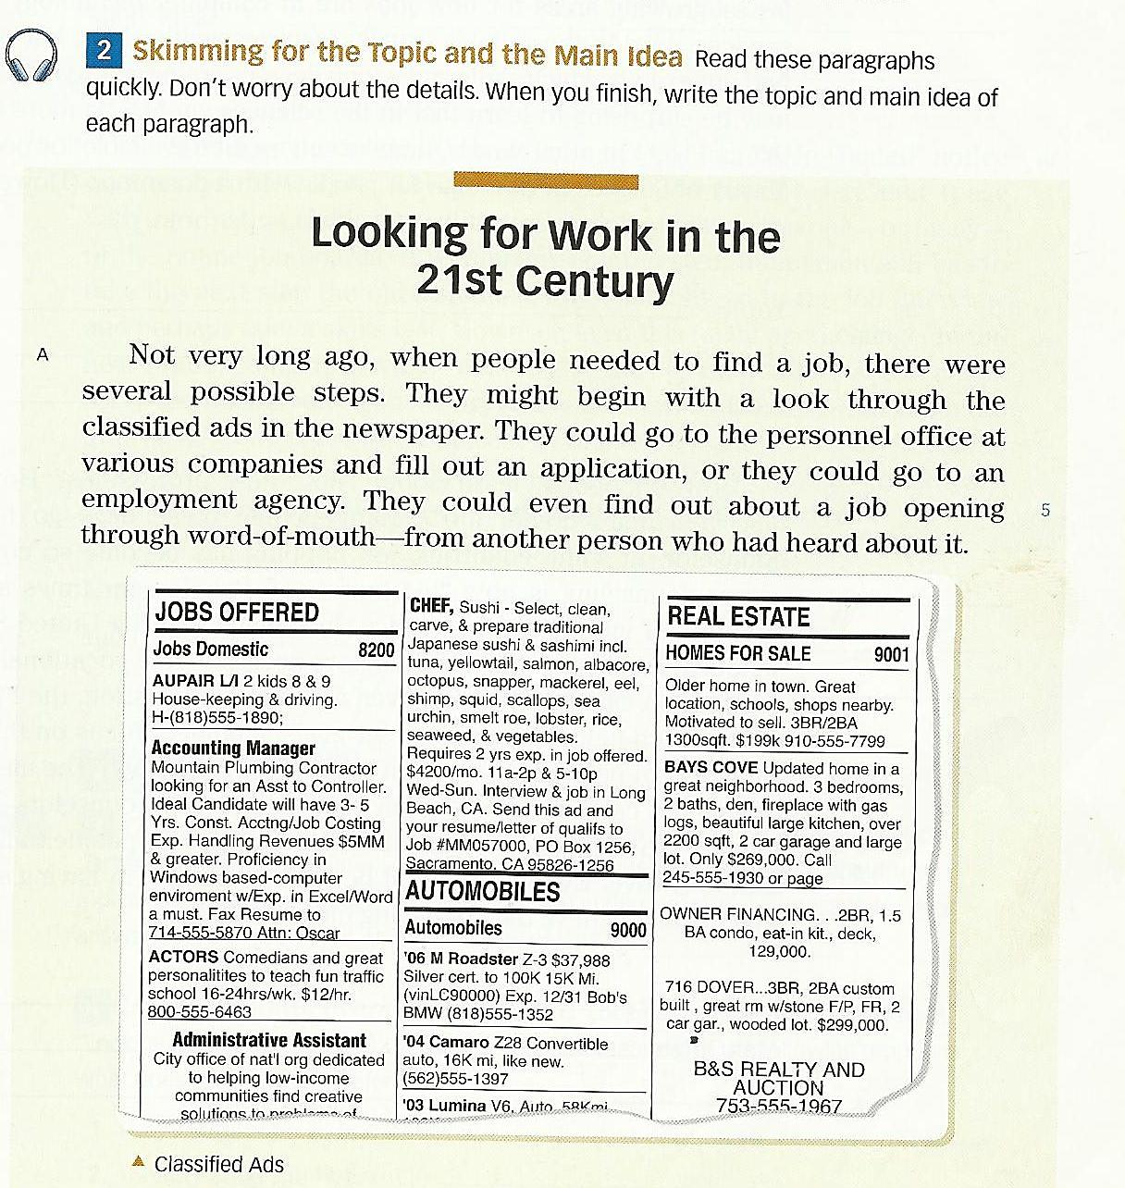

- Topic: Steps of finding a job.

Main Topic: There were several
possible steps to find jobs
Not very long ago.

They (Paragraph A, Line 2)________________

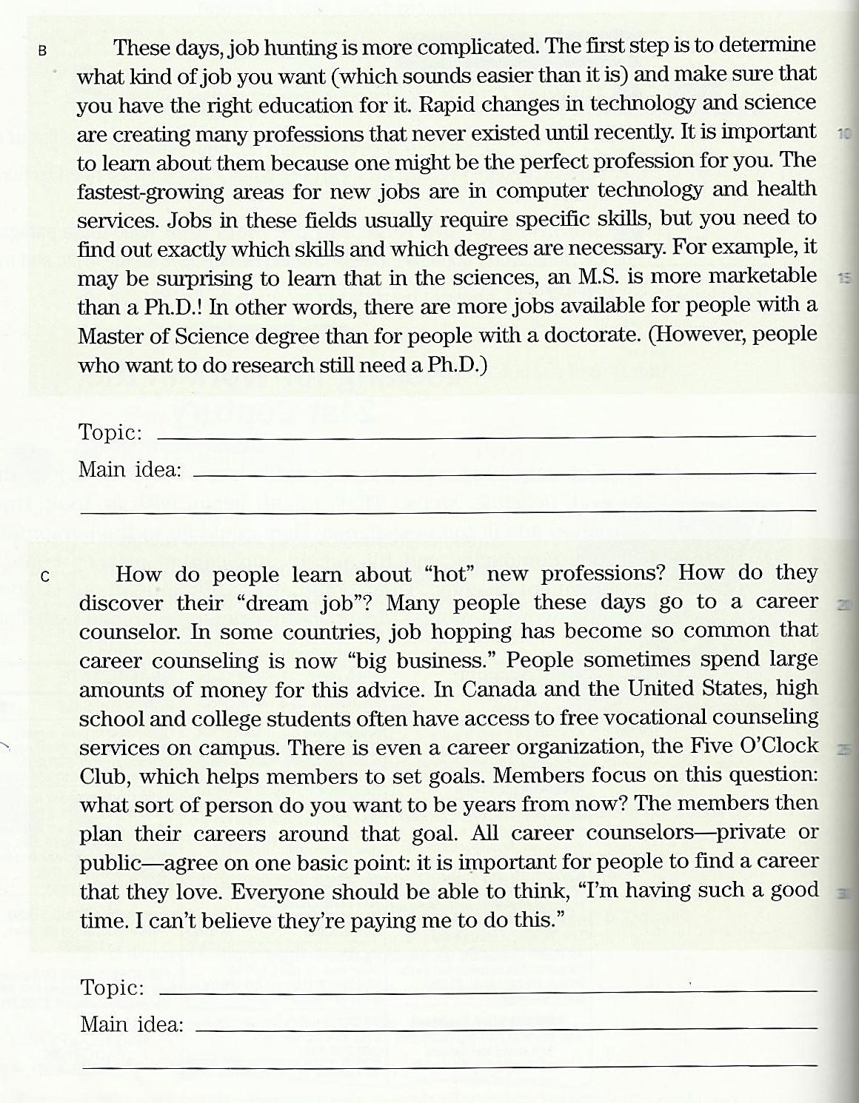

B. Topic: Job Hunting Steps nowadays

Main Idea: Job hunting has become more complicated these days

Them (Paragraph B, Line 11)_________________

C. Topic: Career Counseling
Main idea:

Job hopping has become so common that career counseling is now big business

It (Paragraph D, Line 33)___________

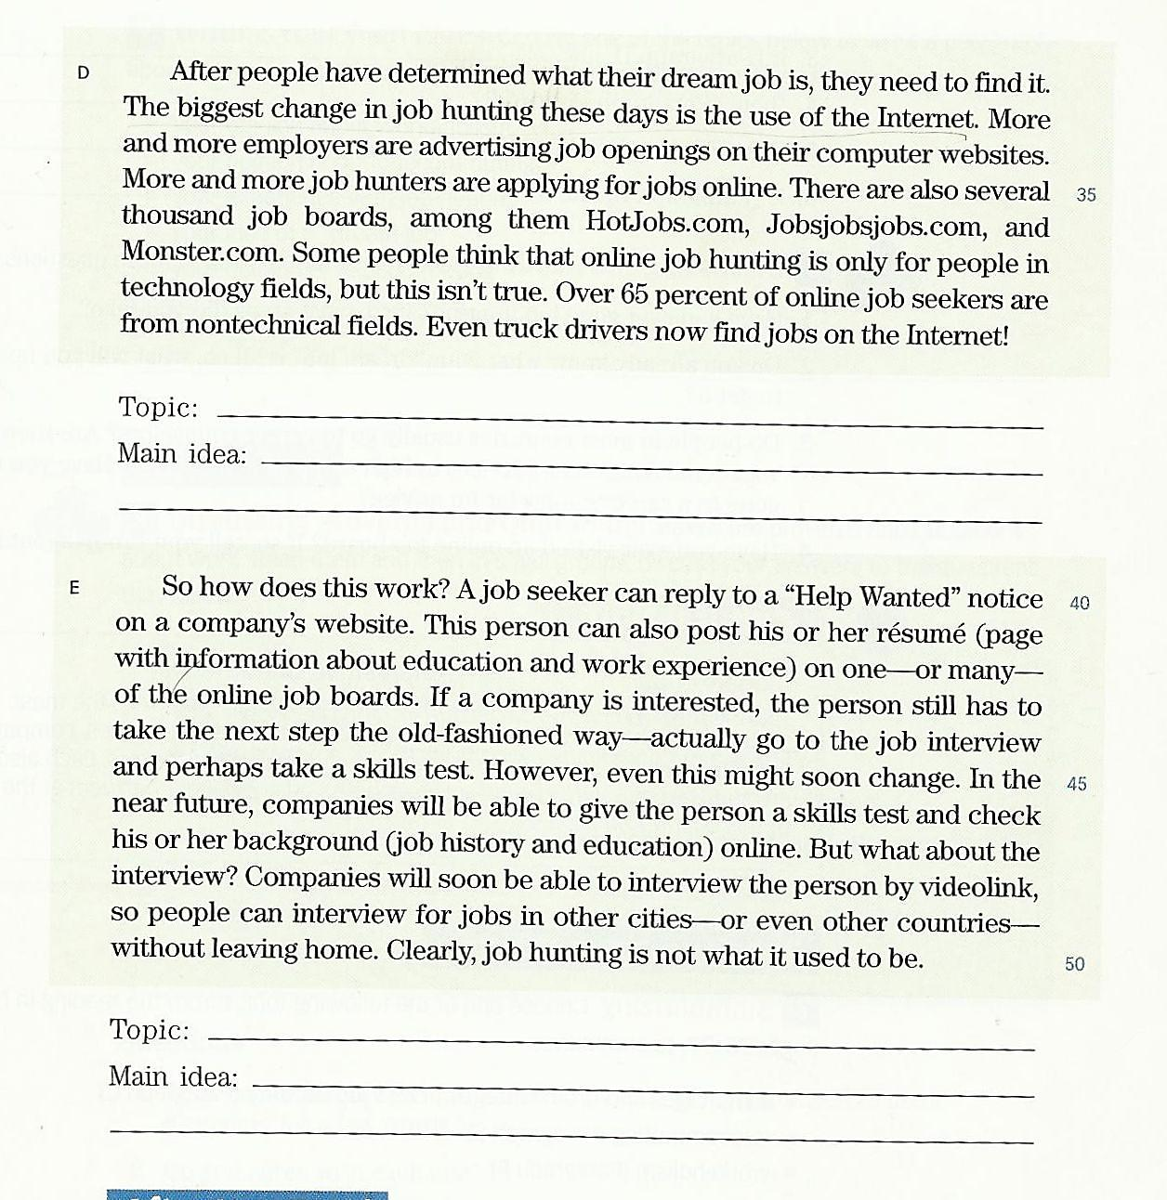

D. Topic:
Internet and Job Hunting

Main Idea:
More and more job hunters are applying for jobs online.

It (Paragraph D, Line 33)__________

E. Topic:
Online Job Hunting Steps

Main Idea:
Job hunting nowadays is not what it used to be

Them (Paragraph D, Line 36)_______

Vocabulary Previewing ( pages 123 / 131 / 135 )
meanings | New words | No.
A place by sea for ships and boats | harbor N | 1
A space between two things / a difference | gap N | 2
Very useful food | nutrients N | 3
hindrances | obstacles N | 4
advantages | benefits N | 5
places | Areas N | 6
An inspector who looks for criminals | detective N | 7
search | Look for V | 8
Make less | reduce V | 9
Need or want | require V | 10
surprise | astonish V | 11
Make happy | Excite V | 12
to rest | Relax V | 13
Concern / benefit | interest N | 14
Stand against | Challenge V | 15
Horrify / terrify / make others feel afraid | Frighten V | 16
Stop or prevent | Hold back PV | 17
Away from others/ nobody with him/ her | Alone Adj | 18

Questions
1.The word “_____________” is closest in meaning to the word “ surprise “.
a. terrify b. challenge
c. laugh d. astonish
2. If you go to the______________ you will many boats and ships.
a. harbor b. office
c. hospital d. restaurant
3. The word “need” is closest in meaning to the word____________________
a. question b. visit
c. require d. invest
4. The phrase “ a space/ distance between two things or persons” is a__________
a. building b. street
c. wall d. gap

5.The word “_____________” is closest in meaning to the phrase “ make less “.
a. reduce b. widen
c. require d. worsen
6. most people prefer to ______________ by the sea coast.
a. relax b. test
c. work d. type
7. The word “hindrances” is closest in meaning to the word_______________
a. questions b. obstacles
c. facilities d. stories
8. The phrase “ an inspector who looks for criminals” is called a/n __________
a. detective b. astronaut
c. teacher d. servant

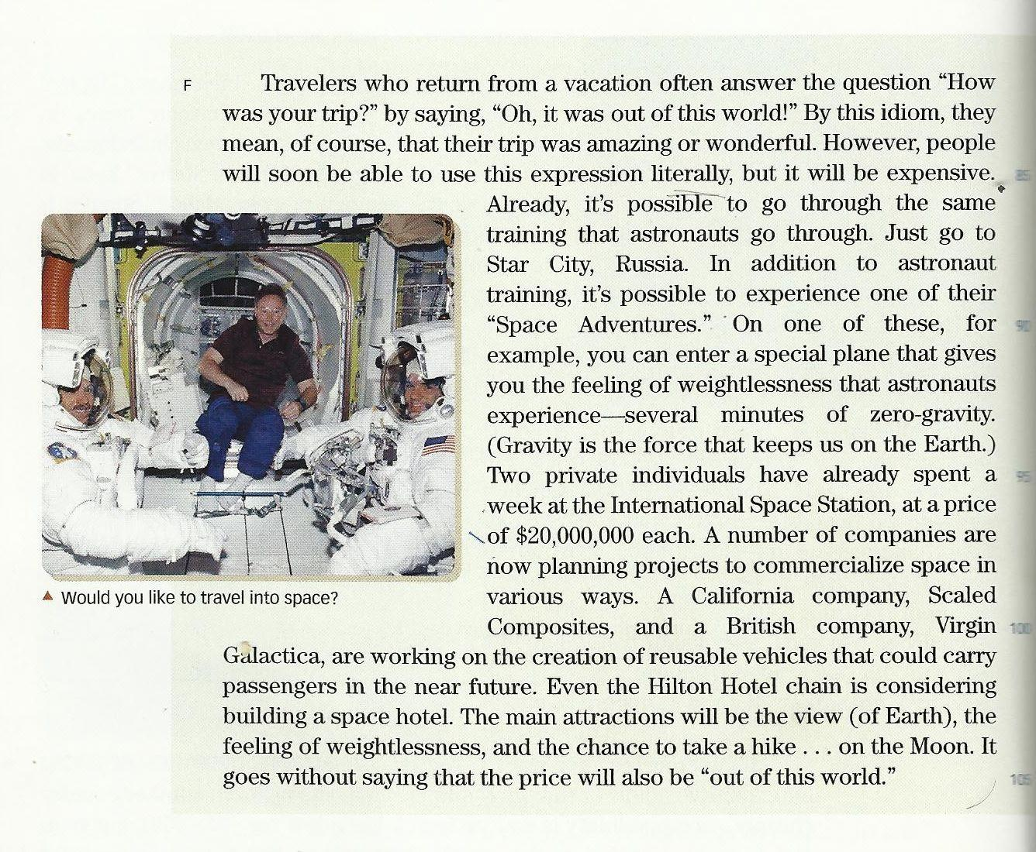

Questions
1. What do the travelers who come from a vacation say about their trip?
a. We were sick? b. It was a long trip
c. Oh, it was out of the world d. Oh, Nice trip
2. The underlined pronoun “ it” line 2 refers to___________________ .
a. the answer b. the question
c. the trip d. this world
3. which of the following is closest in meaning to special ? ______________
a. strong b. enjoyable
c. public d. private
4. literally means: _______________:
a. word by word b. stay alive
c. unreal d. wonderful
5. How long does it take to give you the feeling of weightlessness?
a. Two weeks b. Three minutes
c. One hour d. Several minutes
6. The underlined pronoun “ their” line 3 refers to___________________ .
a. amazing trips b. people
c. travelers d. the vacations
7. It is clear that a trip to space is ______________
a. expensive b. tiring
c. public d. dangerous
8. How much did the two individuals who stayed a week at I S S pay?
a. $20,000,000 b. $40,000,000
c. it was free d. $10,000,000
9. The most appropriate TOPIC of the reading passage is____________________
a. California Company b. Travelling Into Space
c. Amazing Expression D. Galactic
10. The MAIN IDEA of the passage is_____________________________________
a. A trip to the sea is wonderful b. It is very cheap to go to space
c. Space travelling is now possible d. No one like to travel into space

