Lecture 7
Syllable Structure in English

- What Does Syllabification of a Word Mean?
Syllables = المقاطع
الكلمة تتجزأ إلى مقاطع صوتية مفردها (وحدة صوتية)
تصدر المقاطع بشكل قوي و ضعيف
التجزئة الصوتية في الكلام تساعد على سرعة استيعاب العقل لمعالجة الكلمة.
الكلمة الواحدة تحتوي على مقطع واحد على الأقل، أي لابد من وجوده.. مقطع واحد أو أكثر
- Words can be cut up into units called syllables.
- Humans seem to need syllables as a way of segmenting the stream of speech and giving it a rhythm of strong and weak beats, as we hear in Music.
- Syllables exist only to make speech easier for the brain to process.
- A word contains at least one syllable.

- Here are some words divided into their component syllables (a period is used to mark the end of a syllable): period= نقطة = .
tomato = to.ma.to
window = win.dow

Syllables and their parts

Rhyme تتفرع إلى

Syllables
Parts | Onset | rhyme | nucleus | coda
Definition | the beginning sounds of the syllable | the rest of the syllable, after the onset | the core or essential part of a syllable | The last consonants in syllable
Type of sound | These are always consonants | نوعها حسب nucleus و coda | These are most vowels.  And this consonants [r], [l], [m], [n], [ŋ] | They are always consonants
Example | Read, flop , strap | flop , strap | Basic, depend | Basic, depend

ملاحظات مهمة:
- Not all syllables have all parts; the smallest possible syllable contains a nucleus only.
- A syllable may or may not have an onset and a coda.

- The English liquids [ r l ] and the nasals [ m n ] can be the nuclei of syllables under certain conditions. [ r ] can be a nucleus as easily as a vowel, in any position: the words 'bird', have [ r ] as the nucleus; in other words, there is no vowel in the pronunciation of these syllables, even though they have one in the spelling.
[brd]
صوت الـ r في حالة وجودة في كلمة وكل الأحرف فيها ساكنة ، راح يكون حرف vowel لأننا في هالحالة ماراح نتعامل معه كحرف راح نتعامل معه كصوت ولاحظوا عند كتابته بالصوت بيكون حرف متحرك.... وحسب ملاحظة سابقة أن المقطع لابد أن يتكون على الاقل من nucleus

- [ l ] and the nasals [ m n ] become syllable nuclei when they follow an alveolar consonant in the last syllable of a word. This happens in the relaxed or casual rather than very formal articulation of the word. Compare casual vs. formal pronunciations of 'button', 'bottle', 'bottom'.
الاصوات [l] [m][n] تكون syllable nuclei إذا تبعها alveolar consonant وهذه الحالة فقط إذا جت هالأصوت في آخر مقطع في الكلمة
تذكير:
alveolar consonant= (/t/, /d/, /s/, /z/, /n/, /l/)

- The core syllable: is made up of a Nucleus preceded by an Onset
تمثل بهالشكل
العقدة وتمثل المقطع=syllable
σ
ترمز لـ nucleus
ترمز لـ onset
O N
ترمز لـ vowel
ترمز لـconsonant
C V

ملاحظات مهمة:
- Some languages only have CV syllables.
- More commonly, languages allow for syllables of greater complexity.
- The core syllable is, however, found in every language.
- The fact that CV syllables are cross-linguistically attested offers an interesting parallel with their invariable occurrence in early child language.

- Linguists often use tree diagrams to illustrate syllable structure.
'Flop', for example, would look like this (the word appears in IPA symbols, not English spelling).
الرمز | S | O | R | N | C
اختصار لـ | Syllable | Onset | Rhyme | Nucleus | Coda

تمثل كلمة 'Flop' بهالشكل

σ

O R

C V

N C

[F l a p]
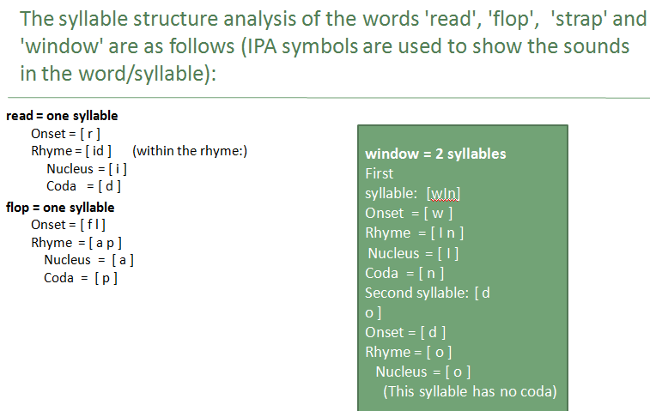

ملاحظات مهمة:
- If a syllable has the coda, it is called as closed syllable
Example : cap, sit, man
b. If a syllable doesn’t have the coda it is called as open syllable.
Example: he, she, me

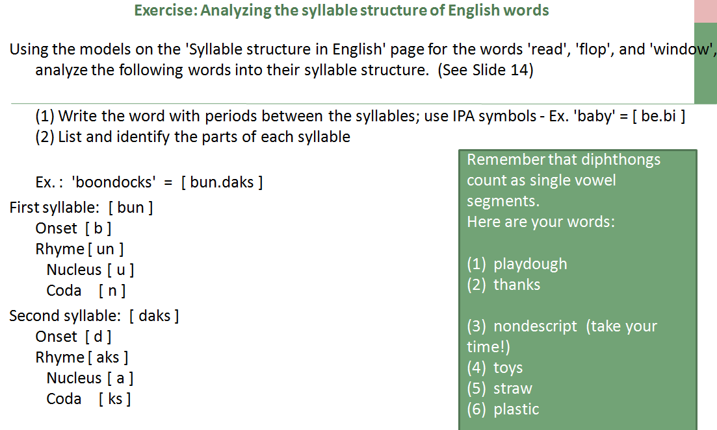

آخر ملاحظة ☺
الشريحة 16 إلى 22 ، صعب ارتبها كمراجعة
الشريحة 23 Do it right now >> زي مايقول الدكتور ☺
خلوها تطبيق لكم..

بدويه
ملتقى جامعة الملك فيصل – المستوى الخامس
2011 - 2012

