Sociolinguistics Language and Society Sociolinguistics:
- It is the study of language and its relation to society, and it draws on insights from sociology, anthropology and social psychology. It feeds insight back into these other disciplines and areas.
- In particular, studies in sociolinguistics have pinpointed the importance of the social function of language and shown that it is often possible to find social explanation of linguistic structure.
- Although there is a long tradition within linguistics of dialect study ( dialectology) and the relationship between language and culture, it was not until the 1960s that interest in sociolinguistics became widespread, largely as a result of Labov’s work in the U.S and Trudgill’s work in Britain.
- Many sociolinguistic studies are concerned with the way in which language varies according to the social context in which language it is used and according to the social group to which a user belongs. It aims to describe this variation and to show how it reflects social structure.
- Those linguistic units which vary systematically in relation to the social variables such as the user’s region, class, ethnic groups, age and gender are called sociolinguistic variables, and their different forms are called variants.

Dialects
- Within any speech community, variations are normally found on all levels of linguistic structure- phonological, grammatical, and lexical. Some of the variations are correlated with what we previously referred to as social variables.
- These include cases of difference between men’s and women’s speech… linguistic variation may also be correlated with the social status of the speaker [or] with other facts in the social and cultural context.
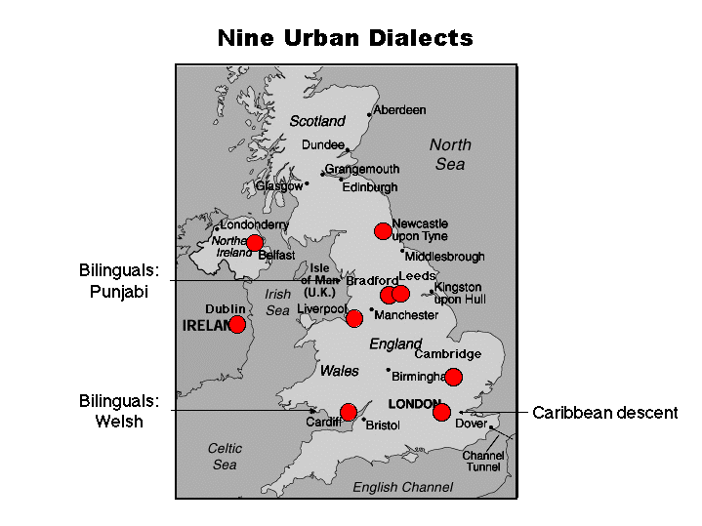
Idiolect:
- The unique characteristics of the language of an individual speaker are referred to as the speaker’s idiolect
- When the language of different speakers (e. g. English ) in different geographical regions and from different social groups shows systematic differences, the groups are said to speak different dialects of the same language.
- The dialects of a single language may thus be defined as mutually intelligible forms of a language that differ in systematic ways from each other.
- Audio Examples of English Dialects:
- Cambridge: Example of a free conversation
- Dublin: Example of a map task
- Audio Examples of English Dialects:
- London : Example of a map task
- American English : Example of a map task
Regional Dialects:
- Dialectal diversity develops when people are separated from each other geographically and socially.
- Dialect differences tend to increase the degree of communicative isolation between groups.
Accents:
- Regional phonological or phonetic distinctions are often referred to as different accents.
Cont.
- The term accent is also used to refer to the speech of someone who speaks a language nonnatively; for example, a French person speaking English is described as having a French accent.
Dialect Atlases:
- Dialectologists produce a dialect map or dialect of a region, on which dialect differences are geographically plotted. The black dots mark dialect areas. But a line drawn on the map separating the areas is called Isogloss.
- Dialects of US 

The standard:
- Even though every language is a composite of dialects, many people talk and think about a language as if it were a “ well- defined” fixed system with various dialects diverging from this norm.
- The dominant or prestige dialect is often called the standard dialect.
Language purists:
- Prescriptive grammarians, or language “purists,” usually consider the dialect used political leaders and the upper socioeconomic classes, the dialect used for literature or printed documents, the dialect taught in the schools, as the correct form of the language.
Banned languages:
- Language purists wish to stem change in language or dialect differentiation because of their false belief that some languages are better than others or that change leads to corruption.
For.ex Russian Kurdish
Black English


