حل مسائل الرياضيات بالآلة CASIO fx-911ES
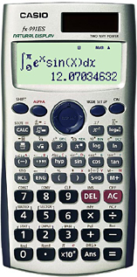

عنــــوان الــــــــدرس | رقم المثال | الصفحة | الخطــــــــــــــــــــــــوات |  | الشكل بالآلة
تحويل العدد من كسري إلى عشري | 25 | 45 | 1 | الآله على مود1 (العادي)
 |  |  | 2 | نضغط زر كسر | 
 |  |  | 3 | ندخل في البسط رقم 1
 |  |  | 4 | ندخل في المقام رقم 8
 |  |  | 5 | نضغط = | 
 |  |  | 6 | نضغط زر S→D | 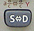
 |  |  | يظهر الناتج = 0,125

عنــــوان الــــــــدرس | رقم المثال | الصفحة | الخطــــــــــــــــــــــــوات |  | الشكل بالآلة
أساسيات الجبر  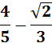 | 37 | 60 | 1 | الآله على مود العادي 1
 |  |  | 2 | نضغط زر الكسر
 |  |  | 3 | ندخل في البسط 4 وفي المقام 5
 |  |  | 4 | نضغط زر ناقص –
 |  |  | 5 | نضغط زر كسر
 |  |  | 6 | ندخل في البسط جذر 2 وفي المقام 3
 |  |  | 7 | نضغط =
 |  |  | 8 | يطلع الناتج على الشاشه
 |  |  | 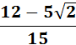

عنــــوان الــــــــدرس | رقم المثال | الصفحة | الخطــــــــــــــــــــــــوات |  | الشكل بالآلة
القوى والأسس  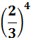 | 44 | 78 | 1 | الآله على المود العادي 1
 |  |  | 2 | نضغط زر القوس | 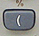
 |  |  | 3 | نضغط زر الكسر
 |  |  | 4 | ندخل في البسط 2 وفي المقام 3
 |  |  | 5 | نضغط زر تقفيل القوس | 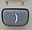
 |  |  | 6 | نضغط زر x اس مربع | 
 |  |  | 7 | ندخل مكان الأس 4
 |  |  | 8 | نضغط =
 |  |  | 9 | تضهر النتيجه

عنــــوان الــــــــدرس | رقم المثال | الصفحة | الخطــــــــــــــــــــــــوات |  | الشكل بالآلة
الجذور | 46-3 | 82 | 1 | الآله على المود العادي 1
 |  |  | 2 | نضغط زر SHIFT | 
 |  |  | 3 | نضغط زر X اس مربع
 |  |  | 4 | ندخل داخل الجذر -32
 |  |  | 5 | ندخل فوق الجذر 5
 |  |  | 6 | نضغط =
 |  |  | يظهر الناتج -2

عنــــوان الــــــــدرس | رقم المثال | الصفحة | الخطــــــــــــــــــــــــوات |  | الشكل بالآلة
اللوغاريتمات | 50 | 86 | 1 | الآله على الوضع العادي مود 1
 |  |  | 2 | نضغط زر log اللي جنبه مربعين | 
 |  |  | 3 | ندخل بالمربع اللي تحت 7
 |  |  | 4 | وندخل بالمربع اللي فوق 49
 |  |  | 5 | نضغط يساوي
 |  |  | يظهر الناتج =2

عنــــوان الــــــــدرس | رقم المثال | الصفحة | الخطــــــــــــــــــــــــوات |  | الشكل بالآلة
اللوغاريتمات | 52 | 87 | 1 | الآلة على المود العادي 1
 |  |  | 2 | نضغط زر log اللي جنبه مربعين
 |  |  | 3 | ندخل بالمربع اللي تحت 3
 |  |  | 4 | نذهب للمربع الثاني ونضغط ALPHA | 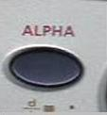
 |  |  | 5 | نضغط الزر اللي فوقه x حمراء
 |  |  | 6 | نضغط يمين بالسهم لنخرج برا القوس | 
 |  |  | 7 | نضغط زر ALPHA
 |  |  | 8 | نضغط الزر اللي فوقه = حمراء | 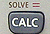
 |  |  | 9 | ثم نضغط 2
 |  |  | 10 | نضغط زر SHIFT
 |  |  | 11 | ثم نضغط زر CALC
 |  |  | 12 | ثم زر =
 |  |  | ستظهر النتيجة X= 9

عنــــوان الــــــــدرس | رقم المثال | الصفحة | الخطــــــــــــــــــــــــوات |  | الشكل بالآلة
حل معادلات خطيه في مجهول واحد | 1 | 123 | 1 | الآلة على المود العادي 1
 |  |  | 2 | نكتب المعادلة نفسها على شاشة الآلة كما يلي:
 |  |  | 3 | نضغط 3 ثم ALPHA
 |  |  | 4 | ثم نضغط – 1
 |  |  | 5 | ثم نضغط ALPHA
 |  |  | 6 | ثم زر CALC
 |  |  | 7 | نضغط 5 وبكذا تكون عندنا شكل المعادلة نفسها على الشاشة
 |  |  | 8 | نضغط SHIFT
 |  |  | 9 | ثم زر CALC
 |  |  | 10 | ثم =
 |  |  | تظهر النتيجة X= 2

عنــــوان الــــــــدرس | رقم المثال | الصفحة | الخطــــــــــــــــــــــــوات |  | الشكل بالآلة
حل معادلتين خطيتين في مجهولين  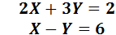 | 2 | 125 | 1 | نضغط زر مود ثم 5 EQN | 
 |  |  | 2 | نضغط رقم 1 | 
 |  |  | 3 | نضغط 2 ثم يساوي | 
 |  |  | 4 | نضغط 3 ثم يساوي | 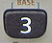
 |  |  | 5 | نضغط 2 ثم يساوي
 |  |  | 6 | نضغط 1 ثم يساوي
 |  |  | 7 | نضغط -1 ثم يساوي وما ننسى السالب
 |  |  | 8 | نضغط 6 ثم يساوي | 
 |  |  | 9 | ثم نضغط يساوي مره ثانيه
 |  |  | 10 | بتظهر X=4
 |  |  | 11 | نضغط يساوي بتظهر Y= -2

عنــــوان الــــــــدرس | رقم المثال | الصفحة | الخطــــــــــــــــــــــــوات |  | الشكل بالآلة
حل معادلة من الدرجة الثانية في مجهول واحد | 5 | 130 | 1 | نضغط MODE ثم نختار 5 EQN
 |  |  | 2 | نضغط على 3
 |  |  | 3 | نضغط 1 ثم =
 |  |  | 4 | نضغط -6 ثم يساوي وما ننسى السالب
 |  |  | 5 | نضغط =
 |  |  | 6 | نضغط 9 ثم =
 |  |  | 7 | نضغط = مره ثانيه
 |  |  | تظهر لنا x=3

عنــــوان الــــــــدرس | رقم المثال | الصفحة | الخطــــــــــــــــــــــــوات |  | الشكل بالآلة
حساب المتتاليات  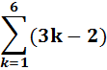 | 2 | 182 | 1 | الآله على المود العادي 1
 |  |  | 2 | نضغط SHIFT
 |  |  | 3 | نضغط زر log اللي جنبه مربعين
 |  |  | 4 | بتضهر لنا سيجما ندخل 1 بالمربع اللي تحت
 |  |  | 5 | ندخل 6 بالمربع اللي فوق
 |  |  | 6 | نذهب للمربع اللي جنب السجما وندخل قوس
 |  |  | 7 | ثم ALPHA
 |  |  | 8 | ثم نضغط الزر اللي فوقه X حمراء | 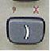
 |  |  | 9 | ثم نضغط -2 ونسكر القوس
 |  |  | 10 | نضغط =
 |  |  | تظهر النتيجة =51

عنــــوان الــــــــدرس | رقم المثال | الصفحة | الخطــــــــــــــــــــــــوات |  | الشكل بالآلة
إيجاد قيمة المشتقة الأولى عند قيم xمعطاة (ميل المماس)  x = -1 | 14 | 231 | 1 | الآلة على المود العادي 1
 |  |  | 2 | نضغط على زر SHIFT
 |  |  | 3 | نضغط الزر اللي مرسوم عليه تكامل | 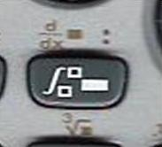
 |  |  | 4 | نكتب بين القوسين
 |  |  | 5 | نكتب عند -1 x =
 |  |  | 6 | نضغط =
 |  |  | تظهر النتيجة = 14

عنــــوان الــــــــدرس | رقم المثال | الصفحة | الخطــــــــــــــــــــــــوات |  | الشكل بالآلة
ايجاد قيمة الداله f(x) عند قيم xمعطاه | 18 | 236 | 1 | نضغط MODE ثم نختار 7 TABEL
 |  |  | 2 | بيظهر لنا f(x) =
 |  |  | 3 | نكتب الداله المعطاة وهي:
 |  |  | 4 | نضغط =
 |  |  | 5 | ندخل قيمة x المعطاة وهي 2
 |  |  | 6 | نضغط =
 |  |  | 7 | نكرر ادخال قيمة x المعطاة وهي 2
 |  |  | 8 | تظهر لنا كلمة step? نضغط 1 دائما
 |  |  | 9 | نضغط =
 |  |  | تظهر لنا قيمة f(x) =8 عندما x = 2

عنــــوان الــــــــدرس | رقم المثال |  | الصفحة | الخطــــــــــــــــــــــــوات |  |  |  |  | الشكـــــــــــــــــــــــــــل
التكامــــــــــل  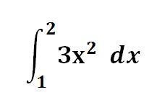 | 9 |  | 271 | 1 |  | اضغط زر التكامل.
 |  |  |  | 2 |  | نحرك الأسهم.
 |  |  |  | 3 |  | نعبي الفراغات 1 و2
 |  |  |  | 4 |  | والفراغ الثالث نضغط 3 ثم زر ALPHA
 |  |  |  | 5 |  | ثم هذا الزر اللي فوقه x حمراء
 |  |  |  | 6 |  | نضغط علامة التربيع
 |  |  |  | 7 |  | الآن يصبح على شاشة الآلة نفس المعادلة المطلوبة
 |  |  |  | 8 |  | نضغط =
 |  |  |  |  |  |  |  | يطلع الناتج7

Mathematical and Statistical Analysis
The following chapter covers most of the statistical features of both Microsoft Excel and your CASIO FX-991 calculator. Both offer a variety of statistical functions that can be of great value in the analysis of data for your labs and assignments.

10.1 CASIO FX-991 Calculator
There are two different versions of CASIO calculators in use on Queen's Campus. The 991s is not sold any longer but has been purchased by most upper year students prior to this year. This year, the 991w is the new version. Both are acceptable as calculators for use in Engineering and Arts and Science examinations.
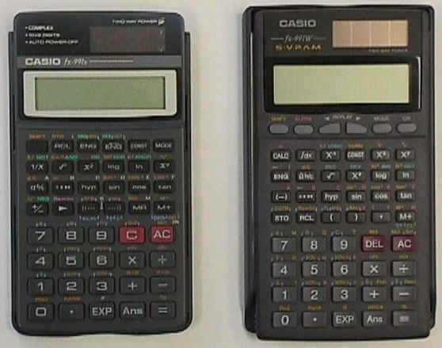
Figure 1: CASIO calculators Model fx-991s and fx-991w. The 991w (on the right) has new features, including a two-line display alpha-numeric display and an equation mode. The calculator is turned on by pressing the <AC> key on the 991s and the <ON> button on the 991w.
The CASIO calculators are similar to any other scientific calculator. The display shows a number of digits of numerical information as well as indicators of other information such as mode, memory usage, etc. The display always shows what's in the 'x' register. This is the last number you've typed into the calculator. The other register is the 'y' register (not displayed on the 991s, in the upper line of the screen on the 991w). This register holds the next-to-last number you've entered into the calculator and is used in the operations involving more than one number. For example, to multiply 2x5 and get an answer, you would enter 2<x>5<=> on the keypad. At the point after you entered the 5 but before you hit the <=> key the 'x' register contains 5 and the 'y' register contains 3. After hitting the <=> key the 'x' register will contain 10 and the 'y' register will be empty.
The keyboard is set up with the black function keys located in the upper portion of the keypad and the dark gray numeric keys in the lower portion of the keypad. The two red buttons are the Clear and All Clear buttons, labeled C and AC, respectively. The calculator is solar powered but will shut down after ca. 10 minutes of idle time. To turn the calculator on, press the red <AC> button. Due to the large number of mathematical functions available, each key on the keypad has several possible functions, depending on the mode of the calculator. The text describing each function is therefore colour-coded. The main colours are white, orange, blue, green and violet and pink. The functions that are printed in white can be used when the calculator is in standard COMP mode. The orange lettering is accessed by pressing the <SHIFT> key followed by the desired key. For example, to calculate the inverse sine of 0.43, you would press <SHIFT>< sin⁻¹>.43<=>. The answer would be displayed as 25.467...
colour coded keys are used in modes as follows:
White normal (Comp) mode
green for Base-n mode.
Violet for complex number mode
blue for Statistical calculations doable in either SD or REGression mode (LR in the 991s)
In addition, there are several registers available for certain memory functions. These are indicated by letters A-F and a few extras. They are coloured silver on the 991s and pink on the 991w. To store a number in memory, press the number, followed by <STO> and followed by the particular memory you wish to put the number into. To recall a number from memory, press <RCL> followed by the memory you have previously stored the number into.
These memories can all be cleared in one step by pressing the appropriate key combination, depending on the mode of the calculator. Press <SHIFT><Mcl><=> (Coloured red here to indicate that you only need to press the = key on the 991w) or <SHIFT><Scl><=> for statistical registers (these two sets of keystrokes are actually the same set of keys on the 991w but they are different sets on the 991s.
To change the current mode of the calculator, press the <MODE> key a number of times and then press the appropriate number to set the mode.
The following table outlines the choices presented for the two calculators for a given number of <MODE> key presses.
# times <MODE> is pressed | CASSIO fx 991s | CASSIO fx 991w
1 | 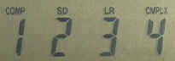  Select the calculational mode  - Press 1 to put the calculator in COMPutational mode for general calculations.  - Press 2 for Standard Deviation mode for statistical calculations. In this mode, the blue lettering or blue brackets around the shifted (orange) lettering indicates functions that you can use.  - Press 3 for Linear Regression Mode. In this mode, Shift-A is the y intercept, shift-B is the slope.  - Press 4 for complex mode. | 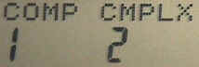  Select the calculational mode  - Press 1 to enter COMPutational mode for general calculations  - Press 2 for CoMPLeX mode. In this mode, you can enter complex numbers in the form x+yi.
2 | 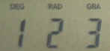  Select the units to measure/calculate angles  - degrees  - radians  - gradians | 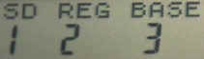  Further Calculation modes:  - Standard Deviations (See Row 1 item 2 in 991s description above.  - REGression mode. for performing a least-squares fitting on a set of data. You can choose various types of fits. (Linear [1] is most common)  - Choose either DECimal (10), HEXadecimal (16), BINary (2) or OCTal (8). Use the keys pictured here (green). 
3 | 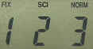  Select the display mode  - Fixed number of decimal places.  - Scientific notation (powers of ten displayed on the right-hand side).  - Normal (floating point) display. | 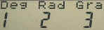  Select the units to measure/calculate angles  - degrees  - radians  - gradians
4 | 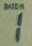  Choose either DECimal (10), HEXadecimal (16), BINary (2) or OCTal (8) to display the x register in the appropriate base. Use the keys pictured here (green). You will need to press the <SHIFT> key to access BIN and OCT (orange).   | 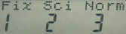  Select the display mode  - Fixed number of decimal places.  - Scientific notation (powers of ten displayed on the right-hand side).  - Normal (floating point) display.
5 | No further choices on the 991s. |   toggle Engineering Mode on or off. EngON displays scientific prefixes such as nano- (10⁻⁹), micro- (10⁻⁶), milli- (10⁻³), kilo- (10³) and Mega- (10⁶), etc. in the display.

10.2 Mean Value and Standard Deviation

Mean Value or Average,
The arithmetic mean is simply the sum of all the observed values divided by the number of atoms in the data set. It is defined as:
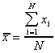
where x_{i} is the ith entry in the set of observed values x and N is the total number of observed points.

Standard Deviation, σ (and s)
The standard deviation (SD) gives information regarding the precision (not the accuracy) of the data, i.e., how much does the data differ from the mean value. Low values of s mean precise measurements (data similar in magnitude) while higher values of s indicate less precise measurements (data is dispersed widely about the mean value).
The standard deviation comes in two flavours. Population SD is symbolized by the greek letter s and represents the deviation of a very large data set from the true mean m. It is defined as:
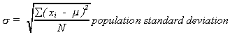
In Real-world situations, we rarely know the true mean m and the number of data points is not large. Thus, we would use the sample SD defined as
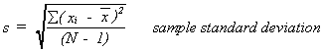
Values of s and s will approach each other as the number of data points goes up and when the sample data is an accurate reflection of the true world population.
The standard error of the mean is then defined as
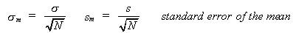.
This last value is the value often reported with the data as the + number. For example, in an experiment, a measured mean is 1.34 and the standard error is .03. This is reported as 1.34 + .03. A shorter way of expressing this is 1.34(3) where the (3) indicates that the last digit of the number is uncertain by that much.

Using the calculator
Both the mean value and standard deviation can be calculated using the calculator. In order to use the statistical functions of your calculator, you must be in one of the statistical modes. Change to Standard Deviation mode . A small SD should now appear on the LCD display panel of the calculator. This signifies that you are in standard deviation mode. All of the statistical functions and thus standard deviation function keys are characterized by blue colouring on the calculator keypad. The first thing that should be done before any calculations are entered is to clear the statistical memory. The clear stats key is denoted by an Sci symbol with a blue outline around it on top of the red C or AC key. To clear the statistical memory, press <SHIFT><Sci><=>. You can now enter data to be analyzed. Every time you enter a number, you must press the <DATA> key so that it can be put into the standard deviation memory. The <M+> key is the DATA key for standard deviation mode. Once you have entered your data, you can find the mean value by pressing <SHIFT> then <><=>. The standard deviation for your data can be found by pressing <SHIFT><xσ_{n-1}><=>.

Using Excel
To determine the mean value and standard deviation of a data set using Excel, you must select Tools I Data Analysis... from the menu bar. From the first dialogue box that appears, you must select Descriptive Statistics from the list of Data Analysis Tools. Then from the second dialogue box that appears, you must click on the Summary Statistics feature at the bottom of the list so that an X appears. This tells Excel that you would like to see the summary output table of statistics. You must then specify in the Input Box, Where your data is located, and in the Output Box, where your output table is to go. See Table 10.1 for the data and Table 10.2 for the output data.
Table 10.1 - Statistical Data
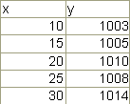
Table 10.2 - Excel Output Data Table for the Data found in Table 10. 1
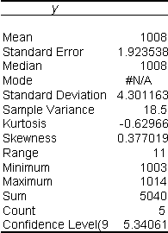

10.3 Least Squares Regression

Mathematics
Regression is the process of fitting a line to a data set so that the distance from each point to the line is minimized. Mathematically, linear least-squares regression is expressed by a series of equations.
Given that:
N is the total number of data points.
x_{i} is the i^{th} entry of the x data set.
y_{i} is the i^{th} entry of the y data set.
is the arithmetic mean value of the x data set.
is the arithmetic mean value of the y data set.
Several quantities appear repeatedly in these calculations. They are represented here along with the key combinations necessary to access them in the 991s and 991w calculators. (use the pink lettered keys on the 991w)
Value | 991s | 991w
Σx² | <RCL>1 | <RCL>A
Σx | <RCL>2 | <RCL>B
N | <RCL>3 | <RCL>C
Σy² | <RCL>4 | <RCL>D
Σy | <RCL>5 | <RCL>E
Σxy | <RCL>6 | <RCL>F
Σx³ | N/A | <RCL>M
Σx²y | N/A | <RCL>X
Σx⁴ | N/A | <RCL>Y
We can then define three quantities, S_{xx} S_{yy}, and S_{xy}, as follows: The keystrokes necessary to calculate these are presented to the left (they are different for the two calculators 991s vs. 991w.)
Statistical function | Keystrokes for 991s (for 991W replace 1,2,3,4,5 with A,B,C,D,E)
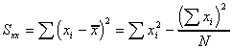 | <RCL>1<-><(><RCL>2<X²><)><÷> <RCL>3<=>
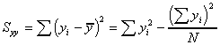 | <RCL>4<-><(><RCL>5<X²><)><÷> <RCL>3<=>
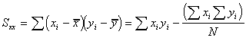 | <RCL>6<-><(><RCL>2<X><RCL>4<)><÷> <RCL>3<=>
These statistical functions are used in analytical solutions indicated below.
From these three equations we can derive six useful quantities:
- The slope, m, of the regression line.
- The intercept, b, of the regression line.
- The standard deviation about regression, s_{r}.
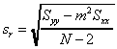
- The standard deviation of the slope, s_{m}.
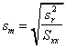
- The standard deviation of the intercept, b.
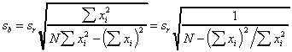
- The correlation coefficient r
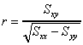

Using the Calculator
Change to Linear Regression mode. The selected mode is indicated by a small LR (991s) or REG (991w) on the LCD output display to indicate that you are in linear regression mode. Again, the statistical function keys and thus the linear regression keys are characterized by blue print on the calculator keypad. Linear regression data is supplied to you in two column form, that is, the data is given as x-values and y-values. For example:
x | y |  | (x, y)
1 | 10 |  | (1, 10)
2 | 12 |  | (2, 12)
3 | 13 | or | (3,13)
4 | 16 |  | (4,16)
5 | 15 |  | (5,15)
Before beginning, clear the statistical memory by pressing <SHIFT><Sci><=>. The first x, y combination is entered by pressing
<1>< , ><1><0><DT> (Note that <DT> on the 991w is labeled <DATA> on the 991s and the button < , > on the 991w is <x_{D}|y_{D}> on the 991s). Then the next combination is entered by pressing the
<2>< , ><1><2><DT>, etc. The entire data set is entered in this manner. The result of the analysis by linear regression is an equation. The equation is given in the form y = Bx + A. Where: B is the slope, and A is the y-intercept.
After you have completed entering the data set, you can use your calculator to find these values. A is given by pressing <SHIFT><A><=> and B is given by <SHIFT><B><=>. Also, the correlation coefficient (r) is displayed by pressing <SHIFT><r><=>. The correlation coefficient (r) is a measure of correlation of the data. The correlation coefficient is an index number that varies from -1.00 through 0 to +1.00. The sign of the coefficient indicates the direction of the linear relationship.
Once you have entered the regression data, you can also find other points on the regression line. For example by pressing the keys
2.5<SHIFT><> will give the value of y when x = 2.5. Similarly, by pressing
14<SHIFT><>, you can obtain the value for x when y = 14.

Using Excel
Excel offers both graphical regression analysis and mathematical regression analysis. The graphical analysis is a means of putting a regression line onto a graph and was discussed in Chapter 9 - Excel for Graphing. The purpose of linear regression is to fit a straight line of the form y = mx + b to a series of data points.
To use the mathematical analysis of linear regression, you must again first select the data set. This time however, you are not selecting the data series on a chart, you are selecting the cells that contain the data on a worksheet. Once this is done, you must select Tools | Data Analysis... from the menu bar. This will call up a dialogue box. Select the Regression feature and click on OK. Again, a dialogue box appears which prompts you to specify where your data is and where you want the output table to go. In order to summarize the output data, we must understand some of the math involved. If the data set from Table 10.1 was entered into Excel, the output Table would be as shown in Table 10.3.
Important: When choosing options, you can specify where you would like Excel to put your output table. You must specify one cell indicating the position of the upper left hand corner of the output table. It is important to:
Allow at least seven columns for the largest data output table.
The output tables include:
A regression statistics table which includes the following features:
The correlation coefficient labeled as Multiple R
The square of the coeff. of correlation, called the coefficient of determination The number of entries in the data set labeled as Observations
An ANOVA table (see 10.6 for definition)
A Regression table which includes:
Coefficients - the slope is labeled as X and the y-intercept is labeled intercept
Standard error of the coefficients
A residual output table that can include:
Residuals
Standardized residuals
Predicted values
Table 10.3 - Excel Linear Regression Output tables
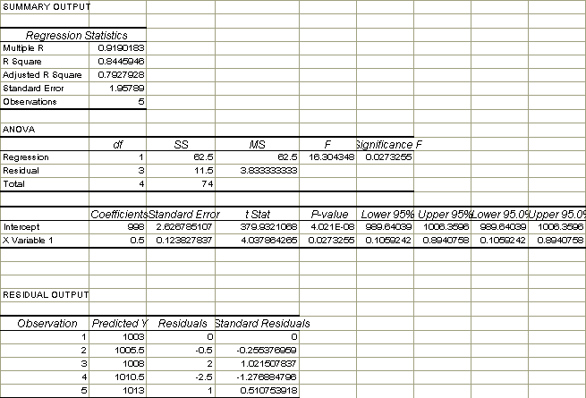

Using Solver
For data types where a linear regression is impossible, you must resort to using a non-linear data-fitting method. There are several methods to use. The most convenient from within Excel is the Solver. Solver is an excel "add-in". If it is installed, it will be available on the Tools menu bar. If it does not show up on the Tools menu then choose Tools | Add-Ins... and select solver from the list. If this fails to work or you can't find the solver on the list you will need to use the original Installation CD and add the proper component. For a detailed description of the use of solver, check the Lab on Applications with Excel. Unfortunately, Solver gives you the answers but is can't give you the error limits of the fitted parameters as we can calculate above for linear systems. Without these error limits our answers are completely useless. No self-respecting research supervisor will accept data without knowing how reliable those data and their analysis are. For a description of using Excel to calculate a set of error limits, click here. (soon).

10.4 Moving Average
Moving average is another statistical feature offered by Excel. Moving average is also included as both a graphical feature and a mathematical feature in Excel. See Chapter 9 for details concerning the graphical moving average.
Using the mathematical feature, the moving average can be calculated by selecting Tools | Data Analysis... from the menu bar. Then the Moving Average feature must be selected from the subsequent dialogue box. Using this method, the moving average period is referred to as the Interval. If you select the Chart Output feature from the moving average dialogue box, you are essentially getting the same result as with the graphical output explained in Chapter 9. But, in this case, you will also get an output table giving the moving average values.

10.5 T-test
The T-test is simply a comparison of the mean values from two experimental data sets. The test is used to determine whether the two means are distinct. This test can be used to decide whether two materials are identical when both have been analyzed by the same procedure. A chemist may have to judge whether the difference in the means establishes that the materials are different or whether the difference in the means is simply caused by indeterminate errors within the two sets. The T-test can be found by selecting Tools | Data Analysis... from the menu bar.

10.6 ANOVA
ANOVA stands for analysis of variance and is mathematically equivalent to the T-test described above, but in the case of ANOVA, more than two experimental means are compared. This statistical procedure is used to determine whether mean values from two or more samples are drawn from populations with the same mean. The relative effects of three or more different treatments or conditions are frequently compared. For instance, the yield of a chemical obtained by using three or more different methods might be investigated. The ANOVA function can be found by selecting Tools | Data Analysis... from the Menu bar.

10.7 Covariance and Correlation
Covariance returns the average of the product of deviations of data points from the respective means. Covariance is a measure of the relationship between two ranges of data. Correlation measures the relationship between two data sets that are sealed to be independent of the unit of measure. The population correlation returns the covariance of two data sets divided by the product of their standard deviations. Both Covariance and Correlation can be found by selecting Tools | Data Analysis... from the menu bar.

10.8 Exponential Smoothing
Exponential Smoothing and Graphical Smoothing discussed in Chapter 9 are not the same thing. Graphical Smoothing is strictly a graphical feature. Exponential smoothing however, uses a mathematical formula to predict a value based on the forecast for the prior period, and adjusts for the error in that prior forecast. This feature can be used by selecting Tools | Data Analysis... from the Menu bar, then selecting Exponential Smoothing from the list of features.

10.9 F-test
The F-test is a test for comparison of variances of two different data sets. The F-test can be chosen by selecting Tools | Data Analysis... from the Menu bar.

10.10 Signal to Noise Ratio
One of the main problems with modem instruments is the amount of sensitivity and precision involved in using them. In order for chemists to do much of their research today, they must use extremely sensitive instruments that are very precise. Since the instrument is detecting very faint signals, the amount of background noise is sometimes high enough to obscure the signal so it can't be detected. A signal to noise ratio (S/N) of 3 or more is desirable. Due to the arrival of the microcomputer as a research aid, statistical features are becoming an important method in the analyses of data. Tasks such as smoothing "noisy" data or comparing the spectrum of an analyte with the stored spectra of pure compounds are now common practice. The most common methods are averaging, digital filtering, Fourier transformation, and correlation techniques.

Ensemble Averaging
Ensemble averaging is a graphical feature where consecutive data sets are collected and summed point by point into the memory of a microcomputer. This process is often referred to as co-addition. After the collection and summation is complete, the data are averaged by dividing the sum for each point by the number of scans performed. The result is one averaged spectrum composed of all the other spectra.

Box-car Averaging
Box-car averaging is another graphical feature for smoothing irregularities in a spectrum, assuming that the irregularities are the result of noise. The first point on the box-car plot is the mean of the first, second and third points on the original curve; point 2 is the average of points 4, 5, and 6, etc.

Digital Filtering
Digital filtering is another feature in which the data set of a spectrum is manipulated by using Fourier transform mathematics. The original signal, which varies as a function of time, is converted to a frequency-domain signal in which the independent variable is now frequency rather than time. The frequency signal is then multiplied by the frequency response of a digital filter. The filtered time-domain signal is then recovered by an inverse Fourier transform.

10.11 Short Theory Questions
- Under which menu is regression analysis found in Excel?
- How do you clear the standard deviation memory using the CASIO FX-991 calculator'.?
- What is the definition of the arithmetic mean?
- What is the definition of linear regression?
- What does Excel call the correlation coefficient in its Regression Statistics output table?
- What does ANOVA stand for?
- Under what heading are the slope and y-intercept found in the regression output table?
- What is the T-test?
- What is the difference between Exponential Smoothing and Graphical Smoothing (see the chapter "Graphing with Excel" for a definition of Graphical Smoothing)?
- How do you change into standard deviation mode on your CASIO FX-991 calculator.
- Does A or B represent the slope in linear regression mode on your CASIO FX-991 calculator'?
Last edited:

إعداد أختكم النوار
أسأل الله لي و لكم التوفيق والسداد
حقوق الطبع غير محفوظة

