-1-

Elements of the Lecture

- What is an Essay?
- The Three Parts of an Essay
a. Introduction€
b. body
c. conclusion
Hint: Unity & Coherence
- The Introductory Paragraph
a. General Statements
b. Different Models of Introductory Paragraph
Funnel, Dramatic, interesting or funny,
surprising, statistics, facts, historical introductions
C. Thesis Statements
1. Writing strong thesis statements
2. How to develop thesis statement
4- Homework

What is an Essay? Essay is..

- Several paragraphs long
- One topic, just as a paragraph
- Discussing too complex topic in several paragraphs
- Tying or connect the paragraphs together by introduction and a conclusion
- No more difficult than a paragraph, except it is longer.
- The principles of organization are the same for both (paragraph and essay)
SO IF YOU CAN WRITE A GOOD PARAGRAPH, YOU CAN WRITE A GOOD ESSAY
The Three Parts of an Essay
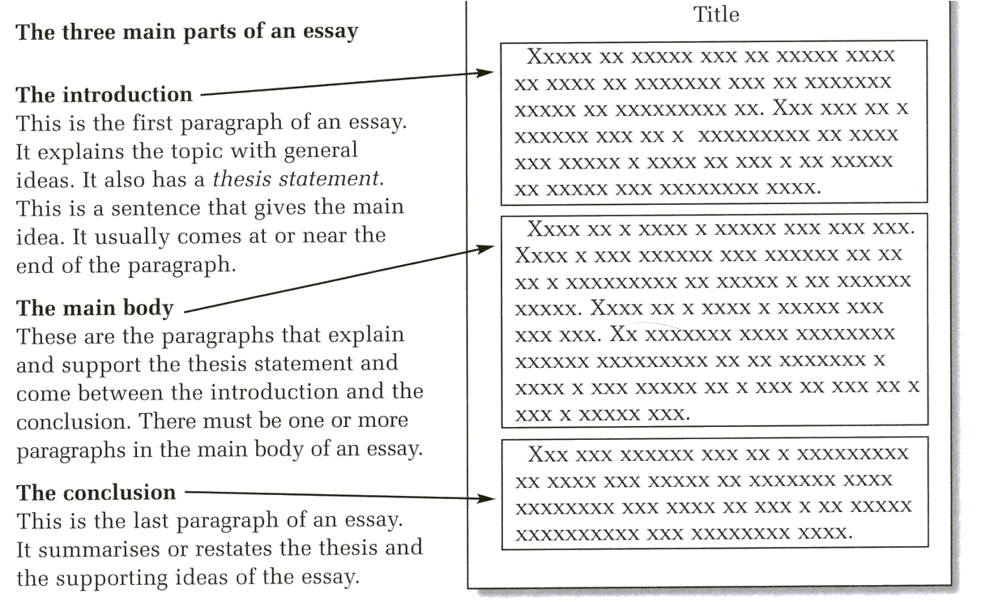
Hint:
- An essay has UNITY and COHERENCE, just as a paragraph does.
- Transition signals and the REPETITION OF KEY NOUNS link the paragraphs into a cohesive whole.

- Unity: a paragraph discusses one and only one main idea from beginning to end. For example, if your paragraph is about the advantages of having a Toyota car, discuss only that. Do not discuss the disadvantages.

Coherence

- Coherence: the sentences must hold together; that is, the movement from one sentence to the next must be logical and smooth, without sudden jumps.

- There are two ways to achieve coherence:
1. Repeated key words
2. Transition signals

Transition Signals

- To introduce an additional idea: in addition, furthermore, moreover, besides, also, too, and.
- To introduce an opposite idea or contrast: on the other hand, in contrast, however, nevertheless, instead, still, and nonetheless, but, yet, although, while, whereas, though, even though..
- To introduce a choice or alternative: otherwise, or, if, unless.
- To introduce a restatement or explanation: in fact, indeed, that is .
- To list in order: first, second, third, next, last, finally, the first, second, the next, last, final…
- To introduce an example: for example, for instance
- To introduce a conclusion or summary: clearly, in brief, in conclusion, indeed, in short, in summary
- To introduce a result: accordingly, as a result, as a consequent, therefore, consequently, hence, thus, so
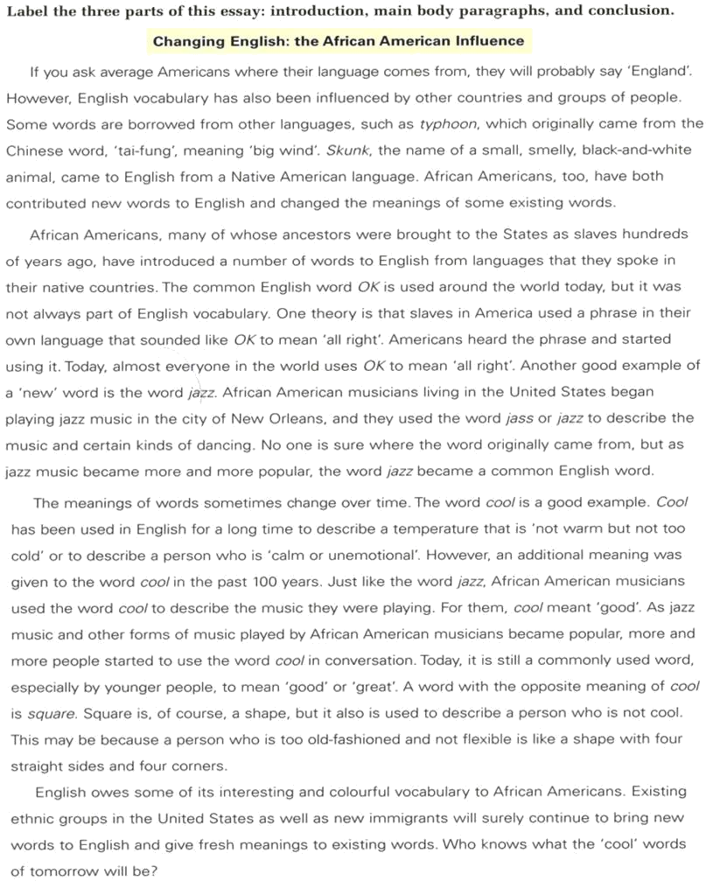

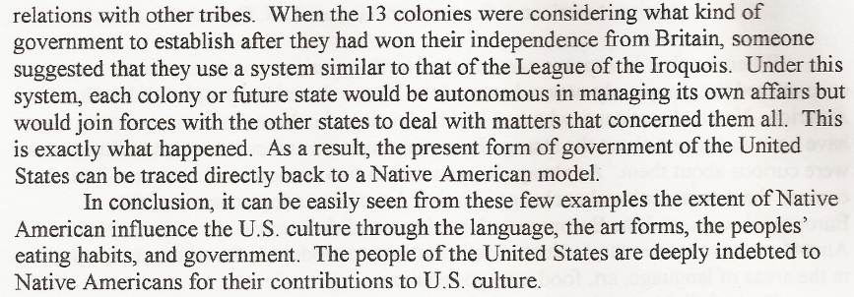
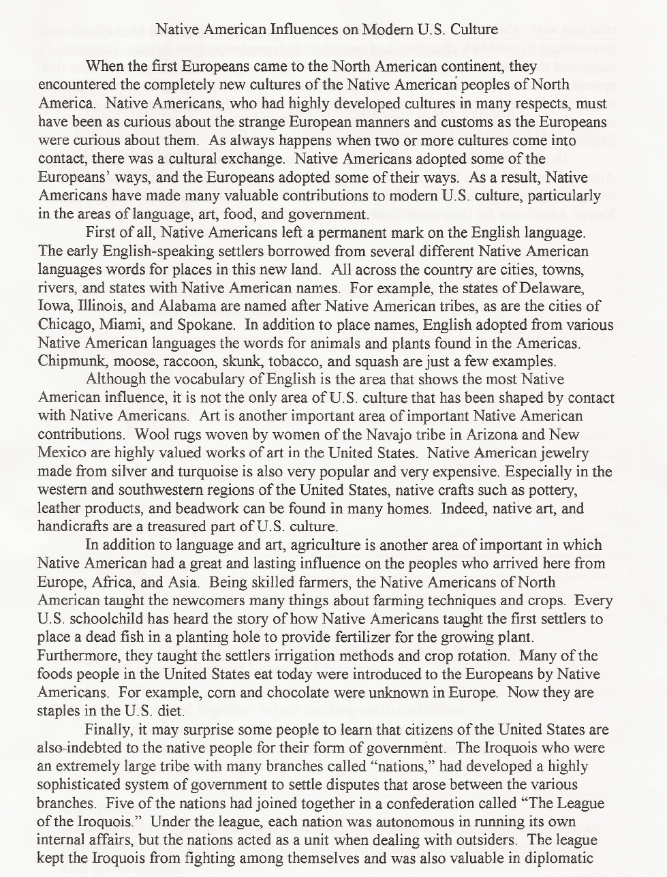
INTRODUCTION PARGRAPH
THESIS STATEMENT
Body Paragraph 1
Body Paragraph 2
Body Par 3
Body Par 4
Concluding Paragraph
- How many paragraphs does this essay contain? How many paragraphs are in the body?
- underline the topic sentence of each body paragraph, and double underline the topic. (Note: the topic sentence is not necessarily the first sentence in every paragraph.)
- Notice which noun phrase appears four times in the introduction. Circle each repetition of this key noun in the other paragraphs of the essay.

The Introductory Paragraph

- It has two parts:
A. General statements
1. introduce the general topic of the essay
2. capture the reader’s interests
B. Thesis statements
1. states the specific topic
2. may list subtopics or subdivisions of the main topics
3. may indicate the pattern of organization of the essay
4. is normally the last sentence in the introductory paragraph,

Notice: General Statements
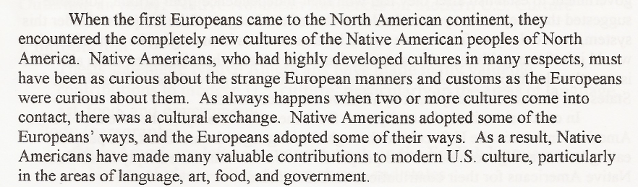

- Notice how the general statements in the introductory paragraph of the model essay introduce the topic. The first sentence is about the arrival of Europeans and their encounter with new cultures.
- The Next sentence points out that there were large differences between European and Native Americans.
- The next two sentences say that two-way cultural exchange happened, but the direction of the exchange and the specific items are not identified.
- The last sentence is the thesis statement. It is specific; it gives the direction of exchange (N. American influences on modern U.S. culture) and lists the subtopics (language, art, food, and government)

Different Models of Introductory Paragraph

- Funnel Introduction:

The funnel introduction begins with one or two very general sentences about the topic. Each subsequent sentence becomes increasingly focused on the topic until the last sentence, which states very specifically what the essay will be about. Writing a funnel introduction is like focusing a camera. You start with a wide picture and gradually narrow the focus so that just one object appears in the camera’s viewfinder: your thesis statement.

Let’s Go and read the following example !!!

Underline the Thesis Statement

Moving to a new country can be an exciting, even exhilarating experience. In a new environment, you somehow feel more alive. Seeing new sights, eating new food, hearing the foreign sounds of a new language, and feeling a different climate against your skin stimulate your senses as never before. Soon, however, this sensory bombardment becomes sensory overload. Suddenly, new experiences seem stressful rather than stimulating, and delight turns into discomfort. This is the phenomenon known as culture shock. Culture shock is more than jet lag or homesickness, and it affects nearly everyone who enters a new culture – tourists, business travelers, diplomats, and students alike.
Although not everyone experiences culture shock in exactly the same way, many experts agree that it has roughly five stages.

2-Dramatic, interesting, or funny story introduction

A dramatic, humorous, or otherwise interesting opening will generate interest in the reader. It is important, after all, to capture the reader’s attention. For process paper’s it is often useful to begin with a description of a scene that establishes the need for a process explanation. Observe here how one student uses a description to set up a process essay.

Underline the Thesis Statement

The rain pours down as if running from a faucet, lightning streaks across the dark restless sky, and thunder pounds the roof and walls of the house. All of a sudden the wind kicks up. Trees sway madly back and forth; loose objects are picked up and thrown all around. The house creaks and moans with every gust of wind. Windows are broken by pieces of shingle from a neighbor’s roof or by loose objects picked up by the wind. Power lines snap like thread. The unprepared house and its occupants are in grave danger as the awesome hurricane approaches. Had they prepared for the hurricane, they might not be in such danger.
Indeed, careful preparation before a hurricane is essential to life and property.

3- Surprising Statistics or Facts Introduction

Got high blood pressure? Try a truffle. Worried about heart disease? Buy a bon-bon. It’s the best news in years! Studies in two prestigious scientific journals say dark chocolate is good for you. It seems that eating a small piece of dark chocolate regularly can reduce the risk of heart disease because dark chocolate – but not milk chocolate or white chocolate – contains high amounts of flavenoids, powerful cholesterol-fighting compounds. What is the next health food going to be? Ice cream? Sugar cookies?
There are so many conflicting news stories about which foods are good for you that it is often difficult to make the right choices at the supermarket.

4-Historical Background Introduction

The Pilgrims who arrived in Massachusetts in 1620 came to find religious freedom. In the seventeenth and eighteenth centuries, large numbers of African men and women were brought as slaves to work on large plantations in the South. Immigrants from northern and southern Europe came in the early nineteenth century to escape poor economic conditions at home. Later in the nineteenth century, the first immigrants from China came as contract laborers to build the railroads connecting East and West. In the twentieth century, political and economic refugees arrived from Asia, Eastern Europe, and Latin America. Indeed, the United States has seen immigrants come from many different parts of the world, and they have come for many different reasons.
Their ability to adjust to life in their adopted land has depended on several factors.

Thesis Statements
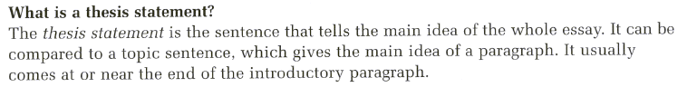

Underline the Thesis Statement
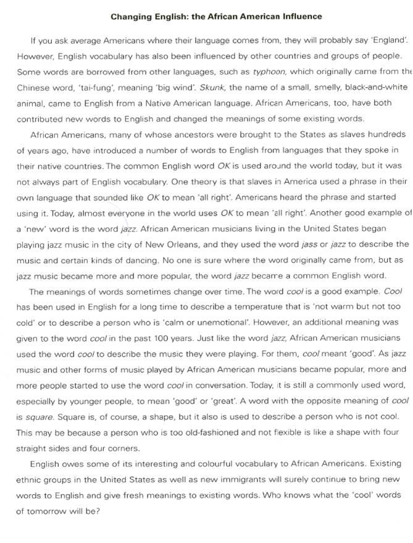

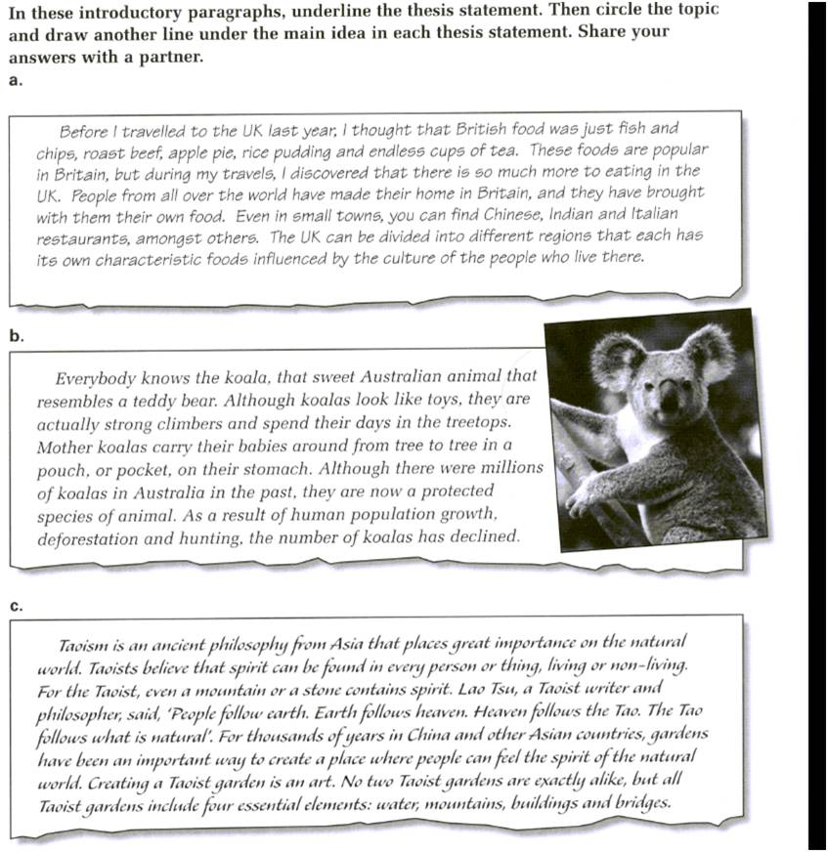

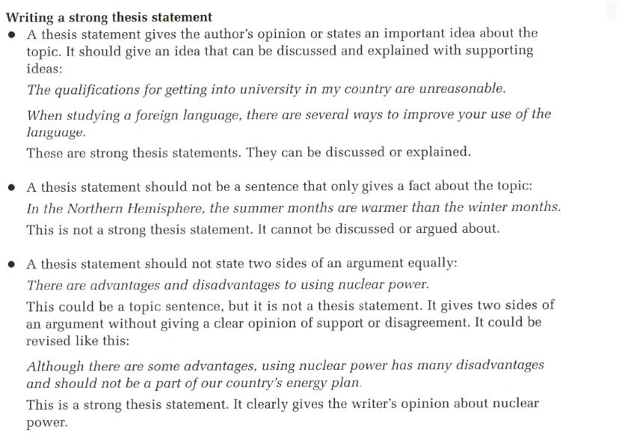

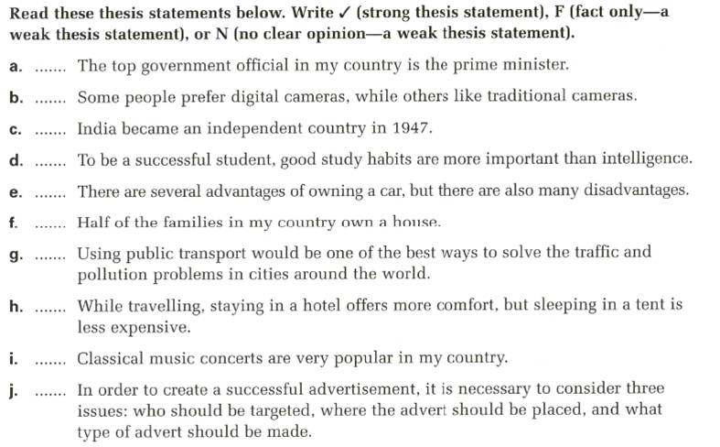

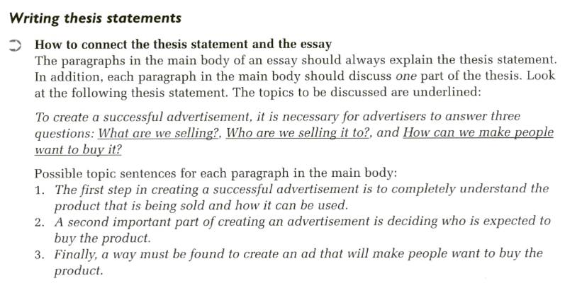

Look at these introductory paragraphs. What should the paragraphs in the main discuss for each thesis statement?
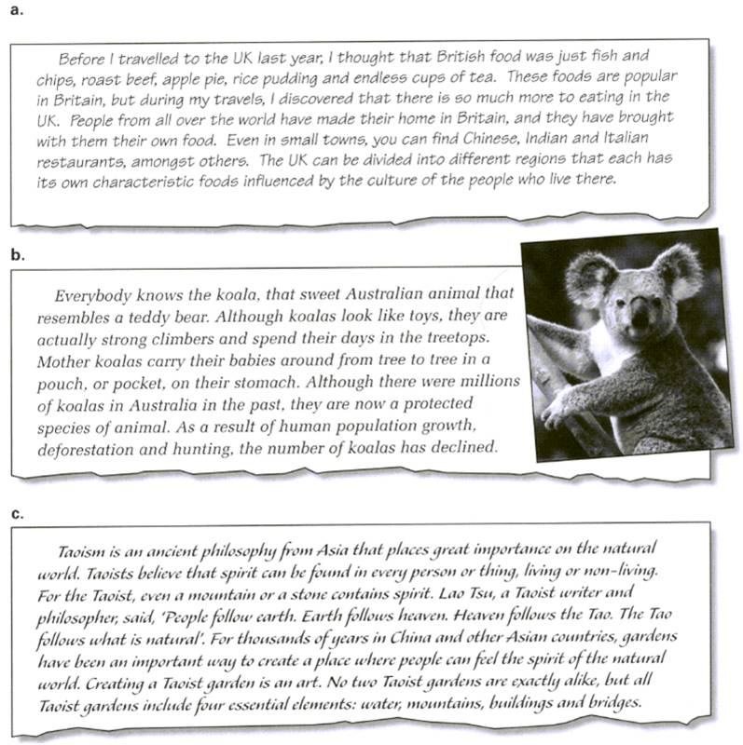

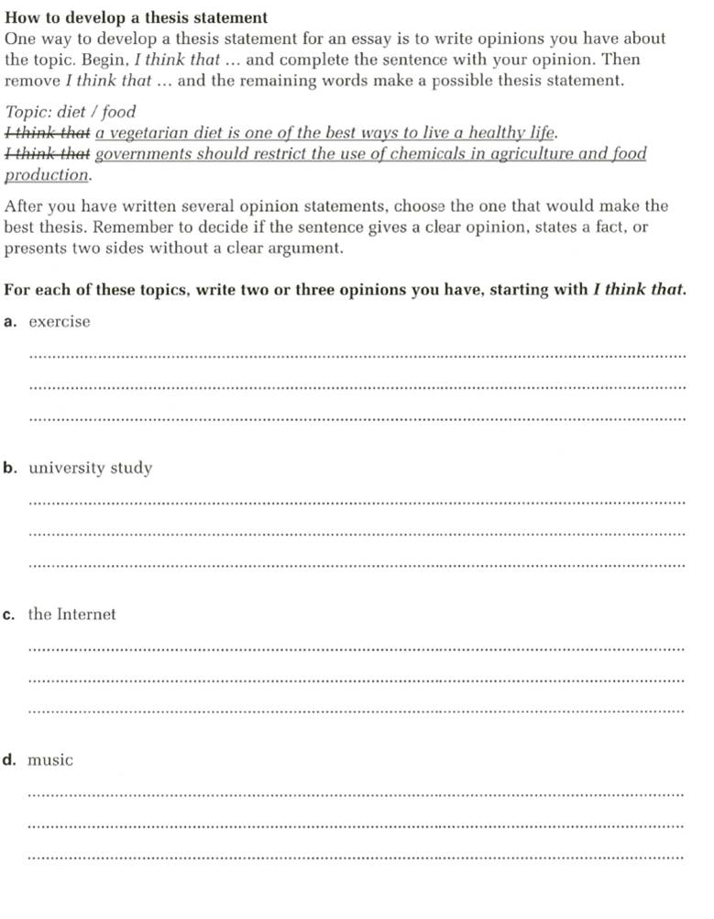
Do The Following Homework!!
Part II: Chapter 4: page 59: Writing Technique Questions
Part II: Chapter 4: page 61: Writing Technique Questions
Part II: Chapter 4: pages 62 + 63: Practice I
Part II: Chapter 4: page 64: practice 2
Notes:_______________________________________________________________________________________________________________________________________________________________________________________________________________________________________________________________________________________________________________________________________________________________________________________________________________________________________________________________________________________________________________________________________________________________________________________________________________________________________________________________________________________________________

