Lecture9
New Vocabulary:
Celebration: {Noun} a special social event, such as a party, when you celebrate something, or the act of celebrating something. e.g. There were lively New Year celebrations all over town. Celebrate: {verb} to take part in special enjoyable activities in order to show that a particular occasion is important. e.g. We always celebrate Eid by having a big dinner
Special: not ordinary or usual. e.g. Is there anything special that you'd like to do today?
Retire: {Verb} to leave your job or stop working because of old age or ill health. e.g. She is going to retire from the company. Retirement: {Noun} when you leave your job and stop working, usually because you are old. e.g. Many teachers over the age of
50 are taking early﻿ retirement
Gathering: {Noun} a party or a meeting when many people come together as a group. e.g. There will be a gathering of﻿ world leaders in Vienna next month
Occasion: a special or formal event. e.g. I have a suit but I only wear it on special﻿ occasions
Days of the week:
Wednesday | Saturday
Thursday | Sunday
Friday | Monday
 | Tuesday
Months of the year:
October | July | April | January
November | August | May | Febraury
December | September | June | March

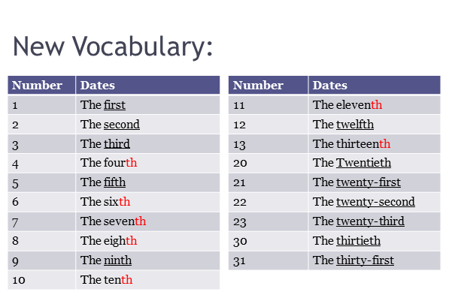
How can we say numbers as dates:
1. With most numbers, just add th to say them as dates:
e.g. Four = Fourth-Fourteen = Fourteenth
2. 1, 2 and 3 are different: e.g. One= First-Two= second-Three= third
3. The spelling changes for some numbers when we add th:
e.g. Five = fifth change ve to f e.g. Twenty= Twentieth change y to
i and add eth.
4. Use {in} with months- {on} with days. e.g. In March on Saturday
Say the following dates:
{1} On January the first. On the first of January.
{2} On the second of January. On January the second
Before you start .........
1. What are some ways that you celebrate special occasions?
Wear special clothes. Go out for dinner
2. What do you do when it is another person’s special day?
Buy a cake. Buy a special gift
Future with going to:
1-I’m going to buy something special.
2-You’re going to get a present.
3-He’s not going to do anything special.
4-Is he going to do something special?
5-What are you going to do for Eid?
1. The form:
a. Affirmative:
Subject + Be + going to +base form of the verb.
He is going to be 45.
They are going to play football.
b. Negative:
Subject + Be + Not + going to + base form.
He is not going to be 45.
They are not going to play football.
c. Question:
yes/no Be + subject + going to + base form ?
Is he going to be 45?
d. Information questions:
Question word + be +subject+ going to + base form?
What are you going to do for Eid?
2. Use:
a. Be + going to is used when the person has already made a decision to do something {intentions}.
e.g. I’m going to buy Mom something special.
b. Be +going to is used when the person has reasons or evidence to predict them {predictions about future} e.g. It’s going to rain.
Indirect Objects:
1-am going to buy my mother a gif.
2-I am going to buy a gift to my mother.
3-I am going to buy a gift for my mother.
4-I am going to buy a gift for her.
5-I am going to buy her a gift.
1-The Form:
Subject + Be + going to + base form + Indirect object+ Direct Object.
I am going to buy my mother a gift.
Or ...........
Subject + Be+ Going to +base form +Direct Object+ to/for +indirect object. I am going to buy a gift to/ for my mother.

Indirect objects can be replaced by Object Pronoun:
e.g. I am going to buy her a gift.-I am going to buy a gift for her.
Exercise 1: What month is it?
1-January is the .. first.. Month of the year.
2-March is .. third.. Month of the year.
3-June is the .. sixth.. Month of the year.
4-July is the .. seventh.. Month of the year.
5-October is the .. tenth.. Month of the year.
6-December is the.. Twelfth..Month of the year.
Exercise 2: Complete the conversations with the correct form of going to:
Sam: What _ are you going to do _(you/do) this weekend?
Derek: I _ am going to see _ (see) my grandfather.
We _ are going to have _ (have) a family gathering for him.
Sam: That’s nice. So, _ is it going to be are _ (it/be) a big gathering?
Derek: No, not really. We _ not going to do _(not do) much.
It _ is going to _ (be) just the family.
Mom _ be is going to bake_ (bake) him a cake.

J3yoons7ab

