-4-
Vowels

You’ll recall that consonants are grouped according to certain “dimensions”: Place of articulation, manner of articulation, etc. Vowels can also be grouped according to the dimensions along which they vary. The Language Construction Kit lists these dimensions as Height, Frontness, Roundedness,

Height
How high is the tongue – i.e., how close to the roof of the mouth? This is usually divided into three positions, quite creatively named “High,” “Mid,” and “Low.” :-) Say “Bee” or “You.” That is High. Say “Cat” or “Father.” That is Low. Say “Say” or “Show.” That is Mid.

Frontness

What part of the tongue is involved; that is, what part is raised or lowered? Is it the part close to the front of the mouth, the back, or the center? These are ever-so-cleverly classified as “Front,” “Central,” and “Back.” Front vowels are heard in “Bee,” “Snake,” and “Cat.” Back vowels are heard in “You,” “Show,” and “Father.” English has only two (some would lump them together and say only one) Mid vowels.
Essentially, it’s the same sound but is classified as to whether it’s used in a stressed or unstressed syllable. For stressed syllables, the Mid vowel is that which you hear in “Shut Up.” The same sound, in an unstressed syllable, is the famous “Schwa Sound,” which all English vowels very sneakily mutate into whenever you don’t bother to put syllable stress on them. It’s the sound of the first syllable in “about,” for one example.

Roundedness
In pronouncing these vowels, your tongue can’t do it all alone; the position of the lips is also a consideration. Compare “See” and “Sue.” Both have High vowels; “See” has a Front vowel and “Sue” a back vowel. What else differentiates them? It’s the lip-rounding; for “See” you pull the corners of your mouth back tightly while for “Sue” you round them into a nice little “O”

Hint:

All vowels involve free passage of lung air through the upper vocal tract.
(This is what distinguishes them from consonants, for which, as you began
to see in the last chapter, there is always some obstruction above the level of the
larynx).
The impediment to the airstream for vowels is located at the glottis, not in the supra-glottal tract: the vocal folds are in close enough contact for vibration to occur. The sound wave that this generates is amplified by the resonance of the cavities above the larynx.

Hint:

This means that vowels are normally voiced: “normally” because voiceless vowels
are a possibility — they can best be thought of as whispered vowels. Although the
vocal folds aren’t actually vibrating for these, there’s still sufficient constriction at the
glottis for the airstream to be impeded and for turbulence (i.e. a sound wave) to be
generated — you can feel this constriction if you say a few vowels in as loud a whisper
as you can.

VOWELS

They are sounds in which there is no obstruction to the flow of air as it passes from the larynx to the lips
They are classified on the basis of a close-open and front- back diagram.

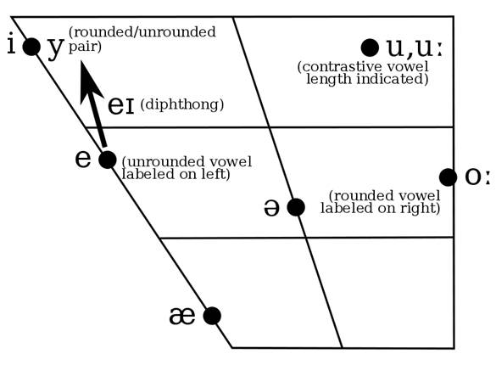
Vowel chart
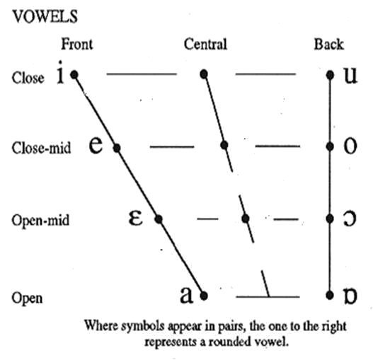

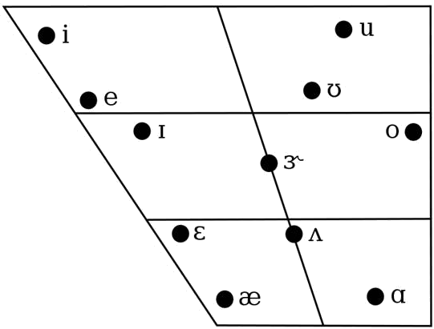

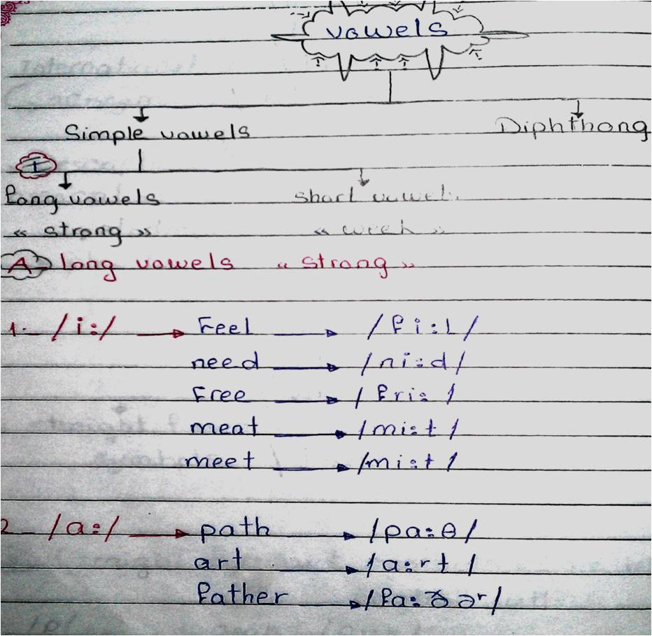

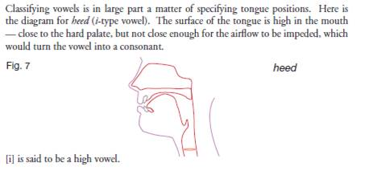
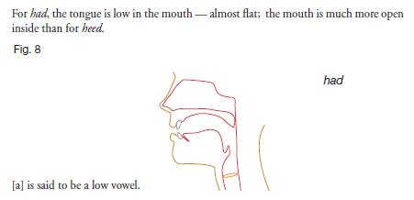
Long E Sound
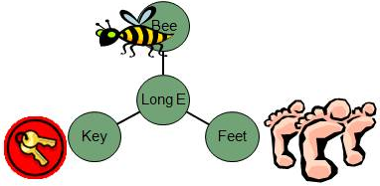

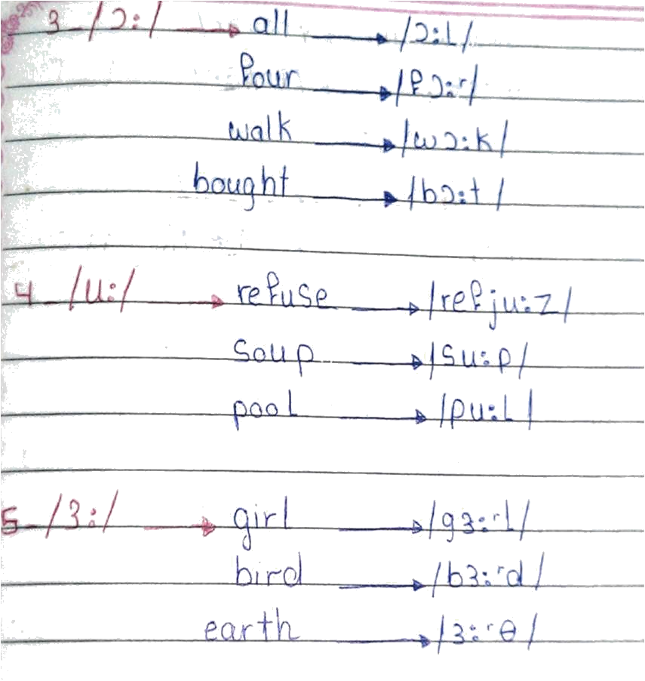
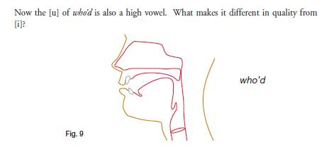

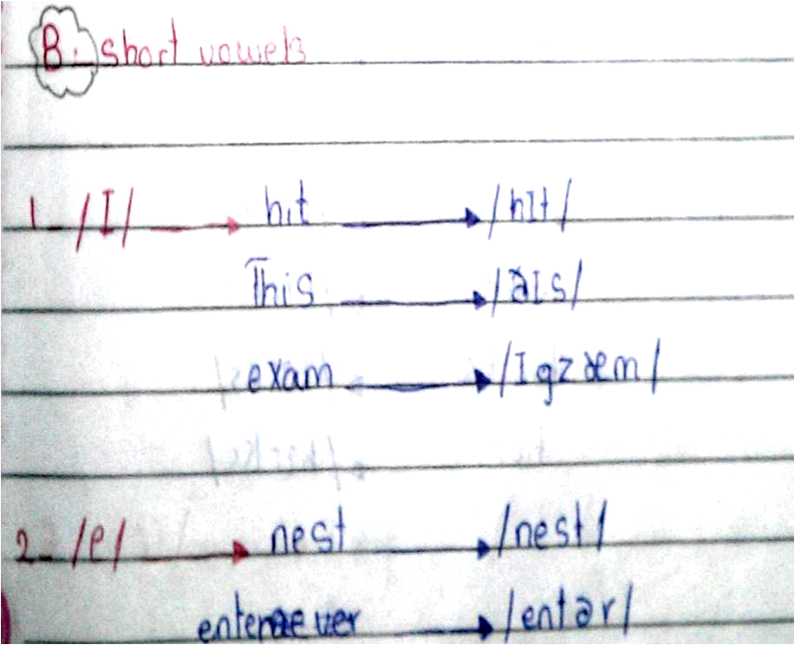
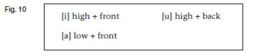
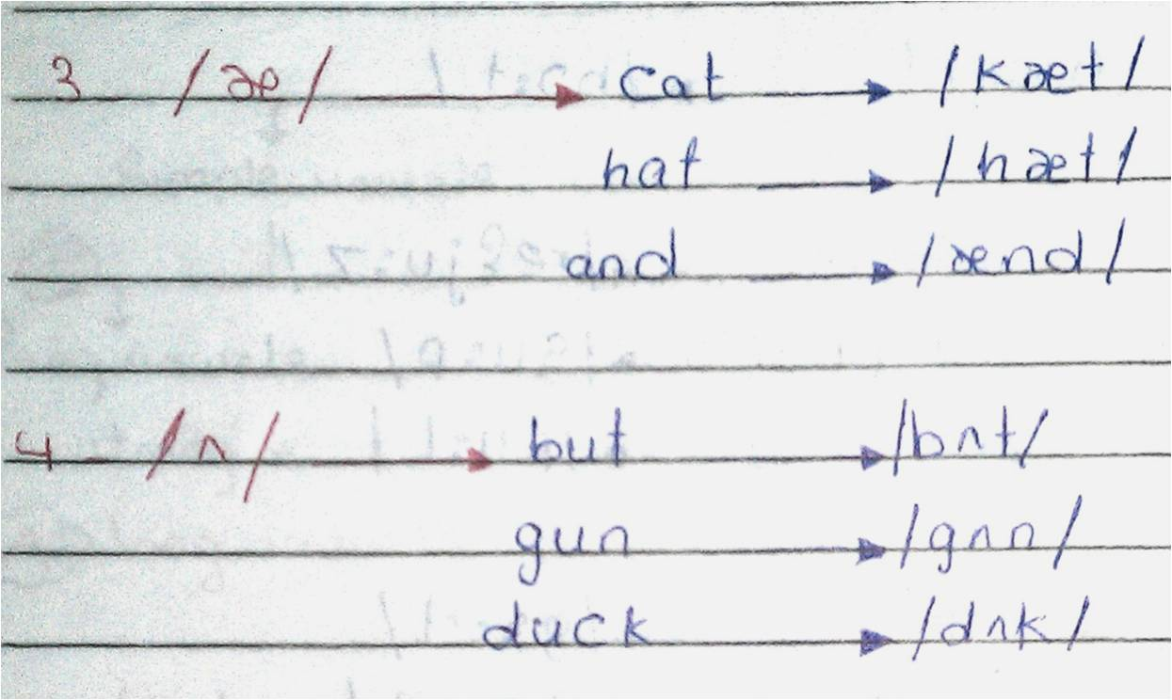

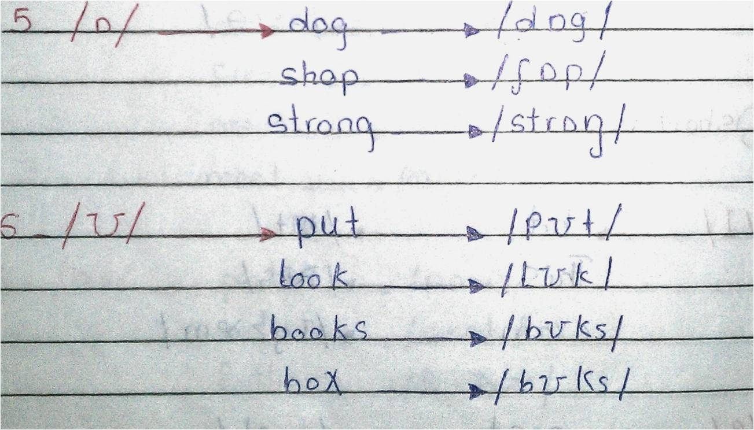
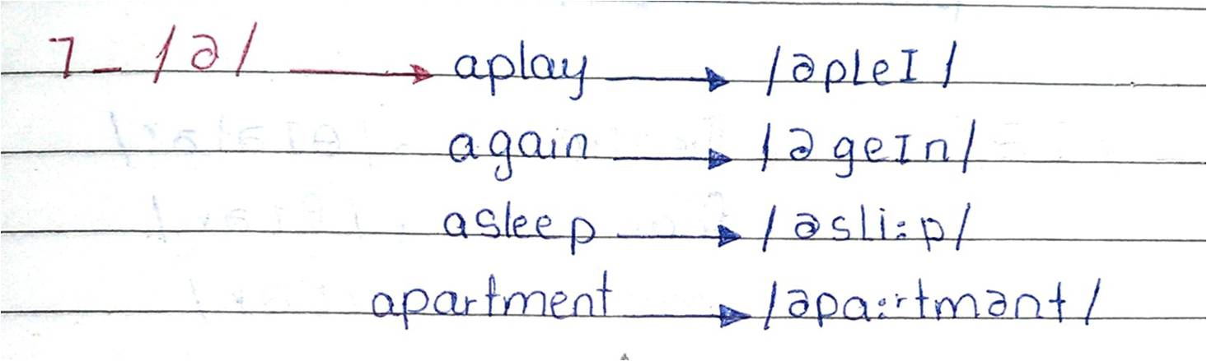

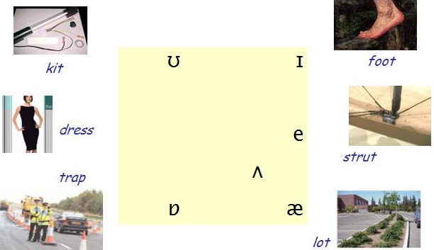

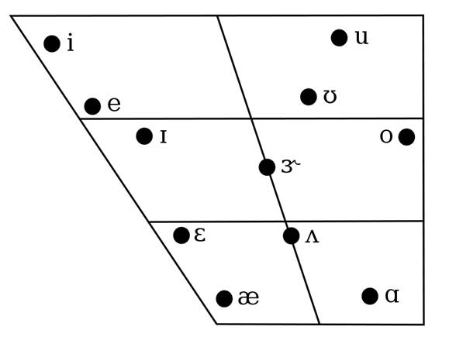
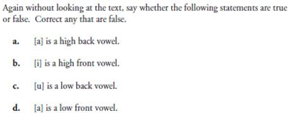
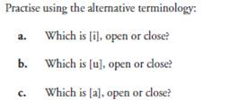
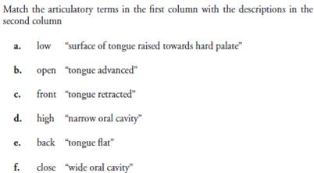
Notes:_________________________________________________________________________________________________________________________________________________________________________________________________________________________________________________________________________________________________________________________________________________________________________________________________________________________________________________________________________________________________

