-5-
The Process of Translation

Learning Outcomes

By the end of this lecture, you should be able to
- show better understanding of the process of translation.
- show knowledge of the five stages recognised in the process of translation
- show understanding of the interaction between the six elements of translation and the five stages recognised in the process of translation.

What is the Process of Translation

- It is a complex cognitive operation which takes place in the mind of the translator.
- This operation helps the translator to interpret and extract the meaning of the original text and re-encode this meaning in the target language.
- It is simply the abstract translating activities that take place in the mind of the translator before the production of the translated text.

What are the stages recognised in the process of translation?

- Editing the source text
- Interpretation of the source text
- Interpretation in a new language
- Formulating the translated text
- Editing the formulation

Editing the source text (ST)

- Editing the ST is the study of the ST for establishing its authorship and authenticity and for reaching a linguistic form which is accepted for translation.
- Editing a ST is important in case of inscriptions on metal, stones clay tablets or other materials found on archaeological sites.

- The translator may not be involved in this stage whether the ST is old or new.
- The Editing of a ST precedes it s translation.

- When editing or transcribing a text recorded on a cassette or a videotape, a number of factors should be considered as clarity of the recording, or the image on a video tape and knowledge of the dialects or slangs used in the ST. In such case the translator translates what is heard from a machine directly and commits it to writing it on paper or a screen.
- When the ST has been edited and adopted for translation, the translator then moves to another stage which is the stage of interpretation of the Source Text.

Interpretation of the source text
Interpretation within the same language is seen as :

- Giving the ST a reading which goes with lexis, grammar and meaning of the text in its linguistic and social context.
- The process of assigning meaning to the text or utterances in it depends on the linguistic systems and contexts of the source Language.

- The interpretation of a ST for giving it a specific meaning is a constructive process which involve s: a linguistic analysis of the written/spoken symbols, script, sounds, lexico-grammatical relations within the sentences and .
- This newly built message will find its way to another language in terms of interpretation in a new language and formulation.

- The translator’s reading, judgement and decision concerning the meaning of a source text tend to be subjective and individualistic.
- The translator however should take into account all other interpretations given to the ST to be translated especially in religious texts, old literary texts.

Interpretation in a new language

- It is defined as ‘transformulating a linguistic/verbal text, or part of it, after interpreting it, to a language other than its own.
- This transformulation is carried out by the translator and carries his/her fingerprints and uniqueness since it shows his/her interpretation of the source text, and the results from his /her interpretation in a new language.

- The end product, interpretation in a new language, is a new text, the translated text.
- The most important aspect of interpretation in a new language is the movement –the crossing- from one language to another.

Formulating the translated text

- It is the stage of the translation process in which the translator chooses the lexis and structures that would make meaningful sentences functioning in a narrow co-text as elements of a well structured text.
- Formulation as a composing operation subjugates the interpretation of the translator of the system of the target language.

- It is the stage during which the translated text gradually takes form.
- This formulation-composition- of the translated text is constrained by the quality and the results of the translator’s interpretive leap from the source text to the target language.
Editing the formulation

- This is the final stage in the translation process.
- When the formulation of the translated text is completed, the translator can commence to edit the formulation.

- The editing of the formulation takes the form of a careful checking of possible slips of the tongue or other inaccuracies
- It also involves a comparison between the translation product on the one hand and the prevailing linguistic features and cultural norms in the text type in the target language on the other.

The interaction of the six elements of translation with the five stages recognised in the process of translation.

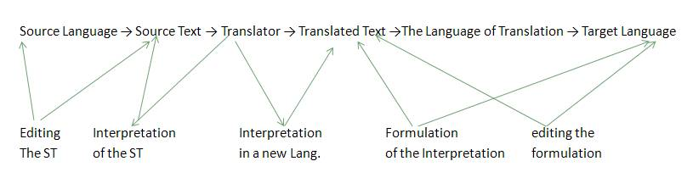

Notes:_________________________________________________________________________________________________________________________________________________________________________________________________________________________________________________________________________________________________________________________________________________________________________________________________________________________________________________________________________________________________________________________________________________________________________________________________________________________________________________________________________________________________________________________________________________________________________________________________________________________________________________________________________________________________________________________________________________________________________________________________________________________________________________________________________________________________________________________________________________________________________________________________________________________________________________________________________________________________________________________________________________________________________________________________ ___________________________________________________________________________

