-5-
ملاحظة :
عند هذه الصورة  توجه للبوربونت ..وانقر على السماعة نقرتين لسماع النطق .

Elements of the Lecture

- Short & Long Vowels with Diagrams
- Diphthongs,
- Triphthongs & Glides

Phonetics
The Study of the way Humans make, Transmit, and Receive Sounds

Phonology
the study of sound systems of languages

Phoneme
A phonological segment that can be phonetically predicted by a rule
– /b/ in bit and /p/ in pit.

The Organs of Speech and Articulation

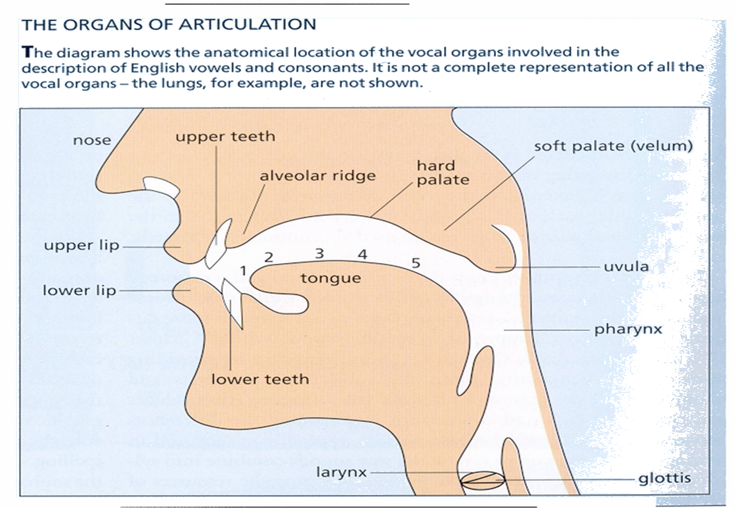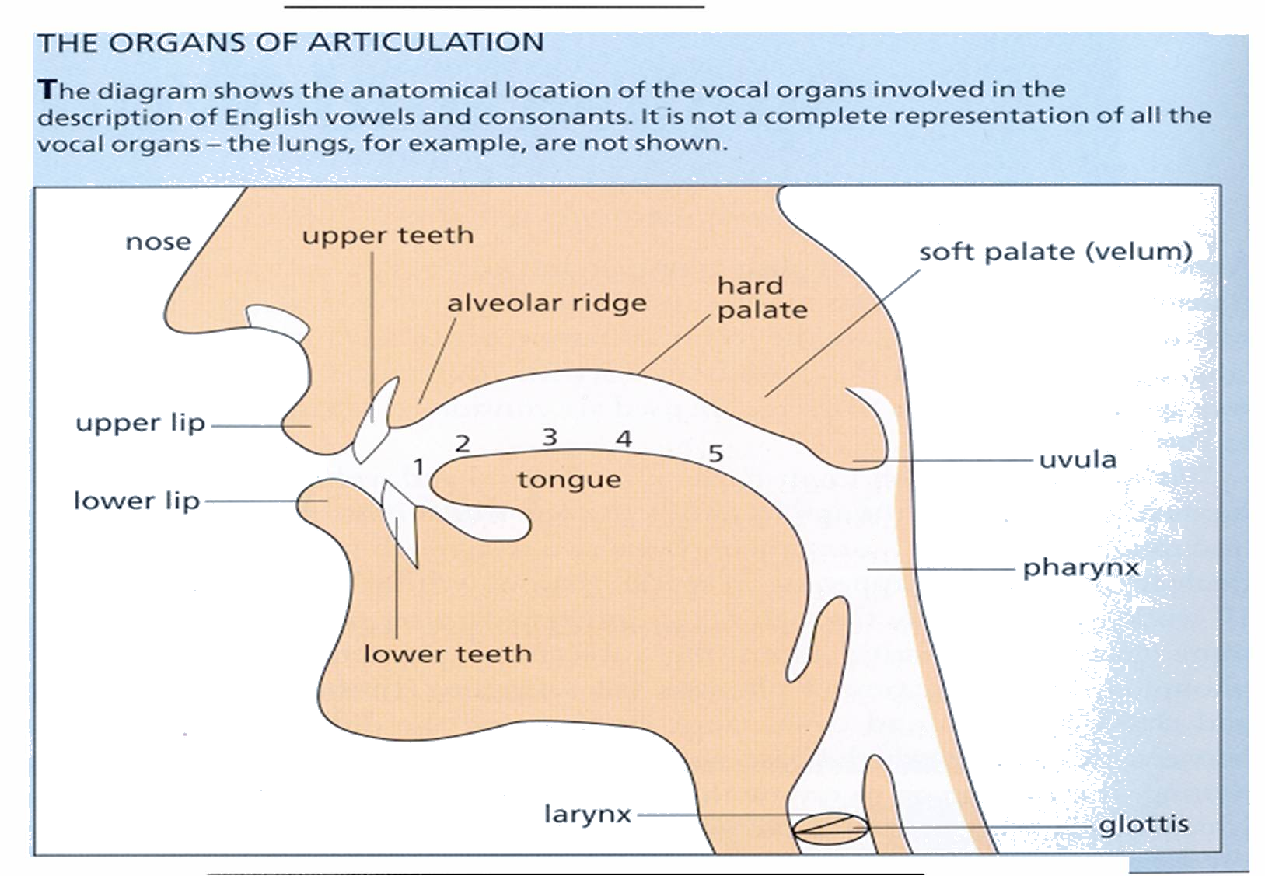

- Languages are made up of vowels and consonants sounds

- English consists of 44 sounds (20 vowels and 24 consonants)

Vowels

- Most vowel sounds are modified by the shape of the lips.
(rounded / spread / neutral)
- Sounds are made by vibrating the vocal cords (voicing).

Vowels can be

single sounds – monophthongs or pure vowels
Double sounds - Diphthongs
Triple sounds - Triphthongs

Pure vowels usually come in pairs consisting of long and short sounds

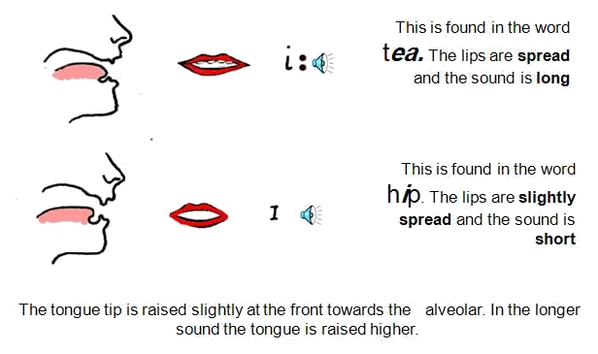

The tongue tip is raised slightly at the front towards the alveolar. In the longer
sound the tongue is raised higher.

The most common sound in English – the Schwa

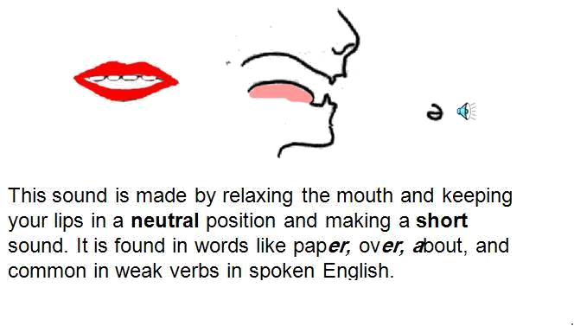

This sound is made by relaxing the mouth and keeping your lips in a neutral position and making a short sound. It is found in words like paper, over, about, and common in weak verbs in spoken English.
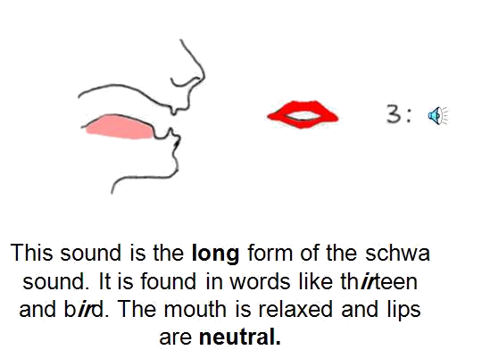
This sound is the long form of the schwa sound. It is found in words like thirteen and bird. The mouth is relaxed and lips are neutral.

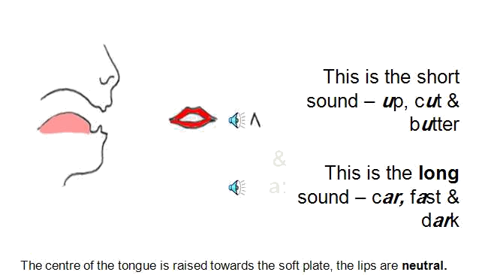

The centre of the tongue is raised towards the soft plate, the lips are neutral.

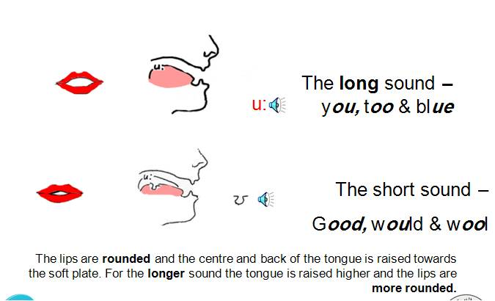
The lips are rounded and the centre and back of the tongue is raised towards the soft plate.
For the longer sound the tongue is raised higher and the lips are more rounded.
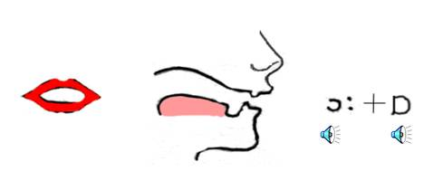

Made with rounded lips and tongue slightly raised at the back
The long sound– door, four & more
The short sound – hot, clock and what.

Two of the vowels do not have long sounds

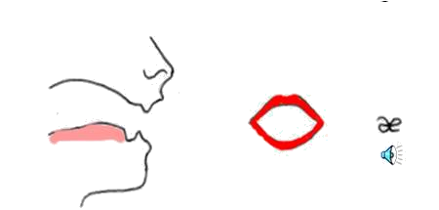

This sound is made with the mouth spread wide open. It is found
in – cat, man, apple & ran

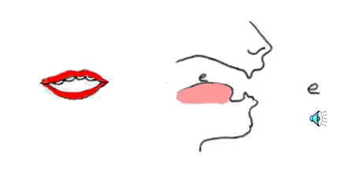

- The sound of ‘e’ is found in – wet, left, when & tell. Like the sound for ‘a’ it is a short sound that has no long version.
- The vowel sounds we have just reviewed make up the rest of the diphthongs etc. that come next.
Diphthongs, Triphthongs & Glides

- Diphthongs are combinations of two sounds-
English has 8 diphthongs
- Triphthongs are combinations of three sounds-
English has 1 triphthong (a diphthong + a schwa sound)
Glides are sounds made when the tongue moves from one position to another.

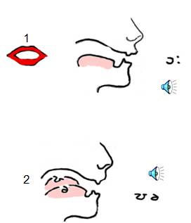 | 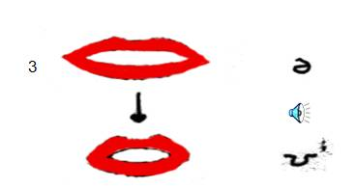
Here we have three sounds;
The sounds from 1) for 2) tour 3) go

Two of these sounds are diphthongs, combinations of vowels.

Diphthongs are made by sliding the tongue for one position to another - this is know as a glide.
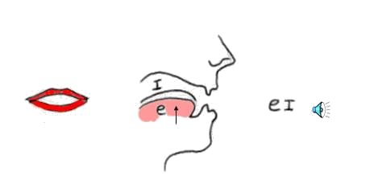
This diphthong is found in – hay, date, scrape & vein.

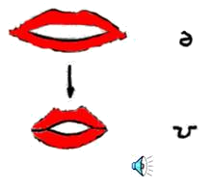
Here two more pure vowels are combined to make a sound. This sound is like saying the letter ‘O’. It begins with a er (schwa) and moves towards the ‘oo’ sound found in good.

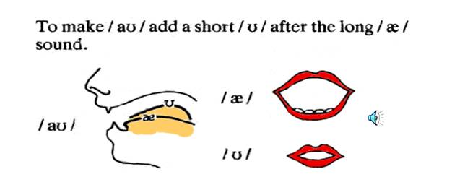
Words like cow, down, ground and town all contain this sound.
(The a: is also used to make this diphthong)

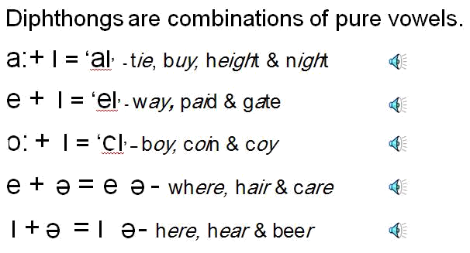
Review all 8 sounds and try the exercises on the worksheets

Notes:_______________________________________________________________________________________________________________________________________________________________________________________________________________________________________________________________________________________________________

