-6-
Phonetic Transcription

The Meaning of Phonetic Transcription

Phonetic transcription (or phonetic notation) is the visual representation of speech sounds (or phones). The most common type of phonetic transcription uses a phonetic alphabet, e.g., the International Phonetic Alphabet.
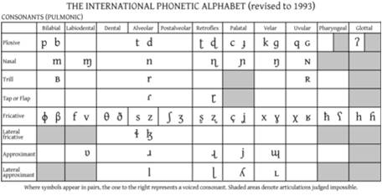
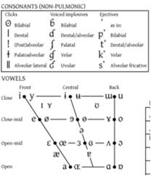

There are two “golden rules” for transcription:

- Think of the pronunciation, not the spelling. Instead of letting

yourself be mesmerized by the written form of the word, look away, or
close your eyes, and ask yourself how you actually pronounce it. Among
a thousand other pitfalls, this will help you to avoid inserting an [l] into
your transcription of salmon, it will ensure that you transcribe the s of
his with [z] not with [s], or the f of of with [v] not with [f], and it will
prevent you from including the silent b of doubt in your transcription.

- Use one symbol for each identifiable sound.

- In many cases, the orthography (i.e. the spelling system) uses more than one letter in cases where a single symbol is required in a transcription:
ps, sh, ch, tch are cases in point.

- And a transcription, though it may be shorter, can convey
more precise information than the orthographic form (the spelling): th
corresponds to either [T] or [D]) and the notorious -ough to [ʌf], [uː], [ə],
[aʊ], [əʊ] or [ɒf] (enough, through, borough, bough, although, cough).

Broad and Narrow

- Broad transcriptions
  - Represent only contrastive sounds (phonemes)
  - Enclosed in slashes: / /
  - Generally use only alphabetic symbols

- Narrow transcriptions
  - Represent phones
  - Capture as much phonetic detail as possible
  - Enclosed in brackets: [ ]
  - Can require use of diacritics

Broad and Narrow Phonetic transcription

Broad phonetic transcription: captures the basic sounds; What the speaker intended to say; roughly eqivalent to a phonemic transcription.
Narrow phonetic transcription: captures the precise pronunciation; what the speaker actually said; makes use of the full resources of the IPA.
Notational convention:
Slashes / / for phonemic transcription
Square brackets [ ] for phonetic transcripton.
English Phonemes

Familiar IPA symbols, same sound:
- [p] ‘pot’ 7. [r] ‘rot’ 12. [m] ‘ma’
- [b] ‘bought’ 8. [f] ‘fought’ 13. [n] ‘not’
- [t] ‘tot’ 9. [v] ‘vote’ 14. [l] ‘lot’
- [d] ‘dot’ 10. [s] ‘sot’ 15. [w] ‘walk’
- [k] ‘kit’ 11. [z] ‘zit’ 16. [h] ‘hot’
- [g] ‘got’

Sound/symbol correspondence
enough through thorough thought bough
[ʌf] [u:] [ə] [ɔ:] [aʊ]
think those thistle thong
[θ] [ð] [θ] [θ]
church chemistry Cheryl
[tʃ] [k] [ʃ]

English Phonemes

Familiar IPA symbols, different sounds:
17. [j] ‘yacht’ “yod”
18. [i] ‘heed’
19. [e] ([ej]) ‘hayed’ ([ej] = a “diphthong”)
20. ‘hod’
21. [o] ([ow]) ‘bode’ ([ow] = a “diphthong”)
22. [u] ‘who’d’

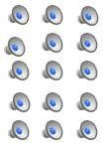


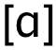

- A diphthong is a phoneme that combines two phones.

Unfamiliar IPA symbols, for consonants:
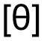
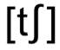
23. ‘thought’ “theta” 28. ‘chop’
24. ‘though’ “edh” 29. ‘jot’
25. ‘shot’ “esh”
26. ‘vision’ “ezh”
27. ‘ring’ “engma”

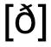
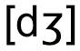

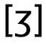

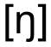
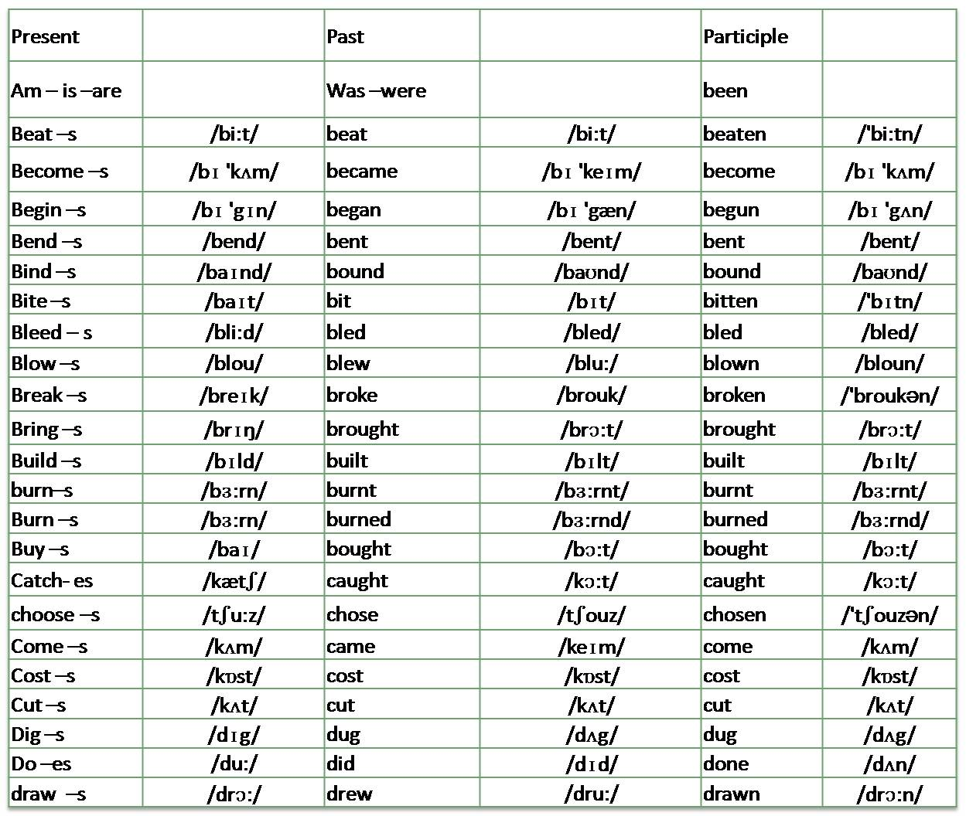

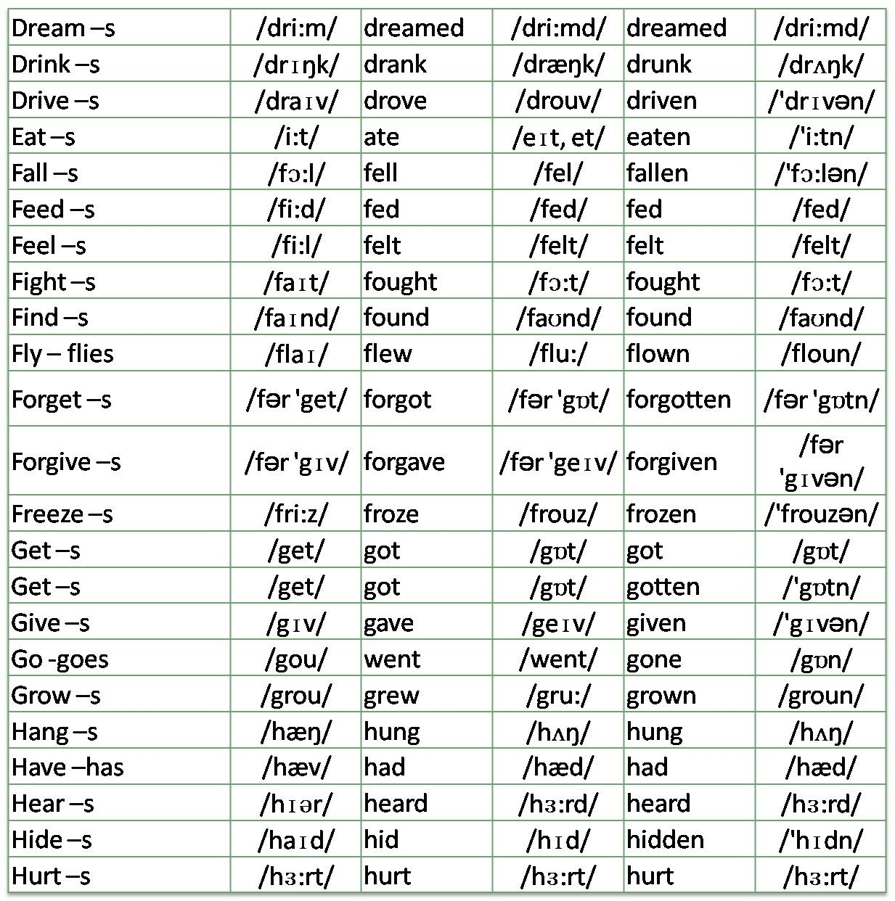

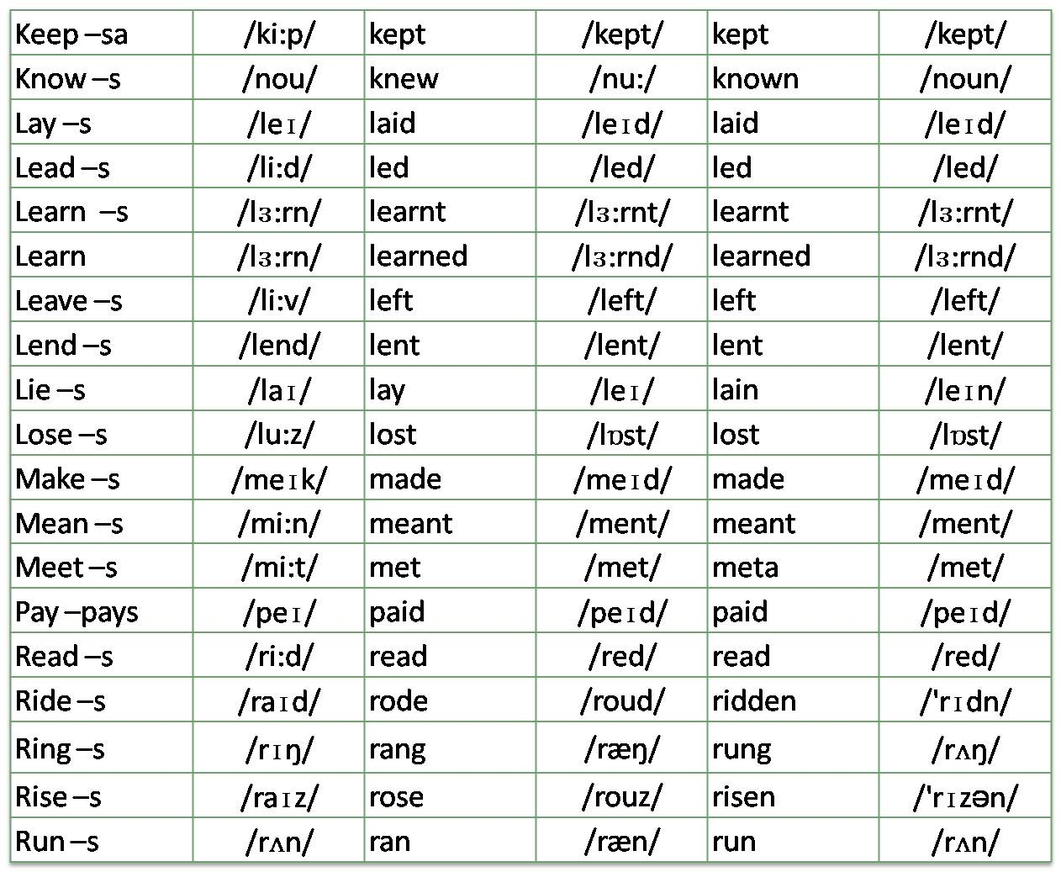

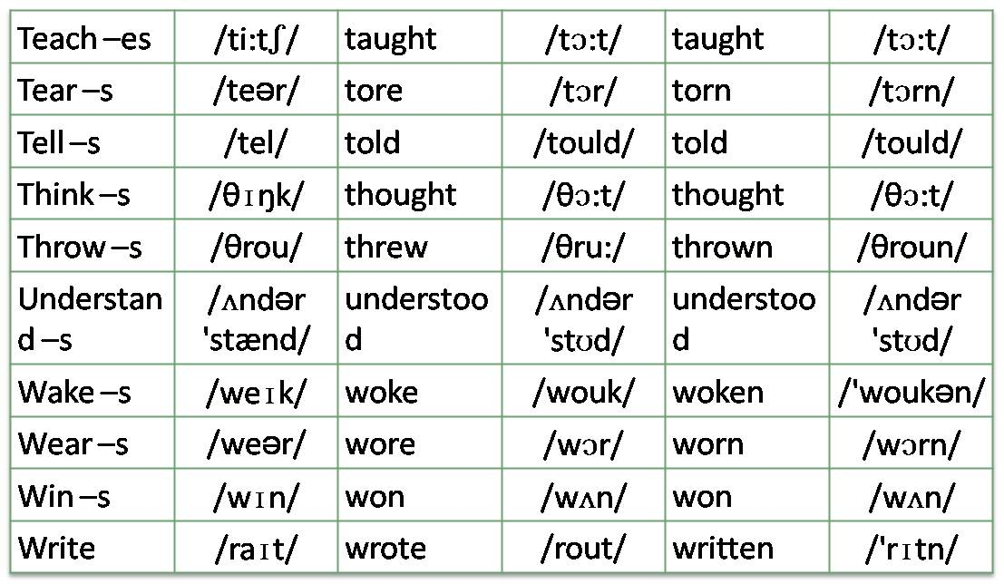

Transcription – the art of reducing speech to writing

Remember: a word in isolation may be spoken differently to a word in connected speech
to = [tu:]
give it to him = [gɪv ɪt tə ɪm]

Notes:________________________________________________________________________________________________________________________________________________________________________________________________________________________________________________________________________________________________________________________________________________________________________________________________________________ _____________________________________________________________________________________________________________________________________________________________________________________________________________________________________________________________________________________________________________________________________________________________________________________________________________________________________________________________________________________________________________________________________________________________________________________________________________________________________________________________________________________________________________________________________________________________________________________________________________________________________________________________________________________________________________________________________________________________________________________________________________________________________________________________________________________________________________________________________________________________________________________________________________________________________________________________________________________________________________________________________________________________________________________________________________________________________________________________________________________________________________________________________________________________________________________________________________________________________________________________________________________________________________________________________________________________________

