Lecture 2
Psycholinguistic Research Methods
WORDS 2
A Basic Question
How are “words” organized in the mind?
Comparison
A desktop dictionary is usually consulted when we:
What a word means
How a word is spelled
How a word is pronounced
And the words are usually organized alphabetically !
Our Mental Lexicon is organized a little bit different it:
It can accommodate new words
It can be accessed very quickly
One example of how quick we can access our mental lexicon is what is commonly referred as the:
“Tip-of-the-tongue phenomena”
Tip-of-the-tongue phenomena
This is the situation where you are unable to access a word (or remember a word)in your mental lexicon and all you needed was the:
meaning of the word
the sound of the word
the first letter
or what the word rhymes with
A technical term
At this pint we should stop calling them words. The technical term for the items in the lexicon is entries. So we should re-phrase the question we posed at the beginning of this lecture and ask:
How are entries organized in the mind?
What the mental lexicon could look like. (picture 1)
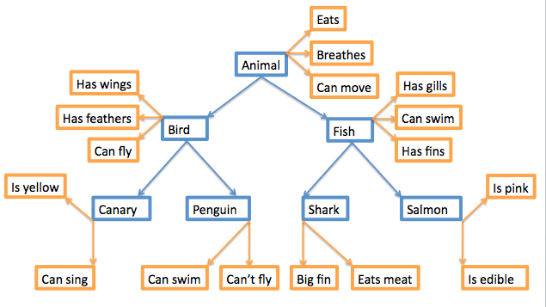
More questions
How are entries linked together?
How are entries accessed?
What information is contained in an entry?
Big problem
The mental lexicon cannot be observed !
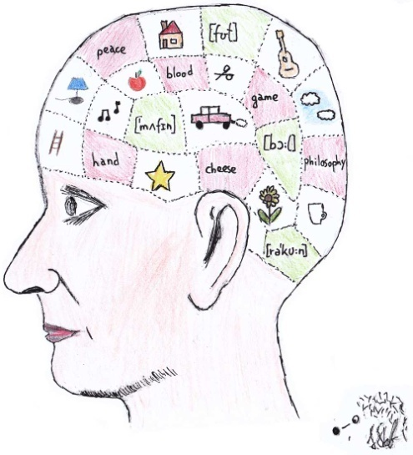

So how can we know?
Through creative experiments such as:
Lexical decision and priming
References *
*آلشريحه 13 فيهآ صور بس مو بآينه بالمحتوى آرجعوو للمحآضرهـ
وبكذا آنتهت المحآضره آلثآنيه ☺

The End

