Lecture 4
Sentence Processing
There is a difference between investigating the mental lexicon and investigating sentence processing.
A sentence is understood(either in the case of reading or listening) through the meaning of its words and analysis of its syntactic structures.
This unconscious ability as parsing.
Parsing
Much of the work in psycholinguistics regarding sentence processing is focused on:
How parsing happens
What are the steps that take place in parsing
Parsing speed
The conditions when parsing doesn’t work
Timed-Reading Experiments
Among the most common timed-reading experiments is the bar-pressing test.
In this test the participant is asked to sits in front of a computer screen and read a sentence one word at a time. The participant presses a bar on the keyboard to read the next word till he/she reaches the end of the sentence.
What we can learn from this experiment
We can learn about the amount of time required to process certain words (content words/function words)
How long participants pause at the end of clause boundaries
Results usually show interesting time patterns.
Eye Movement
Tracking eye movement on words during reading revealed that eye fixation time is usually longer for less frequent words and that the points of fixation are usually content words rather than function words.
Research has shown that the more difficult the sentence is in structure the more regressive saccades there are in addition to longer fixation times.
What happens in the Lab
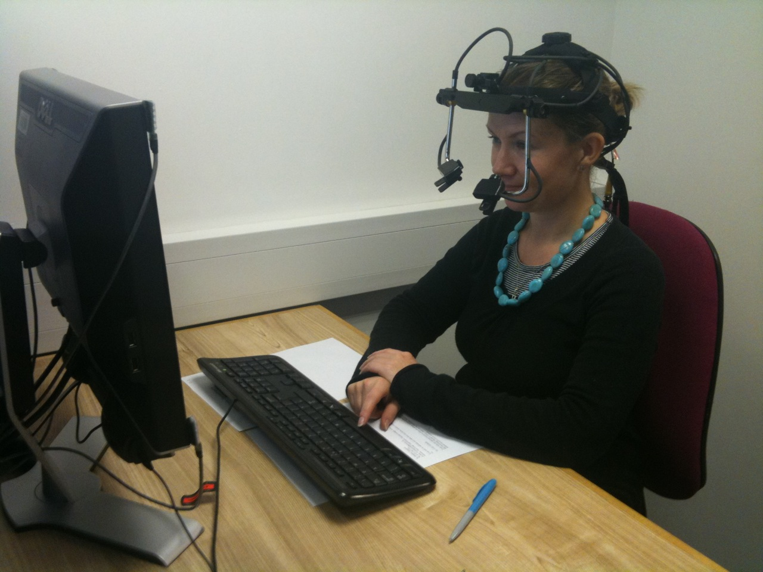
* آلشريحهه الاخيره زي كل مره الصوره مو طآلعه < لاتنسوني من دعوآتكم:$
The End

