-7-

Elements of the Lecture

- Remember Giving advice.
- Using Modals.
- Understanding more reductions.
- Participles.

Remember! Giving Advice

Should
Shouldn’t + Simple form of the verb
Ought to

- These expressions are used to give advice and make suggestions. Other expressions to make suggestions are:
- It might be nice (good) if you…
- Why don’t you …
- If I were you I would …

- It’s more polite to use expressions for making suggestion than to use an imperative. Notice this contrast:

- Get out and take an art class. (less polite)
- You should get out and take an art class. (more polite)

- Let’s see more about Using of Modals… à à à à à

What are modals?

- Auxiliary verbs
How could I teach modals?
Should I teach them?

  - Can
  - Could

  - Had better
  - a
  - Might
  - Must
  - Ought to
  - Shall
  - Should
  - Will
  - Would

Why do we use modals?
What? Would you explain this please?


We use modals to talk about obligations,
suggestions, advise and expectations!

There are two kinds of modals:

- Simple modals : for the present and future
- Perfect modals: to show necessity in the past tense.

Simple modals: Present and future

Modal + base form

Examples:

We should invite your friend to my party.
We could buy some soda if you have money.
You might want to call your mom and tell her you are at a friend’s house.

Perfect modals: past

Modal + have + past participle

Examples:

You should have called me last night.
Mary should have done her homework this week.
We should not have made a big mess here.

Showing strong necessity:

Must………I must go to sleep!
Have to……..I have to go to sleep!
Have got to…I have got to go to sleep!

Had better…for a warning!

Use “had better” to give a warning that something bad will happen if the advise is not followed.

You had better study tonight or you might fail the test.
He had better go home now or he will be in trouble!
Use Should to offer advise

Should means…it would be a good idea.

- You should eat something you are hungry.
- You should read a book and turn off the television.
- They should stop being so loud.
- We should have a party at the beach.

Could or might are more gentle than should….

- You could read a book.
- They might like the movie.
- We could buy some candy.
- I might play basketball.
- He could win your blue marble.

Practicing modals:

Do class surveys:

Who might want to play basketball at recess?
……………………………………………………………………………………
Who should be the student of the week?
…………………………………………………………………………………….
When should we go to doctor?
…………………………………………………………………………………….

Don’t forget to model the appropriate responses!

Sentence pairs:

He must be here | because I see his jacket on his chair.
I should buy a present | because it is Julie’s birthday.
You could call me tonight | since you will be at home.
They should come to my house | to play Nintendo.
He could win a prize | if he turns in his lottery ticket.

Conversation cards: Small group discussions

Why should the school day be shorter? | Name three things you should not do in class. | What could you do to be a good friend?
What would you do if you won a million dollars? | If you could meet one famous person, who would it be? | What might happen if pigs could fly?

Yippee! My students could be successful using modals



The Sound of It: Understanding Reductions

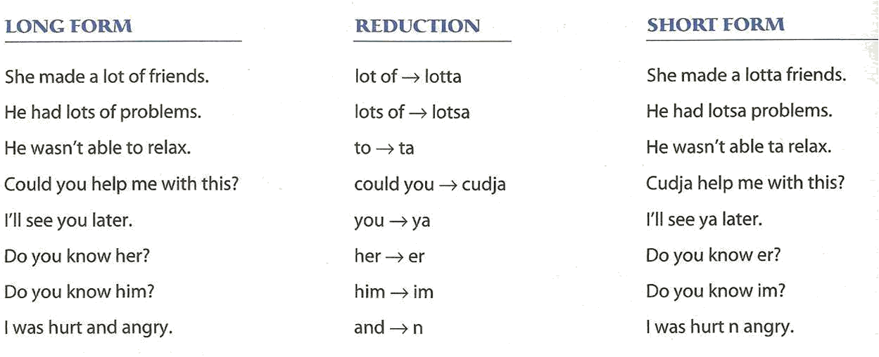

What are participles?

A participle is a form of a verb that functions as an adjective.

-ing Participles
End with -ing

What are participles?

Infinitive | past | Present Participle | Past Participle
bore | bored | boring | bored
interest | interested | interesting | interested

-ed Participles
End with -ed

What are participles?

Infinitive | past | Present Participle | Past Participle
bore | bored | boring | bored
interest | interested | interesting | interested

Participles used as adjectives

Examples :
Present participles are usually active

1a. The boring teacher talked for hours.
1b. The bored students fell asleep.
Past participles are usually passive

2a. I read an interesting magazine yesterday.
2b. The magazine receives a lot of support from interested readers.

More examples:

3a. It was an exciting concert.
3b. The excited fans screamed during the concert.

4a. Many young people experience troubling situations.
4b. The Samaritan Befrienders Hong Kong receives calls from troubled young people.

DON’T CONFUSE PARTICIPLES AND VERBS!

Participles AREN’T preceded by helping verbs.
E.g.
The sputtering sedan wrenched down the boulevard. (participle)
The sedan was sputtering down the boulevard. (verb)
Notes:_________________________________________________________________________________________________________________________________________________________________________________________________________________________________________________________________________________________________________________________________________________________________________________________________________________________________________________________________________________________________

