طريقة اختبار انشاء وتعبير 2
مرحباااا يالغوالي

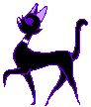

المهم في مذاكرة الماده

حفظ الكلمات اللي هي في المرفق

صمممممم

لأنها مهمه



شوفوا هالتعليق

طريقة آلآختبآر آول شي قطعه 35 فقرةِ مثل هذي

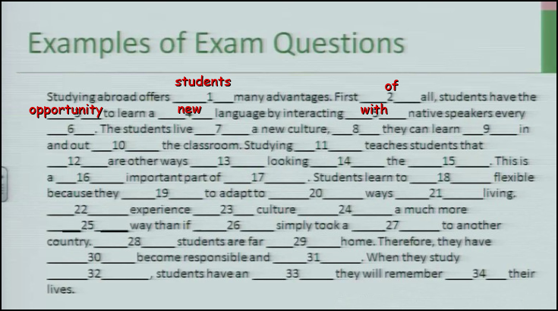

بعدهآإ :

فوكآإبَ مثل هيكآِإ :

هذآ آلفوكآب من آلوحده آلآولىَ :love080:

1. Criterion

a. a quality used to make a judgment

b. a person who speaks more than one language

c. being very good at something

d. the language you want to learn

2. crucial

a. a school or organization where learning takes place

b. extremely important

c. a condition of being very good at something

d. the language you want to learn

3. institute

a. a person who does not speak a second language

b. a person who speaks more than one language

c. a course of learning something you can use very soon

d. a school or organization where learning takes place

وكلةِ موجودَ فَ آلمحآضره 14
نفس آلكلآم آللي فوقِ

آمآ آلمآده هذآ آلمهم فيهآ

وهذا
آللي عليكمَ
1- حفظو آلفوكآب
كله سسسسسهل ومآفيه آي غموضَ حتى آسهل من فوكآب آلنثر بكثثثثير
2- اقرو آلقطع , حاولو تحددو آلحآجآت آللي تتوقعوهآ تجي فرآغآت .. من حروف جر + آلفوكآب
آمآ آذآ جآب لنآ سؤآل من فهم آلقطعه فهذآ سهل وآتوقع عآرفينه من آلترم آللي طآف ومآدة آلنثر

3- ركزو على حروف آلجر , وآختي ضحى مآقصرت بردهآإ يفيدَ مررهَ

4- آلتوبيكآت , آلتوبيكآت , آلتوبيكآإت <+-- هذي آنآ مآ آحبهآ وآللي عنده آي فكرهَ يآريت لو آنه يفهمني آيآهآ

5- آلشي آلجديد علينآ ( آلمقآله ) آسبآبهآ + آلموضوع شنو + رأي آلكآتب فيهآ مثل ص 35

الايدومزidoms

مهمه جدا جدا
</STRONG>
1-Don't look a gift horse in the mouth

a. Don't bring up that topic
b. Don't criticize a gift or an opportunity
c. Don't take unnecessary chances
d. Don't exaggerate a situation

2- Don't make waves
a. Don't jump in the water
b. Don't take unnecessary chances
c. Don't exaggerate a situation
d. Don't make plans before tou have all the necessary information

3- Don't make a federal case out of it
a. Don't interfere; don't cause problems
b. Don't exaggerate a situation
c. Don't make plans before tou have all the necessary information
d. Don't let other people see your faults

4- Don't stick your neck out
a. Don't buy expensive stuff
b. Don't interfere; don't cause problems
c. Don't give people money.
d. Don't help people who didn't ask for your help

5- Don't wash your dirty linen in public
a. Don't listen to what is said in public
b. Don't let other people see your faults
c. Don't listen to other people talking about you
d. Don't wash your clothes outside your home

6- Don't count your chickens before they hatch
a. Don't count chickens
b. Don't make plans before tou have all the necessary information
c. Don't eat eggs
d. Don't exaggerate a situation

7- Don't beat around the bush
a. Don't let other people see your faults
b. Don't talk about unrelated issues, get to the point
c. Don't bring up that topic
d. Don't let other people see your faults

8- Don't go there
a. Don't interfere; don't cause problems
b. Don't bring up that topic
c.Don't talk about unrelated issues, get to the point

وش كمان حسيت انهم مركزين على هالصفحات
13و33و71و55و54و72

خمنوا ان القطعه اللي بتجي هي حقة التاتو
وحطو اسئلة عليها

1-Where did the word ( Tattu) came from ?
From the island (Tahiti)

2-why did the Britons wear tattus ?
They thought it's like (badges of honor)

3-How did the romans change their mind about rattus ?
They believe in purity of human form ( so that they didn't like it )

4-for what Roman used tattus ?
They used it for criminals and condemned people

5-what's the purpose of a MOKO ?
A- To identify the wearer
B- B- to sympolize person's achievements.

6- What time did the 1st tattu discovered ?
On 1991 ina frozen body,and it someone named (OTZI).

7-For what OTZI people used the tattu ?
They used it ( ancestors of contemporary central and northen Europe (place of his people),used the tattu as a medical treatment to reduce pain.

8-when the Egyptians used the tattus ? and what was it's shape ?
They used it (2000 BCE) on their female dancers,it was like (Dot and Dosh).

9-How warriors in (Crusades) الصليبيين time identify themselves ?
With marks of the Jerusalem القدس

9-Tattus were an important part of Culture in ?
South and central of pacific island people.

10-How Hawaiians do Tattus on themselves ?
By tattuing their Tongues with (3) dots.

10-what does (TATAU) means ?
To tap mark into the body.

11-Tattus has been practicing in Japan for what reason ?
For beautification,magic,and to mark criminals, since around 5th century BC.

12-Why the government of Japan outlawed (منعت) Merchants to use tattus ? and at what time ?
Because it was like a subversive (تخريبي) it was covered them from neck to elbows and knees,it was In 1870
الملفات اللي موجوده في المرفق مهمه اطلعوا عليها لانها مراجعة من سبقونا

وراح تكفي حاولت الم اكبرقدرمن المعلومات
وبنزل لكم محتوى المحاضرة الرابعة عشراللي هي عباره عن توضيح طريقة الاختبار
في المرفق
ويقولوا ان الدكتور ركز على صفحة 13و71
وحل 71
come to
rites of passage
arich cultural history
cultural practice
the esrliest record of
ariess
dating back
gave rise

اتمنى لكم ولي كل التوفيق
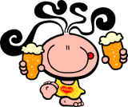
واحد عثثثثكريييم لأول من يرد

