Lecture 4
Introduction to Linguistics
Eng 250
مقدمه في اللغويات التطبيقية

The Sounds of Language[ Part 2]

I. Charting Consonant Sounds
II. Examples
III. Charting Vowels
IV. Single Vowels & Diphthongs
VI. Sample Questions

- Charting Consonant Sounds

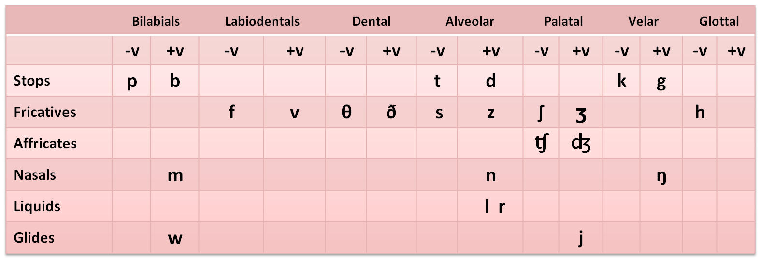

- Examples

- Stops:
[p] people republic sleep
[b] basic symbols rub
[t] table reciting seat
[d] dangerous reading covered
[k] keep recognize steak
[g] goal regard bag

2. Fricatives
[f] food define enough
[v] very revise love
[θ] think diphthong mouth
[ð] that mother ?
[s] self understand house
[z] zero desert quiz
[ ∫ ] shore pushes crash
[ʒ] measure treasure]
[h] house behind

3. Affricate
[ ʧ ] church recharge research [ ʤ] jordan enjoy Jeddah jar

4. Nasals
[m] money remind come
[n] national conference station
[ŋ] // English boring

5. Liquids
[l] learning rely steal
[r] reading cardinal where ?

6. Glides
[w] want reward how
[ j ] you royal enjoy

Approximants :
The combination of the liquids [l] and [r] and the glides [w] and [j] in one category

III. Charting Vowels

Vowels :
All vowel sounds are voiced and produced with a relatively free flow of air

Back | Central | Front
u  Ʊ |  | i  I | High
o  Ɔ | Ə  8 | e  Ɛ | Mid
ɑ | a | æ | Low

IV. Single Vowels & Diphthongs

A. Single Vowels
1. Front Vowels:
[i] bead , beef, key, me, see, we
[I] bid, myth, sit, hit, women
[e] set, ten, when
[Ɛ] bed, dead, said
[æ] bad, laugh, wrap, married, Arab, legality

2. Central Vowels:
[Ə] above , oven, support, Amman
[8] butt, blood, dove, tough, Qatar
[a] carob, desalinate,

3. Back vowels:
[u] boo, move, two, you
[ʊ ] book, could, put, hot
[o] hot, pot ,
[Ɔ] born, caught, fall, raw
[ɑ] bod, cot, swan

B. Diphthongs: Sounds that consist of a combination of two vowel sounds.
[ai] buy, eye, I, my, pie, by, sigh
[au] cow, how, now, doubt, bough
[ ei ] eight, great, late, hate, say
[ ou] boat, throw, home, toe
[ oi ] boy, noise
schwa [Ə ] about , understand

VI. - Sample Questions

1. The study of how speech sounds are made or articulated is called “______”
A. Phonetics B. Acoustic Phonetics
C. Articulatory Phonetics D. Auditory Phonetics

- “ ____” is the only voiceless sound from the following.
A. B B. K
C. M D. G

3. The sounds that are produced by the tongue tip and the upper front teeth are called ___________.
A. Dentals B. Labiodentals
C. Bilabials D. Alveolars

4. For producing only consonant sounds, the __________ and other parts of the mouth are used.
A. nose B. tongue
C. fingers D. ears

5. It is the sound ____ that is only produced by Glottals .
A. [f] B. [p]
C. [d] D. [ h]

6. All of the following sounds are produced by velars except the sound “ __________”
A. [r] B. [K]
C. [ng] D. [G]

7. The sounds that are produced when blocking the air stream and having air pushed through the very narrow opening causing a type of friction are called ___.
A. Dentals B. Fricatives
C. Bilabials D. Alveolars

8. The underlined vowel sound in the word “ key” is one of the _________ .
A. long B. front vowels
C. Back vowels D. central vowels

9. Sounds that consist of a combination of two vowel sounds are called ______
A. Diphthongs B. front vowels
C. Back vowels D. central vowels

10. All of the following sounds are diphthongs except the sound “________”
A. [au] B. [ei]
C. [oi] D. [u:]

11. The underlined vowel sound in the word “ _________” is called a schwa.
A. shore B. hat
C. about D. tin

12. “ ______________” is the study which deals with the physical properties of speech as sound waves in a language.
A. Phonetics B. Acoustic Phonetics
C. Articulatory Phonetics D. Auditory Phonetics

ـألسآحر – ملتقى الانتساب المطور بجامعة الملك فيصل

