Lecture 5
Introduction to Linguistics
Eng 250
مقدمه في اللغويات التطبيقية
The Sounds of Language Part 3

I. Voiceless sounds
II. Voiced sounds
III. Study Questions
1.The Difference between Acoustics and articulatory phonetics
2. Identifying manner of articulation of the initial sounds
3. Identifying place of articulation of the initial sounds
4. Writing the English words as they are transcribed
5. Writing the basic phonetic transcription of English words
IV. Sample Questions

1. Voiceless Sounds

1. Voiceless sounds
- [p] pen open help
- [f] feel refill self
- [θ] thought author health
- [t] table stop seat
- [s] Sunday resize house
- [∫] sure discussion brush
- [ʧ] chair recharge speech
- [k] cure recognize leak
- [h] hand behind Allah

2. Voiced Sounds
- [b] book rebuild club
- [m] male smile team
- [w] wall unwilling how
- [v] voice adventure leave
- [ð] there mother
- [d] danger understand load
- [z] zero razor thesis
- [n] north author south
- [l] land selfishness role
- [r] round surround fou(r)

- [g] gap geography mug
- [ʒ] pleasure measure treasure
- [ʤ] gist adjust language
- [ŋ] ceiling English understanding
- [j] you royal toy

III. Study Questions

1. The Difference between Acoustics and articulatory phonetics
Acoustic phonetics: The study which deals with the physical properties of speech as sound waves in the air.
Articulatory phonetics: The study of how speech sounds are made, or articulated

2. Which of the following words normally end with voiceless ( -V ) sounds and which end with voiced (+V ) sounds
(a) bang +v (d) fizz +v (g) splat -v
(b) crash -v (e) rap -v (h) thud +v
(c) ding +v (f) smack -v (i) wham +v
3. Try to pronounce the initial sounds of the following words and identify the lace of articulation of each.

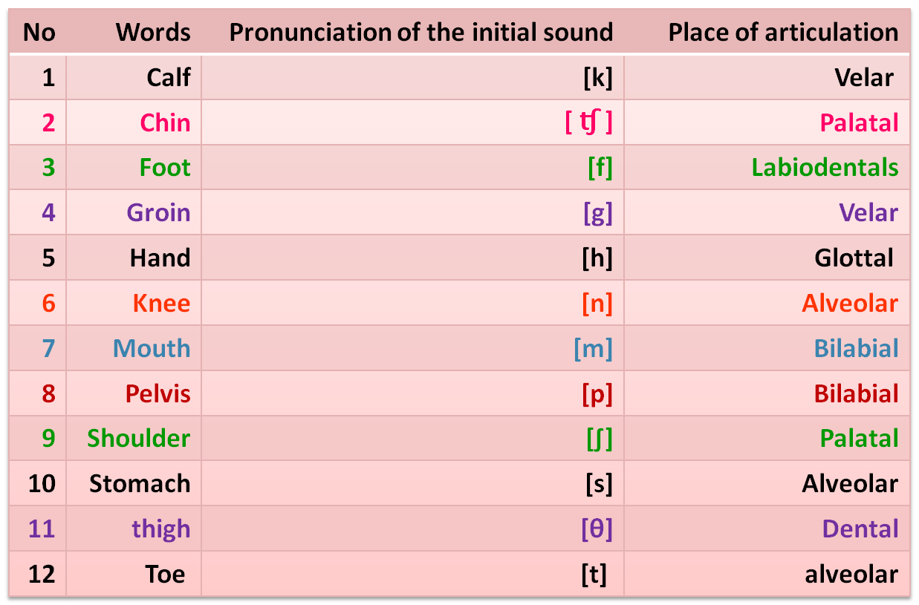

4. Identify the manner of articulation of the initial sounds in the following words

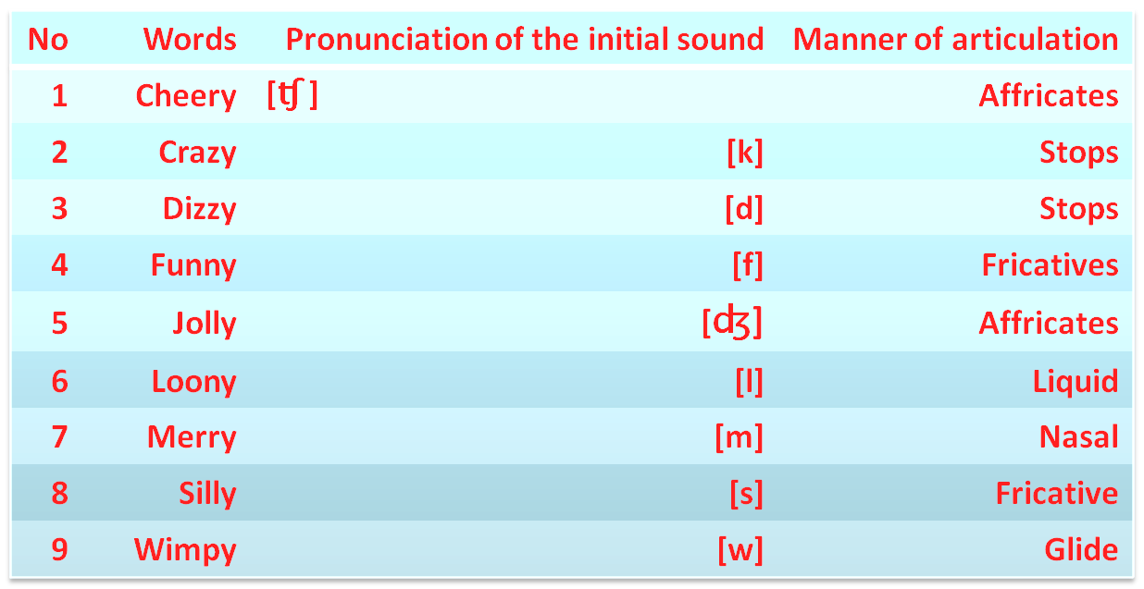

5 Write the English words that the following transcriptions refer to

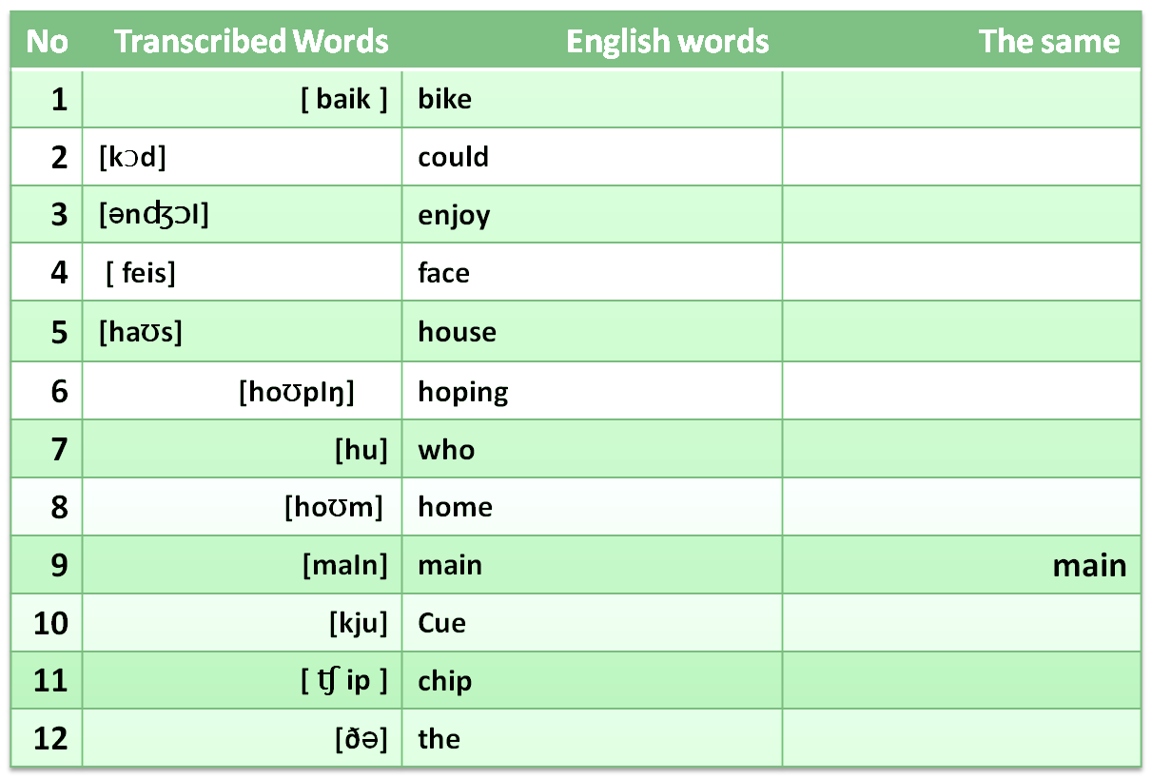

6. Using symbols introduced in this chapter, write the basic phonetic transcription

The same | English words | Transcribed Words | No
 | bike | [ baik ] | 1
 | could | [kƆd] | 2
 | enjoy | [ƏnʤƆI] | 3
 | face | [ feis] | 4
 | house | [haƱs] | 5
 | hoping | [hoƱpIŋ] | 6
 | who | [hu] | 7
 | home | [hoƱm] | 8
main | main | [maIn] | 9
 | Cue | [kju] | 10
 | chip | [ʧip ] | 11
 | the | [ðƏ] | 12

7. Using symbols introduced in this chapter, write the basic phonetic transcription

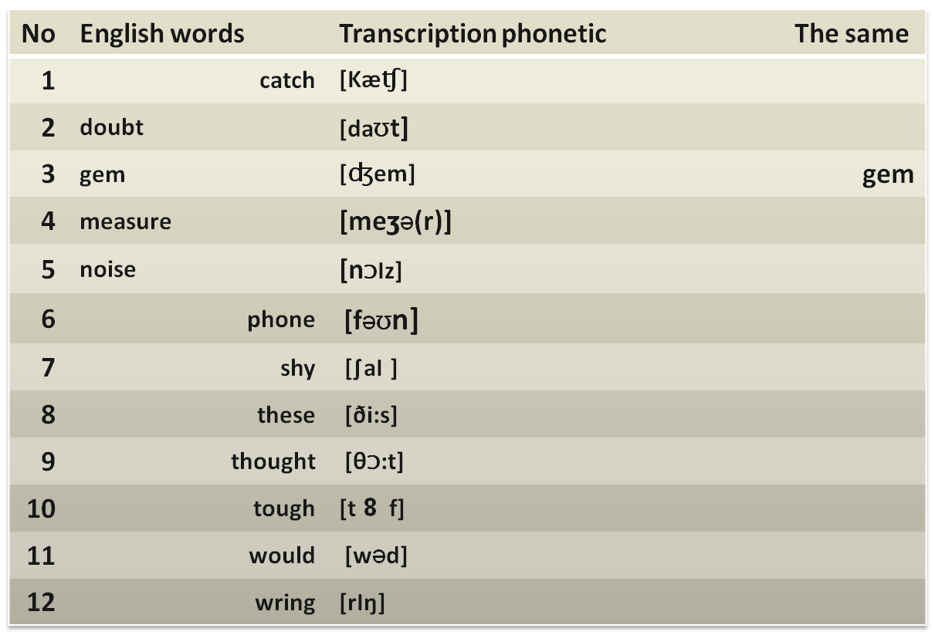

IV. Sample Questions
- The only voiceless sound from the following is___________
A. [e] B. [d]
C. [h] D. [g]

2. The word “ ____________” begins with a palatal sound.
A. soft B. sure
C. suspect D. silent

3. All of the following consonant sounds are nasals except “ __________”
A. [r] B. [m]
C. [n] D. [ŋ]

4. The first consonant sound in the word “ __________” is labiodentals.
A. going B. thigh
C. shoulder D. football

5. “ ___________” is glottal sound.
A. [e] B. [d]
C. [h] D. [g]

6. The word “ ____________” ends with a liquid sound.
A. steam B. general
C. suspect D. big

7. “[daƱt] is the phonetic transcription of the word” ___________”
A. doubt B. date
C. dowt D. diet

8. The phonetic transcription “ ________” refers to the word “ face” .
A. [fais] B. [fi:s]
C. [ies] D. [feis]

with my best regards
Dr. Ghassan

ـألسآحر – ملتقى الانتساب المطور بجامعة الملك فيصل

