Lecture 8
Refining Research Ideas and Beginning
to Design your Study

Elements of Research Design:
Comparison/Control Groups

■ Selecting a comparison group:
Between Groups Designs

■ Compare it to another group (that is similar to

research group except with respect to the
treatment/construct you are measuring)
Within Group Designs
■ Can compare one group to itself over time
(i.e., before treatment and after treatment)
■ Note: qualitative/descriptive studies do not use
comparison groups – they just describe…really well
Elements of Research Design: Between Groups Design
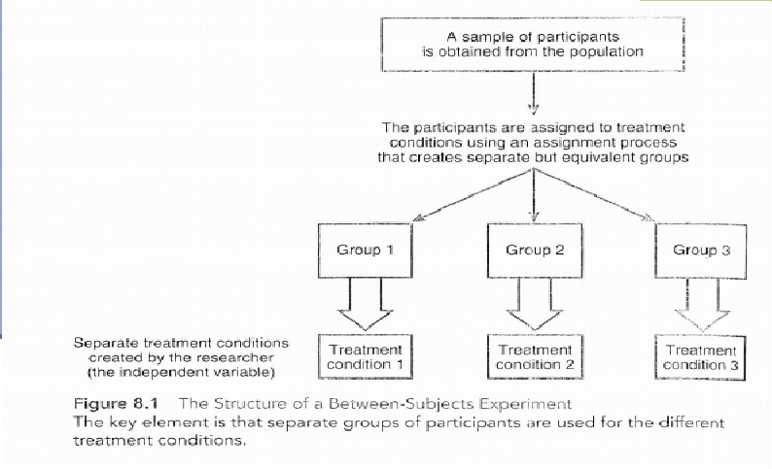
Source: Gravetter, F.J., & Forzano, L. B. (2006). Research Methods for the Behavioral Sciences (2nd ed.). United
States of America: Thomson Wadsworth.
Elements of Research Design: Within
Group Design
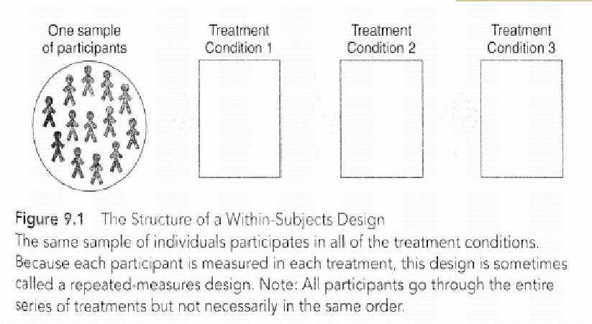
Source: Gravetter, F.J., & Forzano, L. B. (2006). Research Methods for the Behavioral Sciences (2nd ed.). United
States of America: Thomson Wadsworth.
Elements of Research Design: One time vs.
over time research
■ Cross-sectional method
§ Same group of people are observed at one
point in time
■ Longitudinal method

Same group of people are observed at
different points in time as they grow older
Elements of Research Design: Longitudinal Method
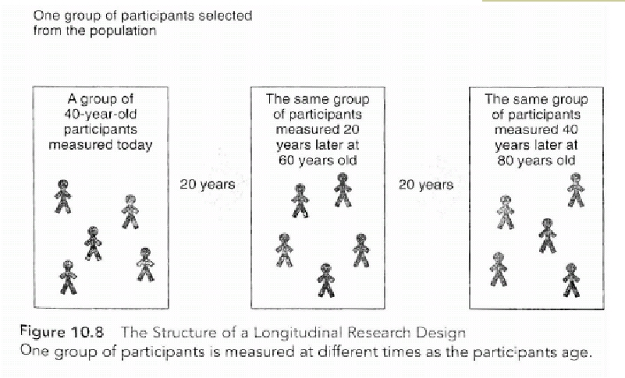
Source: Gravetter, F.J., & Forzano, L. B. (2006). Research Methods for the Behavioral Sciences (2nd ed.). United
States of America: Thomson Wadsworth.
Lecture 9
Elements of Research Design: Defining
your terms
Elements of Research Design: Defining
your terms
■ Independent variable – variable that is
manipulated by the researcher (or the variable
that is thought to affect the outcome/dependent
variable)
■ Dependent variable – variable that is measured
to assess the effects of the independent variable
■ “Operational definition” – procedure for
measuring and defining a construct (i.e., what
measures will you be using)
Turning your research question into a
Research Hypothesis
■ It is the test of your idea or theory
■ A hypothesis is a statement that describes or
explains a relationship among variables
■ It is a prediction that is derived from your
research question
e.g. “Shared Journey staff education will
improve patient satisfaction as compared to
units whose staff did not receive SJ training”
e.g. “internalized stigma is related to increased
depression”
RH & RQ
http://privatewww.essex.ac.uk/~scholp/Hypotheses05.htm
Summary
■ Start thinking about who you want to
participate in your study, how you will recruit
them, how you will collect the data etc.
■ Decide if you want a single or multiple groups
of participants and if you want to collect data
at one time or over time
■ Start thinking about how you can
minimize/eliminate confounds and bias
■ Formulate a research hypothesis

