LECTURE 9
Unit 2
& REALLY:
You can use really  To make statements  Stronger and to  Make negative  Statements softer. | •I really enjoy knitting.  •I really like making things.  •I’m not really into photography

•I don’t really have much time for hobbies  •No, not really | Not really can  also be a polite way  to answer no.

& ANSWER THE FOLLOWING QUESTIONS. GIVE YOUR OWN ANSWERS USING REALLY OR NOT REALLY.
1.Are you interested in sports?
Not really. I don’t really play any sports.
2. Are you into computers?
Well, I am really into computer games.
3. Do you enjoy doing jigsaw puzzles?
Not really. I think jigsaw puzzles are boring.
4. Are you good at fixing things?
No, not really. I’m not good with my hands.
5. Do you make your own clothes?
No, I’m not really into sewing. But I really like shopping.
& LINKING IDEAS:
Add an idea
I do photography, and I like art.
I also like books, especially history books.
I don’t like biographies or poetry.
Contrast two ideas
I like climbing, but my friends don’t.
Give a reason
I can’t go on vacation because I have some work to do.
& My favorite hobby:
- Read about this hobby. Complete the sentences with and, but, or, also, or because.
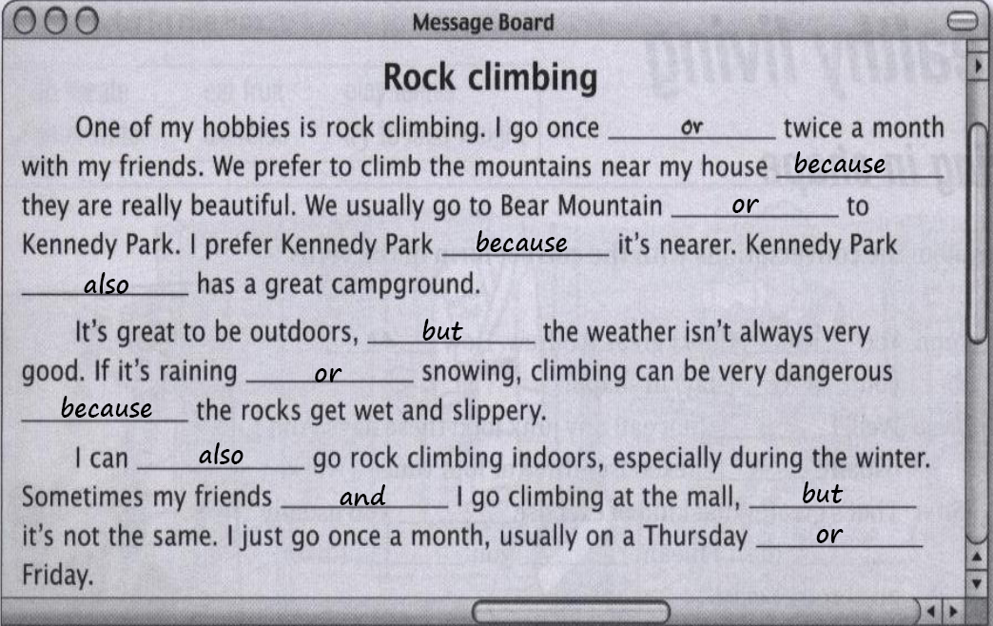
& EXERCISE: Complete the conversations the sentences in the box.
Um, no. He’s lazy and just watches TV all day. Not really. My mom knitted it for me last year.
Actually, no. My sister got it at the bakery. No, but he has a big cap collection.
Well, no. I prefer to make peanut butter cookies. No, I’m not really good with my hands.
Um, no, he just plays computer games! Not really. He does crossword puzzles, though.
1. Jenny: I really like your sweater. Is it new?
Kate: Not really. My mom knitted it for me last year.
Jenny: can you knit or crochet?
Kate: No, I’m not really good with my hands. But I bake a little.
Jenny: Oh, did you make this cake?
Kate: Actually, no. My sister got it at the bakery.
But I like to make cookies some times.
Jenny: Me too. Do you ever make chocolate chip cookies?
Kate: Well, no. I prefer to make peanut butter cookies.
My family loves them!
2. Mike: I want to buy a Yankees baseball cap for my brother.
Greg: Why? Is it his birthday?
Mike: No, but he has a big cap collection.
Does your brother collect anything?
Greg: My brother? Um, no. He’s lazy and just watches TV all day.
Mike: Really? Does he have any hobbies?
Greg: Um, no, he just plays computer games!
Mike: Oh, yeah? My brother is on the computer all the time.
Greg: Oh, does he do computer graphics?
Mike: Not really. He does crossword puzzles, though.
& READING TOPIC SENTENCE
What is the topic sentence?
The topic sentence is the first sentence in a paragraph. It gives the reader an idea of what the paragraph is going to be about.
(Ask yourself what the paragraph is about.)
What does it do?
It introduces the main idea of the paragraph.
THE INTRODUCTION PARAGRAPH
The first paragraph is called the Introduction. The introduction paragraph has two main purposes:
 1. It introduces the topic to prepare the reader for what you will be reading.
 2. It attracts the reader’s attention so that they will be interested in reading more.
& READING EXERCISE: “Some Young People’s Hobbies”
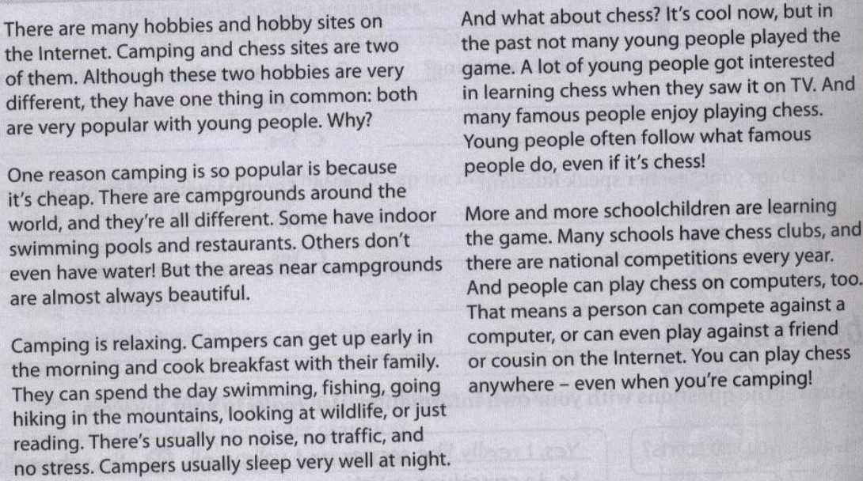
- Read the article again. Then. Then write T ( true ) or F ( false ) for each sentence. Correct the false sentences.
- Camping and chess have nothing in common. F.. They have one thing common.
- Camping is popular because it’s cheap and stress-free. T..
- Campers hardly ever sleep well at night. F.. Campers usually sleep well at night
- Many young people played chess in the past. F.. In the past not many young people . played chess..
- TV shows helped make camping popular. F.. TV shows helped making chess popular
- Many schools now have chess clubs. T..
- You can go camping on the Internet. F.. You can play chess on the Internet..
Vocabulary notebook.. I really like to sing!
Learning tip Word chains.. Link new words together in word "chains."
1. Complete the word chains using the words and expressions below.
playing chess bake cakes read English books
skiing golf writing poetry
Playing chess
Writing poetry
skiing
I'm good at and and

I don't like to or or
Bake cakes
golf
Read English books

2.Now complete the word chains with your own ideas.
I'm good at and and

I enjoy and and

I can't or or

I hate to and and

I'd like to and and

I'm not interested in or or

Sportsoccereadingrammar  chessingingamesurfing | On your own  Think of different things you are Interested in. Can you link them together? Use the last letter of each word or expression to start the next word. How many word did you use?
& UNIT REVISION VOCABULARY:
Hobby Novel Sculpture Design Jog Crime Poetry Biography Mystery Science Knit Sweater Sew Crochet Photography ..
CAN Can is an auxiliary verb, a modal auxiliary verb. We use can to:
talk about possibility and ability make requests ask for or give permission
Structure of Can
subject + can + main verb (base verb)
 | Subject | Auxiliary Verb | Main Verb
+ | I | can | play | tennis
- | He | cannot  can’t | play | tennis
? | Can | you | play | tennis?
& GRAMMAR: VERB FORMS:
Can / can’t + verb  Verb  I can play the piano.  I can’t play very well.  I can’t sing at all. | To + verb  I love to swim.  I like to play pool.  I hate to work out.  I prefer to watch TV.  I’d like to play jazz. | Verb + -ing  I love swimming.  I like playing pool.  I hate working out.  I prefer watching TV.  I enjoy reading. | Preposition + verb + -ing  I’m good at drawing people.  I’m not interested in skiing.

In conversation  I like / love / hate to + verb  Is more common than  I like / love / hate to + verb  + -ing  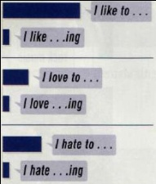 | EVERYBODY & NOBODY  1.All the students are here today.  2.There are no students here today.  - No body is here today. No one is here today.  - Every body is here today. Everyone is here today.
Every body  Every one  No body  No on  English.  watching TV.  music.  homework. | In conversation  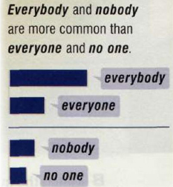

OBJECT PRONOUNS
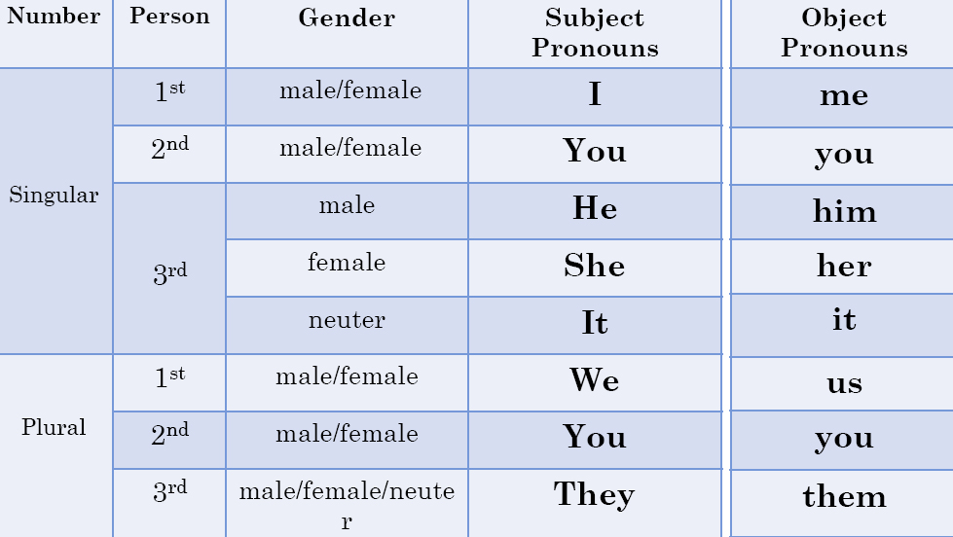
& Which object form of the personal pronoun can substitute the underlined phrase in the sentence?
1\ The teacher always gives the students homework.
(me - them – you)
2\ I am reading the book to my little sister.
(her - us - him)
3\The boys are riding their bikes.
(it – them – her)
4\My father is writing a letter to John.
(me - her – him)
5\I don't know the answer.
(she – her – it)
6\ Sally is going to Anne.
(her - him – me)
7\ Open the window, please.
(it - them – us)
8\ Can you tell the people the way to the airport, please?
(you - them – us)
9\ The books are for Peter.
(him – her – you)
10\ Can you help my sister and me, please?
(her – me – us)
& OBJECT PRONOUNS: EXERCISE
1."Your son is making a lot of noise!" "I'll ask him to be quiet.“
2."Where are my glasses?" "You are wearing them !“
3."Look at Sarah! She seems so happy?" "Her father offered her a car for her birthday!“
4."What are you going to do with those old papers?" "I'm going to recycle them .“
5."How are your kids? "I haven't met them for ages!“
6."Have you met Alan and Tim?" "No, I have never met them ."
7."Do you want this book?" "Yes." "Well, take it ."
8."My mother is fantastic! I like her very much."
9."Don't help me with this exercise! I can do it by myself.“
10."Take the children to bed. Don't let them watch TV. “
& SUBJECT VS. OBJECT
I called you.
You called me.
Ahmad and I are at school.
John and he go to the gym.
I send emails to you and them.
How can he blame you and him for the accident.
I speak with him
He is taller than me
I bought a book for him

By: Amjad Al-ghamdi

