In The Name Of Allah Most Gracious Most Mercifvl

King Faisal University
Deanship of E-Learning and Distance Education



Introduction to Linguistics
Instructor : Dr. Hassen Ammari
All content from 1 to 14
By
Heart story



1st & 2nd Lecture
Animals and human language

Lecture Elements

- Introduction
- Communicative and informative signals
- Displacement
- Arbitrariness
- Productivity
- Cultural transmission
- Duality
- Talking to animals

Introduction
We all heard about animals imitating human voices thinking that they really talk. We know that animals communicate with other members of their own species, but is it possible that any creature could talk to us in our language? Or does human language have properties that make it so unique that it is quite unlike any other communication system and hence unlearnable by any other creature?

Communicative and informative signals
Informative signals is a behavior that provides information, usually
unintentionally
Communicative signals is a behavior used intentionally to provide
information
So, when we talk about distinctions between human language and
animal communication, we are considering both in terms of their
potential as a means of intentional communication.

Displacement
Displacement is a property of language that allows users to talk
about things and events not present in the immediate
environment. Animal communication is generally considered to
lack this property.
It has been proposed that bee communication may have the
property of displacement. Bee communication has displacement
in an extremely limited form.

Arbitrariness
Arbitrariness is a property of language describing the fact that
there is no natural connection between a linguistic form and its
meaning. The aspect of the relationship between linguistic signs
and objects in the world is described as arbitrariness.
There are some words in language with sounds that seem to
‘echo’ the sounds of objects or activities and hence seem to have
a less arbitrary connection (onomatopoeic words).

Productivity
Productivity is a property of language that allows users to create
new expressions, also called ‘creativity’ or ‘open-endedness’. It is
linked to the fact that the potential number of utterances in any
human language is infinite.
The communication systems of other creatures do not appear to
have this type of flexibility. Nor does it seem possible for creatures
to produce new signals to communicate novel experiences or
events.

This limiting feature of animal communication is described in
terms of fixed reference (a property of a communication system
whereby each signal is fixed as relating to one particular object or
occasion).

Cultural transmission
Cultural transmission is the process whereby knowledge of a
language is passed from one generation to the next. We acquire a
language in a culture with other speakers and not from parental
genes. It is clear that humans are born with some kind of
predisposition to acquire language in a general sense. The general
pattern in animal communication is that creatures are born with a
set of specific signals that are produced instinctively. Unlike
animals, human infants, growing up in isolation, produce no
‘instinctive’ language.

Duality
Duality is a property of language whereby linguistic forms have
two simultaneous levels of sound production and meaning, also
called ‘double articulation’. Sounds, like r, a and c as individual
sounds have no meanings. In a particular combination such as car,
we have another level producing a meaning that is different from
the meaning of the combination in arc. So, at one level, we have
distinct sounds, and, at another level, we have distinct meanings.

This duality of levels is, in fact, one of the most economical
features of human language because, with a limited set of discrete
sounds, we are capable of producing a very large number of sound
combinations (e.g. words) which are distinct in meaning.
Among other creatures, each communicative signal appears to be
a single fixed form that cannot be broken down into separate
parts.

Talking to animals
If these five properties of human language make it such a unique
communication system, quite different from the communication
systems of other creatures, then it would seem extremely unlikely
that other creatures would be able to understand it. Some
humans, however, do not behave as if this is the case. There is,
after all, a lot of spoken language directed by humans to animals,
apparently under the impression that the animal follows what is
being said.

If it seems difficult to conceive of animals understanding human
language, then it appears to be even less likely that an animal
would be capable of producing human language. After all, we do
not generally observe animals of one species learning to produce
the signals of another species.

So many experiments have been conducted in order to teach
chimpanzees human language, sign language, or even a system of
communication (using plastic shapes), but the results were so
poor, proving that even the most close creatures to us are unable
to acquire or learn our language.

Email: hammari@kfu.edu.sa

3rd Lecture
The development of writing

Lecture Elements
- Pictograms and ideograms
- Logograms
- Rebus writing
- Syllabic writing
- Alphabetic writing
- Written English

Introduction
It is important, when we consider the development of writing, to keep in mind that a large number of the languages in the world today are used only in the spoken form. We may be able to trace human attempts to represent information visually back to cave drawings made at least 20,000 years ago, or to clay tokens from about 10,000 years ago, which appear to have been an early attempt at bookkeeping, but these artifacts are best described as ancient precursors of writing.

The earliest writing for which we have clear evidence is the kind that Geoffrey Nunberg is referring to as ‘cuneiform’ marked on clay tablets about 5,000 years ago. An ancient script that has a more obvious connection to writing systems in use today can be identified in inscriptions dated around 3,000 years ago.

Pictograms and ideograms
Pictogram (pictographic writing) is a way of writing in which a picture/drawing of an object is used to represent the object. A conventional relationship must exist between the symbol and its interpretation.
Ideogram (ideographic writing) is a way of writing in which each symbol represents a concept/an idea.
The distinction between pictograms and ideograms is essentially a difference in the relationship between the symbol and the entity it represents. The more ‘picture-like’ forms are pictograms and the more abstract derived forms are ideograms.


When the relationship between the symbol and the entity or idea becomes sufficiently abstract, we can be more confident that the symbol is probably being used to represent words in a language.
When symbols are used to represent words in a language, they are described as examples of word-writing, or ‘logograms’.

Logograms
Logogram (logographic writing) is a way of writing in which each symbol represents a word.
A good example of logographic writing is the system used by the Sumerians, in the southern part of modern Iraq, around 5,000 years ago. Because of the particular shapes used in their symbols, these inscriptions are more generally described as cuneiform writing, which is a way of writing created by pressing a wedge-shaped implement into soft clay tablets.
The relationship between the written form and the object it represents has become arbitrary so we have a clear example of word-writing or a logogram.
A modern writing system that is based, to a certain extent, on the use of logograms can be found in China. Many Chinese written symbols, or characters, are used as representations of the meaning of words, or parts of words, and not of the sounds of spoken language.

Quite a large number of different written symbols are required within this type of writing system (i.e. official list of modern Chinese characters has 2,500 characters and other lists contain up to 50,000 characters). This presents a substantial memory load.
To solve this problem a method is needed to go from symbols representing words (i.e. a logographic system) to a set of symbols that represent sounds (i.e. a phonographic system).

Rebus writing
Rebus writing is a way of writing in which a pictorial representation of an object is used to indicate the sound of the word for that object. In this process, the symbol for one entity is taken over as the symbol for the sound of the spoken word used to refer to the entity. That symbol then comes to be used whenever that sound occurs in any words.

A similar process is taking place in contemporary English texting where the symbol “2” is used, not only as a number, but as the sound of other words or parts of words, in messages such as “nd2spk2u2nite” (“(I) need to speak to you tonight”). In this message, the letter “u” also illustrates the process of rebus writing, having become the symbol for the sound of the spoken word “you.”

Syllabic writing
Syllabic writing (syllabary) is a way of writing in which each symbol represents a syllable (a unit of sound consisting of a vowel and optional consonants before or after the vowel). That is when a writing system employs a set of symbols each one representing the pronunciation of a syllable, it is described as syllabic writing. There are no purely syllabic writing systems in use today.

Both the ancient Egyptian and the Sumerian writing systems evolved to the point where some of the earlier logographic symbols were used to represent spoken syllables. However, it is not until the time of the Phoenicians, inhabiting what is modern Lebanon between 3,000 and 4,000 years ago, that we find the full use of a syllabic writing system.
By about 3,000 years ago, the Phoenicians had stopped using logograms and had a fully developed syllabic writing system.

Alphabetic writing
Alphabetic writing (alphabet ) is a way of writing in which one symbol represents one sound segment. This seems to have occurred in the development of the writing systems of Semitic languages such as Arabic and Hebrew. This type of writing system is sometimes called a consonantal alphabet. The early version of Semitic alphabetic script, originating in the writing system of the Phoenicians, is the basic source of most other alphabets to be found in the world.

The early Greeks took the alphabetizing process a stage further by also using separate symbols to represent the vowel sounds as distinct entities, and so created a remodeled system that included vowels. This change produced a distinct symbol for a vowel sound such as a (called ‘alpha’) to go with existing symbols for consonant sounds such as b (called ‘beta’), giving us single-sound writing or an ‘alphabet’

Written English
If indeed the origins of the alphabetic writing system were based on a correspondence between a single symbol and a single sound type, then one might reasonably ask why there is such a frequent mismatch between the forms of written English (you know) and the sounds of spoken English (yu no).

The answer to that question must be sought in a number of historical influences on the form of written English.
There were words derived from forms used in writing other languages, notably Latin and French.
Many of the early printers were native Dutch speakers and could not make consistently accurate decisions about English pronunciations.
Since the fifteenth century, the pronunciation of spoken English has undergone substantial changes

A large number of older written English words were actually ‘recreated’ by sixteenth-century spelling reformers to bring their written forms more into line with what were supposed, sometimes erroneously, to be their Latin origins (e.g. dette became debt, iland became island)

4th Lecture
The sounds of language

Lecture Elements
- Introduction
- Phonetics
- Voiced and voiceless sounds
- Place of articulation: Bilabials / Labiodentals / Dentals / Alveolars / Palatals / Velars / Glottals
- Charting consonant sounds
- Manner of articulation : Stops / Fricatives / Affricates / Nasals / Liquids / Glides / Vowels / Diphthongs
- Subtle individual variation

Introduction
The sounds of spoken English do not match up, a lot of the time, with letters of written English.
If we cannot use the letters of the alphabet in a consistent way to represent the sounds we make, how do we go about describing the sounds of a language like English? One solution is to produce a separate alphabet with symbols that represent sounds. Such a set of symbols does exist and is called the phonetic alphabet (a set of symbols, each one representing a distinct sound segment)

Phonetics
Phonetics is the study of the characteristics of speech sounds.

Articulatory phonetics is the study of how speech sounds are produced.
Acoustic phonetics is the study of the physical properties of speech as sound waves.
Auditory phonetics is the study of the perception of speech sounds by the ear, also called “perceptual phonetics”.

Voiced and voiceless sounds
In articulatory phonetics, we investigate how speech sounds are produced using the fairly complex oral equipment we have. We start with the air pushed out by the lungs up through the trachea /ˈtreɪkiə/ (or ‘windpipe’) to the larynx. Inside the larynx are your vocal cords, which take two basic positions.

1 When the vocal cords are spread apart, the air from the lungs passes between them unimpeded. Sounds produced in this way are described as voiceless.

2 When the vocal cords are drawn together, the air from the lungs repeatedly pushes them apart as it passes through, creating a vibration effect. Sounds produced in this way are described as voiced.

Place of articulation
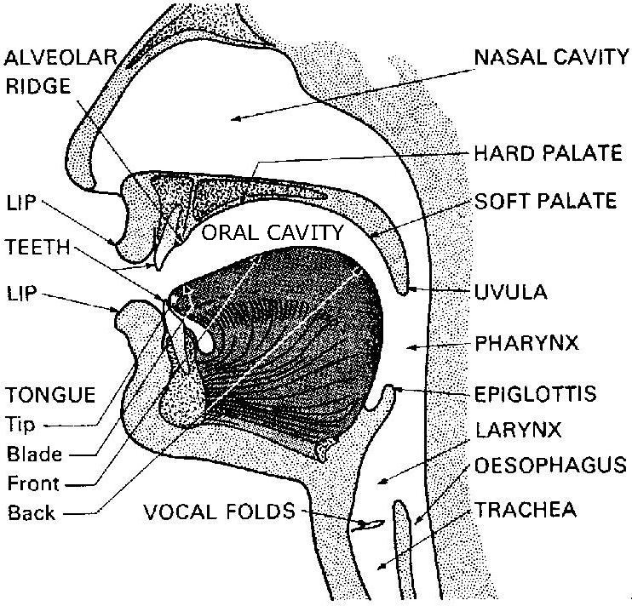

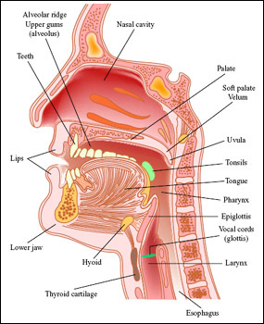
Place of articulation
Once the air leave the lungs and passes through the larynx, it comes up and out through the mouth and/or the nose. Most consonant sounds are produced by using the tongue and other parts of the mouth to limit, in some way, the shape of the oral cavity through which the air is passing. The terms used to describe many sounds are those which denote the place of articulation of the sound: that is, the location inside the mouth at which the constriction takes place.

The following links are very helpful to learn about different places and manners of articulation

http://www.uiowa.edu/~acadtech/phonetics/anatomy.htm
and
http://www.uiowa.edu/~acadtech/phonetics/english/frameset.html

Bilabials: are sounds formed using both upper and lower lips. The lower lip articulates against the upper lip. [p] is voiceless, and [b], [m] and [w] are voiced.

Labiodentals: are sounds formed with the upper teeth and the lower lip. The lower lip articulates against the upper teeth. [f] is voiceless, and [v] is voiced.

Dentals: are sounds formed with the tongue tip behind the upper front teeth (also referred to as interdentals). The tongue tip articulates against the upper teeth. [θ] is voiceless, and [ð] is voiced.
Alveolars: are sounds formed with the front part of the tongue on the alveolar ridge, which is the rough, bony ridge immediately behind and above the upper teeth. The tongue tip and/or blade articulates against the teeth ridge. [t] and [s] are voiceless whereas [d], [z] and [n] are voiced. Other alveolars are [l] and [r].

Palatals (Alveopalatals): are sounds produced with the tongue and the palate. The tongue front articulates against the hard palate. [ʃ] and [tʃ] ] are voiceless whereas [ʒ], [dʒ] and [j] are voiced.

Velars: are sounds produced with the back of the tongue against the velum. The tongue back articulates against the soft palate. [k] is voiceless whereas [g] and [ŋ] are voiced.

Glottals: In fact there is only one sound that is produced without the active use of the tongue and other parts of the mouth. It is the voiceless sound [h]. The vocal folds themselves are the place of articulation.

Charting consonant sounds
Having described in some detail the place of articulation of English consonant sounds, we can summarize the basic information in the accompanying chart. Along the top of the chart are the different labels for places of articulation and, under each, the labels −V (= voiceless) and +V (= voiced). Also included in this chart, on the left-hand side, is a set of terms used to describe ‘manner of articulation’ which we will discuss in the following section

The links below may be of great help to practice the consonant sounds
http://www.antimoon.com/misc/phonchart2008.pdf
http://www.stuff.co.uk/calcul_nd.htm

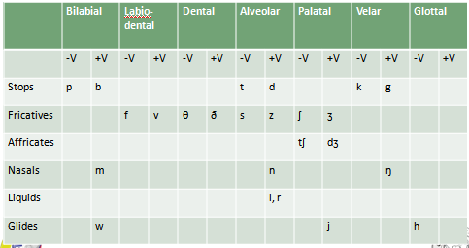

Manner of articulation
So far, we have concentrated on describing consonant sounds in terms of where they are articulated. We can also describe the same sounds in terms of how they are articulated. Such a description is necessary if we want to be able to differentiate between some sounds which, in the preceding discussion, we have placed in the same category. For example, we can say that [t] and [s] are both voiceless alveolar sounds. How do they differ? They differ in their manner of articulation, that is, in the way they are pronounced. The [t] sound is one of a set of sounds called stops and the [s] sound is one of a set called fricatives

Stops: Of the sounds we have already mentioned, the set [p], [b], [t], [d], [k], [g] are all produced by some form of ‘stopping’ of the airstream (very briefly) then letting it go abruptly. This type of consonant sound, resulting from a blocking or stopping effect on the airstream, is called a stop (or a ‘plosive’).

Fricatives: The manner of articulation used in producing the set of sounds [f], [v], [θ], [d], [s], [z], [ʃ], [ʒ] involves almost blocking the airstream and having the air push through the very narrow opening. As the air is pushed through, a type of friction is produced and the resulting sounds are called fricatives.

Affricates: If you combine a brief stopping of the airstream with an obstructed release which causes some friction, you will be able to produce the sounds [tʃ] and [dʒ]. These are called affricates.

Nasals: Most sounds are produced orally, with the velum raised, preventing airflow from entering the nasal cavity. However, when the velum is lowered and the airstream is allowed to flow out through the nose to produce [m], [n], and [ŋ], the sounds are described as nasals.

Liquids: The initial sounds in led and red are described as liquids. They are both voiced. The [l] sound is called a lateral liquid and is formed by letting the airstream flow around the sides of the tongue as the tip of the tongue makes contact with the middle of the alveolar ridge. The [r] sound at the beginning of red is formed with the tongue tip raised and curled back near the alveolar ridge.

Glides: The sounds [w] and [j] are described as glides. They are both voiced and occur at the beginning of we, wet, you and yes. These sounds are typically produced with the tongue in motion (or ‘gliding’) to or from the position of a vowel and are sometimes called semi-vowels or approximants.
The sound [h], as in Hi or hello, is voiceless and can be classified as a glide because of the way it combines with other sounds. In some descriptions, it is treated as a fricative.

Vowels: While the consonant sounds are mostly articulated via closure or obstruction in the vocal tract, vowel sounds are produced with a relatively free flow of air. They are all typically voiced. To describe vowel sounds, we consider the way in which the tongue influences the ‘shape’ through which the airflow must pass. To talk about a place of articulation, we think of the space inside the mouth as having a front versus a back and a high versus a low area.

The vowel chart (Figure A below) fits into the middle of the mouth as shown in the simple cross-section of the head (Figure B).
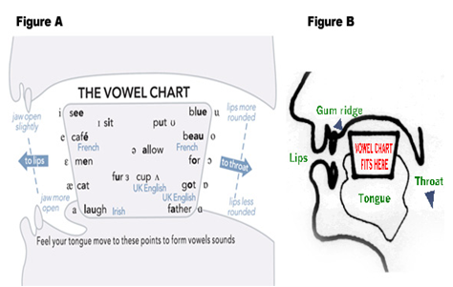

Below is a chart with a list of the sounds with some examples of familiar words
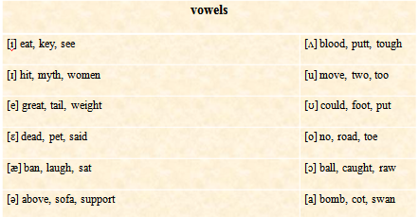

5th Lecture
Lecture Elements
The sound patterns of language
- Introduction
- Phonology
- Phonemes
- Phones and allophones
- Minimal pairs and sets
- Phonotactics
- Syllables and clusters
- Co-articulation effects
- Assimilation
- Elision
- Normal speech

Introduction
In the preceding chapter, we investigated the physical production of speech sounds in terms of the articulatory mechanisms of the human vocal tract. Every individual has a physically different vocal tract. Consequently, in purely physical terms, every individual will pronounce sounds differently. In addition, each individual will not pronounce the word “me” in a physically identical manner on every occasion. How do we manage consistently to recognize all those versions of me? The answer to that question is provided to a large extent by the study of phonology.

Phonology is the study of the systems and patterns of speech sounds in languages. Phonology is concerned with the abstract set of sounds in a language that allows us to distinguish meaning in the actual physical sounds we say and hear.

Phoneme is the smallest meaning-distinguishing sound unit in the abstract representation of the sounds of a language. An essential property of a phoneme is that it functions contrastively. If we substitute one sound for another in a word and there is a change of meaning, then the two sounds represent different phonemes.
The basic phonemes of English are listed in the consonant and vowel charts in lecture 4.

Phones and allophones
While the phoneme is the abstract unit or sound type (‘in the mind’), there are many different versions of that sound type regularly produced in actual speech (‘in the mouth’).We can describe those different versions as phones. Phones are phonetic units and appear in square brackets. A phone is a physically produced speech sound, representing one version of a phoneme

When we have a group of several phones, all of which are versions of one phoneme, we add the prefix ‘allo-’ (=one of a closely related set) and refer to them as allophones of that phoneme. An allophone is one of a closely related set of speech sounds or phones. For example, the [t] sound in the word tar is normally pronounced with a stronger puff of air (aspiration) than is present in the [t] sound in the word star.

Minimal pairs and sets
When two words such as “pat” and “bat” are identical in form except for a contrast in one phoneme, occurring in the same position, the two words are described as a minimal pair (fan–van, bet–bat, site–side).
When a group of words can be differentiated, each one from the others, by changing one phoneme (always in the same position in the word), then we have a minimal set (big, pig, rig, fig, dig, wig).

Phonotactics are constraints (restrictions) on the permissible combination of sounds in a language.
If we look at last minimal set, we can notice that it does not include forms such as lig or vig. According to the dictionary, these are not English words, but they could be viewed as possible English words.

It is, however, no accident that forms such as [fsɪg] or [rnɪg] do not exist or are unlikely ever to exist. They have been formed without obeying some constraints on the sequence or position of English phonemes. Such constraints are called the phonotactics (i.e. permitted arrangements of sounds) in a language and are obviously part of every speaker’s phonological knowledge.

Syllables and clusters
A syllable is a unit of sound consisting of a vowel (V) and optional consonant(s) (C) before or after the vowel.

Coda is the part of a syllable after the vowel.

Nucleus is the vowel in a syllable.

Onset is the part of the syllable before the vowel.

Rhyme is the part of the syllable containing the vowel plus any following consonant(s), also called “rime”

A consonant cluster is two or more consonants in sequence.

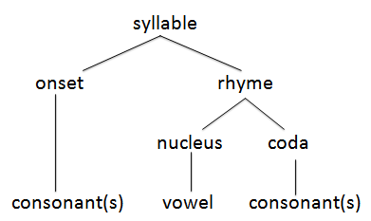
Co-articulation effects
Mostly our talk is fast and spontaneous, and it requires our articulators to move from one sound to the next without stopping. The process of making one sound almost at the same time as the next sound is called co-articulation. There are two well-known co-articulation effects, described as assimilation and elision.

Assimilation is the process whereby a feature of one sound becomes part of another during speech production. when we say words like pin and pan in everyday speech, the anticipation of forming the final nasal consonant will make it easier to go into the nasalized articulation in advance and consequently the vowel sounds in these words will be nasalized.
We may, for example, pronounce and as [ænd] by itself, but in the normal use of the phrase you and me, we usually say [ən], as in [yuənmi].

Elision is the process of leaving out a sound segment in the pronunciation of a word. In the last example, illustrating the normal pronunciation of you and me, the [d] sound of the word and was not included in the transcription. That’s because it isn’t usually pronounced in this phrase. In the environment of a preceding nasal [n] and a following nasal [m], we simply don’t devote speech energy to including the stop sound [d].

Normal speech :These two processes of assimilation and elision occur in everyone’s normal speech and should not be regarded as some type of carelessness or laziness in speaking. In fact, consistently avoiding the regular patterns of assimilation and elision used in a language would result in extremely artificial-sounding talk. The point of investigating these phonological processes is not to arrive at a set of rules about how a language should be pronounced, but to try to come to an understanding of the regularities and patterns which underlie the actual use of sounds in language.

6th Lecture
Lecture Elements
Words and word-formation processes
- Introduction
- Etymology
- Coinage
- Borrowing
- Compounding
- Blending
- Clipping
- Backformation
- Conversion
- Acronyms
- Derivation
- Prefixes and suffixes
- Infixes
- Multiple processes

Introduction
A lot of people use words in their first language without knowing that it is not originally part of their first language. People really had no difficulty coping with the new words. That is, they can very quickly understand a new word in their language (a neologism) and accept the use of different forms of that new word. This ability must derive in part from the fact that there is a lot of regularity in the word-formation processes in our language. In this lecture, we will explore some of the basic processes by which new words are created.

Etymology
The study of the origin and history of a word is known as its etymology, a term which, like many of our technical words, comes to us through Latin, but has its origins in Greek (´etymon ‘original form’ + logia ‘study of’), and is not to be confused with entomology, also from Greek (´entomon ‘insect’).
There are many ways in which new words can enter a language.

Many new words can cause objections as they come into use today, that is, people do not easily accept the use of new words at first and reject them. Instead of looking at these innovated words as an offense against language, it is better to see the constant evolution of new words and new uses of old words as a reassuring sign of vitality and creativeness in the way a language is shaped by the needs of its users.

Coinage
One of the least common processes of word formation in English is coinage, that is, the invention of totally new terms. The most typical sources are invented trade names for commercial products that become general terms (usually without capital letters) for any version of that product (e.g. kleenex, xerox).
New words based on the name of a person or a place are called eponyms (e.g. sandwich., jeans, fahrenheit)

Borrowing is the process of taking words from other languages. English language has adopted a vast number of words from other languages, including croissant (French), piano (Italian), sofa (Arabic). Other languages, of course, borrow terms from English, as in the Japanese use of suupaamaaketto (‘supermarket’) or the French discussing problems of le stress, during le weekend.

A special type of borrowing is described as loan translation or calque. In this process, there is a direct translation of the elements of a word into the borrowing language. Interesting examples are the French term gratte-ciel,which literally translates as ‘scrape-sky’, the Dutch wolkenkrabber (‘cloud scratcher’), the Arabic expression ناطحات السحاب ,or the German Wolkenkratzer (‘cloud scraper’), all of which were calques for the English skyscraper.

Compounding is the process of combining two (or more) words to form a new word. This combining process, technically known as compounding, is very common in languages such as German and English, but much less common in languages such as French, Arabic and Spanish.
In English, for example, we may find different types of compounding: Compound nouns (housewife, classroom), Compound adjectives (part-time, 20-year-old) and Compound verbs ( download, upgrade
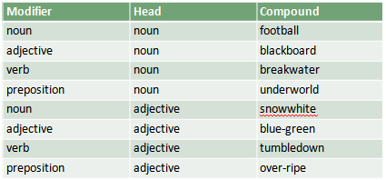
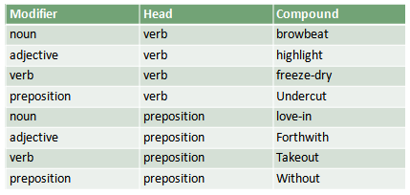

Blending is the process of combining the beginning of one word and the end of another word to form a new word (e.g. brunch from breakfast and lunch).

Most blends are formed by one of the following methods:
- The beginning of one word is added to the end of the other (e.g. breakfast + lunch = brunch, smoke + fog = smog).

2- The beginnings of two words are combined (e.g. cybernetic + organism = cyborg).

- Two words are blended around a common sequence of sounds (e.g. California + fornication = Californication, motor + hotel = motel).

- Multiple sounds from two component words are blended, while mostly preserving the sounds' order (e.g. slimy + lithe = slithy)

Clipping is the process of reducing a word of more than one syllable to a shorter form.
1- Back clipping retains the beginning of a word: ad (advertisement), doc (doctor), exam (examination), fax (facsimile), gas (gasoline), gym (gymnastics, gymnasium).
2- Fore-clipping retains the final part: chute (parachute), coon (raccoon), gator (alligator), phone (telephone), varsity (university).
- Middle clipping retains the middle of the word: flu (influenza), jams or jammies (pajamas / pyjamas ), tec (detective).

Backformation is the process of reducing a word such as a noun to a shorter version and using it as a new word such as a verb (e.g. burgle -19th century- is a back-formation from burglar -which is six centuries older- and sculpt -19th century- from sculptor -17th century).
Back-formation is different from clipping – back-formation may change the part of speech or the word's meaning, whereas clipping creates shortened words from longer words, but does not change the part of speech or the meaning of the word.

Conversion is the process of changing the function of a word, such as a noun to a verb, as a way of forming new words, also known as “category change” or “functional shift” (e.g. vacation in They’re vacationing in Florida).

- Conversion from noun to verb: bottle, butter, chair …
- Conversion from verb to noun: guess, must, spy …
- Conversion from phrasal verb to noun: print out, take over … → (a printout, a takeover).
- Conversion from verb to adjective: see through, stand up …
- Conversion from adjective to verb: empty, clean …
- Conversion from adjective to noun: crazy, nasty …
- Conversion from compound nouns to adjective : the ball park … → (a ball-park figure)
- Conversion from compound nouns to verb: carpool, microwave..
- Conversion from preposition to verb: up, down …

The conversion process is particularly productive in modern English, with new uses occurring frequently.
It is worth noting that some words can shift substantially in meaning when they change category through conversion.

- An acronym is a short form of a word, name or phrase formed from the first letters of the series of words.
- An abbreviation is also a condensed form of a word and an articulated form of the original word.
- An acronym is pronounced as a new word signifying some concept.
- An abbreviation is pronounced as the original word letter by letter.
Acronyms
An acronym is formed from the first letters of a series of words.
For example: AIDS; it is formed from the words Acquired Immune
Deficiency Syndrome whereas, an abbreviation may not include
only the first letter from the words.
For example: Dr.; it is formed
from Doctor. Another difference between an abbreviation and
acronym is that an acronym is pronounced as a word.
For example: NATO, it is formed from the word North Atlantic
Treaty
Organization, but is pronounced as a new word whereas an
abbreviation is pronounced as a separate letter.
For example: BBC; British Broadcasting Corporation. It is spoken
as B, B, C letter by letter.

Another difference between an abbreviation and an acronym is
that an abbreviation contains periods in between for example I.D,
Mr., I.Q etc. Whereas an acronym has no periods in between, it is
a short description.
All acronyms can be abbreviations, but all abbreviations cannot be
acronyms.

Derivation is the process of forming new words by adding affixes. It is the most common word formation process to be found in the production of new English words.
Some familiar examples are the elements un-, mis-, pre-, -ful, -less, -ish, -ism and -ness which appear in words like unhappy, misrepresent, prejudge, joyful, careless, boyish, terrorism and sadness.

Prefixes and suffixes
Looking more closely at the preceding group of words, we can see that some affixes have to be added to the beginning of the word (e.g. un-). These are called prefixes. Other affixes have to be added to the end of the word (e.g. -ish) and are called suffixes.

Infixes
There is a third type of affix, not normally used in English, but found in some other languages. This is called an infix and, as the term suggests, it is an affix that is incorporated inside another word.

Arabic is very well known using infixes.
عَلِمَ
أفعال : أعْلَمَ – عَلَّمَ – تَعَلَّمَ – تَعالَمَ - اسْتَعْلَمَ ...
أسماء مشتقة: عالِم – مَعْلُوم – علاّمة – مَعْلَمَة – عَلِيم ...
مصادر: إعْلام – تَعَلُّم – تَعْلِيم – اسْتِعْلام ...
Multiple processes
In the process of word formation, more than one of the techniques or processes mentioned earlier can be used to form a new word. Forms that begin as acronyms can also go through other processes, as in the use of lase as a verb, the result of backformation from laser.
Some of the formed words lasted for a long time and became part of the language, but others were resisted and disappeared after a period.

7th Lecture
Lecture Elements
Morphology
- Morphology
- Morphemes
- Free and bound morphemes
- Lexical and functional morphemes
- Derivational and inflectional morphemes
- Morphological description
- Problems in morphological description
- Morphs and allomorphs

Morphology
In many languages, what appear to be single forms actually turn out to contain a large number of ‘word-like’ elements. (the Swahili example in the text book will be replaced by an Arabic one). What seems to be one word in Arabic سَأُنقِذُكَ conveys what, in English, would have to be represented as something like I will rescue you.

Now, is the Arabic form a single word? If it is a ‘word’, then it seems to consist of a number of elements which, in English, turn up as separate ‘words’. A rough correspondence can be presented in the following way:
سَ– أُ – نِقذُ – كَ
will – I – save – you
The type of exercise we have just performed is an example of investigating basic forms in language, generally known as morphology.

The term morphology , which literally means ‘the study of forms’, was originally used in biology, but, since the middle of the nineteenth century, has also been used to describe the type of investigation that analyzes all those basic ‘elements’ used in a language. What we have been describing as ‘elements’ in the form of a linguistic message are technically known as ‘morphemes’.

Morphemes
The comparison we made between the Arabic utterance and its English equivalent made it clear that there are elements in what may seem only one entity. But we still can recognize that English word forms such as talks, talker, talked and talking must consist of one element talk, and a number of other elements such as -s, -er, -ed and -ing. All these elements are described as morphemes. The definition of a morpheme is “a minimal unit of meaning or grammatical function”.

Units of grammatical function include forms used to indicate past tense or plural, for example.
The word reopened consists of three morphemes. One minimal unit of meaning is open, another minimal unit of meaning is re- (meaning ‘again’) and a minimal unit of grammatical function is -ed (indicating past tense). The word tourists also contains three morphemes. There is one minimal unit of meaning tour, another minimal unit of meaning -ist (marking ‘person who does something’), and a minimal unit of grammatical function -s (indicating plural).

Free and bound morphemes
From these examples, we can make a broad distinction between two types of morphemes. There are free morphemes, that is, morphemes that can stand by themselves as single words, for example, open and tour. There are also bound morphemes, which are those forms that cannot normally stand alone and are typically attached to another form, exemplified as re-, -ist, -ed, -s.

all affixes (prefixes and suffixes) in English are bound morphemes. The free morphemes can generally be identified as the set of separate English word forms such as basic nouns, adjectives, verbs, etc. When they are used with bound morphemes attached, the basic word forms are technically known as stems. For example:

Un - dress - ed care - less -ness
Prefix stem suffix stem suffix suffix
(bound) (free) (bound) (free) (bound) (bound)

In words such as receive, reduce and repeat, we can identify the bound morpheme re- at the beginning, but the elements -ceive, -duce and -peat are not separate word forms and hence cannot be free morphemes. These types of forms are sometimes described as ‘bound stems’ to keep them distinct from ‘free stems’ such as dress and care.

Lexical and functional morphemes
There are two types of free morphemes. The first is that set of ordinary nouns, adjectives and verbs that we think of as the words that carry the ‘content’ of the messages we convey. These free morphemes are called lexical morphemes. The second is what is called functional morphemes. Examples are and, but, when, because, on, near, above, in, the, that, it, them.

This set consists largely of the functional words in the language such as conjunctions, prepositions, articles and pronouns. Because we almost never add new functional morphemes to the language, they are described as a ‘closed’ class of words.

Derivational and inflectional morphemes
The set of affixes that make up the category of bound morphemes can also be divided into two types. One type we have already considered in chapter 6 when we looked at the derivation of words. These are the derivational morphemes. We use these bound morphemes to make new words or to make words of a different grammatical category from the stem. For example, the addition of the derivational morpheme -ness changes the adjective good to the noun goodness, and the addition of the prefix re- changes the meaning of the word pay when added to it.

The second set of bound morphemes contains what are called inflectional morphemes. These are not used to produce new words in the language, but rather to indicate aspects of the grammatical function of a word. Inflectional morphemes are used to show if a word is plural or singular, if it is past tense or not, and if it is a comparative or possessive form.

English has only eight inflectional morphemes (or ‘inflections’), illustrated below:
Noun + -’s, -s : (teacher’s book / teachers)
Verb + -s, -ing, -ed, -en : (teaches / teaching / played / taken)
Adjective + -est, -er : (younger / youngest)

Morphological description
The difference between derivational and inflectional morphemes is worth emphasizing. An inflectional morpheme never changes the grammatical category of a word. For example, both old and older are adjectives. However, a derivational morpheme can change the grammatical category of a word. The verb teach becomes the noun teacher if we add the derivational morpheme -er.

So, the suffix -er in modern English can be an inflectional morpheme as part of an adjective and also a distinct derivational morpheme as part of a noun. Just because they look the same (-er) doesn’t mean they do the same kind of work

A useful way to remember all these different types of morphemes is in the following chart.

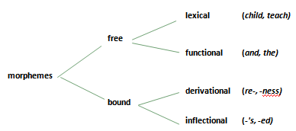

Problems in morphological description
The rather neat chart presented here hides a number of outstanding problems in the analysis of English morphology. So far, we have only considered examples of English words in which the different morphemes are easily identifiable as separate elements. The inflectional morpheme -s is added to car and we get the plural cars. What is the inflectional morpheme that makes sheep the plural of sheep, or men the
plural of man?

And if -al is the derivational suffix added to the stem institution to give us institutional, then can we take -al off the word legal to get the stem leg? Unfortunately, the answer is “No”.
It has been pointed out that an extremely large number of English words owe their morphological patterning to languages like Latin and Greek. Consequently, a full description of English morphology will have to take account of both historical influences and the effect of borrowed elements.

Morphs and allomorphs
Using some processes already noted in phonology (chapter 5: phones and allophones), we may treat differences in inflectional morphemes by proposing variation in morphological realization rules.
Just as we treated ‘phones’ as the actual phonetic realization of ‘phonemes’, so we can propose morphs as the actual forms used to realize morphemes.

For example, the form cars consists of two morphs, car + -s, realizing a lexical morpheme and an inflectional morpheme (‘plural’). The form buses also consists of two morphs (bus + -es), realizing a lexical morpheme and an inflectional morpheme (‘plural’). So there are at least two morphs (-s and -es) used to realize the inflectional morpheme ‘plural’. Just as we noted that there were ‘allophones’ of a particular phoneme, so we can recognize the existence of allomorphs of a particular morpheme.

Take the morpheme ‘plural’. Note that it can be attached to a number of lexical morphemes to produce structures like ‘cat + plural’, ‘bus + plural’ ‘sheep + plural’ and ‘man + plural’. In each of these examples, the actual forms of the morphs that result from the morpheme ‘plural’ are different. Yet they are all allomorphs of the one morpheme. So, in addition to -s and -es, another allomorph of ‘plural’ in English seems to be a zero-morph because the plural form of sheep is actually ‘sheep + Ø’. When we look at ‘man + plural’, we have a vowel change in the word (æ → ε) as the morph that produces the so-called ‘irregular’ plural form men.

8th Lecture

Lecture Elements
Phrases and sentences: grammar
- Introduction
- Grammar
- Traditional grammar
- The parts of speech
- Agreement
- Grammatical gender
- Traditional analysis
- The prescriptive approach
- Captain Kirk’s infinitive
- The descriptive approach
- Structural analysis
- Immediate constituent analysis
- Labeled and bracketed sentences

Introduction
We have already considered two levels of description used in the study of language. We have described linguistic expressions as sequences of sounds that can be represented in the phonetic alphabet and described in terms of their features.

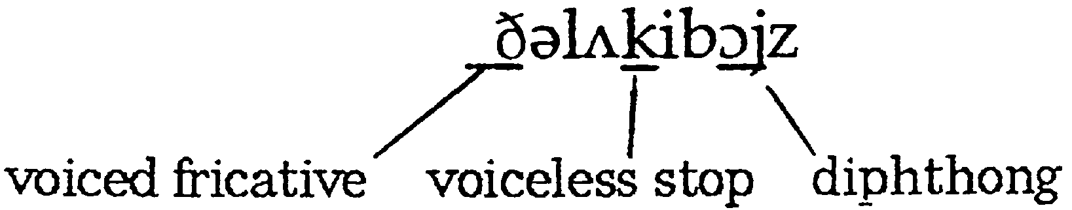

We can take the same expression and describe it as a sequence of morphemes.
The luck -y boy -s
functional lexical derivational lexical inflectional

Grammar
With these descriptions, we could characterize all the words and phrases of a language in terms of their phonology and morphology.
However, we have not accounted for the fact that these words can only be combined in a limited number of patterns.
The English phrase the lucky boys is well-formed, while the two following phrases ∗boys the lucky ∗lucky boys the are not.
(We use an asterisk ∗ to indicate that a form is unacceptable or ungrammatical.)

The process of describing the structure of phrases and sentences in such away that we account for all the grammatical sequences in a language and rule out all the ungrammatical sequences is one way of defining grammar.

Traditional grammar is the description of the structure of phrases and sentences based on established categories used in the analysis of Latin and Greek. Since there were well-established grammatical descriptions of these languages, it seemed appropriate to adopt the existing categories from these descriptions and apply them in the analysis of ‘newer’ languages such as English.

The parts of speech
The technical terms used to describe each part of speech are illustrated in the following sentence and simple definitions of each term are listed below.

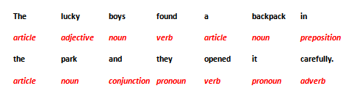

Noun (N): a word such as boy, bicycle or freedom used to describe a person, thing or idea.

Article (Art): a word such as a, an or the used with a noun.

Adjective (Adj): a word such as happy or strange used with a noun to provide more information.

Verb (V): a word such as go, drown or know used to describe an action, event or state.

Adverb (Adv): a word such as slowly or really used with a verb or adjective to provide more information

Preposition (Prep): a word such as in or with used with a noun phrase.

Pronoun (Pro): a word such as it or them used in place of a noun or noun phrase.

Conjunction: a word such as and or because used to make connections between words, phrases and sentences

Interjections are words that show emotion. They are not grammatically related to the rest of the sentence (Wow/Oh/Uh-oh).

Agreement: the grammatical connection between two parts of a sentence, as in the connection between a subject (Cathy) and the form of a verb (loves chocolate).
Agreement can be dealt with in terms of number (singular or plural), person (1st, 2nd, or 3rd person), tense, active or passive voice, or gender (male, female, or neuter).

grammatical gender.
The type of biological distinction used in English is quite different from the more common distinction found in languages that use grammatical gender. Whereas natural gender is based on sex (male and female), grammatical gender is based on the type of noun (masculine and feminine) and is not tied to sex. In this latter sense, nouns are classified according to their gender class and, typically, articles and adjectives have different forms to ‘agree with’ the gender of the noun.

Traditional analysis / grammar: the description of the structure of phrases and sentences based on established categories used in the analysis of Latin and Greek. Such is the case of describing the way to conjugate the verb love comparing Latin and English languages (p. 77).

The Prescriptive approach: an approach to grammar that has rules for the proper use of the language, traditionally based on Latin grammar, in contrast to the descriptive approach. It is one thing to adopt the grammatical labels (e.g. ‘noun’, ‘verb’) to categorize words in English sentences; it is quite another thing to go on to claim that the structure of English sentences should be like the structure of sentences in Latin.

This view of grammar as a set of rules for the ‘proper’ use of a language is still to be found today and may be best characterized as the prescriptive approach. Some familiar examples of prescriptive rules for English sentences are:
- You must not split an infinitive.
- You must not end a sentence with a preposition.

Captain Kirk’s infinitive
The infinitive in English has the form to + the base form of the verb, as in to go, and can be used with an adverb such as boldly. At the beginning of each televised Star Trek episode, one of the main characters, Captain Kirk, always used the expression To boldly go. . . . This is an example of a split infinitive. Captain Kirk’s teacher might have expected him to say To go boldly or Boldly to go, so that the adverb didn’t split the infinitive.

The descriptive approach: an approach to grammar that is based on a description of the structures actually used in a language, not what should be used, in contrast to the prescriptive approach. Two famous approaches are:
- structural analysis
- immediate constituent analysis = labeled and bracketed sentences

Structural analysis: the investigation of the distribution of grammatical forms in a language. The method involves the use of ‘test-frames’ that can be sentences with empty slots in them. For example:
The ----------------- makes a lot of noise.
I heard a ----------------- yesterday.
There are a lot of forms that can fit into these slots to produce good grammatical sentences of English (e.g. car, child, donkey, dog, radio).

As a result, we can propose that because all these forms fit in the same test-frame, they are likely to be examples of the same grammatical category. The label we give to this grammatical category is, of course, ‘noun’.

Immediate constituent analysis

Constituent analysis: a grammatical analysis of how small constituents (or components) go together to form larger constituents in sentences. One basic step is determining how words go together to form phrases. In the following sentence, we can identify eight constituents at the word level: Her father brought a shotgun to the wedding.

her father / a shotgun / the wedding = noun phrases.
to the wedding = a prepositional phrase.
brought a shotgun = a verb phrase.

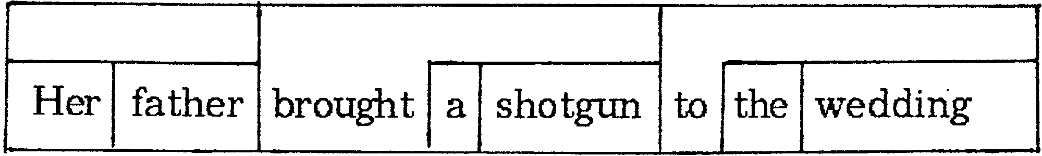

Labeled and bracketed sentences: a type of analysis in which constituents in a sentence are marked off by brackets with labels describing each type of constituent

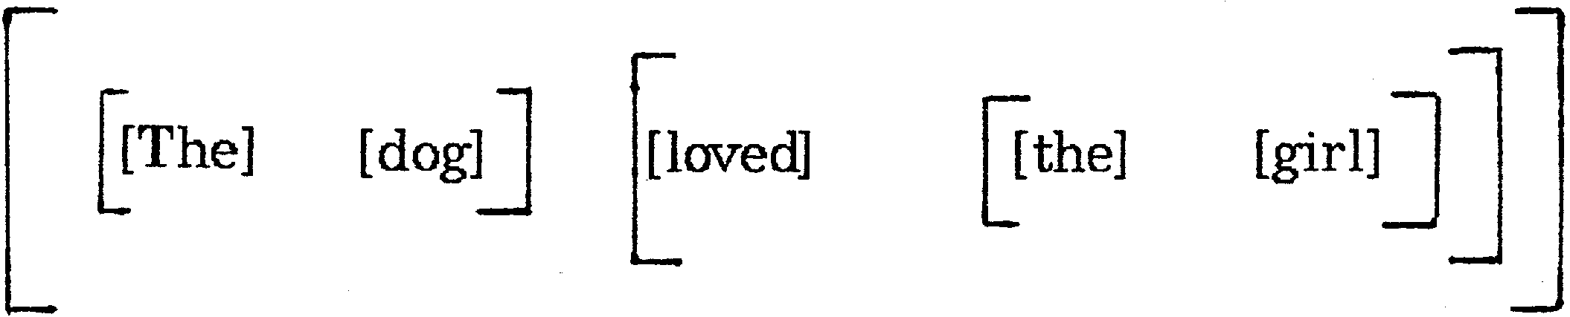

We can then label each constituent using abbreviated grammatical terms such as ‘Art’ (= article), ‘N’ (= noun), ‘NP’ (= noun phrase), ‘V’ (= verb), ‘VP’ (= verb phrase) and ‘S’ (= sentence).

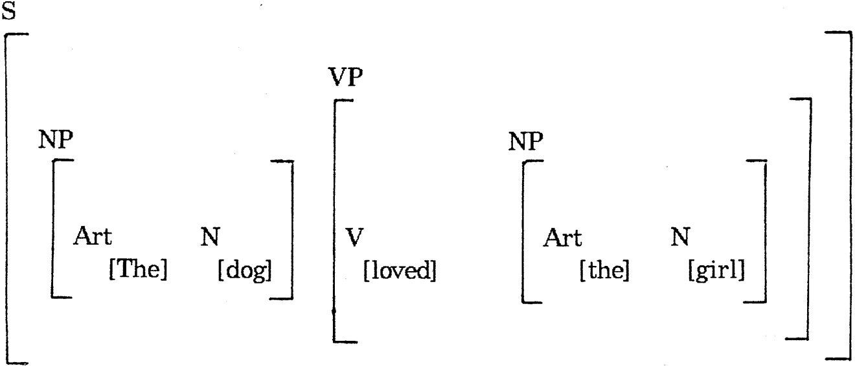

9th Lecture
- Lecture Elements
Syntax
- Introduction
- Generative grammar
- Syntactic structures
- Deep and surface structure
- Structural ambiguity
- Recursion
- Symbols used in syntactic description
- Tree diagrams
- Phrase structure rules
- Lexical rules
- Back to recursion
- Complement phrases
- Transformational rules
Introduction
In the preceding chapter, we moved from the general categories and concepts of traditional grammar to more specific methods of describing the structure of phrases and sentences. When we concentrate on the structure and ordering of components within a sentence, we are studying the syntax of a language.
Generative grammar
Inspired by the original work of Noam Chomsky, linguists have attempted to produce a particular type of grammar that has a very explicit system of rules specifying what combinations of basic elements would result in well-formed sentences. This very explicit system of rules, it was proposed, would have a lot in common with the types of rules found in mathematics.
If we consider the following operation 1 + 1 = 2
The result of this operation is definite ( cannot be changed)
But if we consider the following equation
3x + 2y = z
The result ‘z’ in infinite because each time we change the value of ‘x’ and/or ‘y’, the value of ‘z’ will change.
Starting from this comparison with mathematic rules, linguists tried to create grammatical rules by which we can produces an infinite set of sentences. Such a set of explicit rules is a generative grammar.
Syntactic structures
A generative grammar defines the syntactic structures of a language. The grammar will generate all the well-formed syntactic structures (e.g. sentences) of the language and will not generate any ill-formed structures. This has been called the ‘all and only’ criterion, that is, all the grammatical sentences and only the grammatical sentences will be produced. The grammar will have a finite (i.e. limited) number of rules, but will be capable of generating an infinite number of well-formed structures.
Deep and surface structure
Surface structure: the structure of individual sentences after the application of movement rules to deep structure (form).
Deep structure: the underlying structure of sentences as represented by phrase structure rules (meaning).
If we consider the following pair of sentences:
Charlie broke the window.
The window was broken by Charlie.
In traditional grammar, the first is called an active sentence, focusing on what Charlie did, and the second is a passive sentence, focusing on The window and what happened to it. The distinction between them is a difference in their surface structure, that is, the different syntactic forms they have as individual English sentences. This other ‘underlying’ level, where the basic components (noun phrase + verb + noun phrase) shared by the two sentences can be represented, is called their deep structure.
Structural ambiguity
Structural ambiguity: a situation in which a single phrase or sentence has two (or more) different underlying structures and interpretations.
Let’s say we had two distinct deep structures. One expresses the idea that ‘Annie had an umbrella and she whacked a man with it.’ The other expresses the idea that ‘Annie whacked a man and the man happened to be carrying an umbrella.’ Now, these two different versions of events can actually be expressed in the same surface structure form:
Annie whacked a man with an umbrella. This sentence provides an example of structural ambiguity.
Phrases can also be structurally ambiguous, as in expressions like small boys and girls. The underlying interpretation can be either ‘small boys and (small) girls’ or ‘small boys and (all) girls’. The grammar will have to be capable of showing the structural distinction between these underlying representations.
Recursion
Recursion: the repeated application of a rule in generating structures. Recursive (‘repeatable any number of times’) rules have the capacity to be applied more than once in generating a structure.
E.g. The gun was on the table near the window in the bedroom.
The rule that creates a prepositional phrase can be repeated over and over again.
The same procedure can be used on sentence level.

Symbols used in syntactic description
Symbol | Means | Symbol | Means
S | sentence | N | noun
PN | proper noun | V | verb
Art | Article | Adv | adverb
NP | noun phrase | VP | verb phrase
* | Ungrammatical sequence | Pro | pronoun
→ | consists of / rewrites as | Adj | adjective
( ) | optional constituent | Prep | preposition
{ } | Only one of these constituents | PP | prepositional phrase

NP → Art N This is simply a shorthand way of saying that a noun phrase (NP) such as the dog consists of or rewrites as (→) an article (Art) the and a noun (N) dog.
NP → Art (Adj) N: here we understand that the (Adj) is optional.
NP → Art N Art
NP → Pro NP → N NP → {Art N, Pro, PN}
NP →PN Pro
PN

Tree diagrams
In chapter 8,we looked at ways to describe the structure of sentences by first concentrating on the linear sequence of constituents, then noting how our diagrams could capture some aspects of the hierarchical organization of those structures. To create a more explicit representation of the hierarchical organization of one structure, shown in a labeled and bracketed format on the left below, we can use a tree diagram, shown on the right below.
NP NP
Art N
The girl Art N

The girl

Although this kind of ‘tree’, with its ‘branches’, shown on the right, seems to grow down rather than up, it functions rather well as a diagram representing all the grammatical information found in the other analysis on the left. It also shows very explicitly that there are different levels in the analysis.
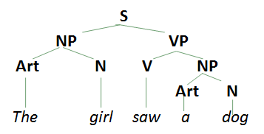

Phrase structure rules
Phrase structure rules: rules stating that the structure of a phrase of a specific type consists of one or more constituents in a particular order.
S →NP VP “a sentence rewrites as a noun phrase and a verb phrase”.
NP →{Art (Adj) N, Pro, PN} “a noun phrase rewrites as either an article, an optional adjective and a noun or a pronoun or a proper noun”.
VP →V NP (PP) (Adv)
PP →Prep NP
Lexical rules
Lexical rules: rules stating which words can be used for constituents generated by phrase structure rules.
PN →{Mary, George} V →{followed, helped, saw}
N →{girl, dog, boy} Adj →{small, crazy}
Art→{a, the} Prep→{near, with}
Pro→{it, you} Adv →{recently, yesterday}

Back to recursion
As we did earlier with the repetition of the prepositional phrase, e.g. The gun was on the table near the window in the bedroom, we can do the same with sentences.
Mary helped George.
Cathy knew that Mary helped George.
John believed that Cathy knew that Mary helped George.
After verbs such as believe and know, as in these examples, the word that introduces a ‘complement phrase’.

Complement phrases
Complement phrase (CP): a structure such as that Mary helped George used to complete a construction beginning with a structure such as Cathy knew.
The word that, as used in these examples, is called a complementizer (C). The role of that as a complementizer is to introduce a complement phrase (CP).
So, we are now in a position to define a CP in the following way: “a complement phrase rewrites as a complementizer and a sentence”, or CP→C S.
We can also see from the same sentence that the complement phrase (CP) comes after a verb (V) knew. This means that we are using the CP as part of a verb phrase (VP), as in knew that Mary helped George. So, there must be another rule that says: “a verb phrase rewrites as a verb and complement phrase”, or VP→V CP.
If we now look at these two new rules in conjunction with an earlier rule, we can see how recursion is built into the grammar. S →NP VP VP →V CP CP →C S

Transformational rules
Transformational rules: rules that are used to change or move constituents in structures derived from phrase structure rules. Let’s consider the following examples: Mary saw George recently. / Recently Mary saw George
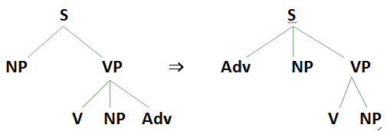

As shown in the earlier slide, we use the symbol ⇒ to indicate that a transformational rule is being used to derive a new structure from the basic structure.
There are many more rules and concepts involved in the analysis of syntax. (We’ve barely scratched the surface structures.) However, having explored some of the basic issues and methods of syntactic analysis in order to talk about ‘structure’ in language, we must move on to consider how we might incorporate the analysis of ‘meaning’ in the study of language.

10th Lecture
Semantics

Lecture Elements
- Introduction
- Conceptual and associative meaning
- Semantic features
- Semantic roles
- Agent and theme
- Instrument and experiencer
- Location, source and goal
- Lexical relations
- Synonymy
- Antonymy
- Hyponymy
- Prototypes
- Homophones and homonyms
- Polysemy
- Metonymy
- Collocation

Introduction
Semantics is the study of the meaning of words, phrases and sentences. Linguistic semantics deals with the conventional meaning conveyed by the use of words, phrases and sentences of a language.
E.g. Fire Department (not Extinguishing Department) or
pain pills (not relief pills).

Conceptual and associative meaning
Conceptual meaning is the basic components of meaning conveyed by the literal use of words.
Associative meaning is the type of meaning that people might connect with the use of words (e.g. needle = “painful”) that is not part of conceptual meaning. Poets, novelists, advertisers and lovers may be very interested in using words in such a way that certain associative meanings are evoked and literary critics often write about this aspect of language use.

Semantic features

NP V NP
The hamburger ate the boy

This sentence is syntactically good, but semantically odd. The components of the conceptual meaning of the noun hamburger must be significantly different from those of the noun boy, thereby preventing one, and not the other, from being used as the subject of the verb ate. The kind of noun that can be the subject of the verb ate must denote an entity that is capable of ‘eating’. The noun hamburger does not have this property and the noun boy does.

This simple example is an illustration of a procedure for analyzing meaning in terms of semantic features. Features such as ‘+animate,−animate’; ‘+human, −human’, ‘+female, −female’, for example, can be treated as the basic elements involved in differentiating the meaning of each word in a language from every other word.
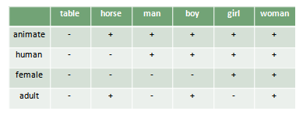
It may not be as easy to come up with neat components of meaning. If we try to think of the components or features we would use to differentiate the nouns advice, threat and warning, for example, we may not be very successful.
Part of the problem seems to be that the approach involves a view of words in a language as some sort of ‘containers’ that carry meaning components.

Instead of thinking of words as ‘containers’ of meaning, we can look at the ‘roles’ they fulfill within the situation described by a sentence. If the situation is a simple event, as in The boy kicked the ball, then the verb describes an action (kick). The noun phrases in the sentence describe the roles of entities, such as people and things, involved in the action. We can identify a small number of semantic roles (also called ‘thematic roles’) for these noun phrases.

Agent is the semantic role of the noun phrase identifying the one who performs the action of the verb in an event (The boy kicked the ball)

Theme is the semantic role of the noun phrase used to identify the entity involved in or affected by the action of the verb in an event (e.g. The boy kicked the ball)

Instrument and experiencer
Instrument is the semantic role of the noun phrase identifying the entity that is used to perform the action of the verb (e.g. The boy cut the rope with a razor)

Experiencer is the semantic role of the noun phrase identifying the entity that has the feeling, perception or state described by the verb (e.g. The boy feels sad)
Location, source and goal
Location is the semantic role of the noun phrase identifying where an entity is (e.g. The boy is sitting in the classroom)
Source is the semantic role of the noun phrase identifying where an entity moves from (e.g. The boy ran from the house)

Goal is the semantic role of the noun phrase identifying where an entity moves to (e.g. The boy walked to the window)

Lexical relations
Not only can words be treated as ‘containers’ of meaning, or as fulfilling ‘roles’ in events, they can also have ‘relationships’ with each other. If we give the meaning of “shallow” as “the opposite of deep”, or the meaning of “daffodil” as “a kind of flower”, or the meaning of “big” as “the same as huge”, we are characterizing the meaning of each word in terms of its relationship to other words.

Synonymy is the lexical relation in which two or more words have very closely related meanings (e.g. “Conceal” is a synonym of “hide”). We should keep in mind that the idea of ‘sameness’ of meaning used in discussing synonymy is not necessarily ‘total sameness’. (purchase: formal / buy informal)

Antonymy is the lexical relation in which words have opposite meanings (“Shallow” is an antonym of “deep”).
Antonyms are usually divided into two main types, ‘gradable’ (opposites along a scale) and ‘non-gradable’ (direct opposites). Gradable antonyms, such as the pair big/small, can be used in comparative constructions like I’m bigger than you. Also, the negative of one member of a gradable pair does not necessarily imply the other. For example, the sentence My car isn’t old, doesn’t necessarily mean My car is new.
With non-gradable antonyms (also called ‘complementary pairs’), comparative constructions are not normally used. We don’t typically describe someone as ‘deader’ or ‘more dead’ than another. Also, the negative of one member of a non-gradable pair does imply the other member. That is, “My grandparents aren’t alive does indeed mean My grandparents are dead”.

Reversives are antonyms in which the meaning of one is the reverse action of the other(e.g. dress/undress, enter/exit, pack/unpack, lengthen/shorten, raise/lower, tie/untie)

Hyponymy is the lexical relation in which the meaning of one word is included in the meaning of another (e.g. “Daffodil” is a hyponym of “flower”).
When we consider hyponymous connections, we are essentially looking at the meaning of words in some type of hierarchical relationship.

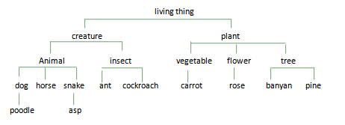

Looking at the diagram, we can say that “horse is a hyponym of animal” or “cockroach is a hyponym of insect”. In these two examples, animal and insect are called the superordinate (= higher level) terms. We can also say that two or more words that share the same superordinate term are co-hyponyms. So, dog and horse are co-hyponyms and the superordinate term is animal.
Prototypes
Prototype is the most characteristic instance of a category (e.g. “Robin” is the prototype of “bird”).
While the words canary, cormorant, dove, duck, flamingo, parrot, pelican and robin are all equally co-hyponyms of the superordinate bird, they are not all considered to be equally good examples of the category ‘bird’. According to some researchers, the most characteristic instance of the category ‘bird’ is robin. The idea of ‘the characteristic instance’ of a category is known as the prototype.

The concept of a prototype helps explain the meaning of certain words, like bird, not in terms of component features (e.g. ‘has feathers’, ‘has wings’), but in terms of resemblance to the clearest example. Thus, even native speakers of English might wonder if ostrich or penguin should be hyponyms of bird (technically they are), but have no trouble deciding about sparrow or pigeon. These last two are much closer to the prototype.

Homophones and homonyms
Homophones are two or more words with different forms and the same pronunciation (e.g. to–too–two).

Homonyms are two words with the same form that are unrelated in meaning (e.g. bank (of a river) – bank (financial institution)).

Polysemy is a word having two or more related meanings (e.g. foot, of person, of bed, of mountain).
If we aren’t sure whether different uses of a single word are examples of homonymy or polysemy, we can check in a dictionary. If the word has multiple meanings (i.e. it’s polysemous), then there will be a single entry, with a numbered list of the different meanings of that word. If two words are treated as homonyms, they will typically have two separate entries.

Metonymy is a word used in place of another with which it is closely connected in everyday experience (e.g. He drank the whole bottle (= the liquid)).
That close connection can be based on a container–contents relation (bottle/water, can/juice), a whole–part relation (car/wheels, house/roof) or a representative–symbol relationship (king/crown, the President/the White House). Using one of these words to refer to the other is an example of metonymy.

Collocation is a relationship between words that frequently occur together (e.g. salt and pepper). One way we seem to organize our knowledge of words is simply on the basis of collocation, or frequently occurring together.

11th Lecture
Language and the brain
Lecture Elements
- Introduction
- Neurolinguistics
- Parts of the brain
- Broca’s area
- Wernicke’s area
- The motor cortex and the arcuate fasciculus
- The localization view
- The tip of the tongue phenomenon
- Slips of the tongue
- Slips of the ear
- Aphasia
- Broca’s aphasia
- Wernicke’s aphasia
- Conduction aphasia
- Dichotic listening
- The critical period
- Genie

Introduction
In the preceding chapters we have reviewed in some detail the various features of language that people use to produce and understand linguistic messages. Where is this ability to use language located? The obvious answer is ‘in the brain’. However, it can’t be just anywhere in the brain.

Neurolinguistics
The study of the relationship between language and the brain is called neurolinguistics. Although this is a relatively recent term, the field of study dates back to the nineteenth century. Establishing the location of language in the brain was an early challenge, but one event incidentally provided a clue.
Because of an accident , a patient suffered from a damage in the front part of his brain, but his language abilities were unaffected. This leads to conclude that while language may be located in the brain, it clearly is not situated right at the front.

Parts of the brain
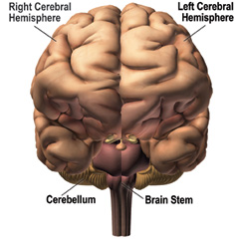
Since that time, a number of discoveries have been made about the specific parts in the brain that are related to language functions. We now know that the most important parts are in areas above the left ear.
- The brain stem (connecting the brain to the spinal cord).
- The corpus callosum (connecting the two hemispheres).
- The two hemispheres (right and left).

Broca’s area
Wernicke’s area
The motor cortex
The arcuate fasciculus

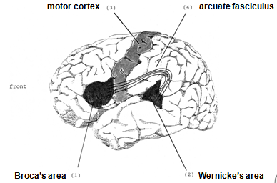

Broca’s area
The part shown as (1) in the illustration is technically described as the ‘anterior speech cortex’ or, more usually, as Broca’s area. Named after Paul Broca, a French surgeon, who reported in the 1860s that damage to this specific part of the brain was related to extreme difficulty in producing speech. So Broca’s area is crucially involved in the production of speech.

Wernicke’s area
The part shown as (2) in the illustration is the ‘posterior speech cortex’, or Wernicke’s area. Carl Wernicke was a German doctor who, in the 1870s, reported that damage to this part of the brain was found among patients who had speech comprehension difficulties. So Wernicke’s area is crucially involved in the understanding of speech.

The motor cortex and the arcuate fasciculus
The part shown as (3) in the illustration is the motor cortex, an area that generally controls movement of the muscles (for moving hands, feet, arms, etc.). Close to Broca’s area is the part of the motor cortex that controls the articulatory muscles of the face, jaw, tongue and larynx. Evidence that this area is involved in the physical articulation of speech comes from work reported in the 1950s by two neurosurgeons, Penfield and Roberts (1959).

The part shown as (4) in the illustration is a bundle of nerve fibers called the arcuate fasciculus. This was also one of Wernicke’s discoveries and is now known to form a crucial connection between Wernicke’s and Broca’s areas.

The localization view
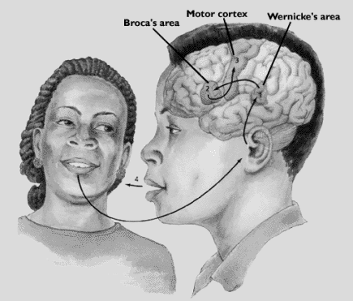

Specific aspects of language ability can be accorded specific locations in the brain. This is called the localization view and it has been used to suggest that the brain activity involved in hearing a word, understanding it, then saying it, would follow a definite pattern. The word is heard and comprehended via Wernicke’s area. This signal is then transferred via the arcuate fasciculus to Broca’s area where preparations are made to produce it. A signal is then sent to part of the motor cortex to physically articulate the word.
This is certainly an oversimplified version of what may actually take place, but it is consistent with much of what we understand about simple language processing in the brain. we are forced to use metaphors mainly because we cannot obtain direct physical evidence of linguistic processes in the brain. Because we have no direct access, we generally have to rely on what we can discover through indirect methods. Most of these methods involve attempts to work out how the system is working from clues picked up when the system has problems or malfunctions.

The tip of the tongue phenomenon
Minor production difficulties of this sort may provide possible clues to how our linguistic knowledge is organized within the brain. In the tip of the tongue phenomenon, we feel that some word is just eluding us, that we know the word, but it just won’t come to the surface. When we make mistakes in this retrieval process, there are often strong phonological similarities between the target word we’re trying to say and the mistake we actually produce, e.g., (distinguisher/extinguisher) and (medication/meditation).
Mistakes of this type are sometimes referred to as malapropisms.

Slips of the tongue
Another type of speech error is commonly described as a slip of the tongue. This produces expressions such as ‘a long shory stort’ (story short), ‘use the door to open the key’ (the key to open the door) , and ‘a fifty-pound dog of bag food’ (bag of dog food ).
Slips of this type are sometimes called spoonerisms after William Spooner.

Slips of the ear
Slip of the ear is a processing error in which one word or phrase is heard as another, as in hearing ‘great ape’ when the utterance was “gray tape”. It may also be the case that some malapropisms (e.g. medication/meditation) originate as slips of the ear.
However, some problems with language production and comprehension are the result of much more serious disorders in brain function.

Aphasia is defined as an impairment of language function due to localized brain damage that leads to difficulty in understanding and/or producing linguistic forms.
The most common cause of aphasia is a stroke (when a blood vessel in the brain is blocked or bursts), though traumatic head injuries from violence or an accident may have similar effects. Those effects can range from mild to severe reduction in the ability to use language.

Broca’s aphasia (also called ‘motor aphasia’) is a language disorder in which speech production is typically reduced, distorted, slow and missing grammatical markers. The frequent omission of functional morphemes (e.g. articles, prepositions) and inflections (e.g. plural -s, past tense -ed) has led to the characterization of this type of aphasic speech as ‘agrammatic’. In agrammatic speech, the grammatical markers are missing. In Broca’s aphasia, comprehension is typically much better than production.

Wernicke’s aphasia.
The type of language disorder that results in difficulties in auditory comprehension is sometimes called ‘sensory aphasia’, but is more commonly known as Wernicke’s aphasia. Someone suffering from this disorder can actually produce very fluent speech which is, however, often difficult to make sense of.
Difficulty in finding the correct word, sometimes referred to as anomia, also happens in Wernicke’s aphasia.

Conduction aphasia is a language disorder associated with damage to the arcuate fasciculus in which repeating words or phrases is difficult. Individuals suffering from this disorder sometimes mispronounce words, but typically do not have articulation problems. They are fluent, but may have disrupted rhythm because of pauses and hesitations. Comprehension of spoken words is normally good. However, the task of repeating a word or phrase (spoken by someone else) creates major difficulty.

Language disorders of the type we have described are almost always the result of injury to the left hemisphere. This left hemisphere dominance for language has also been demonstrated by another approach to the investigation of language and the brain.

Dichotic listening

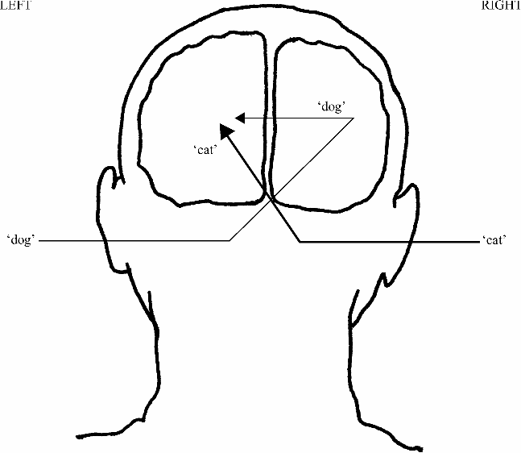

An experimental technique that has demonstrated a left hemisphere dominance for syllable and word processing is called the dichotic listening test. This technique uses the generally established fact that anything experienced on the right-hand side of the body is processed in the left hemisphere, and anything on the left side is processed in the right hemisphere. So, a basic assumption would be that a signal coming in the right ear will go to the left hemisphere and a signal coming in the left ear will go to the right hemisphere.

In this process, the language signal received through the left ear is first sent to the right hemisphere and then has to be sent to the left hemisphere (language center) for processing. This non-direct route takes longer than a linguistic signal received through the right ear and going directly to the left hemisphere. First signal to get processed wins.

The critical period
The apparent specialization of the left hemisphere for language is usually described in terms of lateral dominance or lateralization (one-sidedness). it is generally thought that the lateralization process begins in early childhood. It coincides with the period during which language acquisition takes place. During childhood, there is a period when the human brain is most ready to receive input and learn a particular language. This is known as the critical period.

Though some think it may start earlier, the general view is that the critical period for first language acquisition lasts from birth until puberty. If a child does not acquire language during this period, for any one of a number of reasons, then he or she will find it almost impossible to learn language later on.

Genie
A girl discovered in 1970 at age 13 who had not acquired her first language.
Spent her life in a state of physical, sensory, social, and emotional deprivation.
Unable to speak
Started to imitate sounds, but couldn’t produce grammatically complex speech.
She was using the right hemisphere: in dichotic listening, she showed ‘left ear advantage’

12th Lecture
First language acquisition

Lecture Elements
- Basic requirements
- The acquisition schedule
- Caregiver speech
- Cooing and babbling
- The one-word stage
- The two-word stage
- Telegraphic speech
- The acquisition process
- Developing morphology
- Developing syntax
- Forming questions
- Forming negatives
- Developing semantics

Basic requirements
During the first two or three years of development, a child requires interaction with other language-users in order to bring this general language capacity into operation with a particular language. A child who does not hear or is not allowed to use language will learn no language (Genie).
The crucial requirement appears to be the opportunity to interact with others via language.

Basic requirements
All normal children develop language at roughly the same time, along much the same schedule. Language acquisition schedule has the same basis as the biologically determined development of motor skills. This biological schedule is tied very much to the maturation of the infant’s brain.
We could think of the child as having the biological capacity to cope with distinguishing certain aspects of linguistic ‘input’ at different stages during the early years of life.

What this acquisition capacity then requires is a sufficiently constant type of ‘input’ from which the basis of the regularities in a particular language can be worked out. In this view, young children are seen as actively acquiring the language by identifying the regularities in what is heard and then applying those regularities in what they say.

Caregiver speech
Under normal circumstances, human infants are certainly helped in their language acquisition by the typical behavior of older children and adults in the home environment. The characteristically simplified speech style adopted by someone who spends a lot of time interacting with a young child is called caregiver speech.
Salient features of this type of speech (also called ‘motherese’ or ‘child-directed speech’) are the frequent use of questions, often using exaggerated intonation, extra loudness and a slower tempo with longer pauses.

Cooing and babbling
The earliest use of speech-like sounds has been described as cooing. During the first few months of life, the child gradually becomes capable of producing sequences of vowel-like sounds, particularly high vowels similar to [i] and [u]. By four months of age, the infant creates sounds similar to the velar consonants [k] and [g], hence the common description as ‘cooing’ or ‘gooing’ for this type of production. By the time they are five months old, babies can already hear the difference between the vowels [i] and [a] and discriminate between syllables like [ba] and [ga].
Between six and eight months, the child produces a number of different vowels and consonants, as well as combinations such as ba-ba-ba and ga-ga-ga. This type of sound production is described as babbling. Around nine to ten months, there are recognizable intonation patterns to the consonant and vowel combinations being produced, as well as variation in the combinations such as ba-ba-da-da. Nasal sounds also become more common and certain syllable sequences such as ma-ma-ma and da-dada are produced.

During the tenth and eleventh months, more complex syllable combinations (ma-da-ga-ba), a lot of sound play and attempted imitations. This ‘pre-language’ use of sound provides the child with some experience of the social role of speech because adults tend to react to the babbling, however incoherent, as if it is actually the child’s contribution to social interaction.

The one-word stage
Between twelve and eighteen months, children begin to produce a variety of recognizable single-unit utterances. This period, traditionally called the one word stage, is characterized by speech in which single terms are uttered for everyday objects such as ‘milk’, ‘cookie’, ‘cat’, ‘cup’ and ‘spoon’ (usually pronounced [pun]). Other forms such as [ʌsæ’] may occur in circumstances that suggest the child is producing a version of What’s that, so the label ‘one-word’ for this stage may be misleading and a term such as ‘single-unit’ would be more accurate.

We sometimes use the term holophrastic (meaning a single form functioning as a phrase or sentence) to describe an utterance that could be analyzed as a word, a phrase, or a sentence.

The two-word stage
Depending on what we count as an occurrence of two distinct words used together, the two-word stage can begin around eighteen to twenty months, as the child’s vocabulary moves beyond fifty words. By the time the child is two years old, a variety of combinations, similar to baby chair, mommy eat, cat bad, will usually have appeared. The adult interpretation of such combinations is, of course, very much tied to the context of their utterance.
By the age of two, whether the child is producing 200 or 300 distinct ‘words’, he or she will be capable of understanding five times as many.

Telegraphic speech
Between two and two-and-a-half years old, the child begins producing a large number of utterances that could be classified as ‘multiple-word’ speech. This is telegraphic speech which is characterized by strings of words (lexical morphemes) in phrases or sentences such as this shoe all wet, cat drink milk and daddy go bye-bye. The child has clearly developed some sentence-building capacity by this stage and can get the word order correct.

By the age of two-and-a-half years, the child’s vocabulary is expanding rapidly and the child is initiating more talk. By three, the vocabulary has grown to hundreds of words and pronunciation has become closer to the form of adult language. At this point, it is worth considering what kind of influence, if any, the adults have in the development of the child’s speech.

The acquisition process
As the linguistic repertoire of the child increases, it is often assumed that the child is, in some sense, being ‘taught’ the language. A more accurate view would have the children actively constructing, from what is said to them, possible ways of using the language. The child’s linguistic production appears to be mostly a matter of trying out constructions and testing whether they work or not. One factor that seems to be important in the child’s acquisition process is the actual use of sound and word combinations, either in interaction with others or in word play, alone.

Developing morphology
By the time a child is two-and-a-half years old, he or she is going beyond telegraphic speech forms and incorporating some of the inflectional morphemes that indicate the grammatical function of the nouns and verbs used. The first to appear is usually the ‘–ing’ form in expressions such as cat sitting and mommy reading book. The next morphological development is typically the marking of regular plurals with the -s form, as in boys and cats. The acquisition of the plural marker is often accompanied by a process of overgeneralization.

At the same time as this overgeneralization is taking place, some children also begin using irregular plurals such as men quite appropriately for a while, but then try out the general rule on the forms, producing expressions like some mens and two feets, or even two feetses. Not long after, the use of the possessive inflection -’s occurs in expressions such as girl’s dog and Mummy’s book. The appearance of forms such as was and, at about the same time, went and came should be noted.

These irregular past-tense forms precede the appearance of the -ed inflection. Once the regular past tense forms (walked, played) begin appearing in the child’s speech, the irregular forms may disappear for a while, replaced by overgeneralized versions such as goed and comed. Finally the regular -s marker on third-person-singular present-tense verbs appears. It occurs initially with full verbs (comes, looks) and then with auxiliaries (does, has). The use of forms such as goed and foots is a clear evidence that ‘imitation’ is not the primary force in first language acquisition.

Developing syntax
Similar evidence against ‘imitation’ as the basis of the child’s speech production has been found in studies of the syntactic structures used by young children. One child, specifically asked to repeat what she heard, would listen to an adult say forms such as the owl who eats candy runs fast and then repeat them in the form owl eat candy and he run fast. It is clear that the child understands what the adult is saying. She just has her own way of expressing it. There have been numerous studies of the development of syntax in children’s speech.

In the formation of questions and the use of negatives, there appear to be three identifiable stages. Stage 1 occurs between 18 and 26 months, stage 2 between 22 and 30 months, and stage 3 between 24 and 40 months.

Forming questions
In forming questions, the child’s first stage has two procedures. Simply add a Wh-form (Where, Who) to the beginning of the expression or utter the expression with a rise in intonation towards the end, as in these examples:
Where kitty? Doggie?
Where horse go? Sit chair?

In the second stage, more complex expressions can be formed, but the rising intonation strategy continues to be used. It is noticeable that more Wh-forms come into use, as in these examples:
What book name? You want eat?
Why you smiling? See my doggie?

In the third stage, the required inversion of subject and verb in English questions appears (I can go → Can I go?), but the Wh-questions do not always undergo the required inversion. Apart from the occasional lack of inversion and continuing trouble with the morphology of verbs, stage 3 questions are generally quite close to the adult model.

Forming negatives
In the case of negatives, stage 1 seems to involve a simple strategy of putting no or not at the beginning, as in these examples: no mitten, not a teddy bear, no fall, no sit there.
In the second stage, the additional negative forms don’t and can’t appear, and with no and not, are increasingly used in front of the verb rather than at the beginning of the sentence, as in these examples:
He no bite you I don’t want it
That not mommy You can’t dance

The third stage sees the incorporation of other auxiliary forms such as didn’t and won’t while the typical stage 1 forms disappear. A very late acquisition is the negative form isn’t, with the result that some stage 2 forms (with not instead of isn’t) continue to be used for quite a long time, as in the examples:
I didn’t caught it He not taking it
She won’t let go This not ice cream

Developing semantics
It seems that during the holophrastic stage many children use their limited vocabulary to refer to a large number of unrelated objects. This process is called overextension which is the use of a word to refer to more objects than is usual in the language (ball used to refer to the moon).

The semantic development in a child’s use of words is usually a process of overextension initially, followed by a gradual process of narrowing down the application of each term as more words are learned.

Conclusion
Despite the fact that the child is still acquiring aspects of his or her native language through the later years of childhood, it is normally assumed that, by the age of five, the child has completed the greater part of the basic language acquisition process. According to some, the child is then in a good position to start learning a second (or foreign) language. However, most people don’t start trying to learn another language until much later. The question that always arises is: if first language acquisition was so straightforward and largely automatic, why is learning a second language so difficult?

13th Lecture
Second language acquisition/learning

Lecture Elements
- Introduction
- Second language learning
- Acquisition and learning
- Acquisition barriers
- Affective factors
- Focus on method
- The grammar–translation method
- The audiolingual method
- Communicative approaches
- Focus on the learner
- Transfer
- Interlanguage
- Motivation
- Input and output
- Communicative competence
- Applied linguistics

Introduction
Some children grow up in a social environment where more than one language is used and are able to acquire a second language in circumstances similar to those of first language acquisition. Those fortunate individuals are bilingual. However, most of us are not exposed to a second language until much later and our ability to use a second language, even after years of study, rarely matches ability in our first language. a number of different approaches have been proposed to help learners become as effective communicating in a second language (L2) as they are in their first language (L1).

Second language learning
A distinction is sometimes made between learning in a ‘foreign language’ setting (learning a language that is not generally spoken in the surrounding community) and a ‘second language’ setting (learning a language that is spoken in the surrounding community). In either case, they are simply trying to learn another language, so the expression second language learning is used more generally to describe both situations.

Acquisition and learning
A more significant distinction is made between acquisition and learning. The term acquisition is used to refer to the gradual development of ability in a language by using it naturally in communicative situations with others who know the language. The term learning, however, applies to a more conscious process of accumulating knowledge of the features, such as vocabulary and grammar, of a language, typically in an institutional setting. (Mathematics, for example, is learned, not acquired.)

Acquisition barriers
Very few adults seem to reach native-like proficiency in using a second language. There are individuals who can achieve great expertise in the written language, but not the spoken language. This might suggest that some features of a second language, such as vocabulary and grammar, are easier to learn than others such as pronunciation. This type of observation is sometimes taken as evidence that, after the critical period for language acquisition has passed, around the time of puberty, it becomes very difficult to acquire another language fully

Against this view, it has been demonstrated that students in their early teens are quicker and more effective second language learners in the classroom than, for example, seven-year-olds. It may be, of course, that the effective learning of a second language requires a combination of factors. The optimum age for learning may be during the years from about ten to sixteen when the flexibility of our inherent capacity for language has not been completely lost, and the maturation of cognitive skills allows a more effective analysis of the regular features of the second language being learned.

Affective factors
If there is a strong element of unwillingness or embarrassment in attempting to produce the different sounds of another language, then it may override whatever physical and cognitive abilities there are. If this self-consciousness is accompanied by a lack of empathy with the other culture, then the subtle effects of not really wanting to sound like a Russian or a German or an American may strongly inhibit the learning process.

This type of emotional reaction, or ‘affect’, may also be caused by dull textbooks, unpleasant classroom surroundings or an exhausting schedule of study and/or work. All these negative feelings or experiences are affective factors that can create a barrier to acquisition. Basically, if we are stressed, uncomfortable, self-conscious or unmotivated, we are unlikely to learn anything.

Focus on method
Despite all these barriers, the need for instruction in other languages has led to a variety of educational approaches and methods aimed at fostering second language learning. Many recent approaches designed to promote second language learning have tended to reflect different theoretical views on how a second language might best be learned.

The grammar–translation method
The most traditional approach is to treat L2 learning in the same way as any other academic subject. Vocabulary lists and sets of grammar rules are used to define the target of learning, memorization is encouraged, and written language rather than spoken language is emphasized. This method has its roots in the traditional teaching of Latin and is described as the grammar–translation method.

The audiolingual method
Avery different approach, emphasizing the spoken language, became popular in the middle of the twentieth century. It involved a systematic presentation of the structures of the second language , moving from the simple to the more complex, in the form of drills that the student had to repeat. This approach, called the audiolingual method, was strongly influenced by a belief that the fluent use of a language was essentially a set of ‘habits’ that could be developed with a lot of practice.

Communicative approaches
More recent revisions of the second language learning experience can best be described as communicative approaches. They are partially a reaction against the artificiality of ‘pattern-practice’ and also against the belief that consciously learning the grammar rules of a language will necessarily result in an ability to use the language. They are based on a belief that the functions of language (what it is used for) should be emphasized rather than the forms of the language (correct grammatical or phonological structures).

Focus on the learner
The most fundamental change in the area of L2 learning in recent years has been a shift from concern with the teacher, the textbook and the method to an interest in the learner and the acquisition process. For example, one radical feature of most communicative approaches is the toleration of ‘errors’ produced by students. Just as children acquiring their first language produce certain types of ungrammatical forms at times, so we might expect the second language learner to produce similar forms at certain stages.

Transfer
Of course, some errors may be due to ‘transfer’ (also called ‘crosslinguistic influence’). Transfer means using sounds, expressions or structures from the first language when performing in the second language . If the L1 and L2 have similar features, then the learner may be able to benefit from the positive transfer of L1 knowledge to the L2. On the other hand, transferring an L1 feature that is really different from the L2 results in negative transfer and it may make the L2 expression difficult to understand.

Interlanguage
On close inspection, the language produced by second language learners contains a large number of ‘errors’ that seem to have no connection to the forms of either the first language or second language. Evidence of this sort suggests that there is some in-between system used in the second language acquisition process that certainly contains aspects of the first language and second language, but which is an inherently variable system with rules of its own. This system is called an interlanguage and it is now considered to be the basis of all second language production.

Fossilization is the process whereby an interlanguage, containing many non-second language features, stops developing toward more accurate forms of the second language .

Motivation
Many learners have an instrumental motivation. That is, they want to learn the second language in order to achieve some other goal, such as completing a school graduation requirement or being able to read scientific publications, but not really for any social purposes. In contrast, those learners with an integrative motivation want to learn the L2 for social purposes, in order to take part in the social life of a community using that language and to become an accepted member of that community.

It is also worth noting that those who experience some success in second language communication are among the most motivated to learn. So, motivation may be as much a result of success as a cause.

Input and output
The term input is used to describe the language that the learner is exposed to. To be beneficial for L2 learning, that input has to be comprehensible. It can be made comprehensible by being simpler in structure and vocabulary, as in the variety of speech called foreigner talk.
As the learner’s interlanguage develops, however, there is a need for more interaction and the kind of ‘negotiated input’ that arises in conversation.

Negotiated input is second language material that the learner can acquire in interaction through requests for clarification while active attention is being focused on what is said.
The opportunity
to produce comprehensible output in meaningful interaction seems to be another important element in the learner’s development of L2 ability, yet it is one of the most difficult things to provide in large L2 classes.

Communicative competence can be defined as the general ability to use language accurately, appropriately, and flexibly. The first component is grammatical competence, which involves the accurate use of words and structures. The ability to use appropriate language is the second component, called sociolinguistic competence. It enables the learner to know when to say Can I have some water? versus Give me some water! according to the social context.

The third component is called strategic competence. This is the ability to organize a message effectively and to compensate, via strategies, for any difficulties. In L2 use, learners inevitably experience moments when there is a gap between communicative intent and their ability to express that intent. Some learners may just stop talking, whereas others will try to express themselves using a communication strategy. In essence, strategic competence is the ability to overcome potential communication problems in interaction.

Applied linguistics
In attempting to investigate the complex nature of L2 learning, we have to appeal to ideas not only from linguistic analysis, but from other fields such as communication studies, education, psychology and sociology. This large-scale attempt is often described as applied linguistics. Applied linguistics is the study of a large range of practical issues involving language in general and second language learning in particular.

14th Lecture
Language history and change

Lecture Elements
- Introduction
- Family trees
- Family connections
- Cognates
- Comparative reconstruction
- Sound reconstruction
- Language change
- Old English
- Middle English
- Sound changes
- Syntactic changes
- Semantic changes
- Diachronic and synchronic variation

Introduction
Investigating the features of older languages, and the ways in which they developed into modern languages, involves us in the study of language history and change, also known as philology. In the nineteenth century, philology dominated the study of language and one result was the creation of ‘family trees’ to show how languages were related. Before all of that could happen, however, there had to be the ‘discovery’ that a variety of languages spoken in different parts of the world were actually members of the same family.

Family trees
Sir William Jones, a British government official in India, suggested that a number of languages from very different geographical areas must have some common ancestor. It was clear, however, that this common ancestor could not be described from any existing records, but had to be hypothesized on the basis of similar features existing in records of languages that were believed to be descendants.

During the nineteenth century, a term came into use to describe that common ancestor. It incorporated the notion that this was the original form (Proto) of a language that was the source of modern languages in the Indian sub-continent (Indo) and in Europe (European). With Proto-Indo-European established as some type of ‘great-great-grandmother’, scholars set out to identify the branches of the Indo-European family tree, tracing the lineage of many modern languages.
The following diagram shows a small selection of the Indo-European languages in their family branches.

Family trees
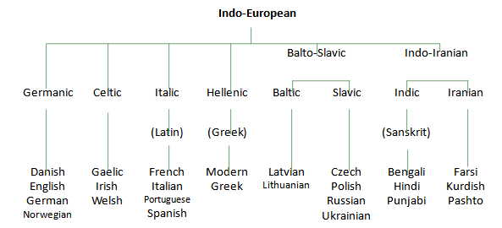
Indo-European is the language family with the largest population and distribution in the world, but it isn’t the only one. There are about thirty such language families containing at least 4,000, and perhaps as many as 6,000, different individual languages. Some of these languages are in danger of extinction while others are expanding. In terms of number of speakers, Chinese has the most native speakers (about 1 billion), while English (about 350 million) is more widely used in different parts of the world.

Family connections
Looking at the Indo-European family tree, we might be puzzled initially by the idea that all these diverse languages are related. After all, two modern languages such as Italian and Hindi would seem to have nothing in common. One way to get a clearer picture of how they are related is through looking at records of an older generation, like Latin and Sanskrit, from which the modern languages evolved.

Sanskrit Latin Ancient Greek
pitar pater patē̆r (‘father’)
bhrā̆tar frā̆ter phrā̆ter (‘brother’)

Cognates
The process we have just used to establish a possible family connection between different languages involved looking at what are called ‘cognates’.

Cognates are words in different languages that have a similar form and meaning (e.g. English ‘friend’ and German ‘Freund’)

Comparative reconstruction
Using information from these sets of cognates, we can embark on a procedure called comparative reconstruction. The aim of this procedure is to reconstruct what must have been the original or ‘proto’ form in the common ancestral language. In carrying out this procedure, those working on the history of languages operate on the basis of some general principles, two of which are presented here.

Majority principle is the choice of the form that occurs more often than any other form in the set of descendant languages. If, in a cognate set, three words begin with a [p] sound and one word begins with a [b] sound, then our best guess is that the majority have retained the original sound (i.e. [p]) and the minority have changed a little through time.

Most natural development principle is the choice of older versus newer forms on the basis of commonly observed types of sound change.

Sound reconstruction
If we were faced with some examples from three languages, as shown below, we could make a start on comparative reconstruction by deciding what was the most likely form of the initial sound in the original source of all three.

Italian Spanish French
cantare cantar chanter (‘sing’)
catena cadena chaîne (‘chain’)
caro caro cher (‘dear’)
cavallo caballo cheval (‘horse’)

Language change
The reconstruction of proto-forms is an attempt to determine what a language must have been like before any written records. However, even when we have written records from an older period of a language such as English, they may not bear any resemblance to the written form of the language found in today’s newspapers.

Old English
The primary sources for what developed as the English language were the Germanic languages spoken by a group of tribes (Angles, Saxons and Jutes) from northern Europe who moved into the British Isles in the fifth century. It is from the name of the first tribe that we get the word for their language Englisc (now called Old English) and their new home Engla-land.

From the sixth to the eighth century, there was an extended period during which these Anglo-Saxons were converted to Christianity and a number of terms from Latin (the language of the religion) came into English at that time.
From the eighth century through the ninth and tenth centuries, another group of northern Europeans came first to plunder and then to settle in parts of the coastal regions of Britain. They were the Vikings and it is from their language, Old Norse, that many English words are originated.

Middle English
The event that marks the end of the Old English period, and the beginning of the Middle English period, is the arrival of the Norman French in England, following their victory at Hastings under William the Conqueror in 1066. These French-speaking invaders became the ruling class, so that the language of the nobility, the government, the law and civilized life in England for the next two hundred years was French. Yet the language of the peasants remained English.
In the two hundred years, from 1400 to 1600 the sounds of English underwent a substantial change known as the ‘Great Vowel Shift’. The effects of this general raising of long vowel sounds (such as [oː] moving up to [uː], as in mōna → moon) made the pronunciation of Early Modern English, beginning around 1500, significantly different from earlier periods. Influences from the outside, such as the borrowed words from Norman French or Old Norse that we have already noted, are examples of external change in the language.
In the following sections, we will look at some of these processes of internal change.

Sound changes
In a number of changes from Middle to Modern English, some sounds simply disappeared from the pronunciation of certain words, resulting in the ‘silent letters’ of contemporary written English.
The sound change known as metathesis involves a reversal in position of two sounds in a word (frist → first).
Another type of sound change, known as epenthesis, involves the addition of a sound to the middle of a word (spinel → spindle).

One other type of sound change worth noting, though not found in English, occurs in the development of other languages. It involves the addition of a sound to the beginning of a word and is called prothesis. It is a common feature in the evolution of some forms from Latin to Spanish, as in these examples:
schola → escuela (‘school’)
spiritus → espíritu (‘spirit’)

Syntactic changes
Some noticeable differences between the structure of sentences in Old and Modern English involve word order. In Old English texts, we find the Subject–Verb–Object order most common in Modern English, but we can also find a number of different orders that are no longer used. For example, the subject could follow the verb, and the object could be placed before the verb, or at the beginning of the sentence. A ‘double negative’ construction was also possible.

However, the most sweeping change in the form of English sentences was the loss of a large number of inflectional affixes from many parts of speech. Nouns, adjectives, articles and pronouns all had different inflectional forms according to their grammatical function in the sentence.

Semantic changes
The most obvious way in which Modern English differs from Old
English is in the number of borrowed words that have come into the
language since the Old English period (as described in Lecture 6).
Two other processes are described as ‘broadening’ and ‘narrowing’ of meaning. An example of broadening of meaning is the change from holy day as a religious feast to the very general break from work called a holiday. We have broadened the use of foda (fodder for animals) to talk about all kinds of food.

The reverse process, called narrowing, has overtaken the Old English word hund, once used for any kind of dog, but now, as hound, used only for some specific breeds. Another example is mete, once used for any kind of food, which has in its modern form meat become restricted to only some specific types.

Diachronic and synchronic variation
Diachronic variation: differences resulting from change over a period of time, in contrast to synchronic variation.

Synchronic variation: differences in language form found in different places at the same time, in contrast to diachronic variation.

Good look

