-2-
Consonants

- The Place Of Articulation
- Manner of Articulation
- IPA Chart
- Terms: Phonemes, Allophones, minimal pairs, Complementary Distribution, Free variation.

- Consonants are sounds produced with some restriction or total closure in the vocal tract as the air from the lungs is pushed through the glottis out the mouth.
- 24 consonants in English (including /j/ & /w/)

Description:
Voicing: Voiced (vibrated) or voiceless (non-vibrated) ?
Manner of articulation
Place of articulation

Place of Articulation

In articulatory phonetics, the place of articulation (also point of articulation) of a consonant is the point of contact where an obstruction occurs in the vocal tract between an articulatory gesture, an active articulator (typically some part of the tongue), and a passive location (typically some part of the roof of the mouth). Along with the manner of articulation and the phonation, this gives the consonant its distinctive sound.

Place of articulation (passive)
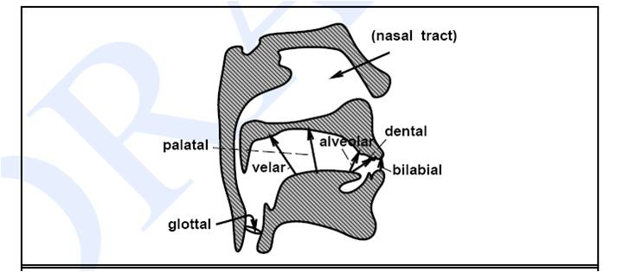

The passive place of articulation is the place on the more stationary part of the vocal tract where the articulation occurs. It can be anywhere from the lips, upper teeth, gums, or roof of the mouth to the back of the throat.

- Bilabial or Labial

Labial: Consonants whose main restriction is
formed by the two lips coming together have
a bilabial place of articulation. In English these
include [p] as in possum, [b] as in bear,
and [m] as in marmot.
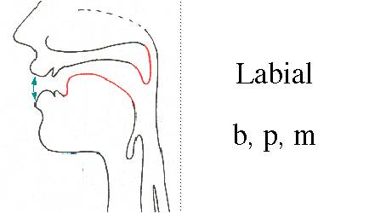
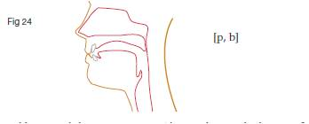
Labial (/p/, /b/, /m/, :
- constriction (or complete closure) at lips
- the only unvoiced labial is /p/
- the only nasal labial is /m/
- Labial consonants are consonants in which one or both lips are the active articulator.

- The Lower Lip and the Upper Lip press together .
- Sounds like : b, m, p,
Ex. /m/ my /p/ pen /b/ book
Note: The lower lip moves to the upper lip.

- Labio-Dental (/f/, /v/):

- The English labiodental consonants [v] and [f] are made by pressing the bottom lip against the upper row of teeth and letting the air flow through the space in the upper teeth. | 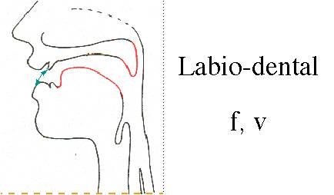
- produced by constriction between lower lip and upper teeth
- in English, all labio-dental phonemes are fricatives
EX: /f/ fan, phone /v/ view, vision

- Dental (/th/, /dh/):

- Dental: Sounds that are made by placing the tongue against the teeth are dentals. The main dentals in English are the [th] of thing or the [dh] of though, which are made by placing the tongue behind the teeth with the tip slightly between the teeth.
- produced by constriction between tongue tip and upper teeth  (sometimes tongue tip is closer to alveolar ridge)  - in English, all dental phonemes are fricatives |  |  | 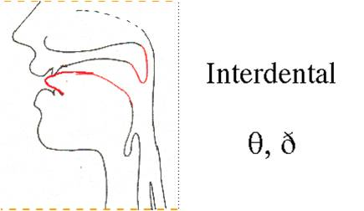
- Ex: /th/ teeth, thin à the tip of the tongue touches the upper teeth.
- /dh/ then, the, there à the blade of the tongue touches the upper teeth.

- Alveolar (/t/, /d/, /s/, /z/, /n/, /l/):

- Alveolar: The alveolar ridge is the portion of the roof of the mouth just behind ALVEOLAR the upper teeth. Most speakers of American English make the phones [s], [z], [t], and [d] by placing the tip of the tongue against the alveolar ridge. The word cooronal is often used to refer to both dental and alveolar. | 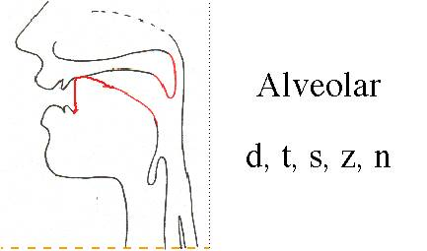
- tongue tip is at or near alveolar ridge
- a large number of English consonants are alveolar
- /l/ before vowel is “light” /l/, after vowel is “dark” /l/.
- /t/ table /d/ door /s/ see
/z/ zoo /n/ nose /i/ eye

- Palato-Alveolar (/sh/, /zh/, /ch/, /jh/, /r/):

- The palato-alveolar sounds [sh] (shrimp), [ch] (china), [zh] (Asian), and [jh] (jar) are made with the blade of the tongue against this rising back of the alveolar ridge | 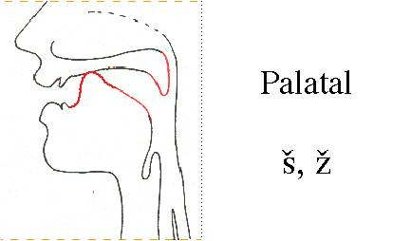
- tongue is between alveolar ridge and hard palate
- 2 fricatives, 2 affricates, 1 retroflex
- retroflex has “depression” midway along tongue
- the palato-alveolar fricatives tend to have strong energy due to weak constriction allowing large airflow

- Palatal (/y/):

- Palatal: The roof of the mouth (the palate) rises sharply from the back of the alveolar ridge.. The palatal sound [y] of yak is made by placing the front of the tongue up close to the palate.
- produced with tongue close to hard palate
- “extreme” production of /iy/
Ex. Yard, you, university, student
Note: Unimportant à is common with the first two letters of (University), however, they sound differently.

- Velar (/k/, /g/, /ng/):

- Velar: The velum or soft palate is a movable muscular flap at the very back of the roof of the mouth. The sounds [k] (cuckoo), [g] (goose), and [N] (kingfisher) are made by pressing the back of the tongue up against the velum. | 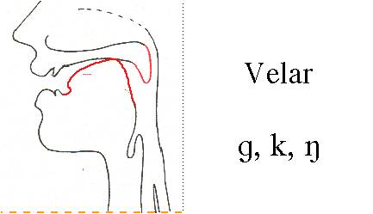
- produced with constriction against velum (soft palate); the back of the tongue touches the velum (the soft palate)
- only plosives /k/ and /g/, and nasal /ng/
- Ex. /k/ car, cat, kind, key
/g/ gas, goal, gear
/ng/ playing, driving

- Glottal (/h/):

- Glottal: (the glottis is the space between the vocal folds). A glottal stop is a speech sound articulated by a momentary, complete closing of the glottis in the back of the throat. It exists in many languages, as in English and Hawaiian uh-oh, O'ahu, and ka'aina.
- /h/ is the nominal glottal phoneme in English; in  reality, the tongue can be in any vowel-like position  - the primary cue for /h/ is formant structure without  voicing, an energy dip, and/or an increase in aspiration  noise in higher frequencies. | 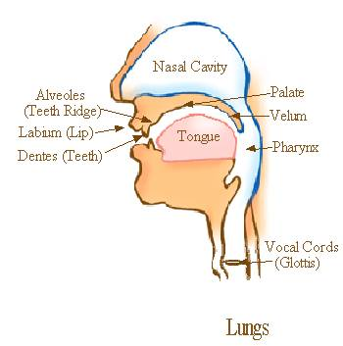

Place of articulation (active):

- The articulatory gesture of the active place of articulation involves the more mobile part of the vocal tract. This is typically some part of the tongue or lips. The following areas are known to be contrastive:
1. The lower lip (labial)
2. Various parts of the front of the tongue:
- The tip of the tongue
- The upper front surface of the tongue just behind the tip, called the blade of the tongue
3.The surface of the tongue under the tip
- In bilabial consonants both lips move, so the articulatory gesture is bringing together the lips, but by convention the lower lip is said to be active and the upper lip passive.

MANNER OF ARTICULATION – PLOSIVES:

- Consonants are sounds which involve full or partial blocking of airflow. In English, the consonants are p, b, t, d, ch, j, k, g, f, v, th, dh, s, z, sh, zh, m, n, ng, l, r, w, and y. They are classified in a number of different ways, depending on the vocal tract details we just discussed.

- Stops, also known as plosives. The air is blocked for a moment, then released. In English, they are p, b, t, d, k, and g.
a. Bilabial plosives: p (unvoiced) and b (voiced)
b. Alveolar plosives: t (unvoiced) and d (voiced)
c. Velar plosives: k (unvoiced) and g (voiced)

Aspiration – the blowing out of air for the voiceless plosives. We use both in English (pit vs poo), but it isn’t a distinction that separates one meaning from another.

FRICATIVES AND AFFRICATES:

- Fricatives : 2. Fricatives involve a slightly resisted flow of air. In English, these include f, v, th, dh, s, z, sh, zh, and h.
a. Labiodental fricatives: f (unvoiced) and v (voiced)
b. Dental fricatives: th (as in thin -- unvoiced) and dh (as in the -- voiced)
c. Alveolar fricatives: s (unvoiced) and z (voiced)
d. Palatal fricatives: sh (unvoiced) and zh (like the s in vision -- voiced)
e. Glottal fricative: h (unvoiced)

Voiceless: / f /, / ө /, / s /, / ʃ/, /h/
Voiced: / v /, / ð /, / z /, / ʒ /

3. Affricates: total closure of speech organs and air is released with friction
Voiceless: / ʧ / Voiced: / ʤ /
church
judge

4. Nasals:

Sounds are produced when air flow through the mouth is completely blocked and released through the nose.
Voiced : / m / , / n / , / ŋ /
There are no voiceless nasals.

5. LIQUIDS

Liquids are sounds with very little air resistance. In English, we have l and r, which are both alveolar, but differ in the shape of the tongue. For l, we touch the tip to the ridge of the teeth and let the air go around both sides. For the r, we almost block the air on both sides and let it through at the top. Note that there are many variations of l and r in other languages and even within English itself! Both / l / and / r / are voiced.
red , led
6. APPROXIMANTS – GLIDES

- Semivowels are sounds that are, as the name implies, very nearly vowels. In English, we have w and y, which you can see are a lot like vowels such as oo and ee, but with the lips almost closed for w (a bilabial) and the tongue almost touching the palate for y (a palatal). They are also called glides, since they normally “glide” into or out of vowel positions (as in woo, yeah, ow, and oy).

- Examples : / w / and / j /
Both sounds are voiced.
wed yet

IPA Chart:

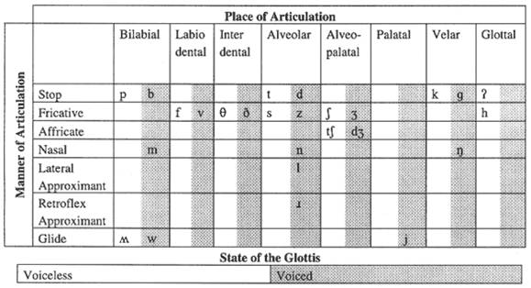

PHONEMES

- Phoneme: smallest significant unit of sound.
Contrast:
/ p / and / b /
‘pin’ and ‘bin’ are phonologically similar except for the first phoneme.
The same applies to / s / and /ʃ/, ‘sip’ and ‘ship’.

- Minimal pairs- two different words which are identical in every way except for one sound sound segment that occurs in the same place in the string.
E.gs.: mat met ray lay
/mæt/ /met/ /reɪ/ /leɪ/
If more than two words in a string, they are called
minimal sets.
E.gs.: sue, shoe, chew bib, bit bid big
/su:/ /ʃu:/ /tʃu:/ /bɪb//bɪt//bɪd/ /bɪg/
ALLOPHONES

Allophone: a variant of a phoneme
Example: the /p/ in ‘pil’ is different though similar sound in ‘spil’.
The difference is in the aspiration /p/ in ‘pit’ can be transcribed /p^{h}ɪ t/ with /p^{h}/ indicating aspiration. What about ‘tap’?
Allophones occur only in certain positions within a word.

ALLOPHONES COMPLEMENTARY DISTRIBUTION

Complementary distribution
When two or more sounds do not occur in the same sound environment.

E.g.: /l/ at the end of a syllable –
/bʊl/ and /l/ at the beginning of a syllable - /let/

ALLOPHONES FREE VARIATION

Free variation - When a word is pronounced in two different ways – using two different phonemes but has no effect on the meaning
Examples:
‘either’ - /aIðə/ or / i:ðə /
‘ed’ endings of the past tense
‘tomato’ - /təma:təʊ/ or /təmeItəʊ/

Notes:________________________________________________________________________________________________________________________________________________________________________________________________________________________________________________________________________________________________________________________________________________________________________________________________________________________________________________________________________________________________________________________________________________________________________________________________________________________________________________________________________________________________________________________________________________________________________________________________________________________________________________________________________________________________________________________________________________________________________________________________________________________________________________________________________________________________________________________________________________________________________________________________________________________________________________________________________________________________________________________________________________________________________________________________________________________________________________________________________________________________________________________________________________________________________________________________________________________________________________________________________________________________________________________________________________________________________________________________________________________________________________________________________________________________________________________________________________________________________________________________________________________________________________________

