-3-
Exercise
CONSONANT DESCRIPTION PRACTICE
Describe the following consonants.

[ s ] | 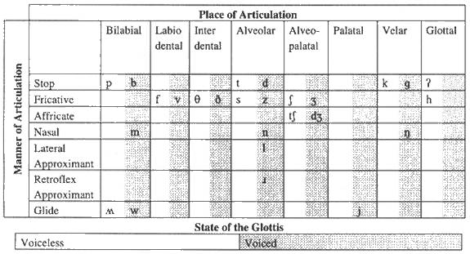
[ d ]

[ Z ]

[ T ]

[ m ]

[ w ]

Give the consonant that the following descriptions correspond to.

voiced velar nasal | 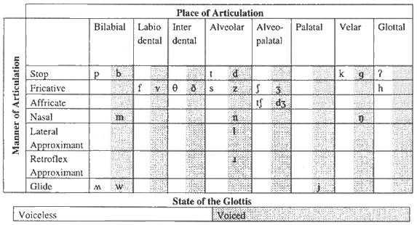
voiceless postalveolar affricate

voiced bilabial stop

voiceless velar stop

voiced alveolar fricative

voiced palatal glide

Say whether the following consonants are voiced or voiceless.

[z], [T], [b], [p], [D], [s].
[f], [v], [t], [d], [k], [g], [S] (this is the symbol for the sh of ship)

3. The following pairs of words are distinguished in pronunciation partly or solely
according to whether they contain a voiced (vd) or a voiceless (vl) consonant. Say
which is the crucial consonant in each case, and specify its voicing status.

pin, bin
fail, veil
toll, dole
gin, chin
zoo, sue

wreath, wreathe (“in smiles”)
either, ether (a kind of gas)
Aleutian, allusion.

4. Changing the voicing of a single consonant in each of the following results in a
different word. Which consonant and which word? (Sometimes there’s more than
one possibility. Concentrate on the pronunciation, not on the spelling.)

seal
razor
ice
scarce
ankle
dug
bicker
lunge
thigh
Confucian

Do you Remember the Vocal Tract?

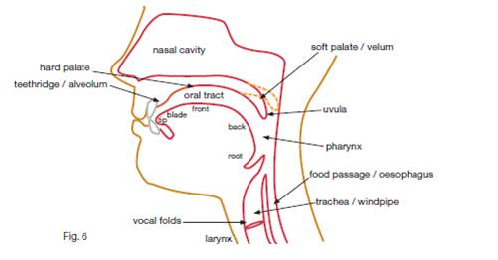

Exercises:

5. Show where the following are situated on this diagram of the upper  vocal tract:  1. blade of tongue,  2. front of tongue,  3. velum,  4. pharynx,  5. larynx,  6.uvula,  7. alveolum,  8. root of tongue. | 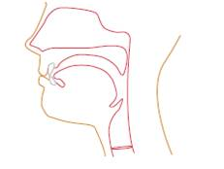

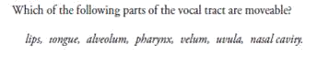
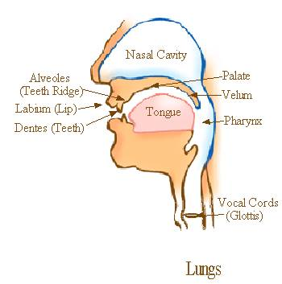

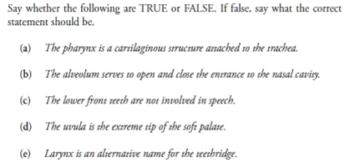
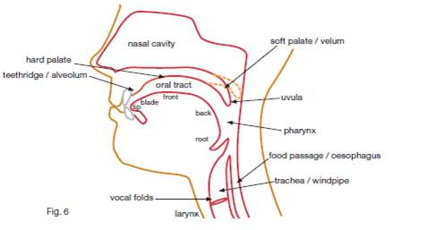
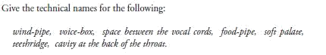

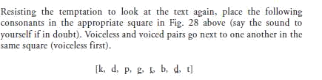
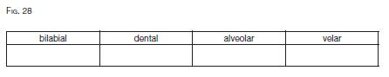

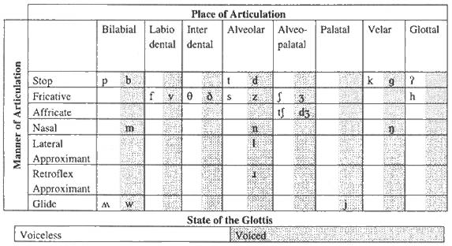

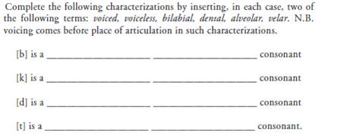
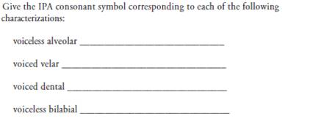
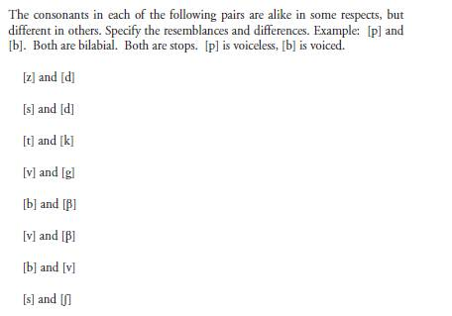
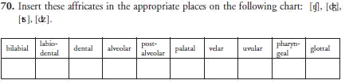

Notes:____________________________________________________________________________________________________________________________________________________________________________________________________________________________________________________________________________________________________________________________________________________________________________________________________________________________________________________________________________________________________________________________________________________________________________________________________________________________________________________________________________________________________________________________________________________________________________________________________________________________________________________________________________________________________________________________________________________________________________________________________________________________________________________________________________________________________________________________________________________________________________________________________________________________________________________________________________________________________________________________________________________________________________________________________________________________________________________________________________________________________________________________________________________________________________________________________________________________________________________________________________________________________________________________________________________________________________________________________________________________________________________________________________________________________________________________________________________________________________________________________________________________________________________________________________________________________________________________________________________________________________________________________________________________________________________________________________________________________________________________________________________________________________________________________________________________________________________________________________________________________________________________________________________________________________________________________________________________________________________________________________________________________________________________________________________________________________________________________________________________________________________________________________________________________________________________________________________________________________________________________________________________________________________________________________________

