-3-

Elements of Chapter 3…

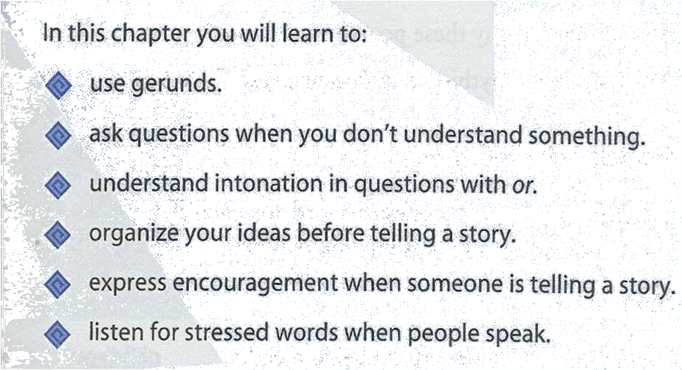
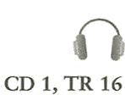
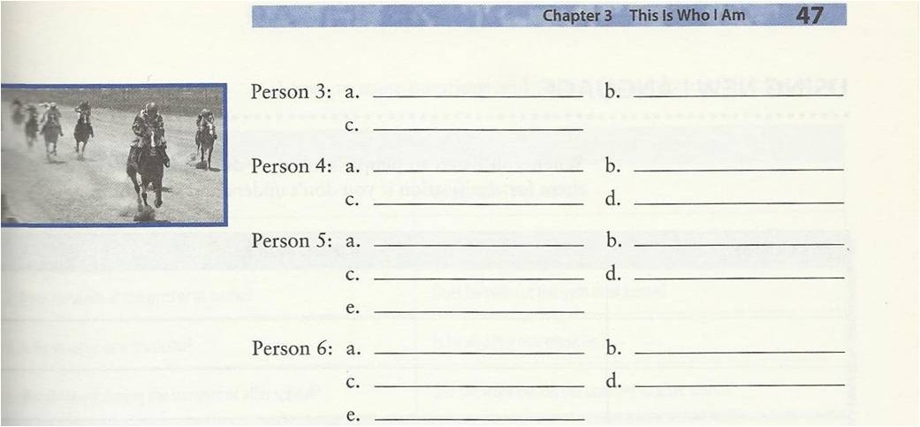

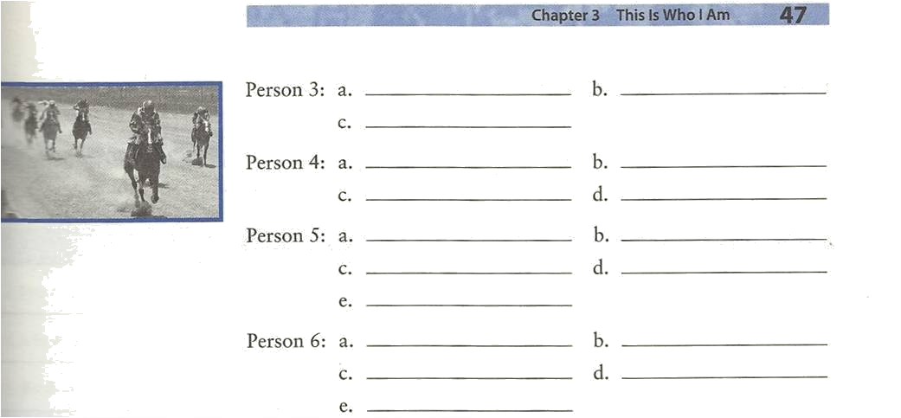
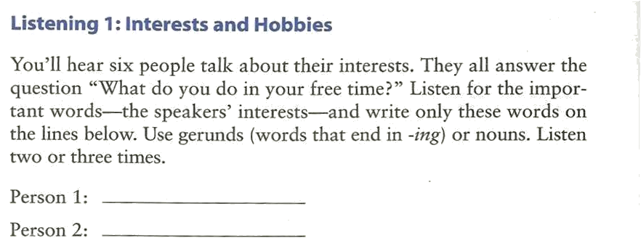

Do it by Yourself J

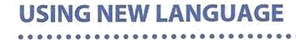
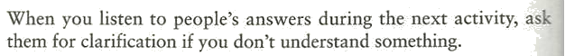
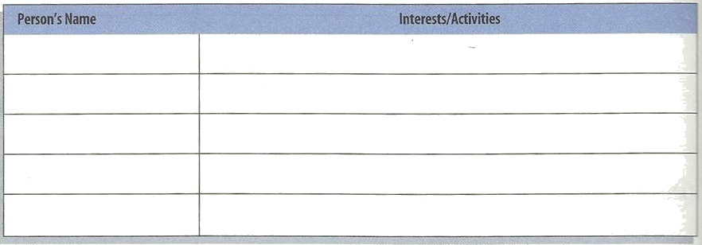
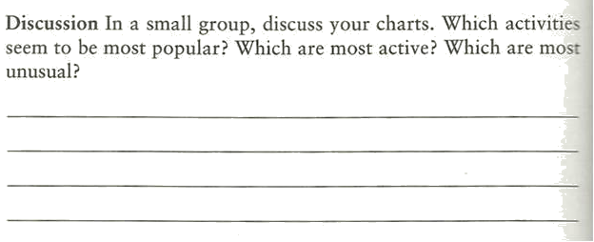

Gerund Form


A gerund is the base form of a verb + -ing.
Gerunds can be used as nouns
verb | + | -ing | = | noun
work | + | -ing | = | working
pay | + | -ing | = | paying
improve | + | -ing | = | improving

Gerunds as Subjects


A gerund can be the subject of a sentence. It is always singular. Use a third-person singular verb after a gerund.
singular subject
Voting is an important responsibility.
Choosing a candidate takes time.

Be Careful!

Don’t confuse gerunds with the
present progressive verb form.

present progressive |  | 
I am voting today.
verb | gerund
 | Voting is an important responsibility.
 | subject

Gerunds as Objects

A gerund can be the object of certain verbs.

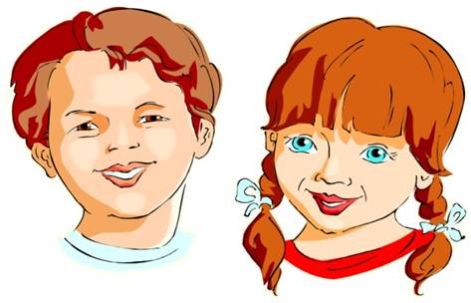 |    | 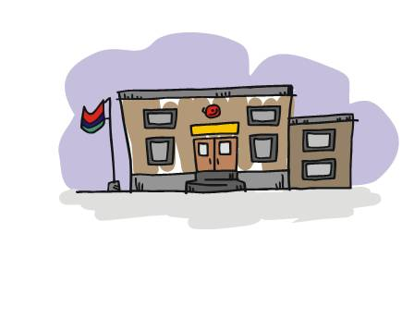
 | I suggest improving our schools.
 | I enjoy working for the people.

Gerunds with Go
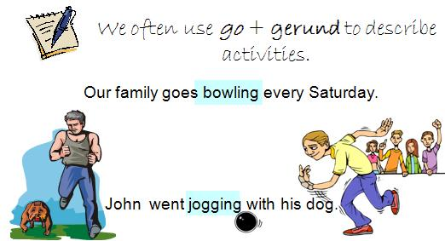

Practice 1

Ask a partner how often he or she does these activities.

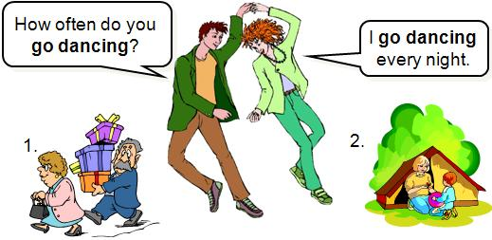

Practice 2

Complete the sentences with gerunds.

Windsurfing
Example: a__________ I s very exciting. | 
- __________ makes me laugh.
- __________ gives me a headache.
- __________ isn’t polite.
- __________ is popular in my country.
- __________ destroys the environment.
- Not __________ can be dangerous.

Ask a partner how often he or she does these activities.
Practice 3

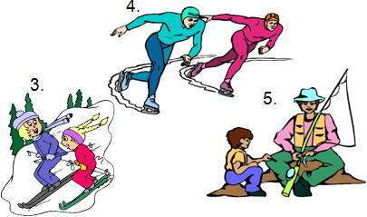

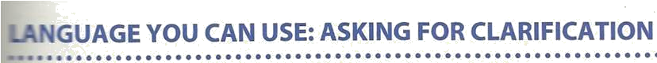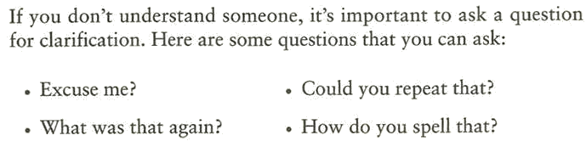
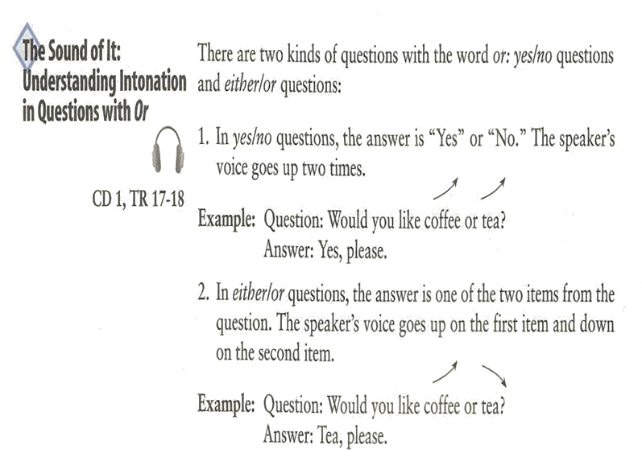

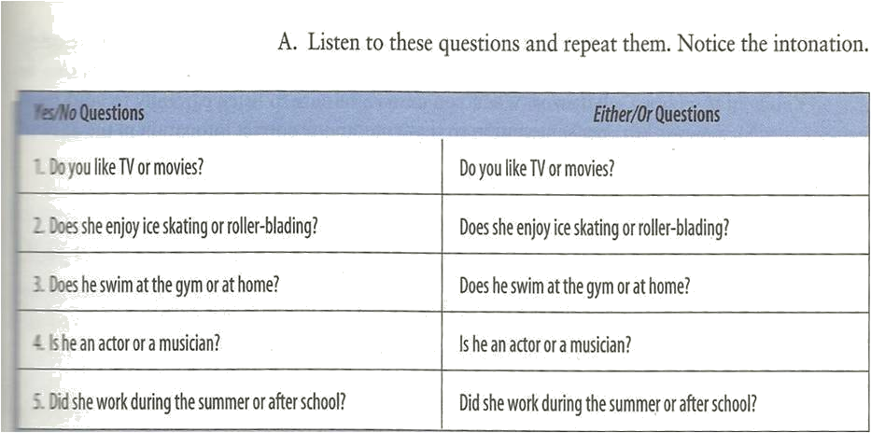

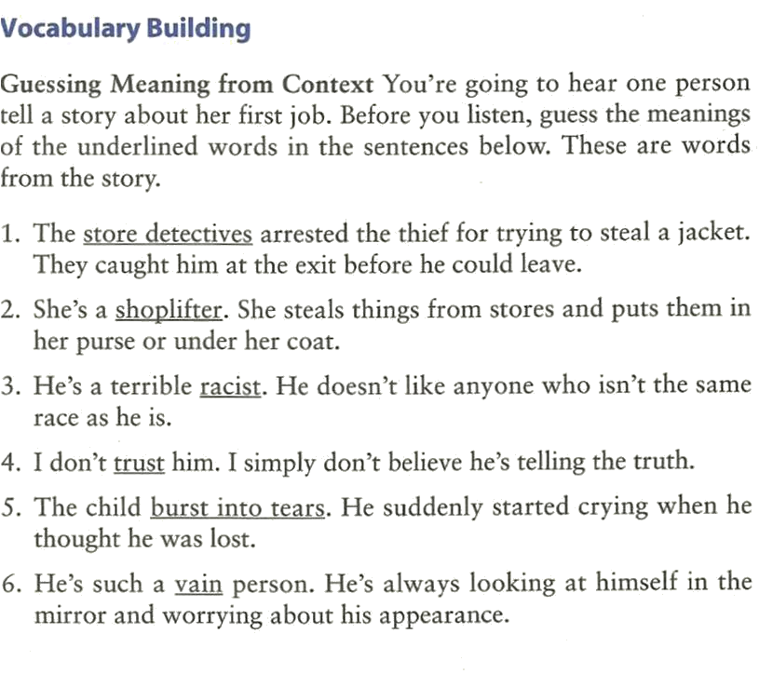

CD 1, TR 19

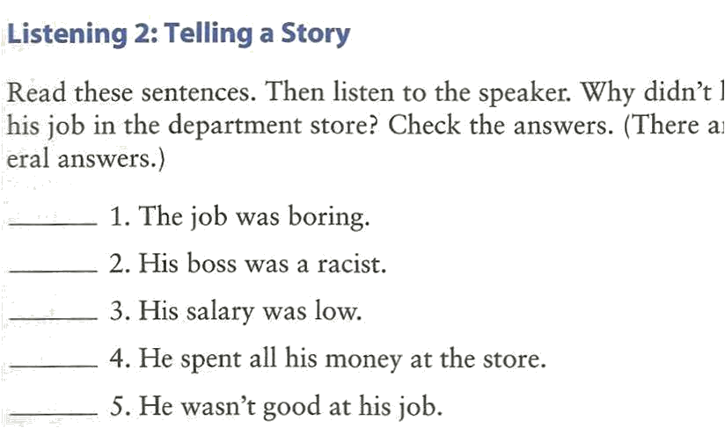
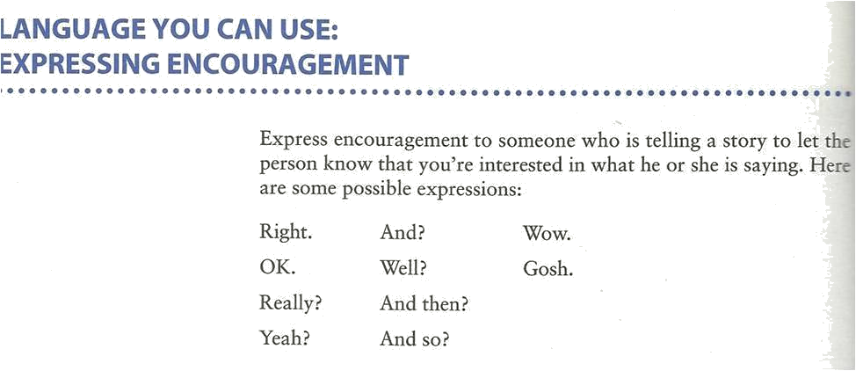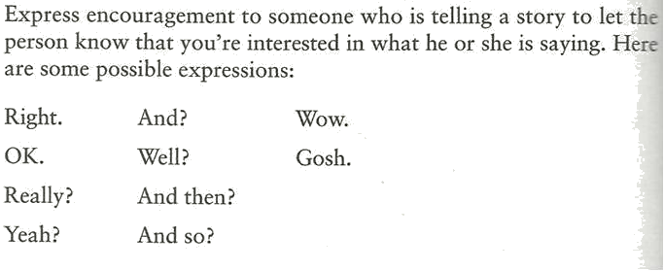
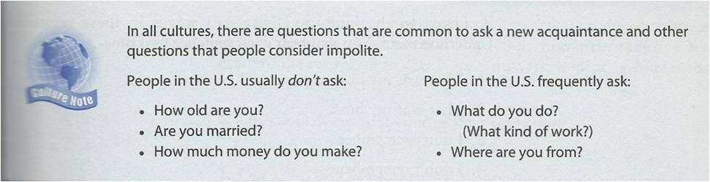
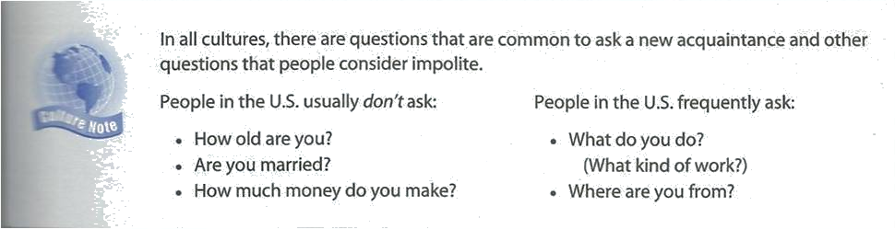

CD 1, TR 20-23

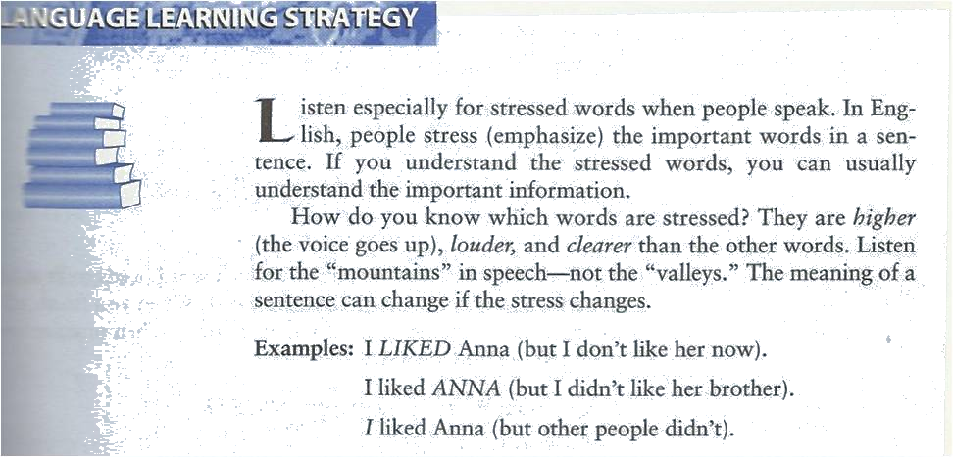

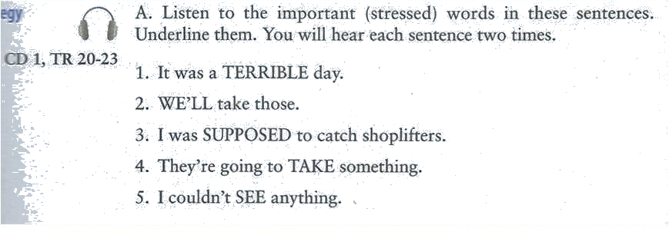

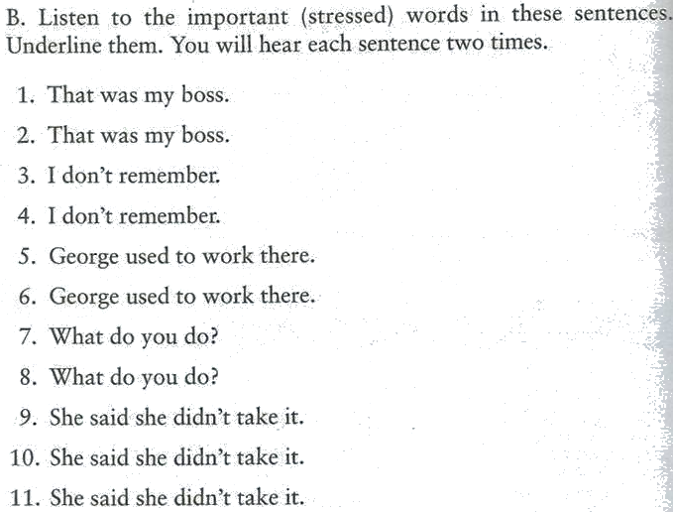

Do it by Yourself J

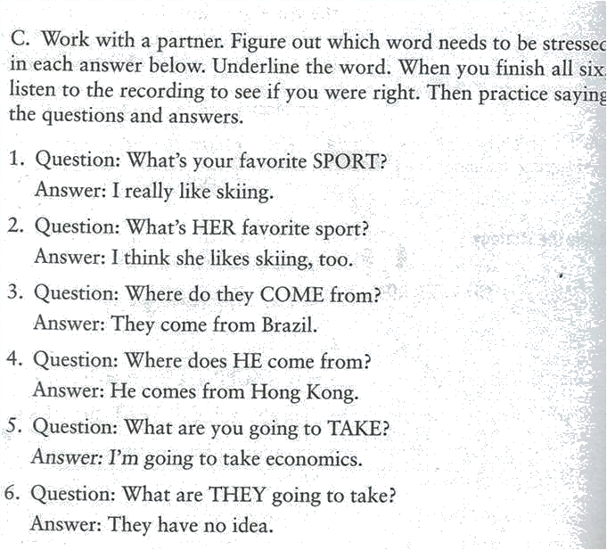

Notes:__________________________________________________________________________________________________________________________________________________________________________________________________________________________________________________________________________________________________________________________________________________________________________________________________________________________________________________________________________________________________________________________________________________________________________________________________________________________________________________________________________________________________________________________________________________________________________________________________________________________________________________________________________________________________________________________________________________________________________________________________________________________________________________________________________________________________________________________________________________________________________________________________________________________________________________________________________________________________________________________________________________________________________________________________________________________________________________________________________________________________________________________________________________________________________________________________________________________________________________________________________________________________________________________________________________________________________________________________________________________________________________________________________________________________________________________________

