-11-

Most Frequent Prefixes and Suffixes

- Word Beginnings and Endings
- You Can Really Use

What Are Prefixes?

Prefixes are first syllables like “non-” and “re-” that have their own meaning.
Prefixes combine with words to create new meanings.

  - Pre + View = Preview (first look)
  - Super + Star = Superstar (top player)

Why Learn Prefixes?

Prefixes add meaning to thousands of words.
Learn a few prefixes, and you open up the meaning of thousands of words.
The four most frequent prefixes are 97% of prefixed words!

Most Common Prefixes

- Anti = against : anti-war
- De = opposite : destroy
- Dis* = not, opposite of : disagree
- En(m) = cause to : encode, embrace
- Fore = before : forecast
- In(m) = in : intake, implant
- Inter = between : interact

Do you know common prefixes?

- Anti  - De  - Dis*  - En(m)  - Fore  - In(m)  - Inter |  | A. between  B. cause to  C. against  D. in  E. before  F. not  G. opposite

Most Common Prefixes

- Mid = Middle : Midway
- Mis = Wrongly : Mistake
- Non = Not : Nonsense
- Over = Over : Overlook
- Pre = Before : Preview
- Re* = Again : Return
- Semi = Half : Semicircle

Do you know common prefixes?

- Mid  - Mis  - Non  - Over  - 12. Pre  - 13. Re  - 14. Semi |  | - Wrong  - Center  - Not  - Half  - Again  - Above  - Before

Most Common Prefixes

15. Sub = Under : Submarine
16. Super = Above: Superstar
17. Trans = Across : Transport
18. Un* = Not : Unfriendly
19. Under = Under : Undersea
20. In, Im, Il, Ir * = Not : Injustice,
Impossible, Illiterate, Irreligious.

Do you know common prefixes?

- Sub  - Super  - Trans  - Un  - Under  - In, Il, Ir |  | - Across  - Not  - Below  - Not  - Above  - Below
What Are Suffixes?

Suffixes are last syllables like “ed” and “ly” that have their own meaning.
Suffixes combine with words to create new meanings.

  - Turn + ed = Turned (in the past)
  - Quick + ly = Quickly (how it turned)

Why Learn Suffixes?

Suffixes add meaning to thousands of words.
Learn a few Suffixes, and you open up the meaning of thousands of words.
The four most frequent suffixes are 97% of suffixed words!

Most Common Suffixes

- -able, ible = can be done : doable
- -al, ial = has property of : personal
- -ed* = past verb : turned
- -en = made of : golden
- -er = comparative : higher
- -er = one who : doer, actor
- -est = superlative : best, biggest

Do you know common suffixes?

- -able  - -al  - -ed  - -en  - -er  - -er  - -est |  | - Past  - Made of  - Having  - One who  - Comparative  - Can  - Superlative

Most Common Suffixes

8. –ful = full of : careful, joyful
9. –ic = having property of : linguistic
10. –ing* = present participle : running
11. –(t)ion = act, process : action
12. –(i)ty = state of : infinity, sanity
13. –(t)ive = adjective : motive, votive
14. –less = without : fearless, careless
Do you know common suffixes?
8. –ful  9. –ic  10. –ing*  11. –(t)ion  12. –(i)ty  13. –(t)ive  14. –less |  | - Present participle  - State of  - Without  - Having property of  - Full of  - Act  - Adjective  - Without

Most Common Suffixes

15. –ly* = having : quickly, quietly
16. –ment = action, process : enjoyment
17. –ness = state of : kindness

18. –ous = having : joyous, religious
19. –s* = more than one : books
20. –y = having : happy, windy

Use these suffixes correctly, and you look and sound pretty smart.

Do you know common suffixes?
15. –ly*  16. –ment  17. –ness  18. –ous  19. –s*  20. –y |  | - Action  - Having  - Having  - Plural  - State of  - Having

Can you use common affixes?

- I have a different idea; I __agree.
- That can’t be; it’s just __possible.
- Say that again; please __peat it.
- Aliens look bad; they are __friendly.

- Tina took the car since she want__ it.
- Now the car is run__ down the road.
- Tina is in a hurry; she’s driving quick__.
- Do you think that she has any ticket__?

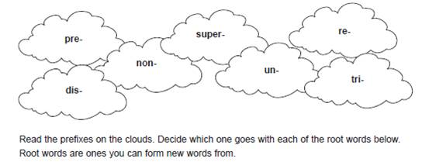
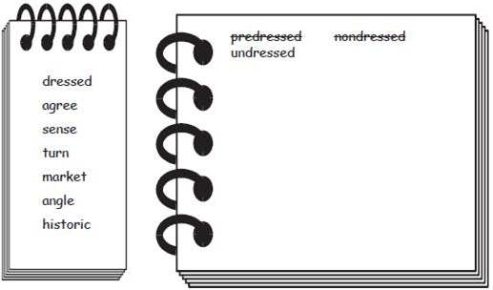
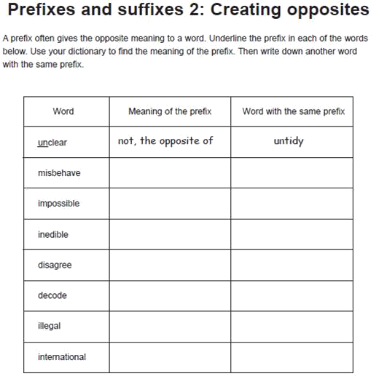

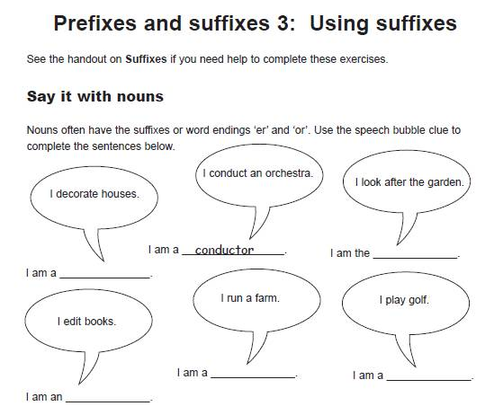

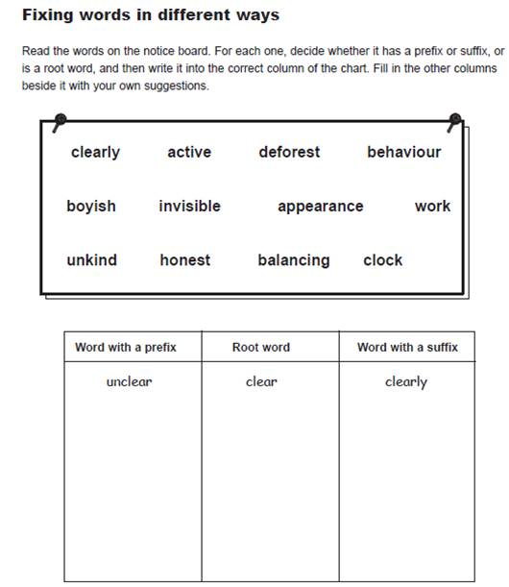

1. A program __ __ designs, writes, and tests programmes for perform __ __ various tasks on a comput .

2. A systems anal __ __ studies organization __ __ systems and decides what act __ __ needs to be taken to maxim __ __ efficien __ __ .

3. Laser print __ __ are prefer __ __ to other types of print __ __ devices because of their speed and quite

4. The microcomput __ __ we have purchased does not have a FORTRAN compil __ __ . It is programm __ __ in BASIC only.

5. We have found that operat __ __ s who have the freedom to take short breaks during the day great __ __ improve their perform .

6. The number of ship __ __ s will increase over the com __ __ months.

7. We decided to computer __ __ the entire planet to give each divis __ __ more independ .

B. Now decide for each word that has a suffix what part of speech the word is
(eg. noun (n), verb (v) , adverb (adv), adjective (adj) ). Insert the correct form - n, v, adv or adj into the spaces.
programmer (for) performing a computer
analyst organizational action
maximize efficiency printer preferable printing (device)
quiteness microcomputer compiler programmable greatly

shipment computerize division independence (a way of...)storing Spooling turning (...your office....) (big...) savings developer (...are)

producing increasingly sophisticated application
a growing global ...(market)

C. Insert the right prefixes into the spaces:

1. Floppy disks are __ __ expensive and __ __ useable.

2. If a printer __ __ functions, you should check the __ __ face cable.

3. The __ __ plexor was not working because someone had __ __ connected it by mistake.

4. __ __proper installation of the __ __ glare shield will make it __ __ possible to read what is on the screen.

5. After you __ __ fer text using the 'cut and paste' feature, you may have to format the text you have inserted.

5. After you __ __ fer text using the 'cut and paste' feature, you may have to format the text you have inserted.

Notes:___________________________________________________________________________________________________________________________________________________________________________________________________________________________________________________________________________________________________________________________________________________________________________________________________________________________________________________________________________________________________________________________________________________________________________________________________________________________________________________________________________________________________________________________________________________________________________________________________________________________________________________________________________________________________________________________________________________________________________________________________________________________________________________________________________________________________________________________________________________________________________________________________________________________________________________________________________________________________________________________________________________________________________________________________________________________________________________________________________________________________________________________________________________________________________________________________________________________________________________________________________________________________________________________________________________________________________________________________________________________________________________________________ _________________________________________________________________________________________________________________________________________________________________________________________________________________________________

