-12-
Comparatives & Superlatives

Elements of Class

- Comparatives and Superlatives
- Exercises

Contents

- Introduction
  - What is a noun?
  - What is an adjective?
  - What is a syllable?
    - Syllable – further examples
- Adjectives
  - Comparative form
    - How to built comparative forms?
  - Superlative form
    - How to built superlative forms?
- Summary
  - Comparison chart

What is a noun?

Noun is a word which refers to a thing, person,activity, place etc.
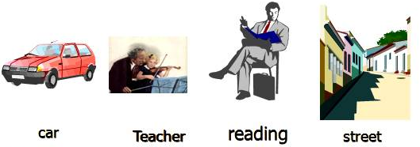
What is an adjective?

Adjective is a word which describes a noun
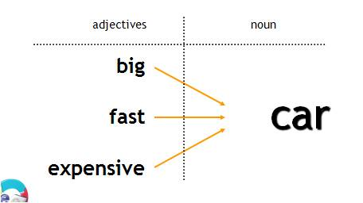

Examples
Adjectives
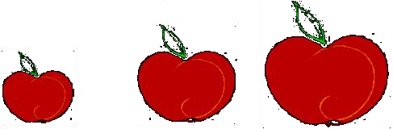

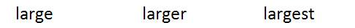
The first apple is large.
The second apple is larger than the first.
The third apple is the largest of the three.

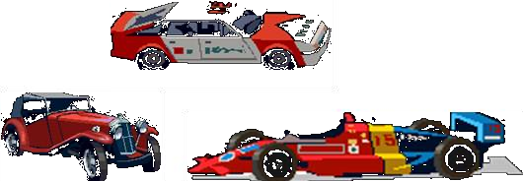

The jalopy is a fast car.
The racecar is the faster car.
The dragster is the fastest car.

What is a syllable?

Syllable is a part of a word containing vowel sound

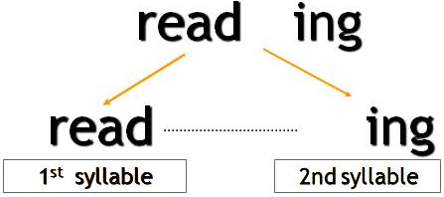

Syllables – examples
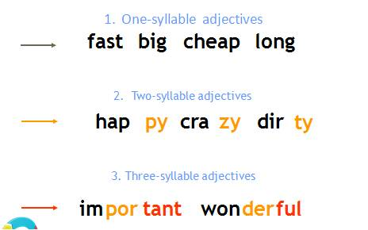

LET’S START J

Adjectives and adverbs are words the modify other words. The comparative form of an adjective or adverb compares two things. The superlative form of an adjective or adverb compares three of more things.

What is a “comparative form”?

Comaprative form expresses the idea of ‘more’
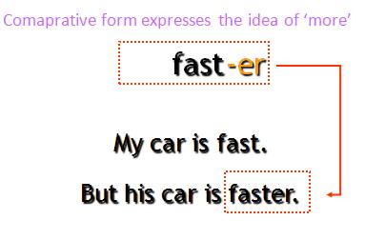

“Comparative form”?

How is a ‘comparative’ form built?

one syllable adjectives | 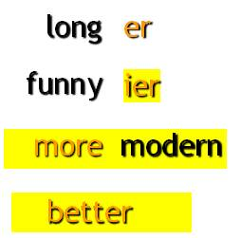
two syllable adjectives ending in -ly
other two and three syllable adjectives
irregular adjectives for example ‘good’

Change of ‘y’ into ‘i’

We want the comparative form
of the adjective ‘funny’
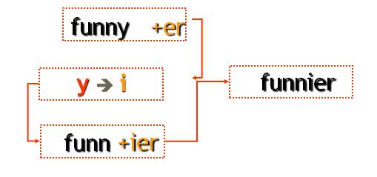

What is a “superlative form”?
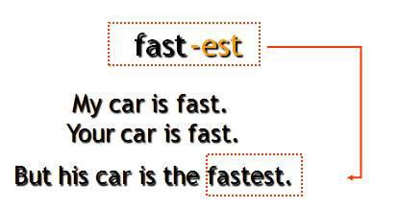
Comaprative form expresses the idea of ‘most’

“Superlative form”?

one syllable adjectives | 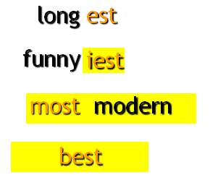
two syllable adjectives ending in -ly
other two and three syllable adjectives
irregular adjectives for example ‘good’

Summary comparison

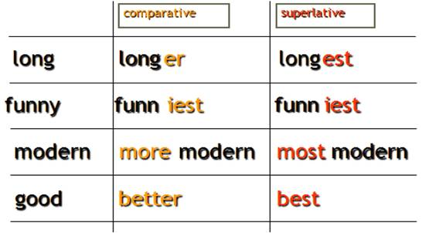

To make comparative and superlative forms of adjectives some rules must be followed.

Rule 1

To form the comparative or superlative
of one syllable words with
more than one vowel OR ending
with more than one consonant at the
add -er OR -est.

tall | taller | tallest
neat | neater | neatest
deep | deeper | deepest

Rule 2

To form the comparative or
superlative of a one syllable word ending
in e add -r OR -st.

wide | wider | widest
fine | finer | finest
cute | cuter | cutest

Rule 3

To form the comparative or superlative of a one syllable word with one vowel and one consonant at the end double the consonant, and add -er OR -est.

sad | sadder | saddest
big | bigger | biggest
fat | fatter | fattest

Rule 4

To form the comparative or superlative of a two syllable word ending in y, change the y to i, then add -er OR -est.

happy | happier | happiest
jolly | jollier | jolliest
lazy | lazier | laziest

Rule 5

To form the comparative or superlative of a two syllable word ending a vowel-sound that is not stressed then add -er OR -est.
Adjectives ending in –le, -ow, er frequently take –er and –est.

yellow | yellower | yellowest
gentle | gentler | gentlest
simple | simpler | simplest

Rules at a Glance

Adjective form | Comparative | Superlative
Only one syllable, with more than one vowel or more than one consonant at the end. Examples:  light, neat, fast, tall, neat, deep | Add -er:  lighter, neater, faster, taller, neater, deeper | Add -est:  lightest, neatest, fastest, tallest. neatest, deepest
Only one syllable, ending in E. Examples:  wide, fine, cute | Add -r:  wider, finer, cuter | Add -st:  widest, finest, cutest
Only one syllable, with one vowel and one consonant at the end. Examples:  hot, big, fat, sad | Double the consonant, and add -er:  hotter, bigger, fatter, sadder | Double the consonant, and add -est:  hottest, biggest, fattest, saddest
Two syllables, ending in Y. Examples:  happy, silly, lonely, jolly | Change y to i, then add -er:  happier, sillier, lonelier, jollier | Change y to i, then add -est:  happiest, silliest, loneliest, jolliest
two syllable word ending a vowel-sound that is not stressed  yellow, simple | Add -er:  yellower, simpler | Add -est:  yellower, simpler
Two syllables or more, not ending in Y. Examples:  modern, interesting, beautiful, | Use more before the adjective:  more modern, more interesting, more beautiful | Use most before the adjective:  most modern, most interesting, most beautiful

NOTE: Like adjectives some adverbs can
take comparative and superlative
forms, with -er and -est:
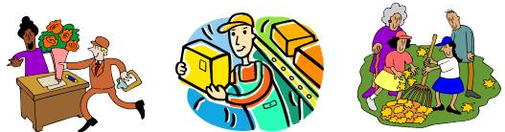
Sally works hard.
Steve works harder than Sally
Kathy and Sue work the hardest of all.

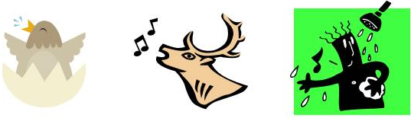
The bird sings loudly.
The moose sang louder than the bird.
Pete sang the loudest of them all.

List of Adverbs in Which -er and -est May Be Added

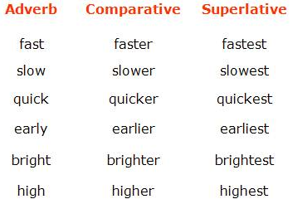
However, the majority of adverbs do not take these endings. Instead, they form the comparative using more and the superlative using most:

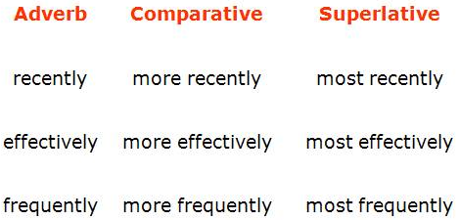

Irregular Comparative and Superlative Adjectives and Adverbs

Some comparative and superlative forms are irregular and do not follow any rules or patterns. These must be memorized.

USE OF COMPARATIVES

Comparatives are very commonly followed by than and a pronoun or noun group, in order to describe who the other person or thing involved in the comparison is,

e.g.:
John is taller than me.
I think that she’s more intelligent than her sister.

OTHER USES OF COMPARATIVES

- Comparatives are often qualified by using words and phrases such as much, a lot, far, a bit/little, slightly etc., e.g.:
You should go by train, it would be much cheaper.
Could you be a bit quieter?
I’m feeling a lot better.
Do you have one that’s slightly bigger?
- Two comparatives can be contrasted by placing the before them, indicating that a change in one quality is linked to a change in another, e.g.:
The smaller the gift, the easier it is to send.
The more stressed you are, the worse it is for your health.
- Two comparatives can also be linked with and to show a continuing increase in a particular quality, e.g.:
  - The sea was getting rougher and rougher.
  - Her illness was becoming worse and worse.
  - He became more and more tired as the weeks went by
USE OF SUPERLATIVES

Like comparatives, superlatives can be placed before nouns in the attributive position, or occur after be and other link verbs, e.g.:

the most delicious chocolate cake I’ve ever eaten
Annabel was the youngest
This restaurant is the best

As shown in the second two examples, superlatives are often used on their own if it is clear what or who is being compared. If you want to be specific about what you are comparing, you can do this with a noun, or a phrase beginning with in or of, e.g.:

Annabel was the youngest child
Annabel was the youngest of the children
This restaurant is the best in town.

THE OPPOSITES OF COMPARATIVE AND SUPERLATIVES

We use the forms less (the opposite of comparative more), and the least (the opposite of superlative the most).
Less is used to indicate that something or someone does not have as much of a particular quality as someone or something else, e.g.:

This sofa is less comfortable.
I’ve always been less patient than my sister.

The least is used to indicate that something or someone has less of a quality than any other person or thing of its kind, e.g.:

It’s the least expensive way to travel.
She was the least intelligent of the three sisters.

Irregular Adverbs
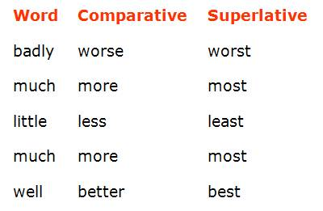

Irregular Adjectives

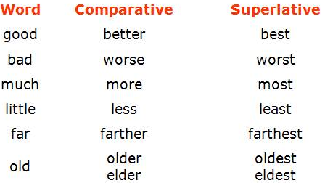

Example:

Nathan made good stew.
Molly's stew was better than Nathan's.
Ezra made the best stew of all.

Let’s Start Exercising

1. The weather in winter is _____________ than it is in summer.
A. colder B. cold
C. coldest D. the coldest

2. I have ___________ money than you do.
A. much B. more
C. most D. least

3. Abdullah is ______________ of all boys.
A. the fastest B. the most fastest
C. fast D. faster

Do More Exercises

- What is the comparative of "sad"?
  - sader
  - sadder
  - sadier
  - saddier

- What is the comparative of "destructive"?
  - destructiver
  - more destructiv
  - destructivier
  - more destructiver
- What is the superlative of "soft"?
  - softest
  - softiest
  - softtest
  - most soft

- What is the comparative of "hot"?
  - hoter
  - hotter
  - hotest
  - Hottest

- What is the comparative of "heat"?
  - heater
  - heatter
  - heatier
  - hetter
  - none of these

- What is the superlative of "ugly"?
  - uglier
  - uggliest
  - uglyest
  - Ugliest

- What is the superlative of "unpleasant"?
  - unpleasant
  - most unpleasant
  - more unpleasant
  - unpleasantest

10. To fall from a motorcycle is _____ to fall from a bicycle.
- more painful
- b) more painful than
- c) painfuller than
- d) the painfullest

11. If you suffer asthma, don’t go to Mexico City. It is one of the _____ cities in the world
- pollutest
- b) more polluted
- c) polluter than
- d) most polluted

12. The _____ place from Chile is Australia. It’s on the other side of the world.
- farther
- farthest
- farther than
- farthest than
13. I don’t think your bike is _____ mine.
- fastest than
- faster
- fastest
- faster than
14. Michael was _____ basketball player in the world
- taller
- tallest
- the taller
- the tallest
15. Speaking Japanese is _____writing it.
a) the easiest
b) easy
c) easier than
d) easyer than
Write the following sentences using the correct form of the adjective
(comparative or superlative)
- Clare is __________________________________________________ Mike. (old)
- Jane is ________ of the four. She eats very well and does a lot of sports, (healthy)
- The coach thinks that Peter is the __________________ player of the team, (fast)
- The Sahara desert is one of the ___________________deserts in the world. (hot)
- The climate in the North of Chile is _______________________ in the South, (dry)
- Asia is _________________________________________________ Europe. (big)
- A Rolls-Royce is one of _______________________ cars in the world. (expensive)
- ____________________________ hurricanes are developed over México, (violent)
- Diamonds are ______________________________ jewels in the world. (precious)
- History classes are _________________________ chemistry classes. (interesting)
Notes:_______________________________________________________________________________________________________________________________________________________________________________________________________________________________________________________________________________________________________

