محاضره 1
Main Points
Causes and Consequences of the Reformation
- Before the Reformation ALL Christians in Europe were Roman Catholic

- Reformation Ended the Religious Unity in Europe
- Attack on the medieval church—its institutions, doctrine, practices and personnel
- The Reformation caused a split in Christianity with the formation of the new Protestant religions
- The Medieval Church
- Mission of the Church: To save the soul of all the members.
- Tithe: People donated one tenth (1/10) of the produce from their lands to the church each year.
- Wealth: Church became wealthiest group in Europe
- Church was the Center of daily life. The local church served as a church,
meeting place, and shelter during war.
- Community: The church dominated community life and controlled interaction between Christians

The Problem of the Catholic Church
Greed, corruption and absenteeism

- Sales of indulgences: The release of a soul from purgatory (hell) for
monetary donation – a HUGE abuse of Church power! Extortion of money from the poor
- Unfair Land and wealth distribution
- The corruption of the Papacy
- European population was increasingly anti-clerical

- Absenteeism of church leaders during natural disasters (plague, famine) or to solve everyday problems for people
New Socio-economic realities
- Better educated, urban populace was more critical of the Church than rural
Peasantry
- Renaissance monarchs were growing impatient with the power of the Church
- Society was growing more humanistic and secular
- Growing individualism
Technological Developments
- Scientific developments contradicted Church doctrine
- Invention of movable type (printing) in 1450 by Johann Gutenberg
- Manufacture of paper becomes easier and cheaper
- Spread of ideas faster than the Catholic Church could control them
- Intensified intellectual criticism of the Church
- Protestant ideals appealed to the urban and the literate

Calls for Reform
- The Church’s political power started being challenged
- Unwillingness to depend on the Church and rejection of the constraints it enforced
- Growing human confidence vs. “original sin”
- Catholic church becomes defensive and unable to respond to the criticism
- The confusing nature of scholasticism and of church dogma

- Reformers
- Desiderius Erasmus (1466-1536)
- A Dutch scholar, humanist, and theologian.
- Was ordained a Catholic priest, but never
- practiced priestly duties.
- Studied, instead, theology and classical Greek
- at the universities of Paris and Cambridge.
- Was critical of some of the practices and
- doctrines of the Catholic Church.
- Sought to reform the Catholic Church.
- 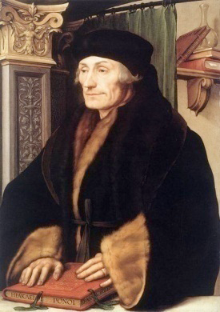
- In Praise of Folly -
- by Erasmus
- Written in Latin in 1509
- Best-seller (only the Bible sold more by 1550)
- Erasmus was a devout Catholic who sought to reform the Church, not destroy it
- Criticized immorality and hypocrisy of Church leaders and the clergy
- The book inspired renewed calls for reform, and influenced Martin Luther
- Reformers
- Martin Luther (1483-1546)
- A German Priest
- Openly addressed the problems in the Church
- Said that faith is private and church should have no
- Control over it.
- 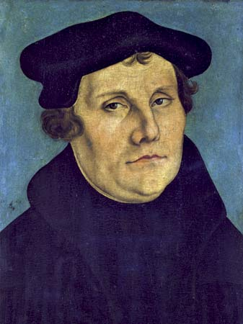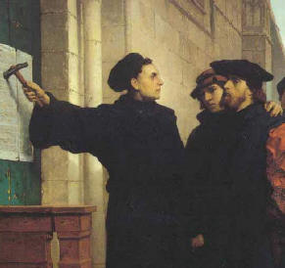
- Oct 31, 1517, Martin Luther posted 95 Theses on the church door in Wittenburg, Germany
- The 95 theses summarized his criticisms of Church
- 1000s of copies distributed throughout Germany and Europe.
- Reformation Begins
- By 1521 Luther was calling for Germany to spilt from the catholic Church
- Wanted German princes to overthrow Papal power in Germany and establish a German Church
- Jan 1521 – Luther is excommunicated
- He was summoned by Imperial Diet of Holly Roman Empire to the city of Worms by Emperor Charles V and was ordered to change his ideas
- Luther – “NO” – The Edict of Worms was issued, making Luther an outlaw
- Luther kept in hiding by German princes
- Lutheranism
- Lutheranism (Protestantism) Spreads
- Followers of Luther’s religious practices increased
- Protestantism Gained support among many German princes
- 1524, German peasants revolted (The Peasants’ Revolt) and hoped Luther would support them, but… because Luther needed the support of German princes, he did not help the peasants
- Germany is in turmoil – is it Catholic? Is it Lutheran?
- To establish peace, the Holy Roman Emperor Charles V accepted the Peace of Augsburg, and allowed German princes to choose their own faith and religion.
- Protestantism Spreads across Europe
- Ulrich Zwingli and the Zwinglian Reformation
- John Calvin and Calvinism
- Henry VIII and the English Reformation
- Protestantism Spreads across Europe
- Ulrich Zwingli (1484-1531) / The Zwinglian Reformation
- priest in Zurich, Switzerland
- Revolted against the Catholic Church:
- 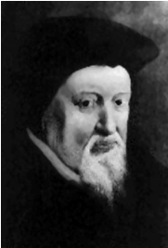
- Banned all religious relics & images
- Whitewashed all church interiors.
- Banned music in church services
- Did not merge with Luther because he disagreed with him on communion
- Protestantism Spreads across Europe
- John Calvin (1509-1564) and Calvinism
- Replaced Zwingli (killed in religious war)
- French, fled to Switzerland for safety
- 1536 – began reforming Geneva, Switzerland
- Created a church-government of elect and laity
- Used consistory (moral police)
- Sent missionaries throughout Europe to convert
- Catholics
- His ideas spread to France, Netherlands, Scotland
- Mid 16th Century – Calvinism more pop than Lutheranism
- 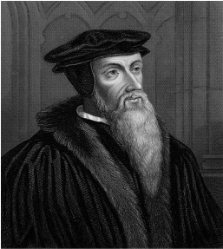
- John Calvin (1509-1564)
- Anti-Catholic
- Was influenced by Martin Luther, but..
- Disagreed with Luther’s “Salvation through Faith alone.”
- Established his own Protestant Religion in Switzerland
- Calvinism: Started in Switzerland
- England and America = Puritans
- Scotland = The Presbyterians
- Holland = The Dutch Reform
- France = The Huguenots
- Germany = The Reform Church
- South Africa = Boers
- Calvinism believes in:
- Predestination: It is decided, at birth, if people will go to heaven or hell
- Preach a purified existence and opposed to drinking, gambling, card playing, swearing, etc.
- 
- Reformation in England
- Political, not religious motives for reform
- Henry VIII – King of England needs a male heir
to carry on the Tudor Dynasty
  - Married Catherine of Aragon
(Aunt of Charles V, the Holly Roman Emperor)
  - Catherine gave him a daughter, Mary and no son,
  - So Henry wanted a divorce!
  - In the Catholic Church, you need an annulment, granted by the
- Church. The Pope ONLY can grant it to a King.
- Political, not religious motives for reform
- The Pope refused to grant the annulment, too political
- Standoff between: The King of England and HRE Emperor
- After a long argument, Henry decided to break away from the Catholic Church
- Archbishop of Canterbury granted Henry VIII a divorce
- Act of Supremacy(1534) established the Church of England
- King Now controls over religious doctrine, appointments, etc
- Henry VIII dissolved Catholic claims, sold its land and possessions
- Took power but remained close to Catholic teachings
- Henry and His Wives

- 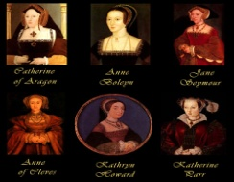
- Henry was desperate for a son. So much so he married 6 times!!
- The saying goes…
Divorced, Beheaded, Died
Divorced, Beheaded, Survived
- The Church of England 1547 – Henry died
His 9 year old son, Edward VI, took the throne
- The Church of England or the Anglican Church became more Protestant, which triggered the anger of the Catholic Church
- 1553 – Edward VI died
His half-sister Mary (Catholic) took throne
- Mary wanted to restore Catholicism
- She had over 300 Protestants burned alive as heretics, which earned her the title “Bloody Mary.”
- Mary increased tensions between Catholics and Protestants

