Lecture 21
Unit 6
Location Expression:
 |  | 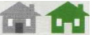 | 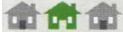 |  |  | 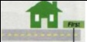 | 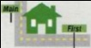 | 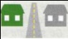
behind | In front of | Next to | between | inside | outside | On First Street | On the corner of Main and First | Across (the street) from opposite
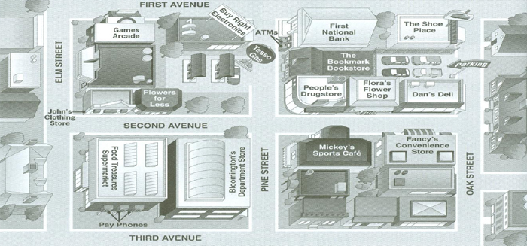
1.The bookstore is a cross from Tesso Gas.
2.Flora’s Flower Shop is between the drugstore and the deli.
3.The department store is next to the supermarket.
4.The clothing store is on the corner of Second and Elm.
5.Games Arcade is on First avenue.
6.The Shoe Price is on the corner of oak and first.
7.The parking lot is behind Dan’s Deli.
aquarium museum running stadium visitors’ center
hotel parking skateboard ramp library water park
You can . . .
- See sea animals at an aquarium.
- Swim in an outdoor pool at a water park.
- Go jogging on a running path.
- Go skateboarding on a skateboard ramp.
- Borrow books in a library.
- See art and interesting old things at a museum.
- Ask for information at a visitors’ center.
- Leave your car at a parking garage.
- Watch a baseball game at a stadium.
- Sleep at a hotel.
Some people are at the Sea View Hotel. Where do they want to go? Look at the map.
Complete the conversations with the names of the places.
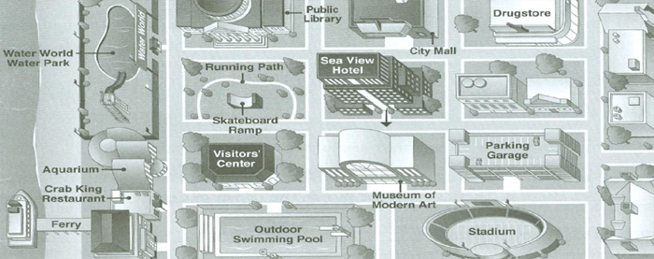
- A. Can you tell me how to get to the skateboard ramp?
B. Sure. When you leave the hotel, turn right. It’s on the next block. It’s there on your right.
- A. Can you tell me how to get to the drugstore?
B. Yes. Go out of the hotel, and turn left. Turn left again at the corner, go one block, and turn right. It’s on your left.
- A. Can you help me? I’d like to go to the ferry.
B. Yes. Turn right our of the hotel. Go straight for another block, and make a left.
Well tow blocks. It’s on your right, next to the restaurant.
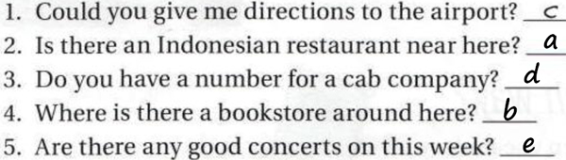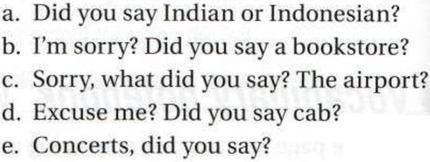
Echo Question:
In an “echo” question,  You repeat something  You heard, and you  Add a question word  To check information  You didn’t hear. | A: The new Samsung mobile is great  B: Excuse me  The new what?  A: There is a drugstore on Main St.  B: I’m sorry, it’s where?
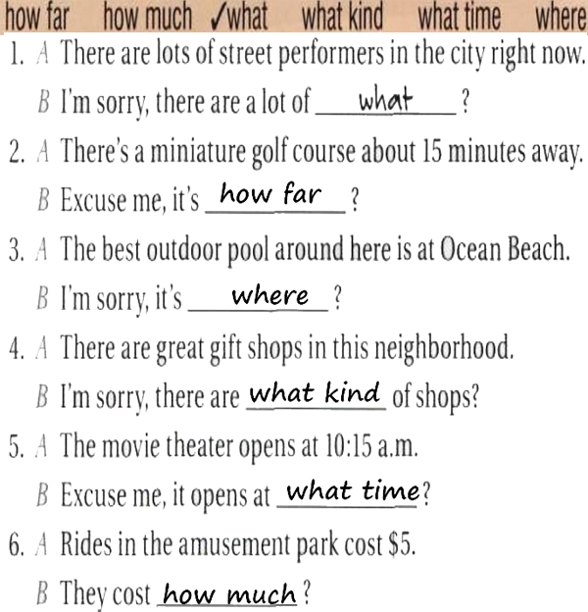
Reading:
1.Chinatown is now home to:
a. 16,000 people. b. less than 14.000 people. c. More than 14.000 people.
2.Across from the cathedral on Grant
a. Ching Chung Temple. b. St. Mary’s Square. c. Chinatown Gate.
3.Portsmouth square is ___________ the Chinese Culture Center.
a. next. b. behind. c. inside. d. across from.
4.Operator had to speak:
a. Six languages. b. Only English and Chinese. c. English and five Chinese dialects.
5.You can sample fortune cookies in
a. Ross Alley. b. Jackson St. c. St. Mary Cathedral.
& Use the map to number the directions to the bank below:
Directions: ( Walk one more block – Turn right – Walk u[ one block – Make a left – It’s on the left, just past the post office ).
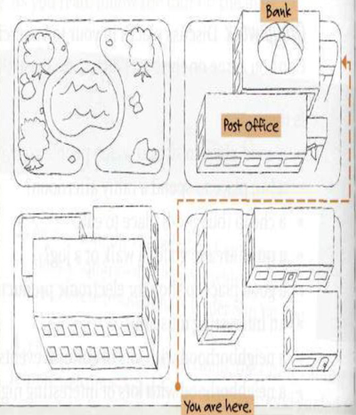
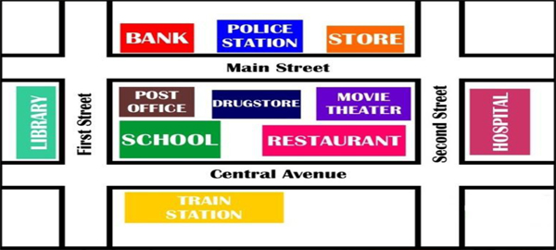
1.The police station is between the bank and the store.
2.The movie theater is behind the restaurant.
3.The store is next to the police station beside.
4.The train station is far from the bank.
5.The school is near from the drugstore.
6.The post office is across from the bank.
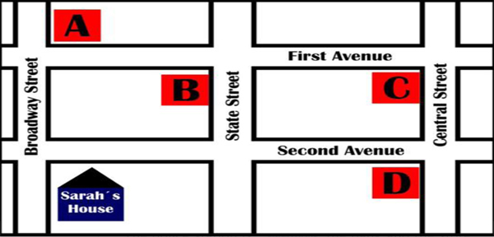
Today is your birthday, you invited Sarah, and you are giving her directions to get to your home.-
You.- Hi! Sarah, What are you doing tonight?
Sarah.- Nothing, Why?
You.- Because, today is my birthday, and I'm having a party. Do you want to come?
Sarah.- Great! Where do you live?
You.- Ok, from your house, Walk straight ahead on Broadway Street, then turn right on First Avenue, walk two blocks, my house is on the corner of First Avenue and Central Street.
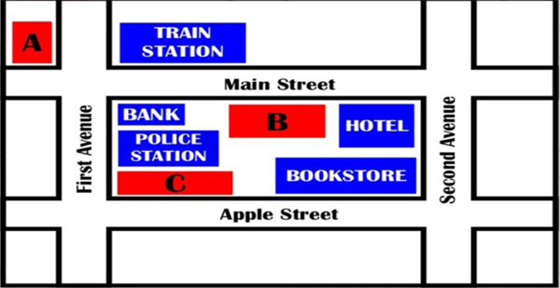

1.The restaurant is between the bank and the hotel.
2.The school is in front of the police station.
3.The supermarket is across from the train station.
New Vocabulary:
# Department store: a large shop divided into several different parts, each of which sells different things.
# Avenue: ‍a wide road, with trees or tall buildings on both sides, or a wide countryside path or road with trees on both sides.
# Directions: instructions that you give to someone about how to find a particular place. e.g. Can you give ‍ me directions to ‍ your house? Museum: ‍a building where objects of historical, scientific or artistic interest are kept.
# Straight: ‍continuing in one direction without bending or curving.
# Block: ‍a large, usually tall building divided into separate parts for use as offices or homes.
# Ferry: ‍a boat or ship for taking passengers and often vehicles across an area of water, especially as a regular service.
# Terminal: the area or building at a station, airport or port which is used by passengers leaving or arriving by train, aircraft or ship.
# Aquarium: a glass container in which fish and other water animals can be kept.
# Stadium: a large closed area of land with rows of seats around the sides and often with no roof which is used for sports events.
There is / There are:
# We use there is (singular) / there are (plural) to say that something is located in the place or exists:
There is an apple on the table. There is a student in the class.
There are five apples on the table. There are twenty five students in the class.
# We use there isn’t (singular) / there aren’t (plural) to say that something isn’t located in the place or doesn’t exist:
There isn’t an apple on the table. There isn’t a student in the class.
There aren’t any apples on the table. There aren’t any students in the class.
# We use Is there…? (singular) / Are there...? (plural) to ask whether something is located in the place or exists:
Is there +a/an+ singular noun?
Is there an apple on the table?
Are there +any+ Plural noun?
Are there any apples on the table
Offers & Requests:
Offers  Can I help you?  What can I do?  How can I help? | Requests  Can you help me?  Can you tell me how to get to the aquarium?  Could you give me directions?
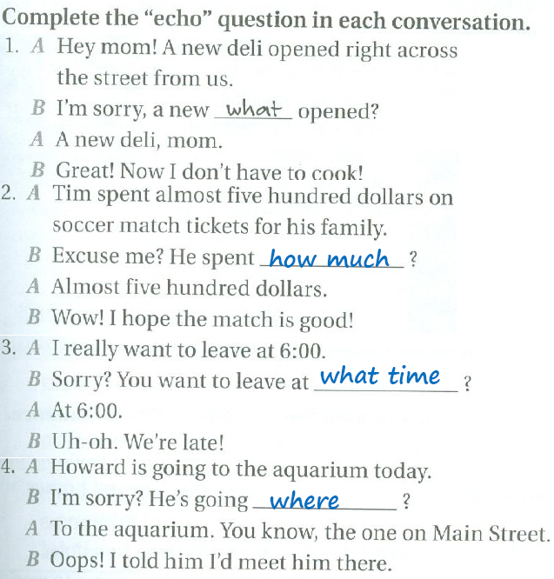
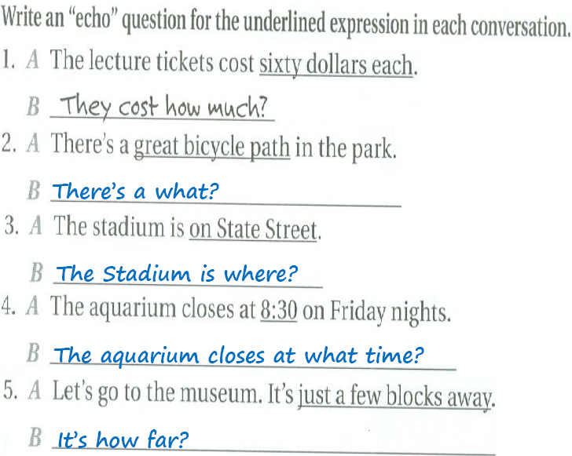
Amjad Al-Ghamdi.. بـ التوفيق جميعًآ

