Lecture 31
Unit 11
Appearances
In Unit 11, you learn how to . . .
* use have and have got to describe people.
* use phrases with verb + -ing and prepositions to identify people.
* talk about what people look like.
* show that you're trying to remember a word.
* use You mean to help someone remember something.

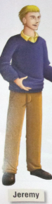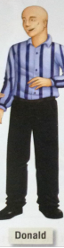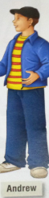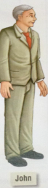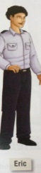
Before you begin . . .
Look at the picture. Can you find someone who . . .
Is short? Is young? Is thin? Has long hair? Has dark hair?
Is tall? Is old? Is heavy? Has short hair? Has blond hair?

What does he look like?
Height
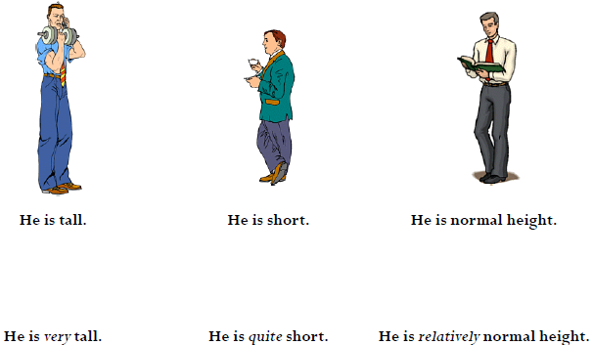
Weight
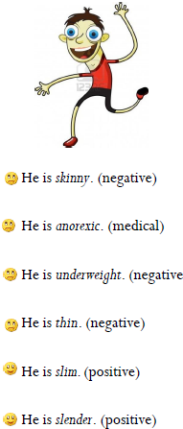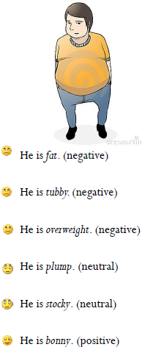

Hair

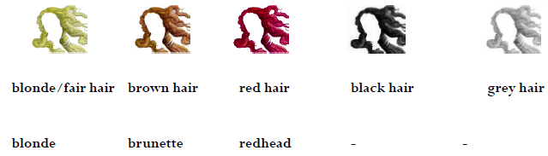

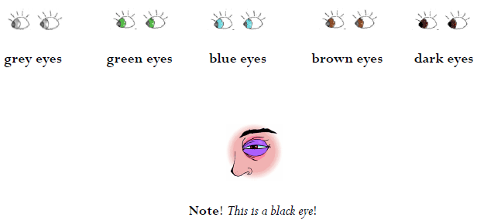

Types of hair
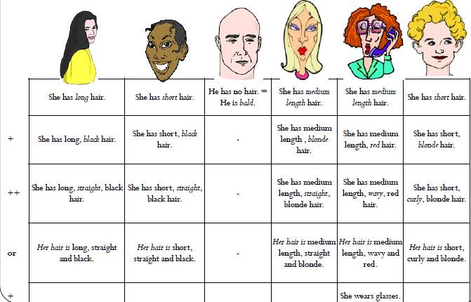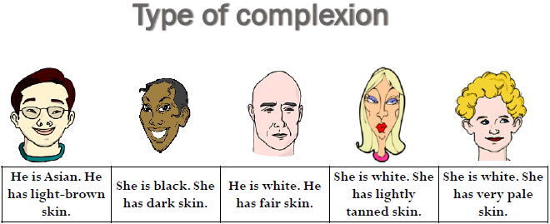

Stewart Six foot three. I'm serious.  Gus No kidding! So does he have curly black hair like you?  Stewart No, he's got straight blond hair and blue eyes. And he's thinner than me, too. I mean, he's really skinny.  Gus Wow! Do you two don't look at all alike!  Stewart No, not at all. | Gus What does your twin brother look like, Stewart? Do you look alike? I mean, are you identical twins?  Stewart No, we look totally different. Bill's a lot taller than me. He takes after my dad.  Gus How tall is he?  Stewart Six three.  Gus Huh? . . . How tall is he?
Describing People
* There are a number of expressions used to ask and answer questions to describe people.
Form
* Look like

What + do/does + subject + look like?
A: What does he look like?
B: He’s tall and thin and wears glasses.

Use
What + look like is used to ask about someone’s physical appearance?
What does Sami look like ?
He is short and fat, and he has black hair.

Note
* A: What does he look like? (Appearance)
B: He is young and has short hair.

* A: What’s he like? (Personality)
B: He is very kind and funny.

* A: How does he look? : What’s your opinion of his physical/ emotional condition
B: He looks tired / nervous?

Describing People
Form
* Look like

Who + do/does + subject + look like?
A: Who does he look like?
B: He looks like his father.

Use
Who + look like is used to ask about whom someone resembles.
A:Who does John look like?
B: He looks like Mr. Bean.

Describing People
Form
* Look alike
Do + subject + and + subject + look alike?
A: Do Ahmad and Ali look alike?
B: No, they look totally different.

Use
Look alike is used to ask if two people are similar in appearance.
A: Do Tom and Stewart look alike?
B: Yes, they’re identical twins.

Describing People
Form
* Yes/No questions with have
Do/Does + subject + have + described feature?
A: Does he have curly hair?
B: No, he has straight hair.

Describing People
Form
* How + adjective questions with be
How + adjective + be + subject?

A: How tall is he?
B: He is 175 cm.

A: How old is he?
B: He is 20.

Have got
* The verb “have got” is another way of saying “have”
have got = have
I’ve got red hair = I have red hair
He’s got short hair = He has short hair

1.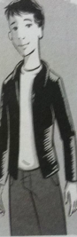 2.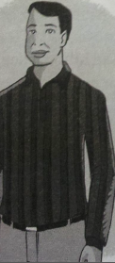
Look at the pictures. Correct the three mistakes in each description:
1. Paul is old. He's a little heavy. He's got blond hair. He looks a lot like Richard. He's wearing a black sweater.
Paul isn't old. He's young.
He is thin. He's got dark hair.
2. Richard is young. He's very thin with curly hair. He looks a lot like Paul. He's wearing a white sweater.
Richard is old. He's a little heavy.
His hair isn't curly, it's straight.
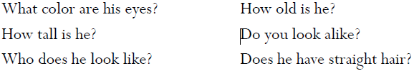

Complete the conversation with the missing questions:

George Did you meet my brother Bob at the class gathering yesterday?
Hamid Do you look alike? ?
George No, we look totally different.
Hamid Who does he look like? ?
George Actually, he takes after my dad. I look like my grandfather, I guess.
Hamid How tall is he? ?
George He's six four. He's a lot taller than me.
Hamid Does he have straight hair? ?
George No, he doesn't. it's very curly. But it's blond like mine.
Hamid What color are his eyes? ?
George he's got green eyes.
Hamid How old is he? ?
George He's twenty-one. Hey, there's Bob now! Let's go say hi!

Answer the questions with true information:
1. Are you taller or shorter than your parents?
I'm taller than my mother, but I'm shorten than my father.
2. Who do you look like?
________________________________________________________________________
3. How many people have dark hair in your family?
________________________________________________________________________
4. What famous person do you look like? In what way do you look alike?
________________________________________________________________________

By: samiyah al-zahrani..

