Psycholinguistics
Dr. Mohammad Almoaily

Textbook


Fundamentals of Psycholinguistics
Author:
Eva M. Fernandez and Helen Smith Cairns
Publisher:
WILEY-BLACKWELL
(2011)

Introduction
Content:
- What is psycholinguistics?
- Some disciplines related to psycholinguistics.
- Exemplary questions in the field of psycholinguistics.

Psycholinguistics
What is psycholinguistics?
“Psycholinguistics is an interdisciplinary field of study in which the
goals are to understand how people acquire language, how people use
language to speak and understand one another, and how language is
represented and processed in the brain”
(Fernandez and Cairns, 2011, p.1)
Some disciplines related to psycholinguistics:
- Phonetics
- Discourse analysis
- Language pathology (e.g. speech therapy)
- Neuroscience
- Language teaching
Exemplary Questions in psycholinguistics
- How are words and word meanings represented in someone’s mind?
- How are sentences composed in someone’s mind at the time of speech?
- How are words and sentences and their meanings analyzed at the time of listening or reading?
For example, we may ask:
How language is processed by the brain?
- Language perception (listening and reading).
- Language production (speaking and writing).
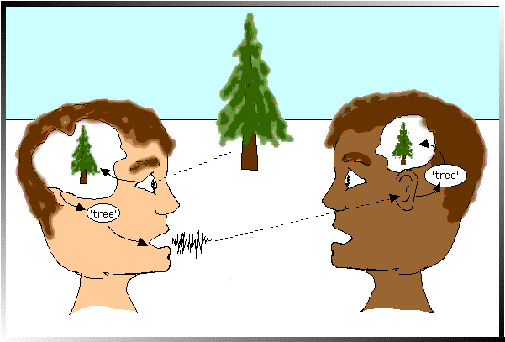

Picture references
- https://sites.google.com/site/wuhpnet/psycholinguistics

