Lecture 10
Speech Perception
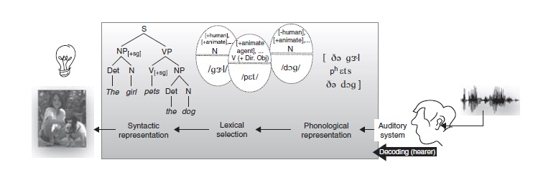
Contents:
Perceiving Speech
    - The phonemic inventory and speech perception
    - Constructive speech perception
    - Bottom-up and top-down information
    - Suprasegmental information in the signal
The Role of Orthography

Perceiving Speech

- The phonemic inventory and speech perception:
Knowledge of the phonemic inventory of a language is necessary for perception. This explains why is it easier for beginning language learners to understand material with subtitles.
- Constructive speech perception:
The perception system is constructive because it uses additional information to the signal, such as lip movement, in the perception of speech.

Bottom-up vs. top-down processing:

Bottom-up processing:
Using the acoustic signal (i.e. phonemes) to understand speech.
Top-down information:
Using contextual information to understand speech.
(e.g. sandstorm.. “…. …. … windows”).

- Suprasegmental information in the signal:
Variations in duration, pitch, stress, and amplitude (loudness) can affect speech perception. Compare: Trustee with trusty

The Role of Orthography in perception (while reading):

Orthography is the writing system of a language.
Researchers have found that phonology and orthography play an important role in the perception of written texts.
For example: French learners of English have difficulties identifying the phoneme /p/ in words like absurd than lapsus
Exercise

Knowledge of the phonemic inventory of a language is:
- Not necessary for perception
- Necessary for perception
- Necessary for production
- Both B and C

The answer is D

