Sixth Lecture
Grammar – Vocabulary – Reading
Chapter 4-5

Elements of Lecture
1. Previewing Vocabulary
2. Present Progressive Tense
3. Non-Action Verbs
4. Negative Form of Present Progressive
5. Forming Questions with Present Progressive
6. Spelling for Progressive Tense
7. Comparison: Simple present vs. present progressive
---------------------------------------------------
1. Vocabulary Previewing
( Interaction- pages 65 / 70 )
Adverbs | Adjectives |  |  | Verbs |  | Nouns | No.
often | bilingual |  |  | age |  | beverages | 1
never | chronic |  |  | damage |  | blood pressure | 2
sometimes | healthy |  |  | Exercise |  | brain | 3
 | mental |  |  | solve |  | diseases | 4
 | physical |  |  |  |  | Junk food | 5
 | Sleep- deprived |  |  |  |  | Stress | 6
 | Overweight |  |  |  |  | wrinkles | 7
 |  |  |  |  | dentist |  | 8
 |  |  |  |  | toes |  | 9
 |  |  |  |  |  |  | 10

Vocabulary Exercise
1. The word ‘ ___________” means lines on one’s skin
a. stress b. wrinkles c. beverages d. toes

2. “________” means that a person is unable to sleep.
a. sleep- deprived b. sleep too much
c. relaxed d. healthy
3. The word that has the same meaning as sickness is __________ .
a. wealth b. disease c. health d. earth
4. My friend suffers from ___________.He has become too fat.
a. overweight b. poorness c. English d. hard work
5. “ __________________” means worry.
a. Relaxation b. Stress c. Health d. highness
6. The opposite meaning of sick is ________________.
a. rich b. happy c. healthy d. tired

Vocabulary Exercise

7. The phrase “ get older” means ___________.
a. age b. to be young c. fat d. strong

8. “________” means not even once.
a. Always b. never c. sometimes d. rarely
9. The word that has the same meaning as “ drinks of all kinds” is___ .
a. water b. food c. vegetables d. beverages
10. “ Unhealthy things to eat” means__________________.
a. overweight b. junk food c. honey d. milk
11. “ __________________” means find an answer.
a. solve b. shake c. draw d. watch
12. The opposite meaning of “Physical” is ________________.
a. successful b. happy c. healthy d. mental

2.The Present Progressive (page 92)

This tense is used to describe an action that is occurring right now (at this moment, today, this year, etc.). The action has begun and is still in progress.

he is typing a paper for her class.
He can’t talk. He is fixing the sink right now

The Present Progressive (page 92)

John is living in Modesto, but he might move soon.

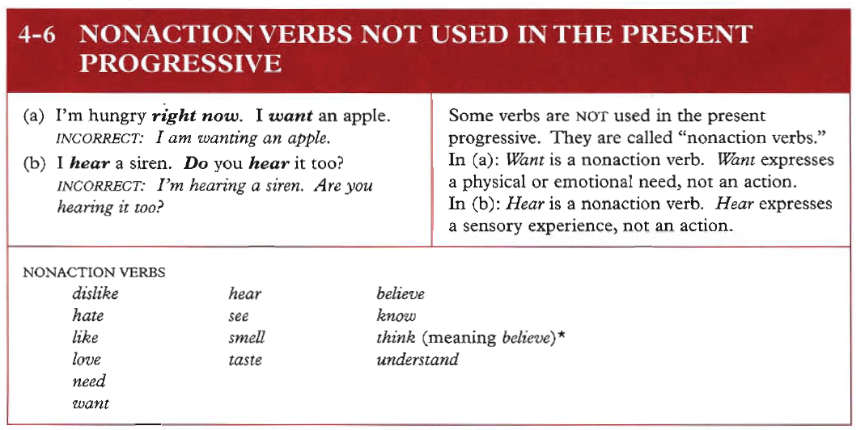

Examples:
1. I hear you now clearly.
2. They understand the lesson now.
3. Be careful! We smell dangerous chemical gas

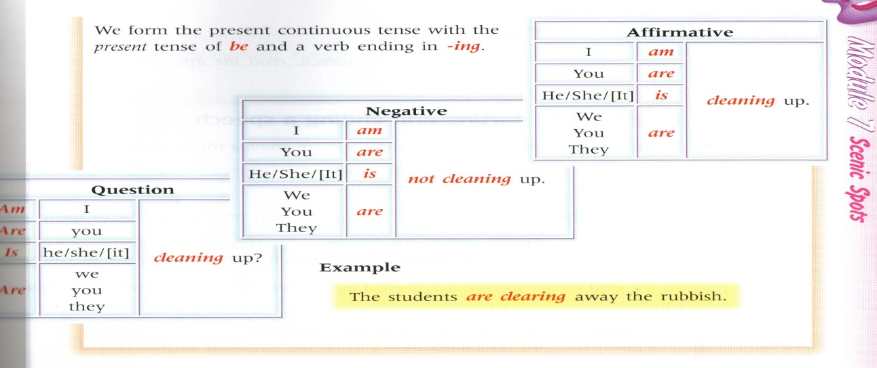

Most verbs | + ing | Walk walking
Verbs ending in e | -e + ing | Come coming
Verbs ending in ie | -ie + y + ing | Lie lying
Short verbs ending in a vowel + a consonant | Double the consonant + ing | Run running

AzNow try these ones:

drive driving
hope hoping
smile smiling
dance dancing

joke joking

shake shaking
choose choosing
come coming
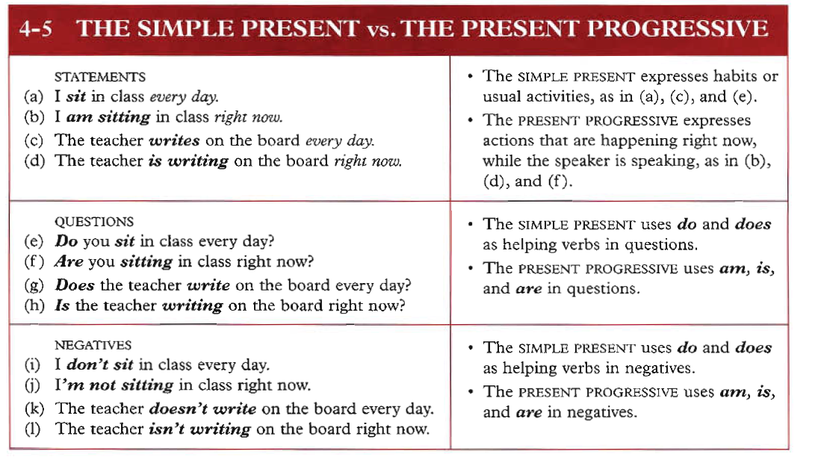

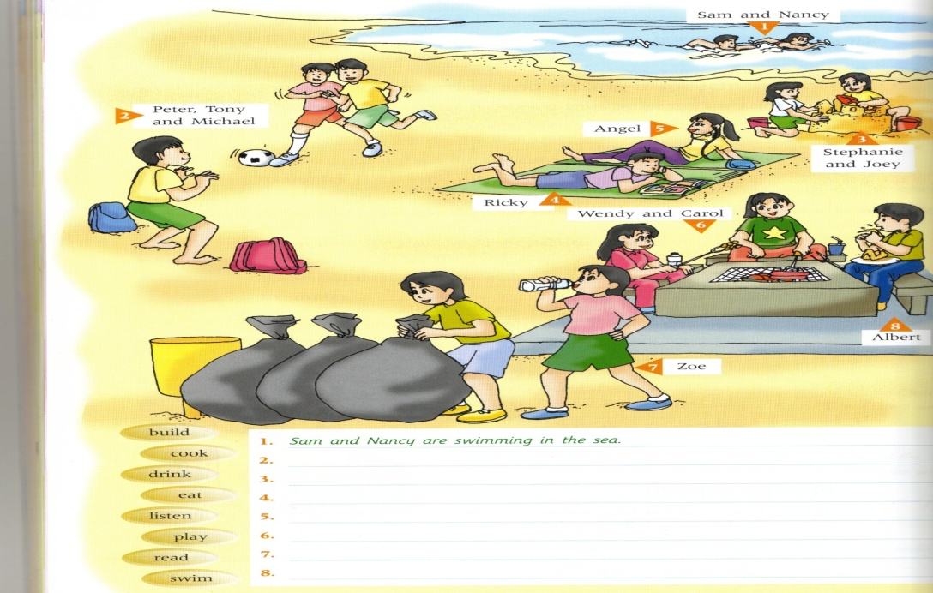

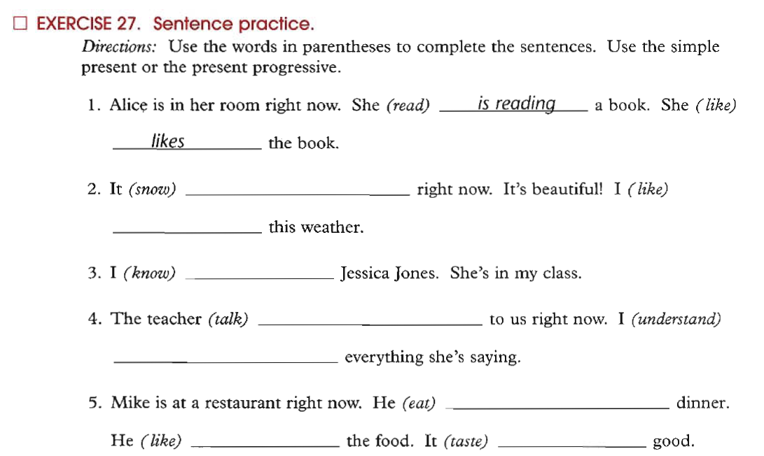

Sample Questions
1. The men ____________ in the building now.
a. worked b. works c. are working d. working

2. ___________________ waiting me at the moment? – near the pharmacy.
a. Where he is b. Where does he
c. Where did he d. Where is he
3. The boys __________________________ football now .
a. are play b. play
c. is playing d. aren’t playing
4. Listen! The baby ________________ in the next room.
a. will cry b. crying
b. are crying d. is crying
5. I can’t go with you. I ______________ my homework now.
a. did b. have don c. am doing d. do

Sample Questions
6. She ____________ meat with rice now.
a. isn’t liking b. doesn’t like c. is liking d. like

7. She___________________ meat with rice at the moment.
a. eats b. doesn’t eats c. is eating d. eat
8. The boys __________________________ football now .
a. are play b. play
c. is playing d. aren’t playing
9. look! The car________________ coming toward us.
a. will come b. coming
b. are coming d. is coming
10. My mother is in the kitchen. She ______________ now.
a. cooked b. have cooked c. is cooking d. cook

