Lecture 10
Unit 3 : health
Lesson A : in this learn, we’ll learn how to use the simple present continuous.
Jung food: food that is unhealthy but is quick & easy to eat.
Meat: the flesh of an animal when it is used for food.
Karate: a Japanese fighting sport, in which you use your feet & hands to hit & kick.
Weight: the amount that something or someone weighs.
Diet: the kind of food that a person eats each day.
Honwst: telling the truth or able to be trusted & not likely to steal, cheat or lie.
Snack: a small amount of food that is eaten between meals, or a very small meal.
Hiking: the activity of going for long walks in the countryside.

Complete the following sentences with the words from the box.
Jung food – meat – karate – weight – diet – honest – snack – hiking
- I like __________ . every weekend I go walking in the mountains. hiking
- You can trust ahmad. He is a very ___________ man. honest
- You should eat vegetables & fruits.___________ is very unhealthy. Jung food
- Don’t eat large meals all the time. Sometimes a small_________ is better. snack
- I think the best sport is ___________. You learn how to fight & defend yourself. karate
- I have some extra killos. I should lose some________. weight
- If you want to lose weight, it is important to have a healthy_________. diet
- Eating vegetables is very healthy, but I prefer to have________ for lunch. Meat

Healthy living
Are you doing anything to stay healthy?
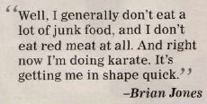
1)
§ brian doesn’t eat a lot of jung food.
§ he doesn’t eat red meat.
§ he is doing karate.

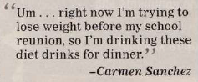
2)
* Carmen is trying to lose weight.
* she is drinking diet drinks for dinner.

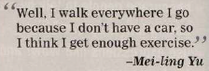
3)
# mei-ling walks everywhere because she doesn’t have a car.
# she thinks she gets enough exercise.

4)
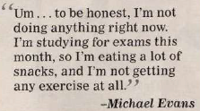
$ micheal is not doing anything right now.
$ he is studying for exams this month.
$ he is eating a lot of snacks.
$ he isn’t getting any exercise at all.

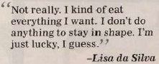
5)
% lisa eats everything she wants.
% she doesn’t do anything to stay in shape.

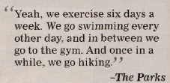
6)
- The parks exercise six days a week.
- They go swimming every other day, in between they go to the gym.
- Once in a while, the go hiking.

Complete these sentences with a simple present or present continuous verb.
- I usually _________ to the gym twice a week. go
- This month, I __________ a lot of snacks. Am eating
- I generally ___________ healthy food. Eat / have
- I _________ karate right now. Am doing
Present simple
Use Present simple to talk about “all the time” and routines . (facts & habits)
How do you stay in shape?
I walk everywhere.

Do you exercise regularly?
Yes, I do. I exercise six days a week.
No, we don’t. we don’t exercise at all.

Present continuous
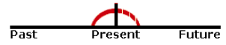
Use 1:
Use Present continuous to talk about “now”
- I am sitting.
- I am not standing.
- You are learning English now.
- What sports are you playing these days?
I am doing karate. It’s getting me in shape.

The structure of the present continuous tense is:
Subject + auxiliary verb+ main verb
Be + (base+ing)
 | subject | auxiliary verb |  | Main verb
+ | I | Am |  | Speaking | To you.
+ | You | Are |  | Reading | This.
- | She | Is | Not | Living | In London.
- | We | Are | Not | Playing | Football.
? | Is | He |  | Watching | TV?
? | Are | they |  | Waiting | For john?

Use 2:
Use Present continuous to talk about temporary events.
Longer actions in progress now
- I am studying to become a doctor .
- I am not studying to become a dentist.
- I am reading the book tom sawyer.
- Is she trying to lose weight?
Yes, she is. She’s drinking diet drinks.
No, she’s not . she’s not trying to lose weight.
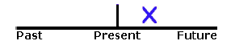
Use 3: near future

- I am visiting my grandparents next Friday.
- I am not working next week.
- Are you playing football this weekend?

Non-continuous verbs
Abstract verbs
To be , to want, to cost, to seem, to need, to care, to contain, to owe, to exist…
Possession verbs
To possess, to own, to belong, to have…
Emotion verbs
To like, to love, to hate, to dislike, to fear, to envy, to mind…
Examples:
He is needing help now. Not correct
He needs help now. Correct
He is wanting a drink now. Not correct
He wants a drink now. Correct

