LECTURE 9 Unit 2 Interests
REALLY
•I really enjoy knitting.

•I really like making things.

•I’m not really into photography

•I don’t really have much time

for hobbies

•No, not really

ANSWER THE FOLLOWING QUESTIONS. GIVE YOUR OWN ANSWERS USING REALLY OR NOT REALLY .
1.Are you interested in sports?
Not really. I don’t really play any sports.

2. Are you into computers?
Well, I am really into computer games.

3. Do you enjoy doing jigsaw puzzles?
Not really. I think jigsaw puzzles are boring.

4. Are you good at fixing things?
No, not really. I’m not good with my hands.

5. Do you make your own clothes?
No, I’m not really into sewing. But I really like shopping.

LINKING IDEAS

Add an idea
I do photography, and I like art.
I also like books, especially history books.
I don’t like biographies or poetry.

Contrast two ideas
I like climbing, but my friends don’t.

Give a reason
I can’t go on vacation because I have some work to do.
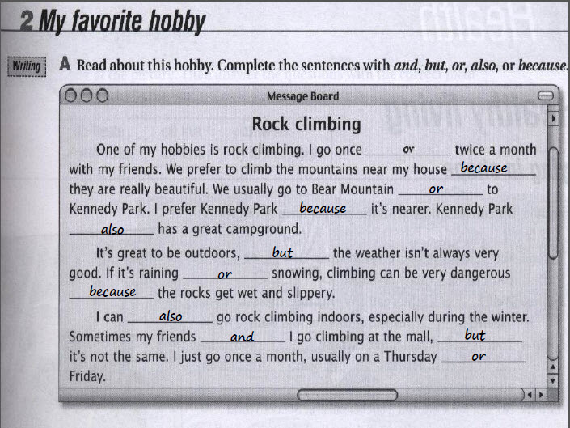
EXERCISE
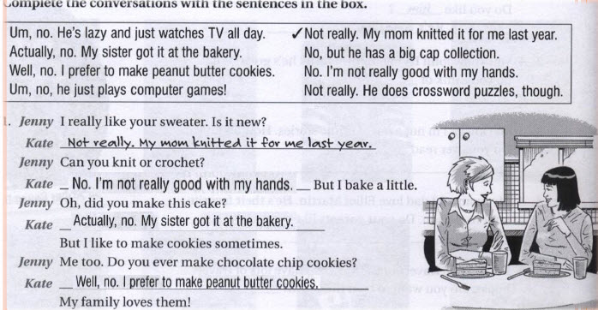
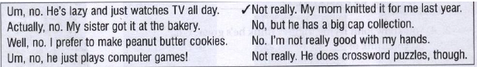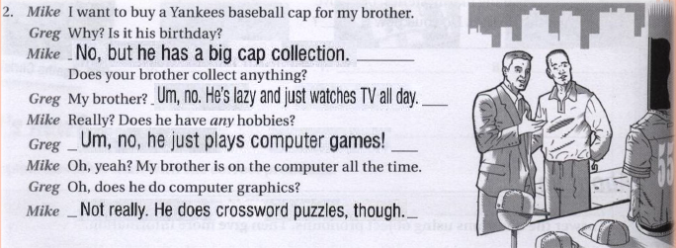
READING
TOPIC SENTENCE

What is the topic sentence?
The topic sentence is the first sentence in a paragraph. It gives the reader an idea of what the paragraph is going to be about.
(Ask yourself what the paragraph is about.)

What does it do?
It introduces the main idea of the paragraph.
THE INTRODUCTION PARAGRAPH

The first paragraph is called the Introduction. The introduction paragraph has two main purposes:

 1. It introduces the topic to prepare the reader for what you will be reading.
 2. It attracts the reader’s attention so that they will be interested in reading more.

READING EXERCISE

READING EXERCISE
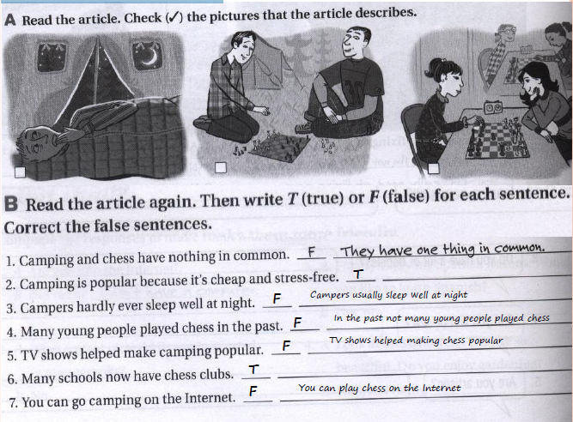

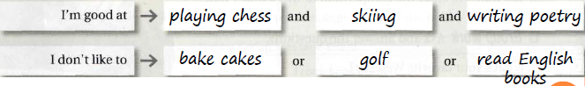

sportsoccereadingrammar
chessingingamesurfing

UNIT REVISION
VOCABULARY
Hobby
Novel
Sculpture
Design
Jog
Crime
Poetry
Biography
Mystery
Science
Knit
Sweater
Sew
Crochet
Photography
CAN
Can is an auxiliary verb, a modal auxiliary verb. We use can to:
talk about possibility and ability
make requests
ask for or give permission

Structure of Can
subject + can + main verb (base verb)
  Subject
  Auxiliary Verb
  Main Verb
+ | I
  can
  play
  tennis
- | He | cannot  can‘t
  play
  tennis
? | Can
  you
  play
  Tennis ?

GRAMMAR: VERB FORMS

EVERYBODY & NOBODY
1.All the students are here today.
2.There are no students here today.
A .No body is here today. No one is here today
B .Everybody is here today. Everyone is here today

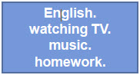

OBJECT PRONOUNS
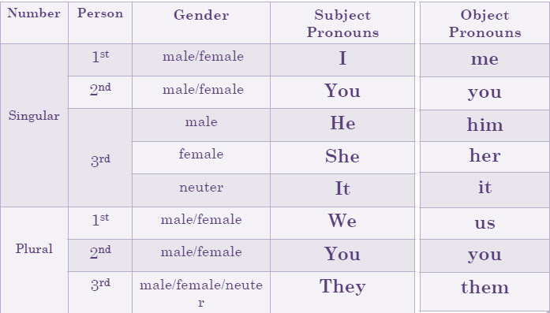
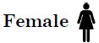
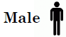

Which object form of the personal pronoun can substitute the underlined phrase in the sentence
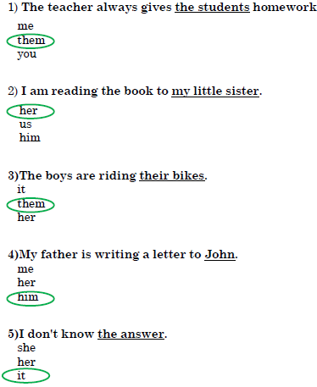

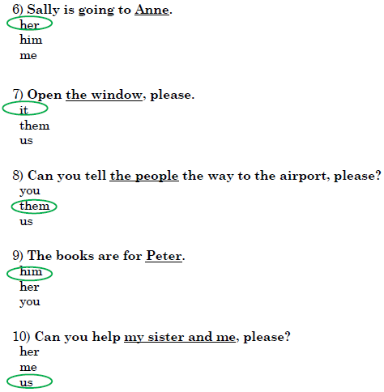

OBJECT PRONOUNS : EXERCISE
1."Your son is making a lot of noise!"
"I'll ask him to be quiet.“

2."Where are my glasses?"
"You are wearing them !“

3."Look at Sarah! She seems so happy?"
"Her father offered her a car for her birthday!“

4."What are you going to do with those old papers?"
"I'm going to recycle them .“
5."How are your kids?
"I haven't met them for ages!“

6."Have you met Alan and Tim?"
"No, I have never met them ."

7."Do you want this book?"
"Yes."
"Well, take it."

8."My mother is fantastic! I like her very much."

9."Don't help me with this exercise! I can do it by myself.“

10."Take the children to bed. Don't let them watch TV

SUBJECT VS. OBJECT
○ I called you.
 You called me.

○ Ahmad and I are at school.
○ John and he go to the gym.

○ I send emails to you and them.
○ How can he blame you and him for the accident.

○ I speak with him
○ He is taller than me
○ I bought a book for him

Exercise

Good luck for all

توتا الشمري
☺

