LECTURE 12 Unit 3 Health
Look at the picture. Then answer the questions with the correct form of the verbs in the box
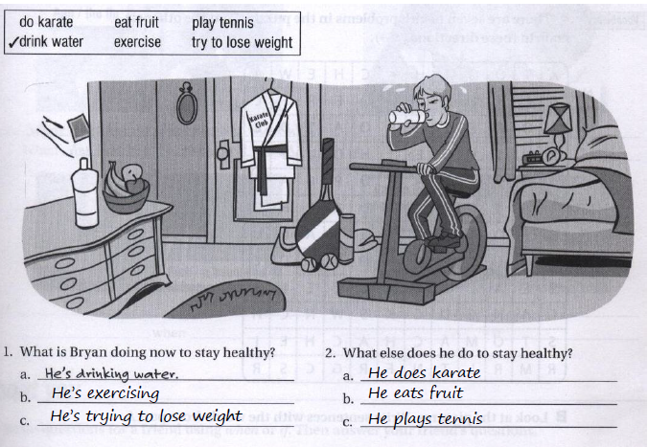
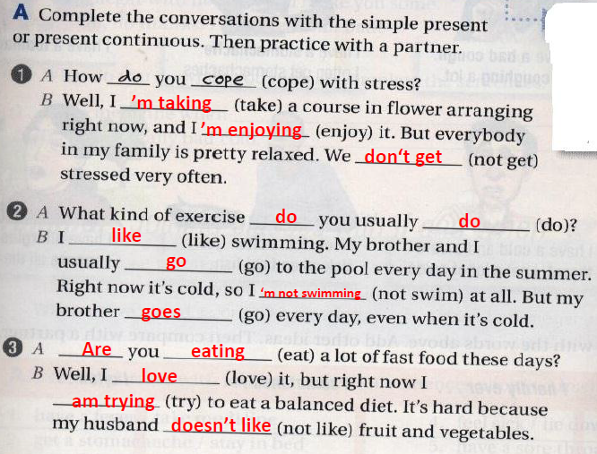
ACHES AND PAINS
Fever: an illness or a medical condition in which you have a very high temperature.
The flu: a common illness that makes you feel very tired and weak, gives you a sore throat, and makes you cough and have to clear your nose a lot [influenza] Cough : to suddenly push air out of your throat with a short sound, often repeatedly.
LECTURE 12 Unit 3 Health
Stomachache : pain in your stomach or near your stomach.
toothache : a pain in a tooth
headache: a pain in the head

A cold: a common illness that makes it difficult to breathe through your nose and often makes your throat hurt.

Sore throat: a pain in the front of your neck.

sick : suffering from a disease or illness. if you are sick, the food in your stomach comes up through your mouth [vomit, throw up]
allergy: a medical condition in which you become ill or in which your skin becomes red and painful because you have eaten or touched a particular substance
sneeze: if you sneeze, air suddenly comes from your nose, making a noise
Pain , Ache ,Sore
Pain: for a short time.
After the accident I felt a pain in my knee.
ache: for a long time.
I have a bad headache.
sore: a pain to the move, touch or swallow.
I have sore eyes.
His elbow is sore
Adverbs of Frequency
Never: at no time.
I never get colds. I always feel healthy.
Hardly ever: almost never.
I hardly ever have a stomachache.
Sometimes: from time to time, now and then.
Sam sometimes gets a toothache. He eats a lot of candies.
Often: many times, frequently.
They often feel sick after having seafood.
always: all the time.
I love chocolate. I always eat it
LECTURE 12 Unit 3 Health
Joining Clauses With if and when :
What is a clause?
A clause is a group of words that contains a verb (and usually other components too). A clause may form part of a sentence or it may be a complete sentence in itself. For example:
He loves sports, and he plays football on weekends.
I am driving the car that I bought last week.

When: for usual situations.
If: for unusual situations.

I watch TV when I have free time.
When I feel tired, I get some rest.

I’ll visit Eiffel Tower if I go to Paris.
If it rains tomorrow, I’ll stay at home.
Exercise 1:
Join the phrases with when and if to make true sentences about yourself:
1. Have a fever/ take medicine.
When I have a fever, I usually take medicine.

2. Get a stomachache / stay in bed
I hardly ever stay in bed when I get a stomachache.

3. Have a cough / go to the doctor
Sometimes I go to the doctor when I have a cough.

4.Feel sick / lie down for a while
When I feel sick, I usually lie down for a while.

5. Have a sore throat / drink hot tea with honey
When I have a sore throat, I always drink hot tea with honey.
LECTURE 12 Unit 3 Health
6. Have a headache / take aspirin
When I have a headache, I never take aspirin.
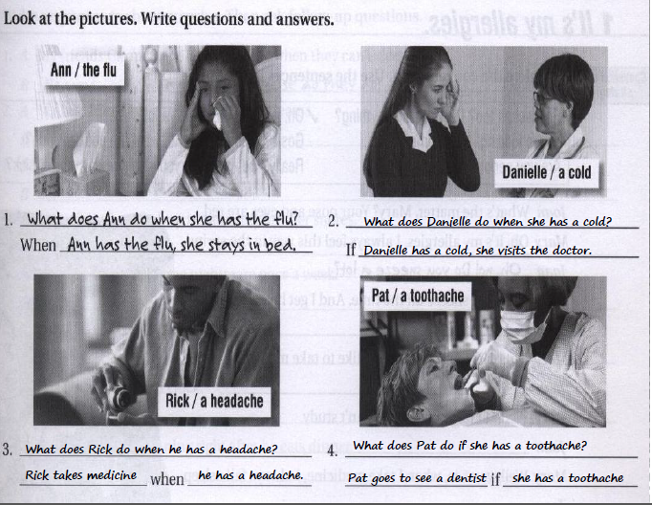

Good luck for all ☺
Toota

