English 101
Lecture (6)
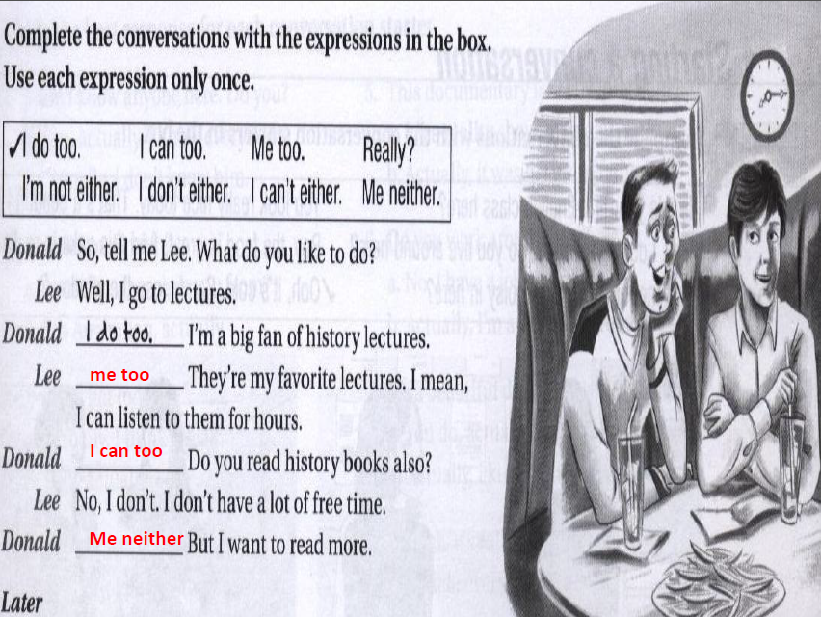
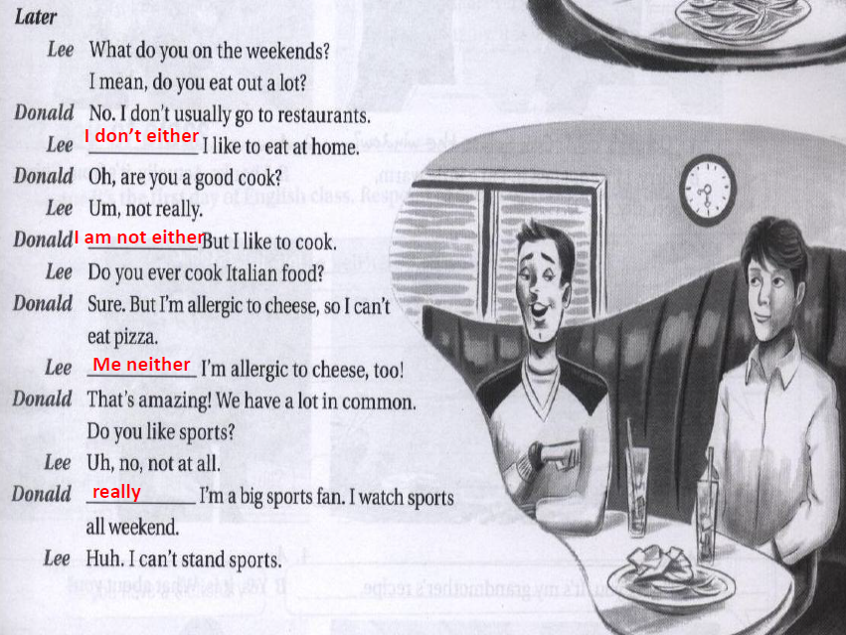
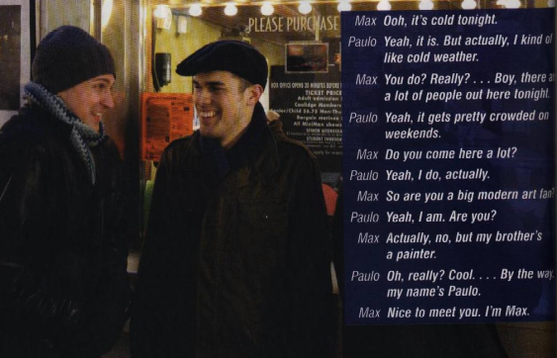
Think of a Way to Start a Conversation .:-
1. ) You met someone new at a family party. The food is really good.
This food is delicious!
2.) It’s a very windy day. You’re just arriving at a new class.
It’s really windy today. / Is this room B?
3.) You’re in a long line in a museum. It’s a cold day.
It’s freezing out here. / This exhibit got a great audience.
4.) You’re working out at a new gym. The room is very hot.
Do you think this room is too hot?
5.) You’re in a new English class. You meet someone during the break.
Do you want to get some coffee?
6.) You’re at the bus stop on a beautiful day. Someone arrives and smiles at you.
How often does this bus come?
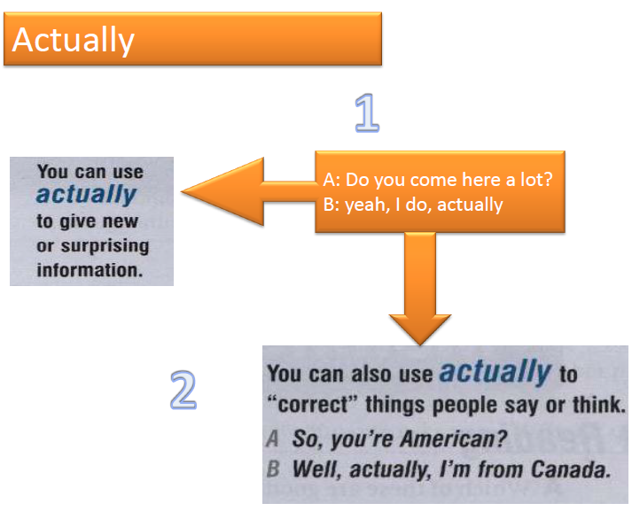
Match each conversation starter with a response .:
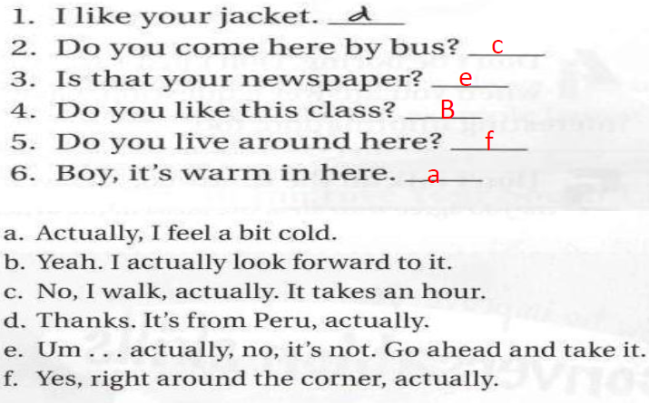

- Choose the best response for each conversation starters:

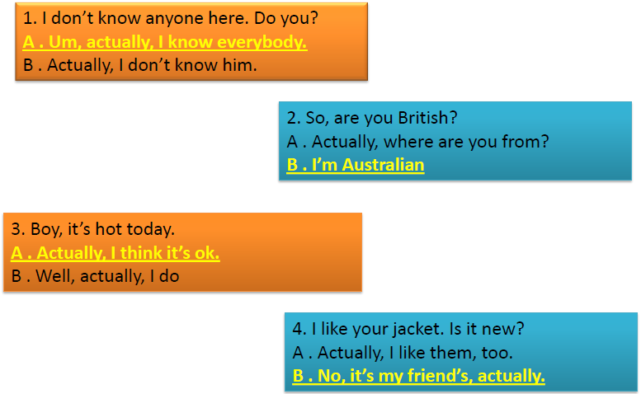
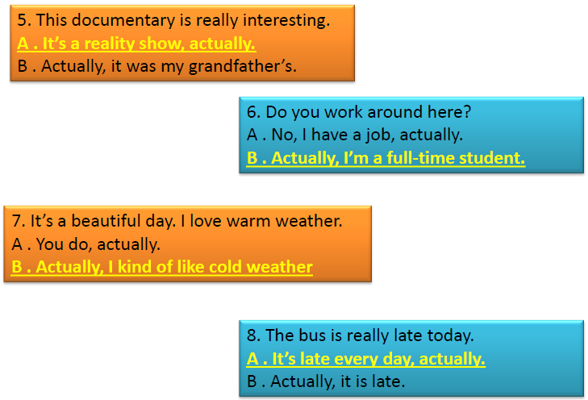

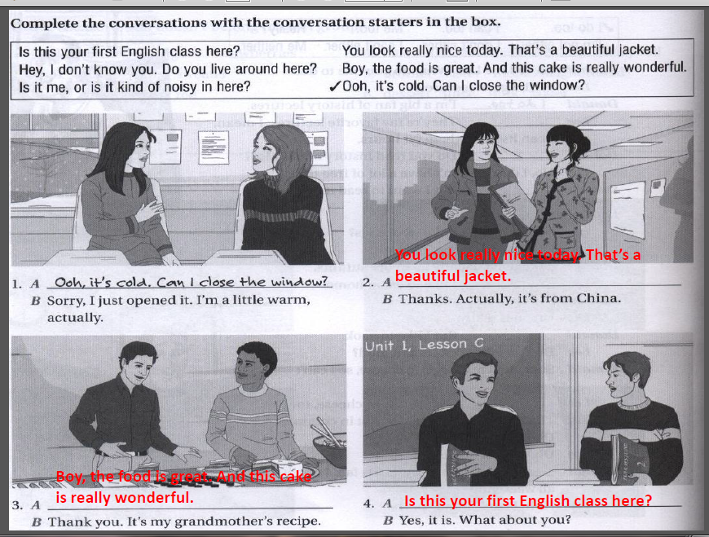
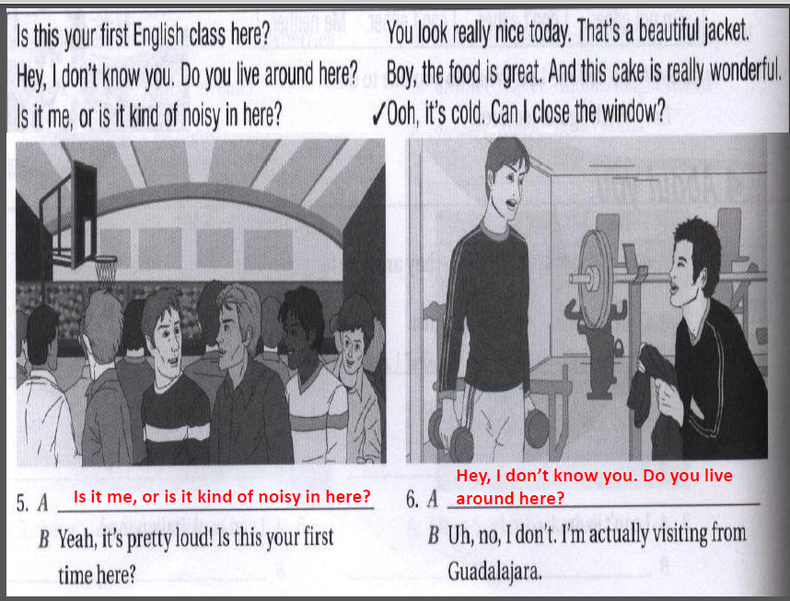
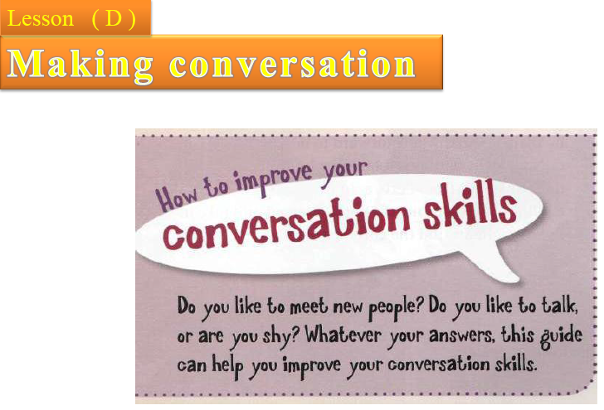
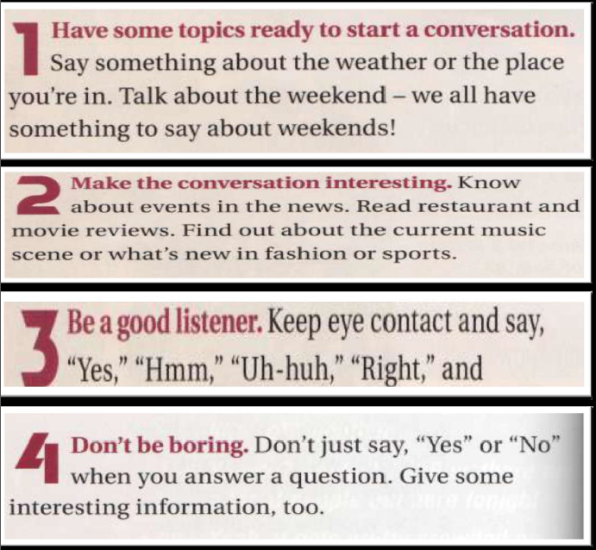
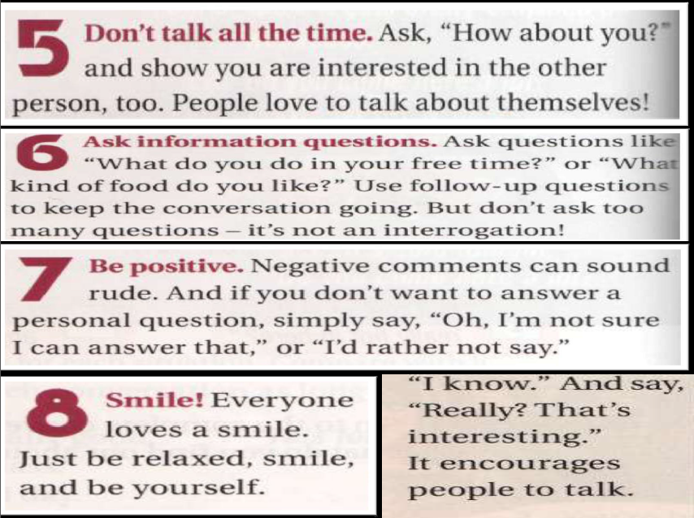

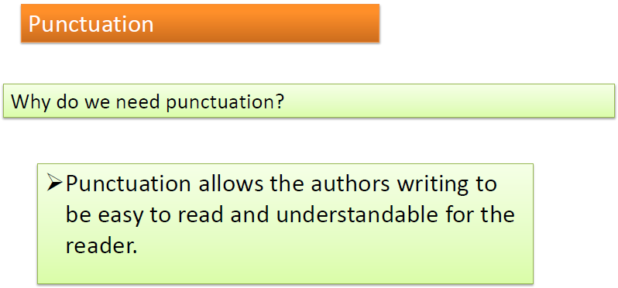

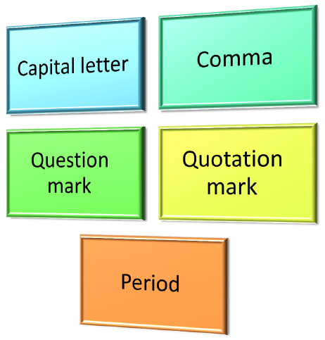

•1.Use Capital letter to start a sentence.
I am a good student.
He was born on August 4th, 1990.
•2.Use a comma (,) before quotation marks (“ ”) and lists.
The teacher says, “study hard to pass the exam”.
She has two dogs, three cats, one bird, and five fish in
her house.

•3. Use a period (.) at the end of a statement and a question mark (?) at the end of a question.
I went to the store for groceries.
Will you come over after school?

