Lecture 22
Unit 7 –Going Away
Lesson A: Getting Ready
New Vocabulary :
 Pack: to put things into cases, bags etc. ready for a trip somewhere

 Suitcase: a large case with a handle, used for carrying clothes and possessions when you travel.
 Cap: a taxi

 Cheap: low price. [≠ expensive]

 Flight: a journey in a plane

 Bargain: something you buy cheaply or for less than its usual price.

 Relative: a member of your family

 Snorkeling: when you swim under water using a snorkel. A snorkel is a

tube that allows someone who is swimming to breathe air under water.

 Schedule: a list that shows the times that buses, trains etc. leave or arrive at a particular place [= timetable]
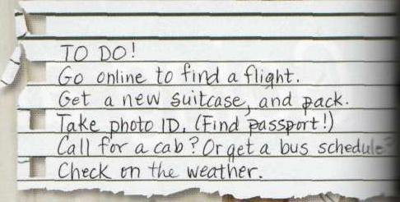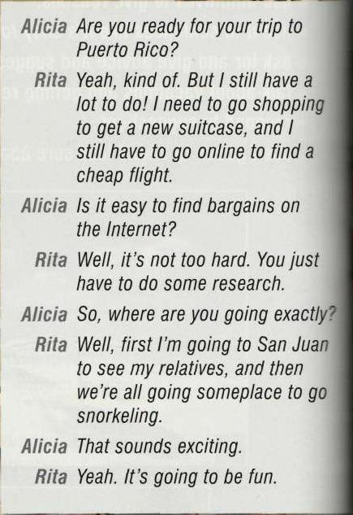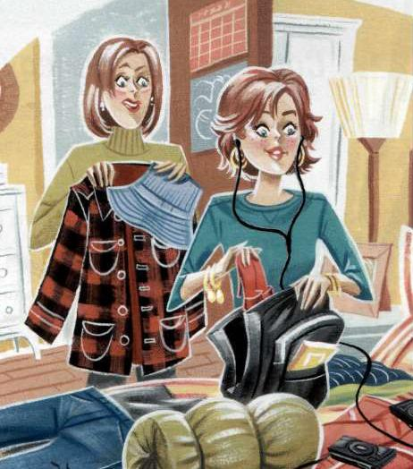

Infinitives for reasons
Use
To give a reason
to answer the question “why”
Form
Main clause + infinitive for reason
I have to go online to find a f light.
I’m going to San Juan to see my relatives.
He has to go to the bank to change some money.

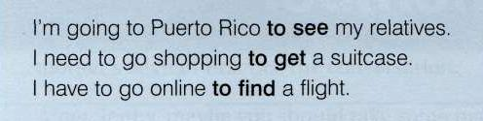
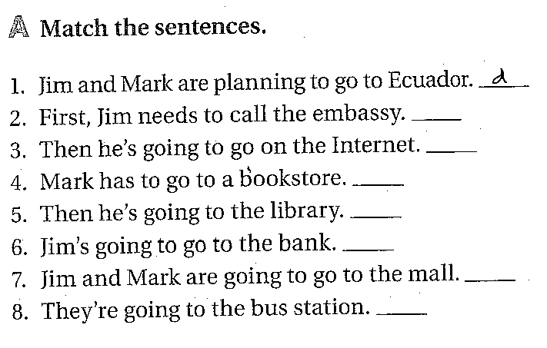
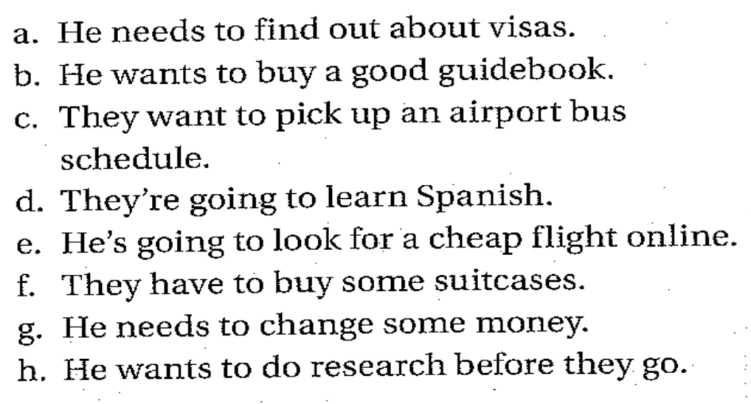

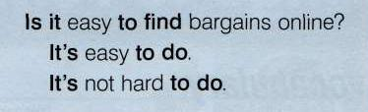
Grammar
 Affirmative statements
It’s + adjective + to . . .
It’s easy to find cheap f lights.
It’s fun to meet new people.
It’s good to know a little of the language.

 Negative statements
It’s + not + adjective + to . . .
It’s not hard to do.

 Questions with “Is it”
Is it + adjective + to-infinitive?
Is it easy to find parking spaces here?

1-i need to get a phrase book to learn some expressions.
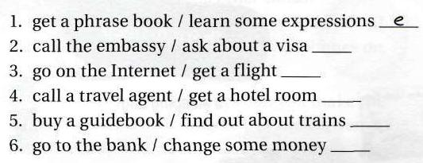
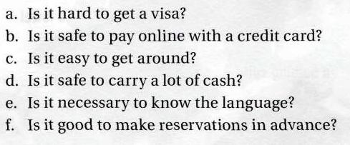
Lesson B : Things to Remember
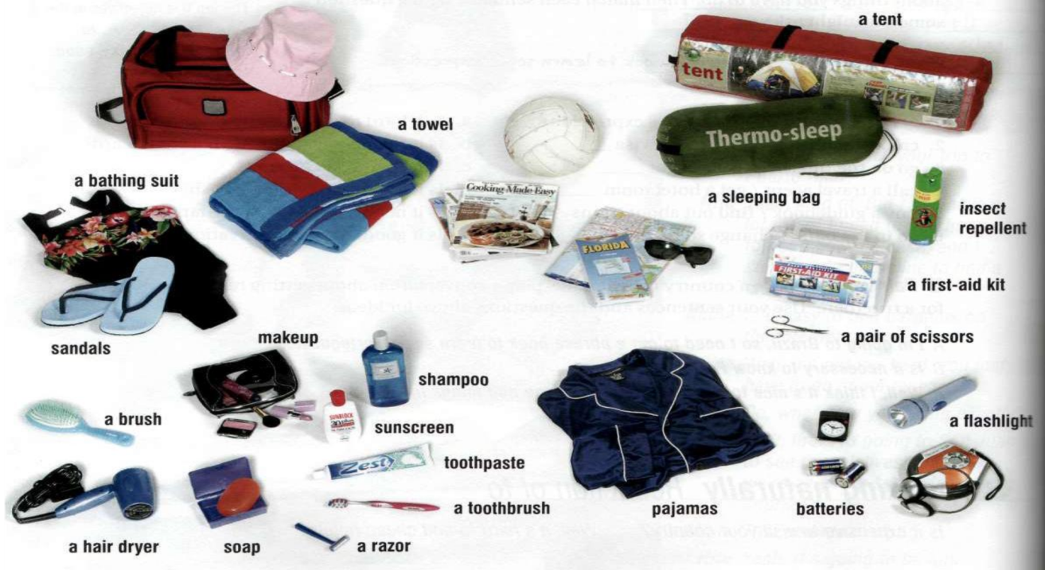
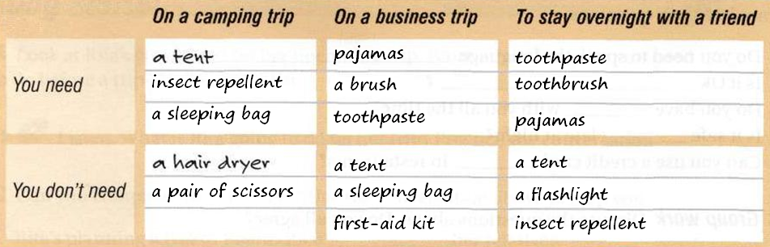
Building Language
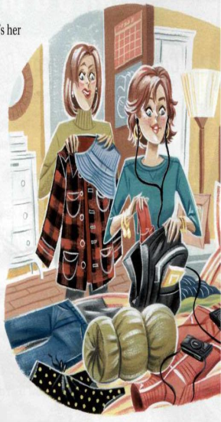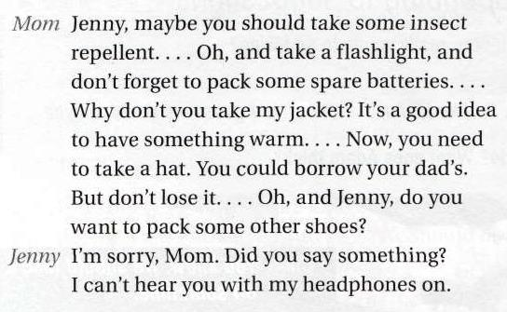

Advice and Suggestions
Suggestions   Could  Subject + could (not) +base verb  You could borrow your dad’s hat You couldn’t go without a camera   Questions with: Why don’t you ….?  Why don’t you take my jacket   Questions with: Do you want to …?  Do you want to pack some other shoes?   The expression: It’s a good idea to …  It’s a good idea to take your sunglasses. | Strong Advice   Should  Subject + should (not)+ base verb  You should take some insect repellant.  You shouldn’t carry a lot of cash with you.   Need to  Subject + need to + base verb  You need to take a cap   Imperatives  Take a hat  Don’t forget to pack a jacket

