Lecture 25
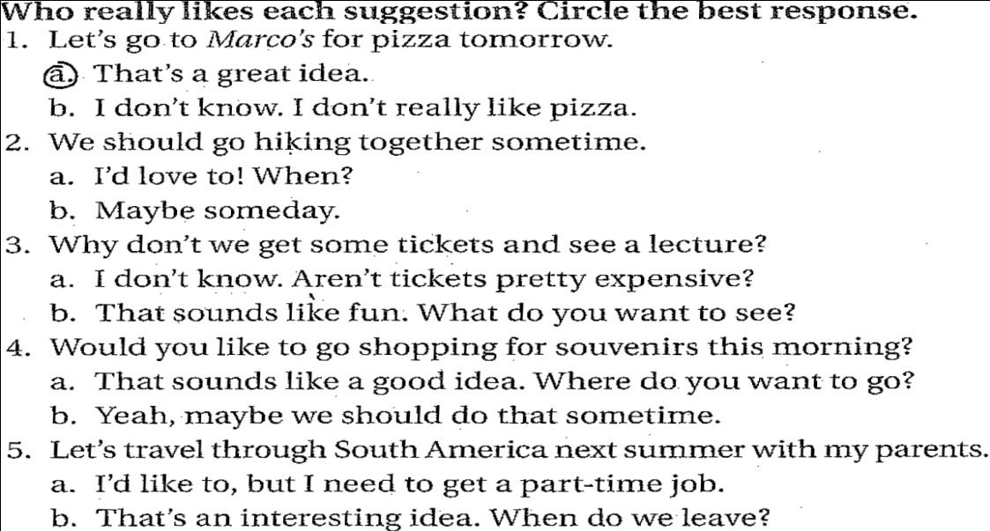
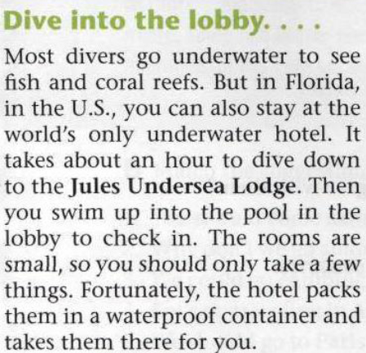 | 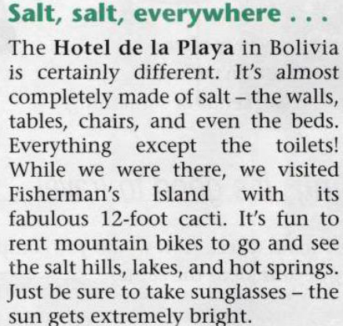 | 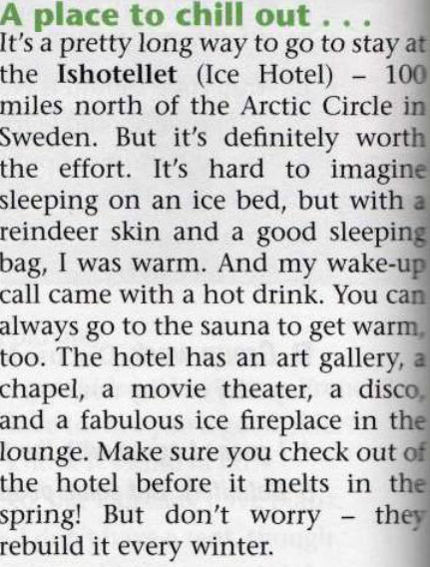
1.The hotel is:  a. on water  b. above water.  c. under water  d. over water  2.You must __________ to get to the hotel  a. walk  b. dive  c. swim  d. run  3.You can take ______________ with you.  a. some things  b. a suitcase  c. a bag  d. a lot of things | 1.______________ in the hotel is made of salt.  a. Everything  b. Almost everything  c. Some things  d. Nothing  2.If you want to go there, don’t forget to take:  a. a mountain bike  b. cacti  c. sunglasses  d. salt  3.It’s fun to see ____ there.  a. the nature  b. the bright sun  c. the mountain bikes  d. the sea | 1.It’s ___________ to get to the hotel  a. hard  b. easy  c. not difficult  d. impossible  2.In the hotel, you will sleep in:  a. sleeping bag  b. ice bed  c. reindeer skin  d. ground  3.The best time to go there is  a. in spring  b. in summer  c. before winter  d. in the middle of winter

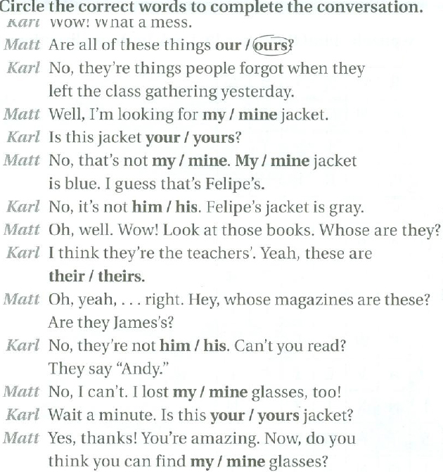

Amjad Al-Ghamdi

