Lecture 23
Going away
# New Vocabulary:
Pack: to put things into cases, bags etc. ready for a trip somewhere
Suitcase: a large case with a handle, used for carrying clothes and possessions when you travel.
Cab: a taxi
Cheap: low price. [≠ expensive]
Flight: a journey in a plane
Bargain: something you buy cheaply or for less than its usual price.
Relative: a member of your family
Snorkeling: when you swim under water using a snorkel. A snorkel is a tube that allows someone who is swimming to breathe air under water.
Schedule: a list that shows the times that buses, trains etc. leave or arrive at a particular place [= timetable]
# Infinitives for reasons:
Use  to give a reason  to answer the question “why” | Form  Main clause + infinitive for reason  I have to go online to find a flight.  I’m going to San Juan to see my relatives.  He has to go to the bank to change some money.
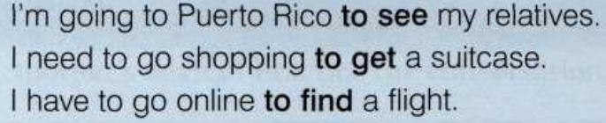
Grammar  Affirmative statements  It’s + adjective + to . . .  It’s easy to find cheap flights.  It’s fun to meet new people.  It’s good to know a little of the language. | Negative statements  It’s + not + adjective + to . . .  It’s not hard to do.  Questions with “Is it”  Is it + adjective + to-infinitive?  Is it easy to find parking spaces here?
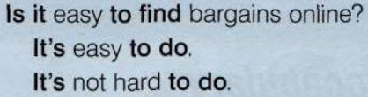
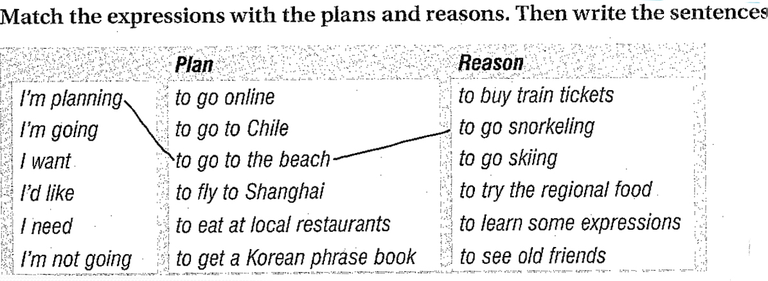
1. I’m planning to go to the beach to go snorkeling.
2. ________________________________________.
3. ________________________________________.
4. ________________________________________.
5. ________________________________________.
6. ________________________________________.
# Lesson B: Thing to Remember:
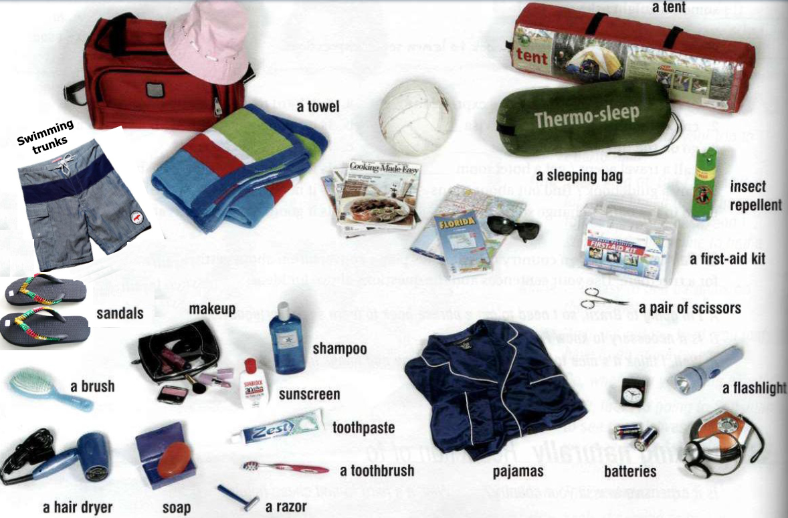
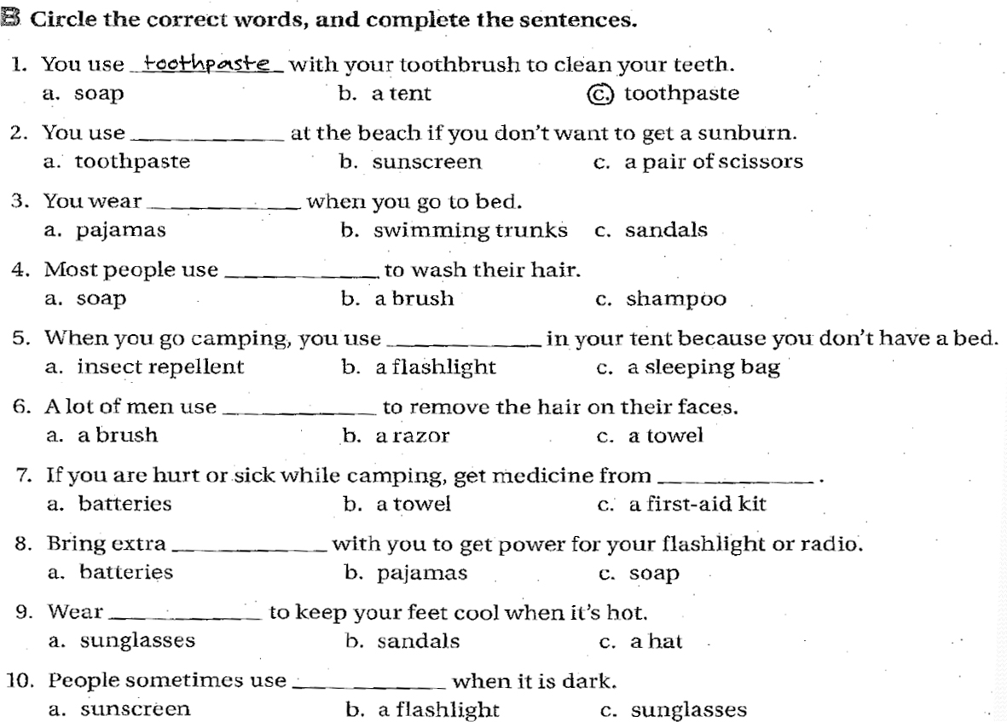
# Advice and Suggestions:
Strong Advice  Should  Subject + should (not) + base verb  You should take some insect repellant.  You shouldn’t carry a lot of cash with you.  Need to  Subject + need to + base verb  You need to take a cap  Imperatives  Take a hat  Don’t forget to pack a jacket | Suggestions  Could  Subject + could (not) + base verb  You could borrow your dad’s hat  You couldn’t go without a camera  Questions with: Why don’t you ….?  Why don’t you take my jacket  Questions with: Do you want to …?  Do you want to pack some other shoes?  The expression: It’s a good idea to …  It’s a good idea to take your sunglasses.

# Conversation strategy Responding to suggestions:
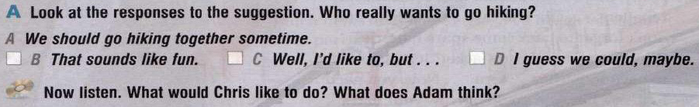
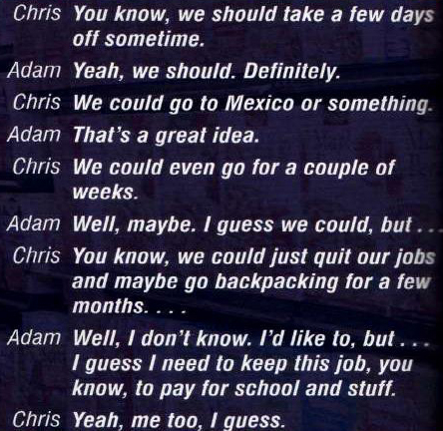
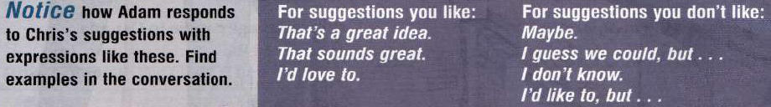

B. Match the suggestions with the responses:
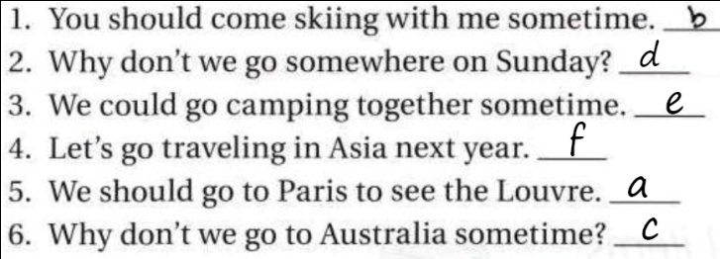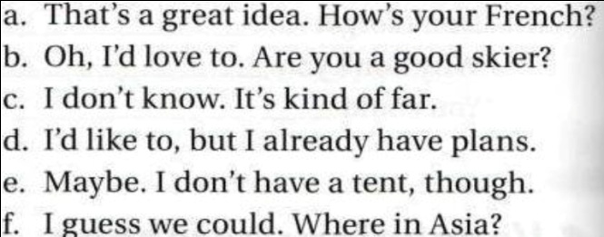

Amjad Al-Ghamdi

