Lecture 26
Unit 8

Things at home

Kitchen | Living room | Bathroom | Bedroom
Cabinets | Armchair | Mirror | Clock
Dishwasher | Lamp | Sink | Nightstand
Faucet | End table | Toilet | Carpet
Stove | Sofa | Bathtub | Curtains
Microwave | Cushions | Shower | Dresser
Oven | Coffee table
BUILDING LANGUAGE
2) John: those small round speakers are cool.  Andy: Which once? The little silver once?  Jon: Yeah. The once on the right. | 1) Meg: Hmm. The rug in the middle is nice, and I like that red one, too. Which one do you like?  Lia: I like all of them. They're all nice.

1) A Which rug do you like? Do you like the blue ____________?
B Not really. I like the ______________ one ______________.
2) A Which speakers do you like? The silver ______________?
B Uh, no, I like the ________________ ones.

Order of Adjectives:
Before a noun, the usual order of types of adjectives is:
Noun | Material | Nationality | Shape | Color | Size | Opinion
Carpet | wool | Thai | square | blue | big | Beautiful
 | metal | Iraqi | rectangular | red | little | Awesome
 | plastic | English | round | black | small | Pretty
 | cotton | American |  |  | tiny | Ugly
 |  |  |  |  |  | Disgusting

 | I like the green rug. Which one do you like?  I like the blue one in the middle.  Those speakers are cool. Which ones do you like?  I like the silver ones on the right. |  | Usual adjective order:  opinion, size, color, shape, nationality, material  they have beautiful Turkish rugs.  I like the big red rug.  I want those cute little round speakers.
3) I'd like to buy the __________.  Which ________ would you like? |  | 2) I don't like the _________.  Which _________ do you like? |  | 1) I like the __________.  Which __________ do you like?
Lesson c
Do you mind . . .?
1. Conversation strategy Asking politely
A In which request is someone (a) asking you do something?
(b) asking permission to do something?
Would you mind opening the window? _______
Do you mind if I open the window? ______
Claudia: Hello! Come on in.
Mei: These are for you, Claudia. Are the others here yet?
Claudia: Oh, thank you. No , not yet. So just main yourself at home. Can I get you some tea?
Mei: No, thank you. I'm fine. Do you mind it call my husband?
Claudia: No, go ahead. After your phone call, would you mind helping me in the kitchen? I hate to ask you, but I'm running a bit late.
Mei: No, not at all. What can I do?
Claudia: Well, . . . could you chop the onions?
Mei: No problem. I'm happy to help.
"Do you mind . . .?"  "No, go ahead."  "Would you mind . . .?"  "No, not at all." | Notice how Mie uses Do you mind. . .? to ask for Permission, and Claudia uses Would you mind . . .? to ask Mei to do something.  Also notice than they answer no to show they agree. Find the example in the conversation.

Complete the questions with Would you mind or Do you mind it:
1. A ________________________ I borrow your dictionary?
B No, Not at all. Go ahead.
2. A ________________________ answering the phone for me?
B OH, no. No problem.
3. A ________________________ closing that door?
B No, not at all.
4. A ________________________I take off my shoes?
B No, Go right ahead.
5. A ________________________ I use your complete for a minute?
B No problem.
6. A _________________________ handing me the potato salad?
B Of course not. Here you are.
7. A _________________________ opening the window?
B I'd be happy to.
8. A _________________________ I eat the last piece of apple pie?
B Not at all. Go ahead.
9. A _________________________ I turn on the news foe a minute?
B Not, not at all.
10. A ________________________ tuning down the radio a little?
B No problem. Is this OK now?

AGREEING TO REQUESTS
Answer No to agree to requests with mind:  Do you mind if I use your phone?  No, go (right) ahead. / No, not at all  Would you mind helping me in the kitchen?  No, not at all. / Oh, no. No problem | Answer Yes to agree to requests with Can and Could:  Can I use your phone?  Yes. / Sure. / Go (right) ahead.  Could you chop the onions?  Yes. / Sure. / OK. / No problem.
Complete the answers. Then practice with a partner:
1. A I hate to ask this, but would you mind turning off your cell phone during dinner?
B _________________________. But do you mind if I make just one quick call?
1. A Do you mind if I use your computer to check my e-mail?
B _________________________. Go right ahead.
3. A Can I borrow your cell phone for a few minutes?
B Well, I'm expecting a call, but ________________________.
4. A Would you mind helping me with dinner tonight?
B _________________________. What are you making?
5. A Could you get some milk when you go to the supermarket?
B _________________________. What kind do you want?
 | 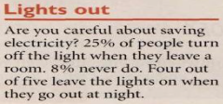  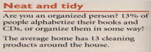  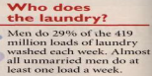  1.________ people leave the lights on when they go out at night.  a. All  b. Most  c. A few  d. Some  2.Almost all unmarried men do ______ of laundry a week  a. only one load  b. three loads  c. one load or more  d. no load  3._______ of people don’t organize their books in a specific way  a. 87%  b. 29%  c. 13%  d. 25% |  | 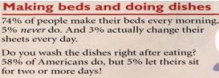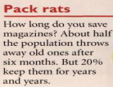  1.________ people never do their beds.  a. All  b. Most  c. A few  d. Some  2.__________ of Americans don’t do the dishes after eating.  a. 5%  b. 3%  c. 74%  d. 58%  3.___________ of American people throw away old magazines.  a. about 20%  b. about 25%  c. about 74%  d. about 50%
* to link actions  when  as soon as = "immediately,"  "right after"  while = "at the same time as"  before / after |  | Ordering events  * To show a sequence:  first, next, (and) then  * Before a noun:  before / after  during = "at the same time as"
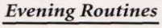
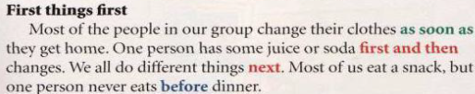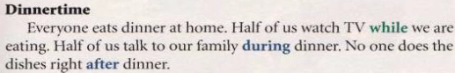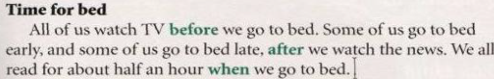

Label the pictures. The first letter of each word is given for you:
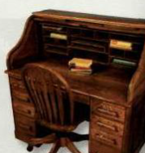 | 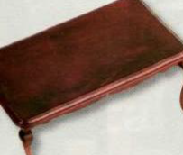 | 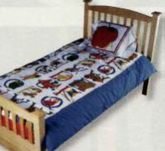 | 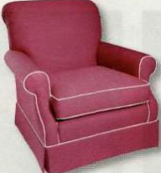
________________________ | ________________________ | ______________________ | ________________________

Learning tip Alphabet game
Make learning new words into a game! Choose a topic and try to think of a word for each letter of the alphabet.
 | s |  | j |  | a
 | t |  | k |  | b
 | u |  | l |  | c
 | v |  | m |  | d
 | w |  | n |  | e
 | x |  | o |  | f
 | y |  | p |  | g
 | z |  | q |  | h
 |  |  | r |  | i

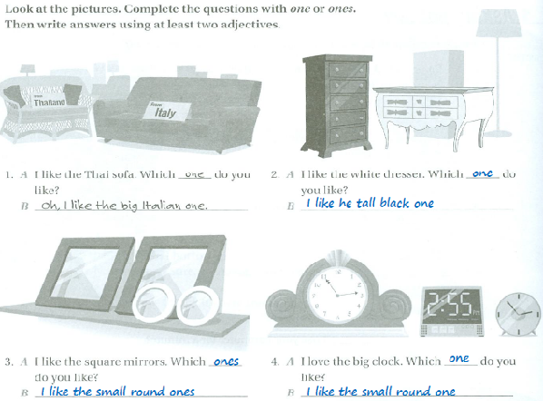
Unscramble the sentences about Sam's living room:
1. small / living room / There's / a / sofa / in / his
_______________________________________________________________________.
2. has / square / some / cool / cushions / He / on the sofa
_______________________________________________________________________.
3. end table / a / There's / beautiful / on the left / Japanese
_______________________________________________________________________.
4. a / TV / He / big / on the wall / has / black
_______________________________________________________________________.
5. in front of / There's / a / the / coffee table / sofa / long / dark
_______________________________________________________________________.
6. are / on the floor / some / cotton / nice / rugs/ There
_______________________________________________________________________.
POSSESSIVE ADJECTIVES
* We use possessive adjectives to show who owns or "possesses" something. The possessive adjectives are:
Example sentence | Possessive adjective | Gender | Person | Number
This is my book. | My | Male / female | 1st | Singular
I like your car. | Your | Male / female | 2nd | Singular
His name is "John" | His | Male | 3rd | Singular
Her name is "Mary" | Her | Female | 3rd | Singular
The dog is eating its food. | Its | neuter | 3rd | Singular
We like our house. | Our | Male / female | 1st | Plural
Your children are nice. | Your | Male / female | 2nd | Plural
The students thanked their teacher. | their | Male / female / neuter | 3rd | Plural
POSSESSIVE PRONOUNS
We use possessive pronouns depending on:
* number: singular (e.g.: mine) or plural (e.g.: ours)
* person: 1st person (e.g.: mine), 2nd person (e.g.: yours) or 3rd person (e.g.: his)
* gender: male (his), female (hers)
Possessive pronouns | Gender (of "owner") | person | Number
Mine | Male / female | 1st | singular
Yours | Male / female | 2nd | singular
His | Male | 3rd | singular
Hers | Female | 3rd | singular
Ours | Male / female |  | plural
Yours | Male / female |  | plural
theirs | Male / female / neuter |  | plural

POSSESSIVE ‘S
* When we want to show that something belongs to somebody or something, we usually add 's to a singular noun and an apostrophe ' to a plural noun, for example:
Ahmad’s car - Sami’s pen - Mary’s house - the boy’s ball
* The friend of my father * My father’s friend
More than one ball. | One ball.
The boy's balls. | The boy's ball. | One boy.
The boys' balls. | The boys' ball. | More than one boy.
Plural noun | singular nouns
My children's dog. | My child's dog.
The men's work. | The man's work.
The mice's cage. | The mouse's cage.
People's clothes. | A person's clothes.

Irregulars Plurals

By: samiyah alzahrani..

