Lecture 29
Unit 10
Communication
In unit 10, you learn how to . . .
* make comparisons with adjectives.
* use more and less with noun and verbs.
* talk about different ways of communicating.
* manage phone conversations.
* interrupt and restart conversations on the phone.
* use just to soften things you say.
Before you begin . . .
Complete the sentences with the words below.
Do you use any of these ways of communicating?
# text messaging. # a webcam.
# video conferencing. # instant messaging.
1 | 2 | 3 | 4
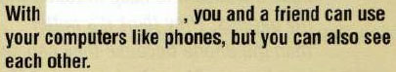 | 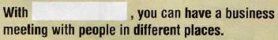 | 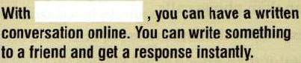 | 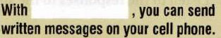
# How do you keep in touch with people?
Alma Jones  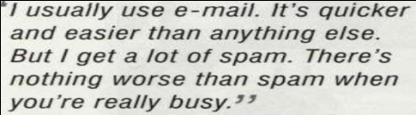 | Tim Henry  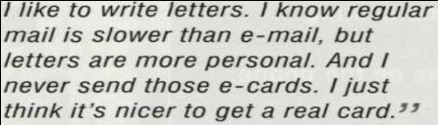 | Mayumi Sato  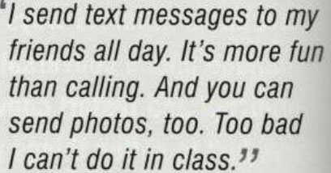
Ken Johnson  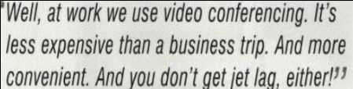 | Paco Rodriguez  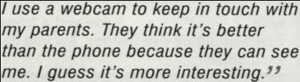

Comparative Adjectives
•Comparative adjectives can be used to talk about differences between two things, people, or events.
Form
•For most one-syllable and some two-syllable adjectives, add –er
quick : quicker old: older fast : faster
E-mail is quicker than regular mail.
That car is older than mine.
BUT
fun : more fun
funny : funnier
Bowling is more fun than golfing

Comparative Adjectives
Form
•For most other adjectives of two or more syllables, use more + adjective
modern : more modern pleasant : more pleasant
The weather in Dammam is more pleasant than in Riyadh.
•Less is also used with adjectives in comparisons. It expresses the opposite of more
less + adjective
less modern
Our city is less modern than London
Comparative Adjectives
Form
•Some adjectives have irregular forms for the comparative.
good : better bad : worse far : farther
Real cards are better than e-cards
•Than can be used with an adjective to compare two nouns in the same sentence. But not all comparisons need to include than or need to include both nouns.
Real cards are better than e-cards. They’re more personal.
Spelling Rules
Form
•For adjectives ending in –e. add –r
nice : nicer
•For adjectives ending in a consonant + y, change the y to -i and add -er
busy : busier easy : easier
•For most adjectives ending in a vowel + consonant, double the final consonant
big : bigger thin : thinner
But don’t double the consonant in words ending in -w :
slow : slower

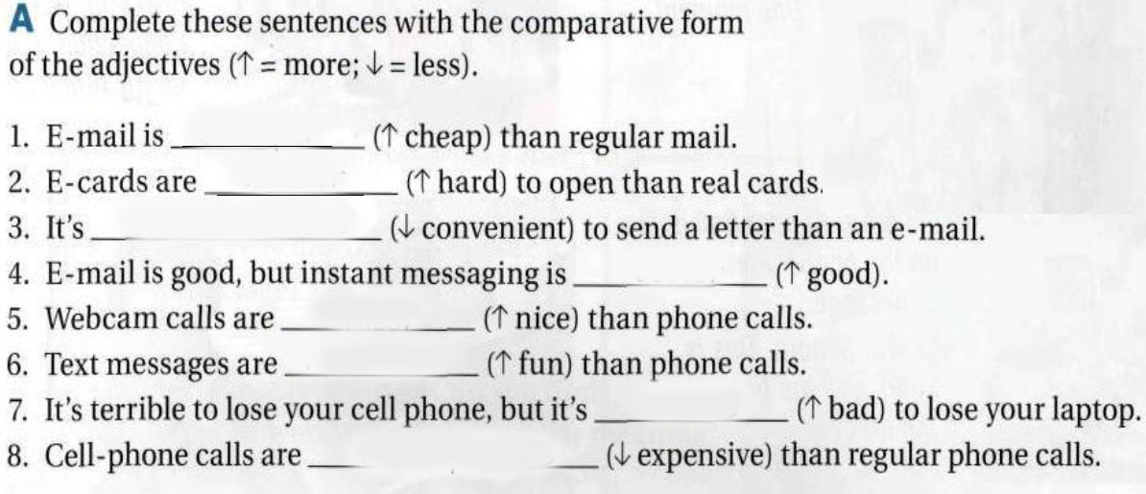

# Complete the chart below the comparative form of the adjective in the box.
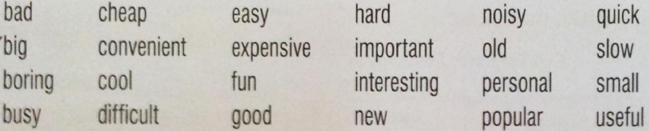
Adjective + -er / -ier |  | more / less + adjective |  | irregular adjectives

# Complete the conversation.
Hassan: I love my new laptop. It’s so much ______ (good) than my old desktop.
Ali: But aren’t regular computers ______ (cheap) than laptop?
Hassan: Yes, but they’re _____ (useful) than laptops because you can’t take them to the library or on a trip.
Ali: Well, maybe laptop are ______ (cool) than desktops, but my big computer is ______ (quick) than most laptop.
Hassan: Yeah, but it sure is a lot ______ (heavy)!

Amjad Al-Ghamdi Al-7lwa ;$

