بسم الله الرحمن الرحيم
من 1الى 14الحمدلله خلصنا
First Lecture
Chapter ONE
Using Be
English Language
Basic English Grammar
Present Verbs to Be
There are 3 present verbs to be;
Am
Is
Are
How to use each on of them
Am (used with I only) :-
- Are ( used with plural subjects )  - We are students  - They are girls  - You are boys/ a boy  - The books are in the bag now  - Samia and Reem are sisters  - Our friends are very kind  - His brothers are Fahd and Rami | Iam a student .  Iam happy.  Iam in the library now.  Iam from Saudi Arabia.
Is ( used with singular subjects)
He is a boy.
She is a girl.
It is an insect.
The car is new.
My friend is from Jordan.
Summer is hot now in Saudi Arabia.
Your pen is on the table.
Contractions with Be
- Am (used with I only) :-
- Iam / I’m a student.
- Iam / I’m happy.
- Iam / I’m in the library now.
- Iam / I’m Saudi Arabia.
________________
- Is ( used with singular subjects)
- He is / H’s a boy.
- She is / She’s a girl.
- It is / It’s an insect.
- The car is / The car’s new.
- My friend is / My friend’s from Jordan.
- Summer is hot now in Saudi Arabia.
Your pen is on the table
- Are ( used with plural subjects )
- We are / We’re students
- They are / They’re girls
- You are / You’re boys/ a boy
- The books are in the bag now
- Samia and Reem are sisters
- Our friends are very kind
- His brothers are Fahd and Rami
Yes/No Question with BE
1. He is a mechanic.
Is he a mechanic? – Yes, he is
- No, he isn’t
2. They are at home.
Are they at home ? – Yes, they are.
- No, they aren’t
3. Iam a student.
Are you a student? – Yes, Iam
_ No, Iam not
4. The car is expensive.
Is the car expensive? - Yes, it is
- No, it isn’t
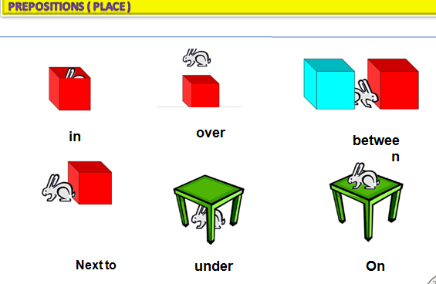
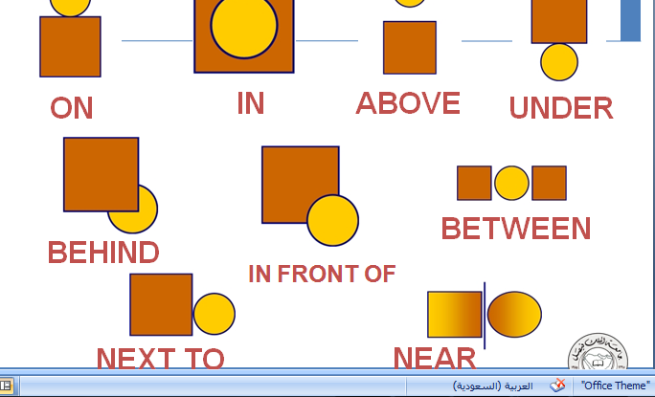
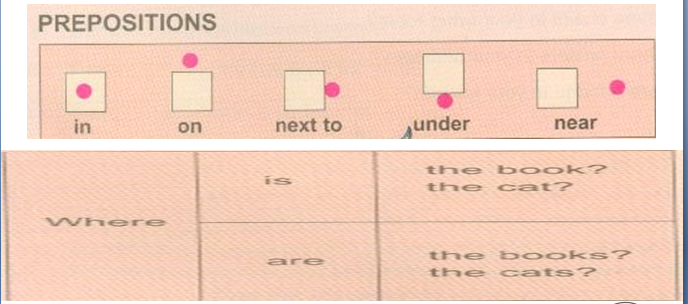

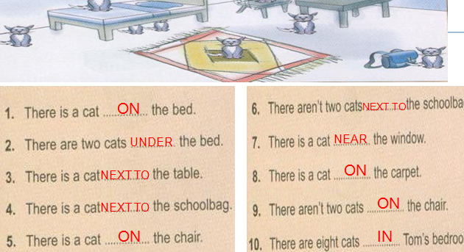

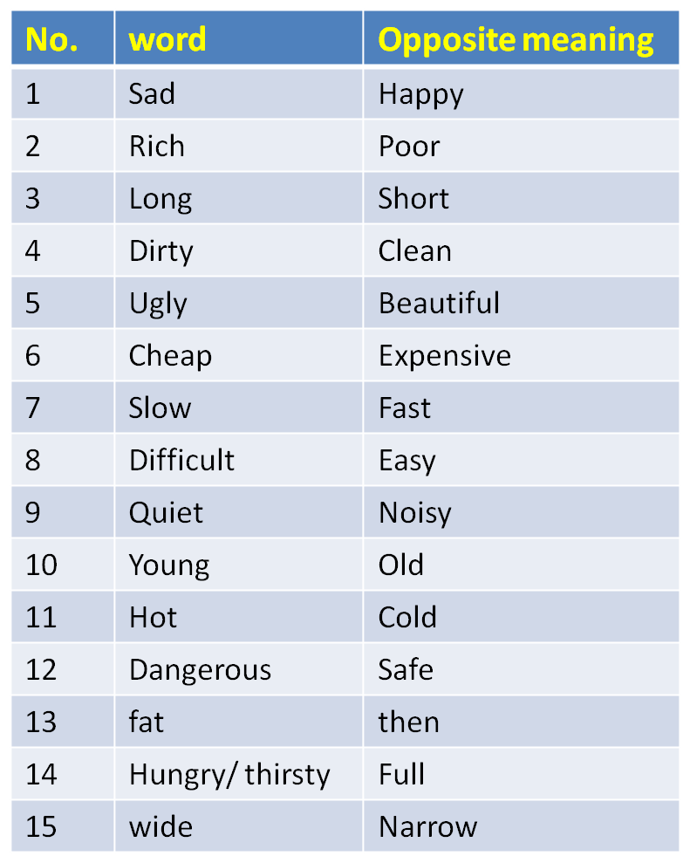
The Opposite Meaning
Exercise 1
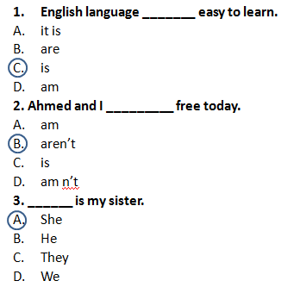
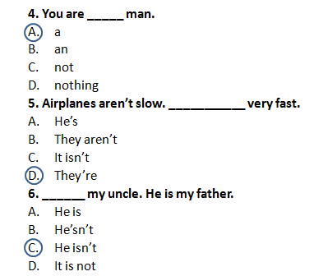
Exercise 1

Exercise 1
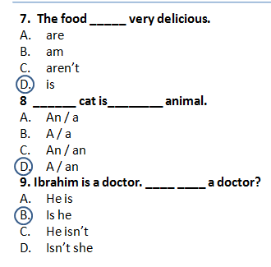
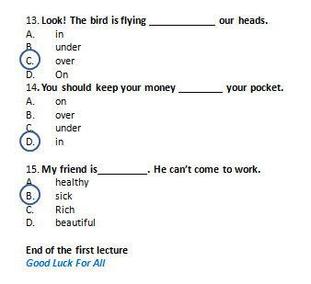
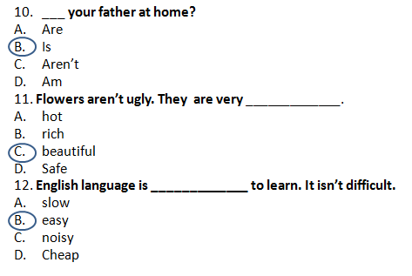

Lecture 2
Reading Skill
- Scanning
- Skimming
- Previewing Vocabulary
- Revising some structures
- Writing : Jumbled sentences
IV. Writing: Jumbled sentences
I. Read the following essay ,then answer the questions that follow
My name is Elena Sanchez. I am from Mexico, but now I live in California. I'm a student here in English language classes at a small college.
I live in an apartment building. It's on the corner of Olive Street and Sycamore Avenue. My address is 2201 Olive Street. There's a big olive tree in front of the building. There's a park across the street. There are a lot of oak trees in the park. The trees are beautiful in the summer.
A lot of my neighbors are from different countries. The people next to me are from Indonesia. The family across from the Indonesian family is from Colombia
. The stores in this neighborhood are always busy. There's a Korean drugstore and an Armenian flower shop.
There are three restaurants on Olive Street: One Mexican, one Japanese, and one Moroccan-Italian-American.
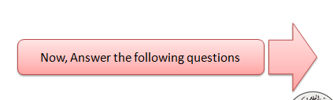

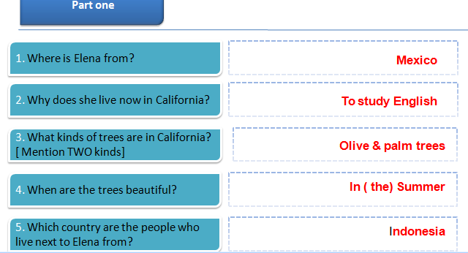

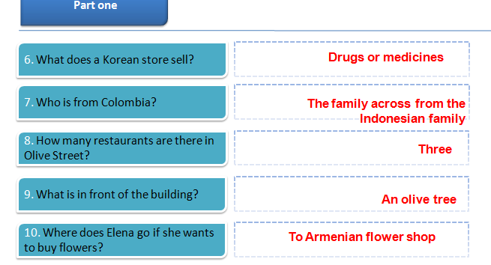

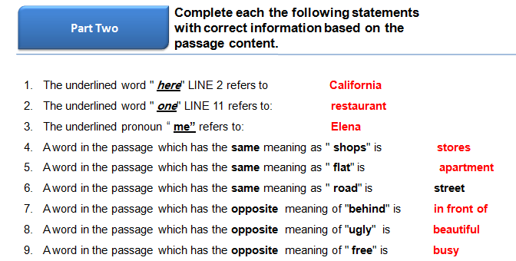

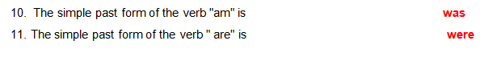

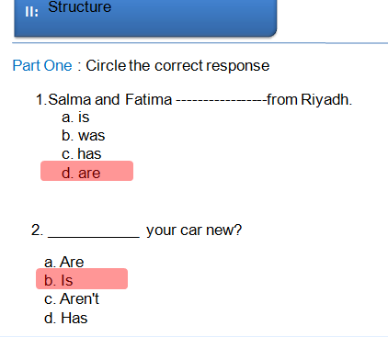

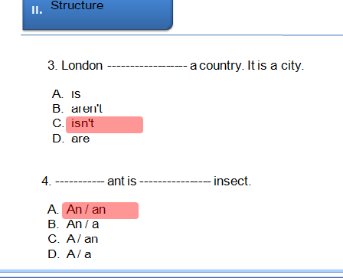
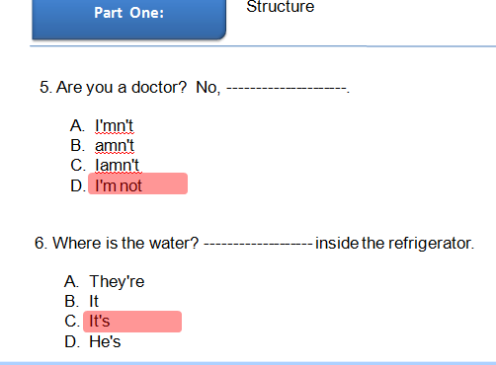
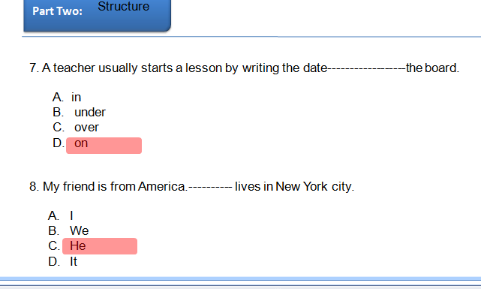

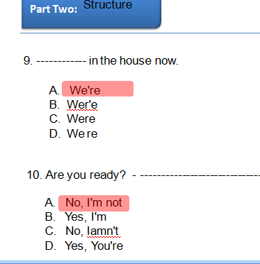

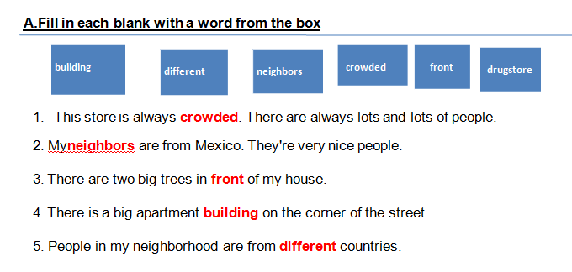

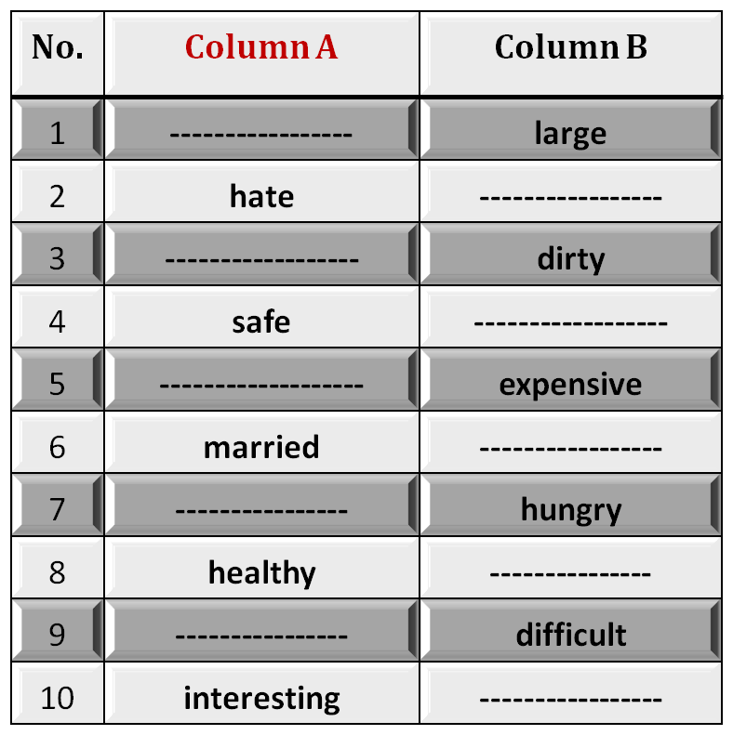
B. Identifying Opposites
Fill in each blank space with the opposite meaning

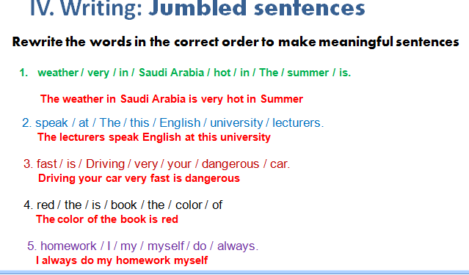 Lecture3
Eng 121
Grammar – Vocabulary - Reading
Chapter Three
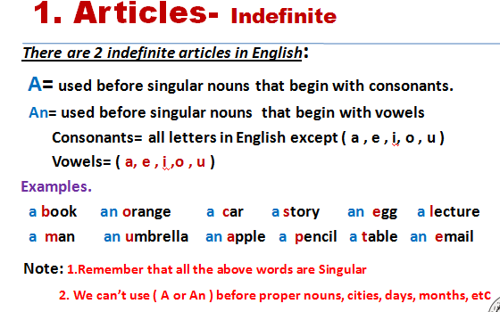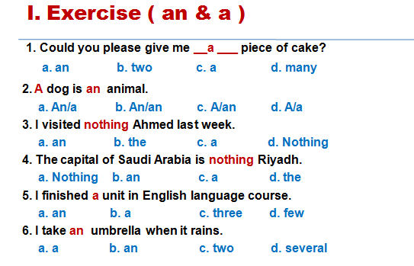
Elements of the Lecture
Scanning and Skimming reading text
1-Articles ( A , An )
2- Pronouns
3- Verbs to Be
4. Have / Has / Had
5. Previewing Vocabulary

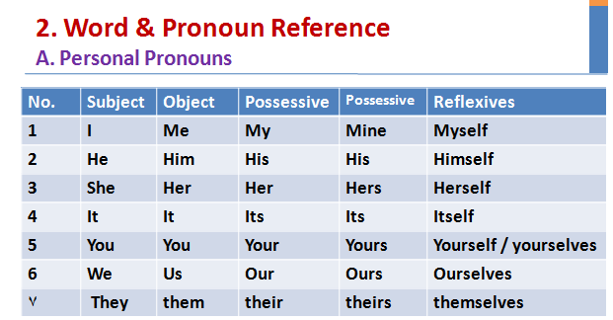
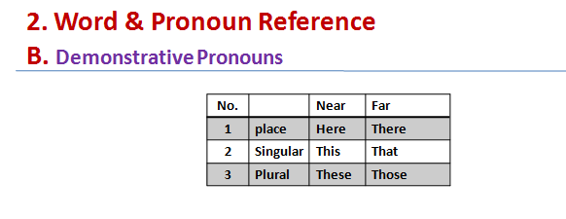
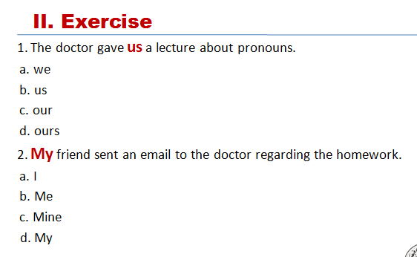
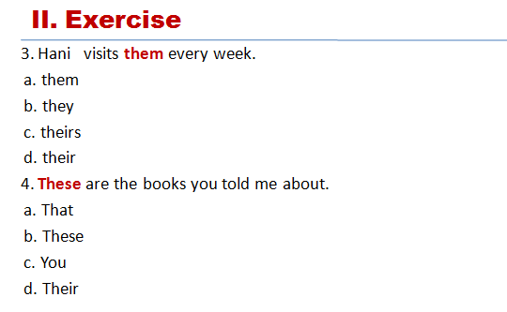
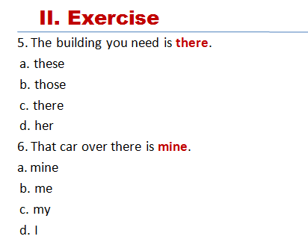
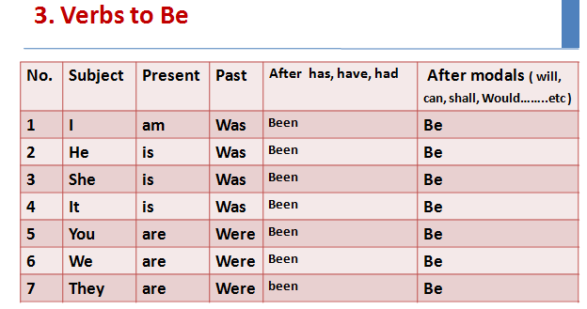
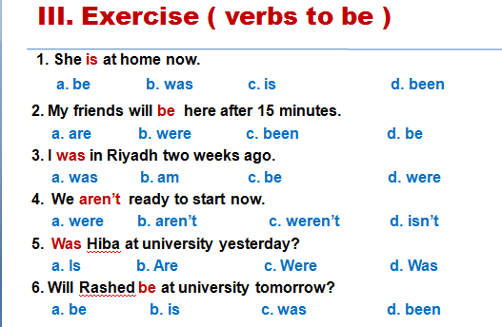
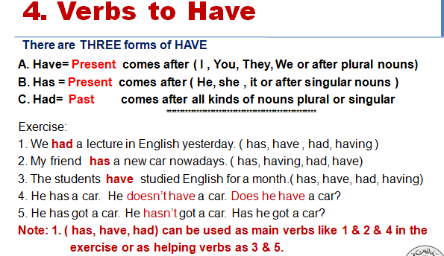
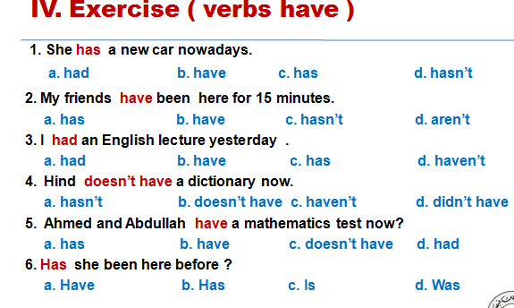
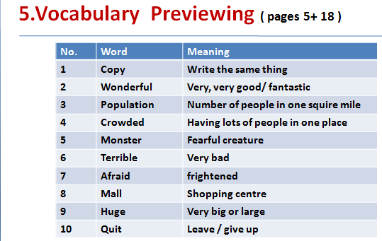
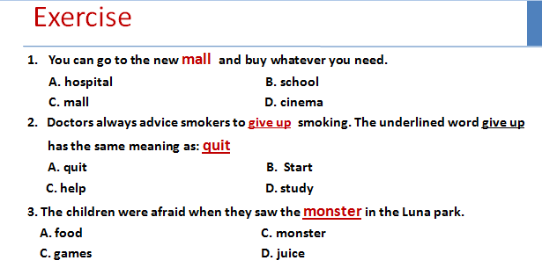
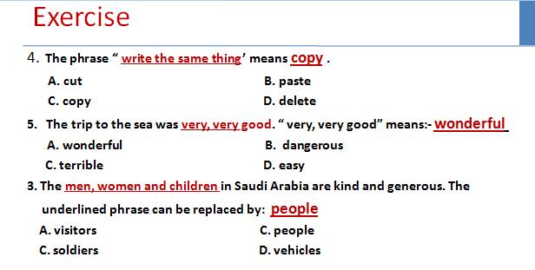
Lecture Four
Eng 121
Grammar – Vocabulary - Reading
Chapter Three

Elements of the Lecture
1- Do / Did / Done
2- Prepositions with Time ( at – on – in )
3-Vocabulary Previewing
4-Reading
A. Word & Pronoun reference
B. Scanning & Skimming

1. Do- Does- Did- Done- doing
They are used as helping verbs in order to form Questions & Negative OR used as
main verbs.
- I, We, They, You or any plural subjects + do ( Present )
- He, She, It + does ( present)
did - Plural OR singular subjects+
- After (has, have, had) + done
- After ( is, am, are, was, were) + doing ( active progressive)
_________
e.g:- - We do the homework every week
- She does the homework every week
- The students did the homework last week
- They are doing the homework now/ at the moment
- Salma has done the homework
.
- Exercise
1. Sultan did his best to get full mark in the last homework.
a. do b. does c. did d. done
2. Fatin has done the homework perfectly.
a. done b. did c. do d. does
3. You will do me favor if you tell me the answer
a. doing b. do c. doing d. did
4. He always does the right thing.
a. do b. doing c. does d. done
5. The students are doing the exercises now.
a. do b. doing c. done d. did
6. Did you do the homework yesterday?
a. Have you do b. Can you doing c. Do you d. Did you do
2.Prepositio
At = used before o’clock / night
On =before days / following morning
In = before years and months/ morning/ evening / seasons
==============
Exercise:
1. He goes to work at seven o’clock
a. in b. on c. at d. for

2. She was born in October
a. at b. in c. on d. with
3. The weather is hot in summer.
a. in b. on c. At d. From
4. Students don’t go to university on Friday.
a. in b. At c. Over d. on

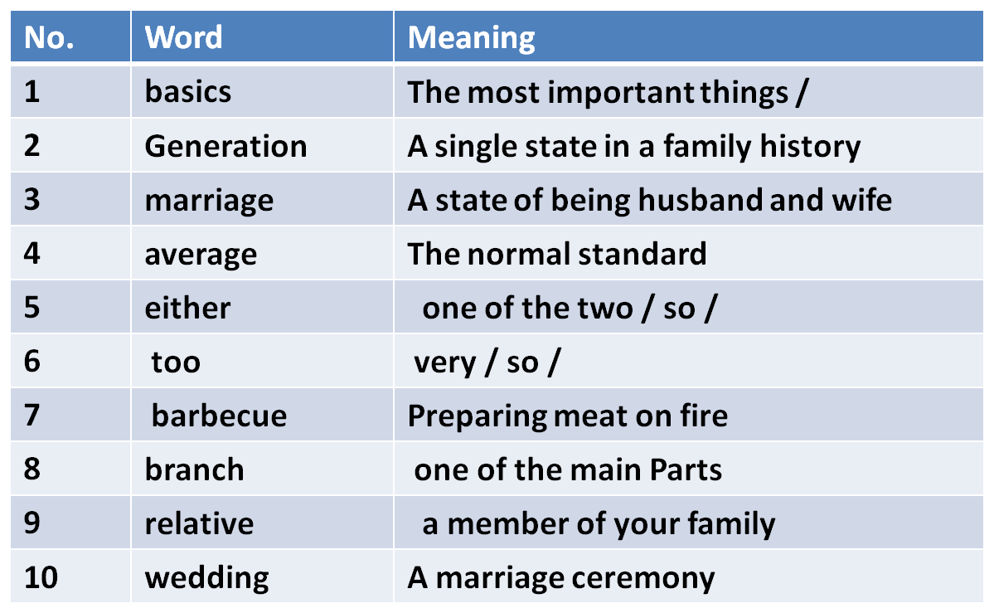
5.Vocabulary Previewing ( pages 45, 50, 56,57, 61)

Exercise
1. Where is the car? It’s in the garage
A. library B. bog
C. garage D. kitchen
2. If you didn’t find the book, you can look for it in the other room. the underlined
word look for means: search
A. buy B. search
C. read D. eat
3. English language is easy . It is not difficult.
A. beautiful C. boring
C. safe D. easy
Exercise
4. The word “ classifications’ means categories .
A. entertainments B. eatables
C. categories D. customers
5. The word “gourmet means food specialist
A. a policeman B. Food specialist
C. mechanic D. who works at hospital
6. “separated from others” . The underlined phrase means: alone
A. happy C. sick
C. alone D. busy
4.Reading :
A. Word & Pronoun Reference
Ahmed and his sister are from Riyadh. They study English at university. She is older than him. He speaks English better than her. They always go there by bus. It is a very suitable place for practicing English. They always speak English with each other to improve their language.
1. She refers to : his sister
2. him refers to : Ahmed
3. They refers to: Ahmed and his sister
4. There refers to : university
5. He refers to: Ahmed
6. It refers to: university
7. Their refers to: Ahmed and his sister
B. Scanning & Skimming
8. Where are Ahmed and his sister from? They’re from __________.
A. university B. Riyadh
C. English D. the bus
9. Who is better in English? _______________
A. Ahmed’s sister B. English language
C. Ahmed D. English
10. How do they go to university? _______________________
A. On foot B. In a taxi
C. By plane D. By bus
Lecture 5
Lecture Five
Eng 121
Vocabulary– Grammar- Reading
Chapter 3-4
Elements of Lecture 5

I- Previewing Vocabulary
2- Present Simple Tense
3- Negative Forms
4. Forming Questions
3- 5- Spelling & Pronunciation Of Final – es
6- Scanning & Skimming Reading Text
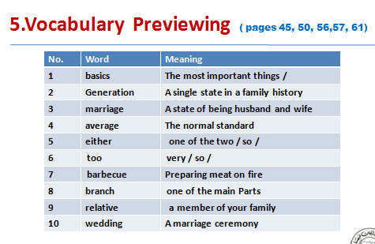
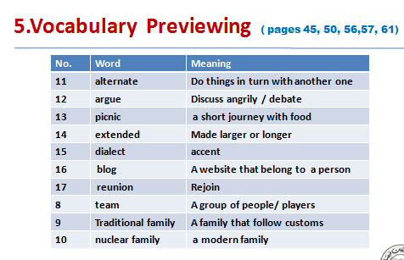
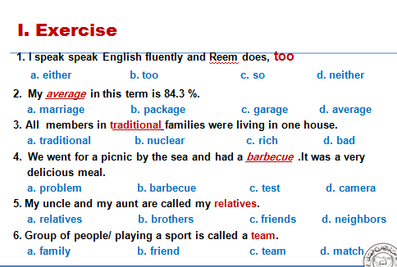
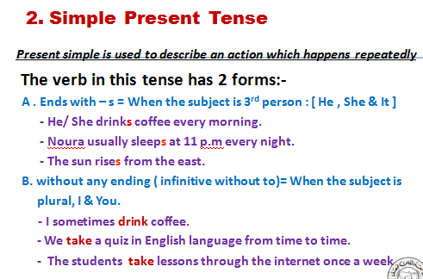
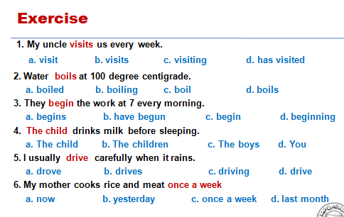
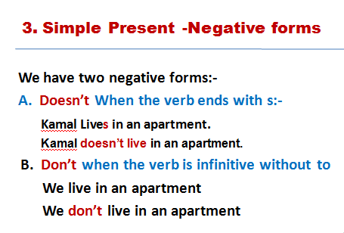
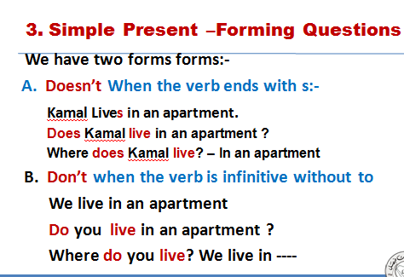
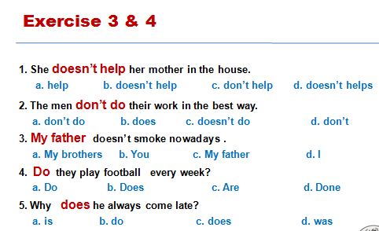
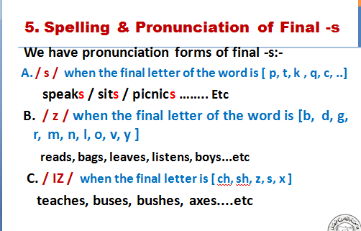
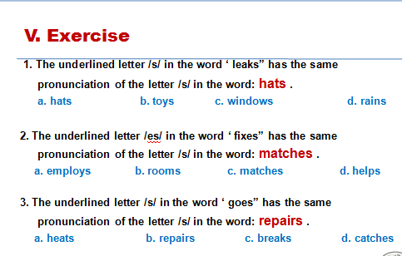
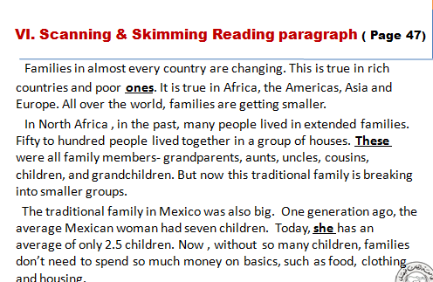
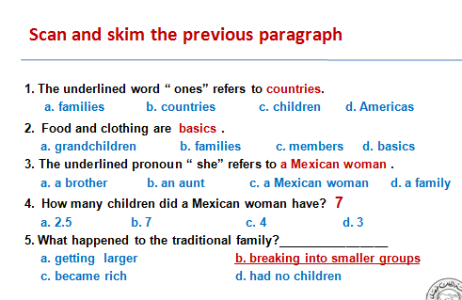
Lecture Six
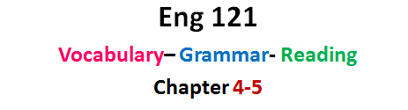
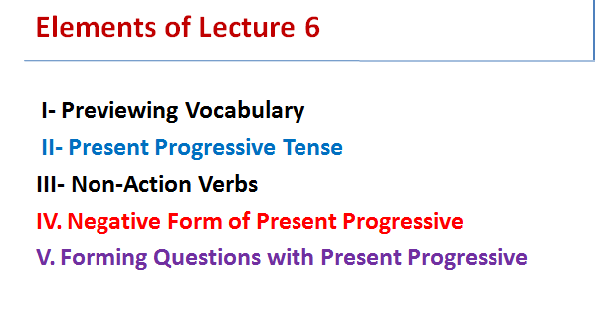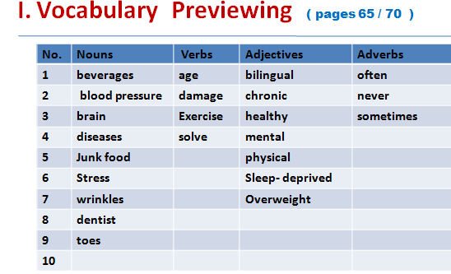
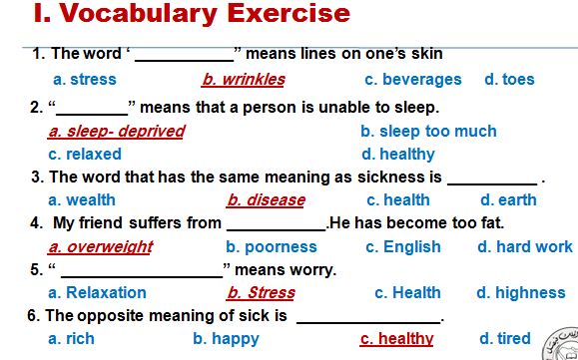
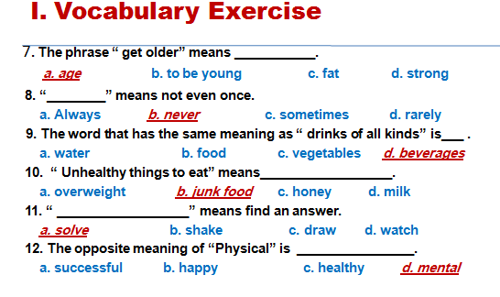
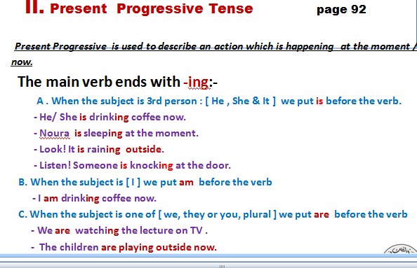
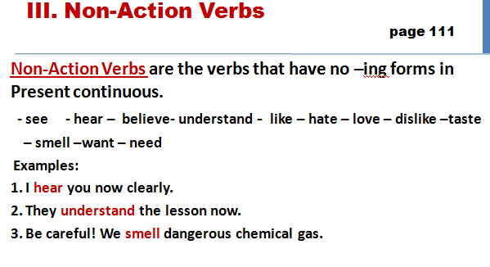
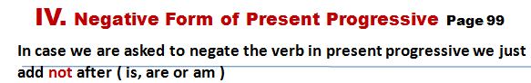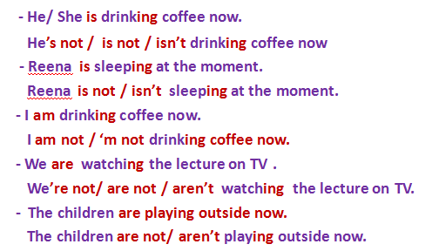
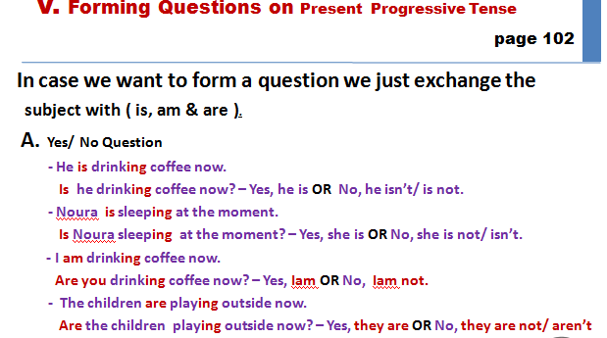
V. Forming Questions on Present Progressive Tense
page 102
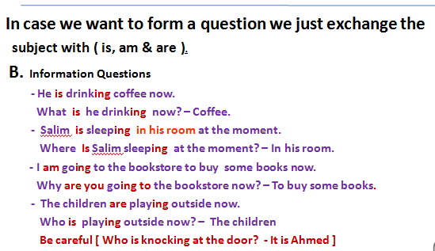
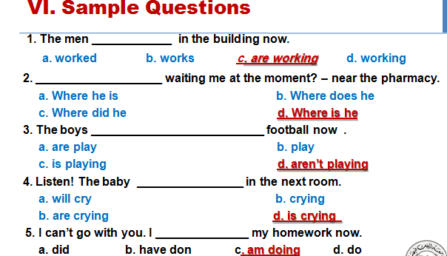
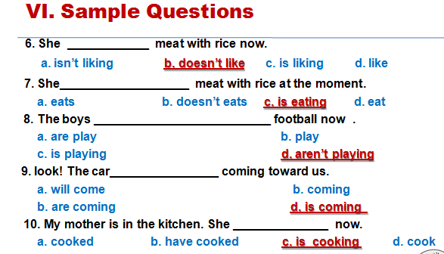
Lecture 7
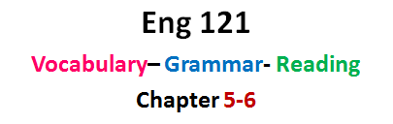
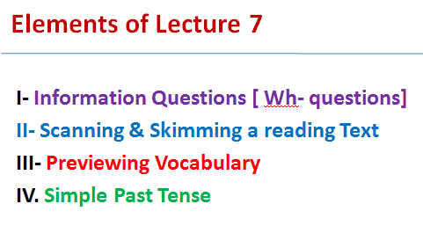
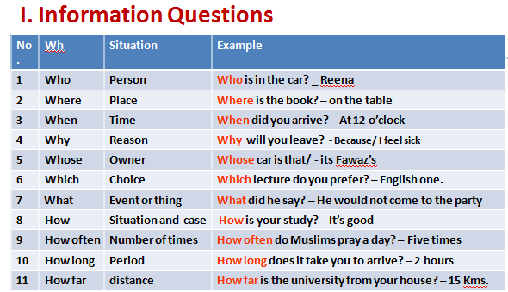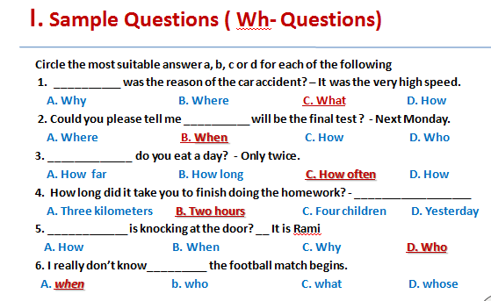
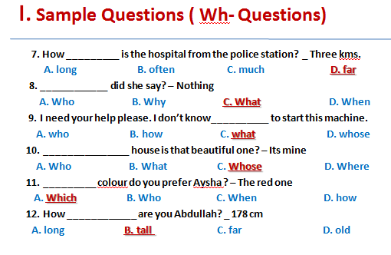
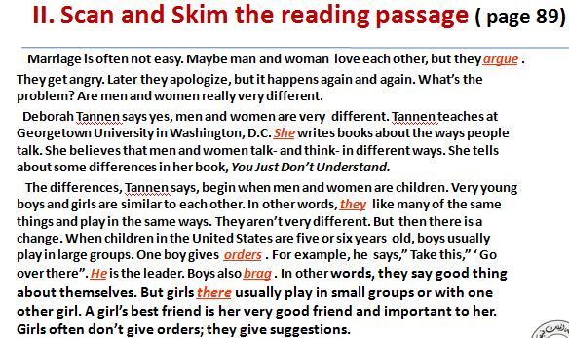
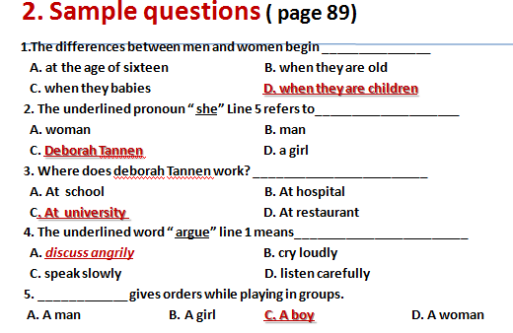
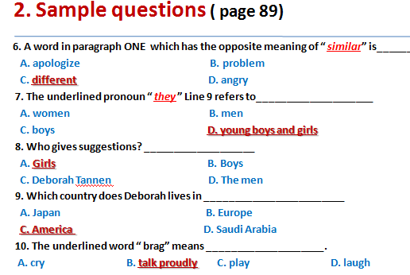
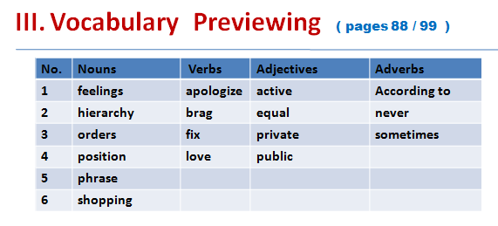
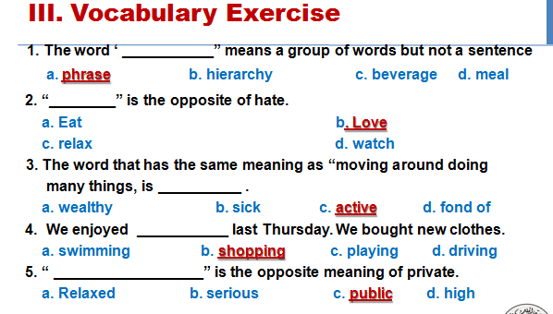
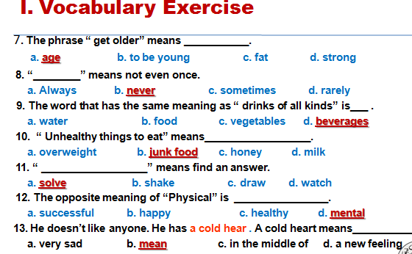
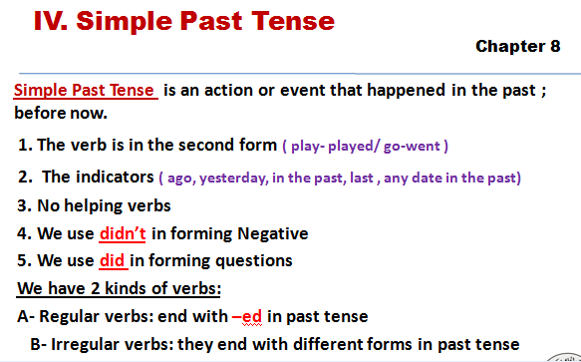
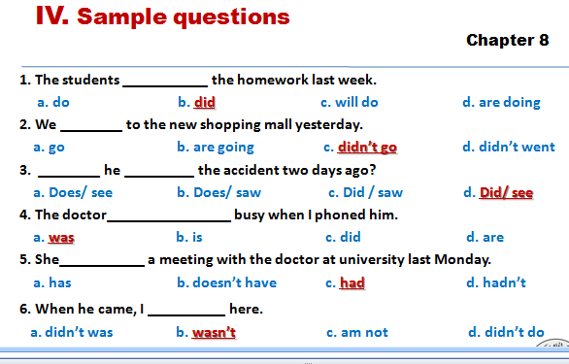
Lecture 8
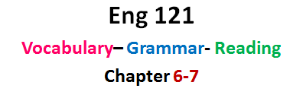
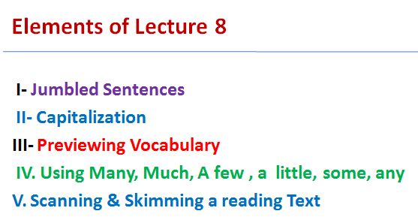
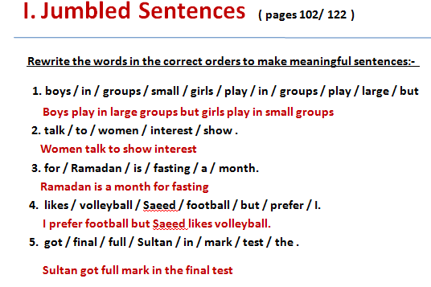
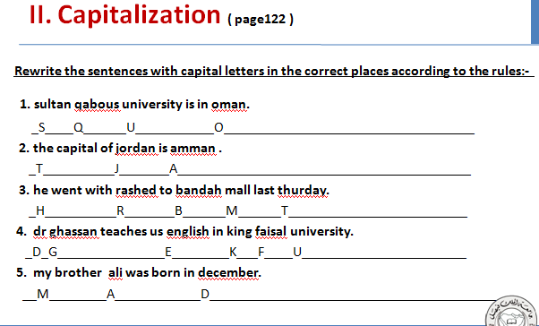
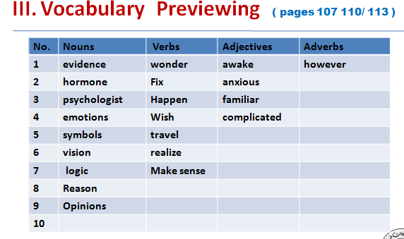
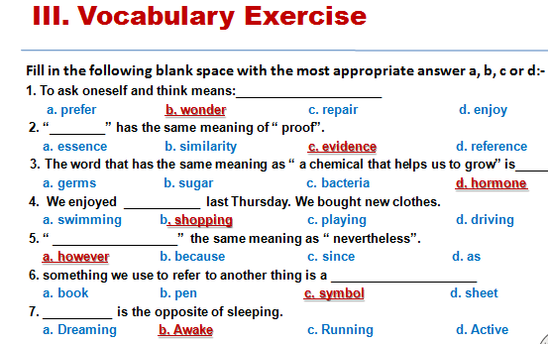
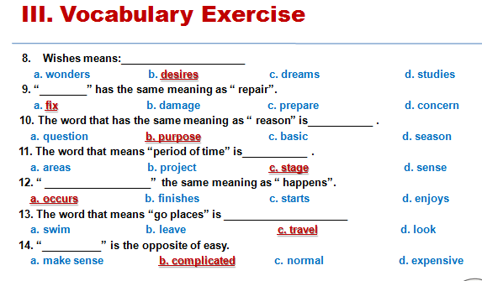
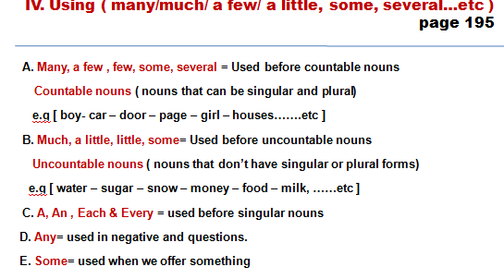
IV. Sample Questions
( many/much/ a few/ a little, some, several…etc )
page 195
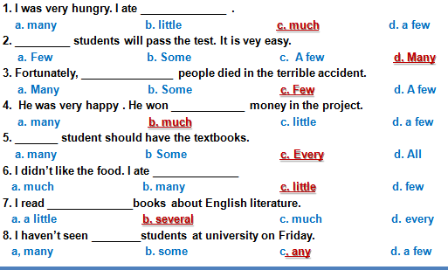
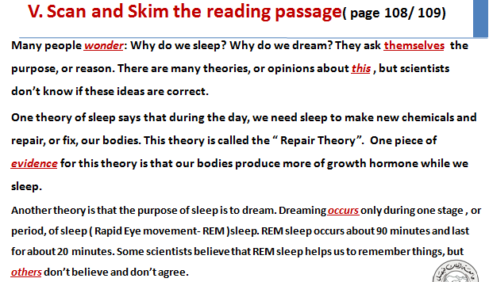
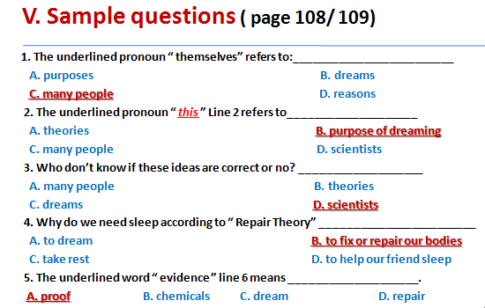
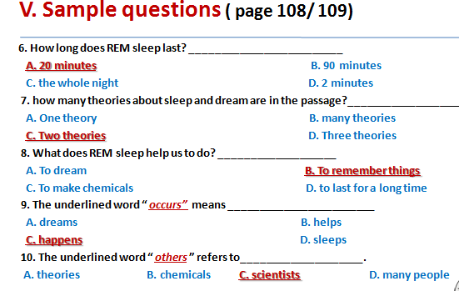
Lecture 9
Contents of Lecture 9
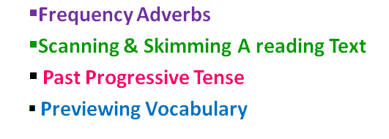
موضوعات المحاضرة التاسعة

- Adverbs of frequency page 56
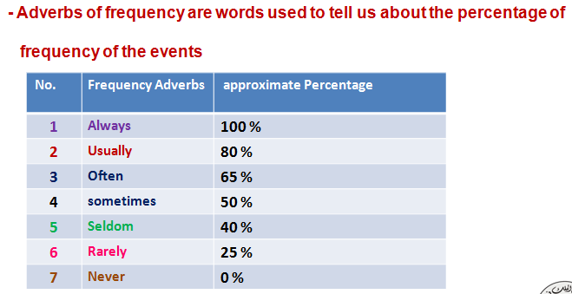
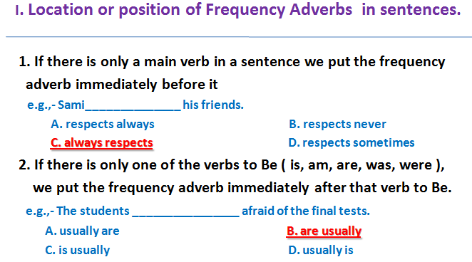
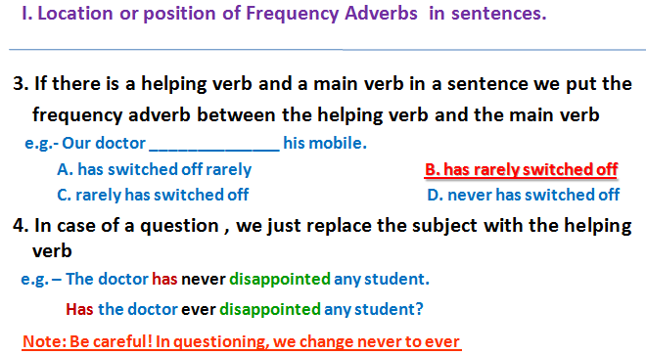
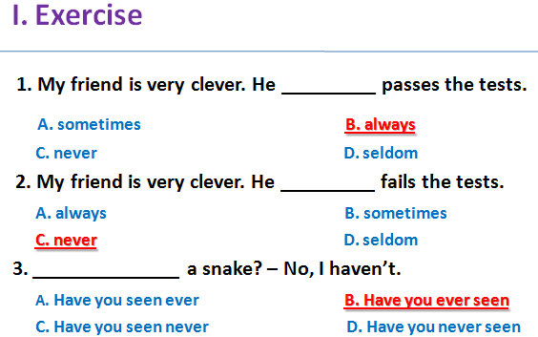
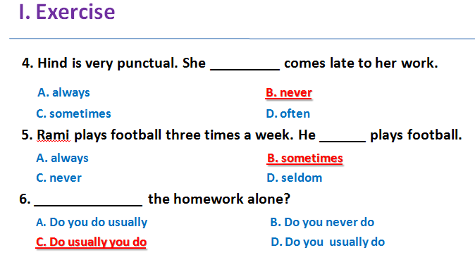
- Read the following essay ,then answer the questions that follow page 128
Some people go to work each day and then come home. They spend time with their family and friends. Maybe they watch TV or go to a movie. Sometimes they exercise or read. This is their life. But for other people, this is not enough. They look around their neighborhoods and see people with terrible hardships: sickness, loneness, and homelessness. Other people see problems with the environment. Many people want to help. They volunteer. They give some of their time to help others.
Volunteers help in many ways. Some visit sick and lonely people. Some give their friendship to children without parents. Some build houses for homeless people .
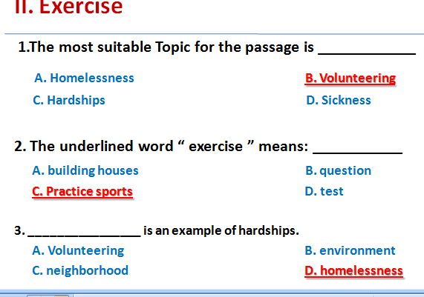
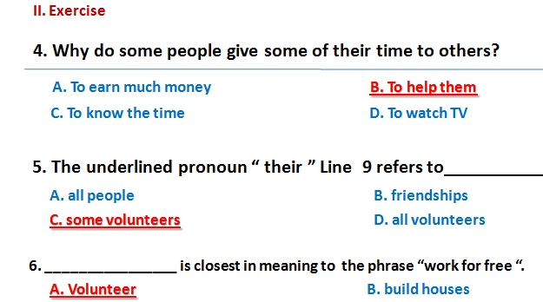
C. give some time D. look around
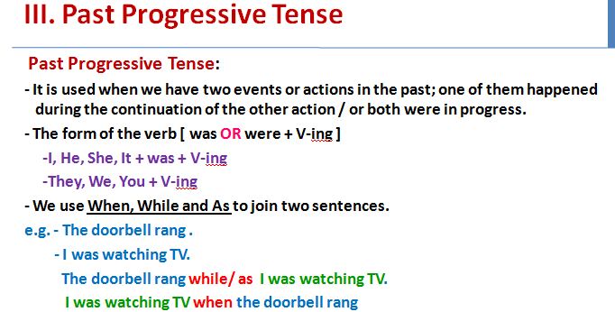
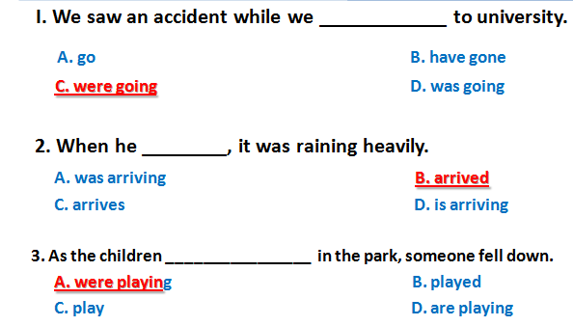
- Vocabulary Previewing ( pages 127 / 132 / 139 )
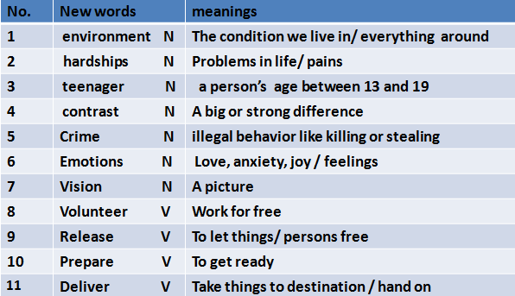
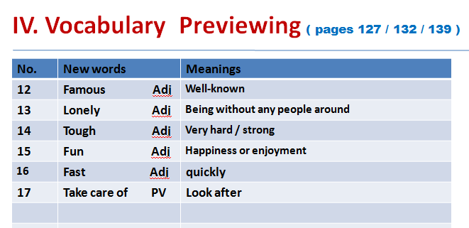
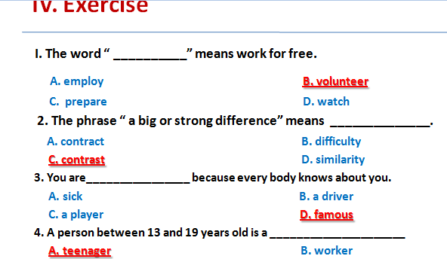
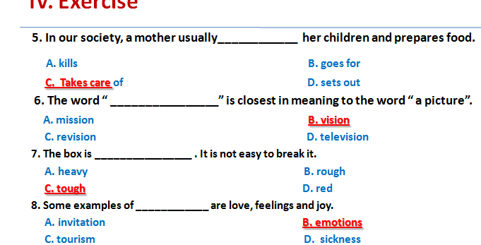
Lecture 10
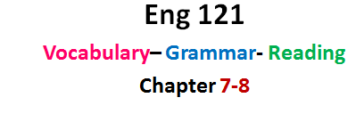
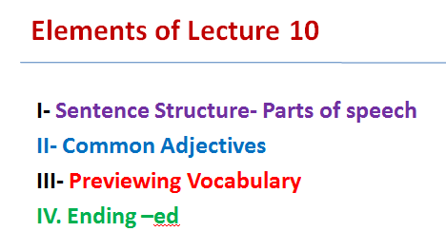
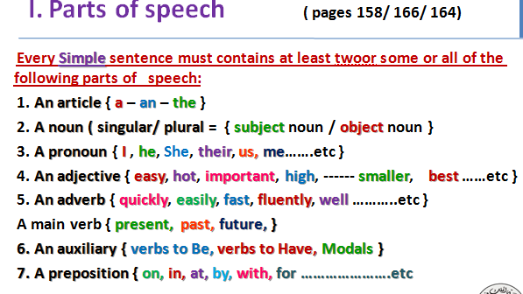
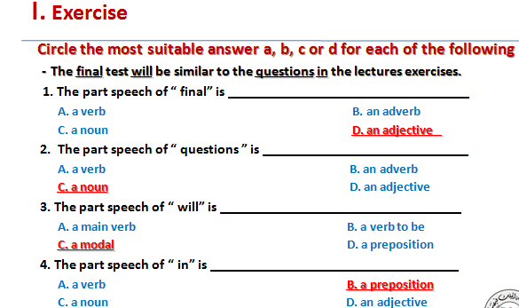
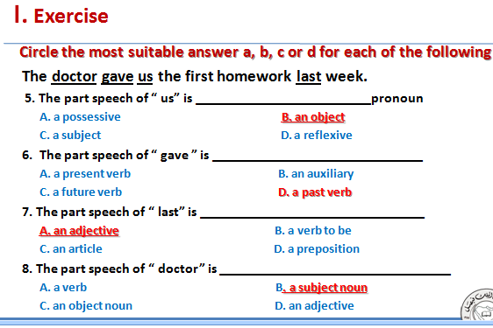
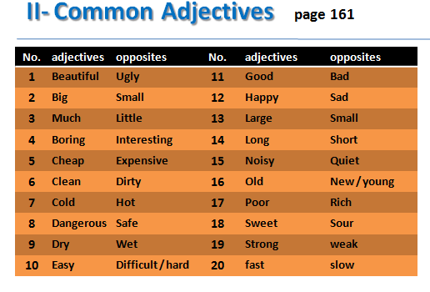
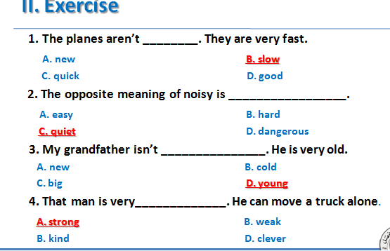
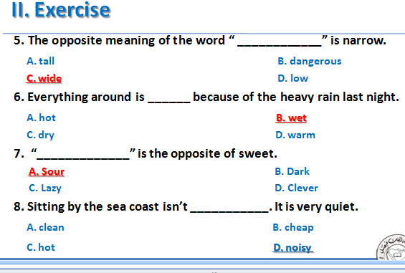
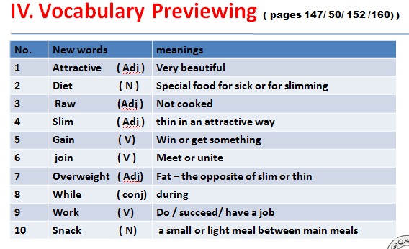
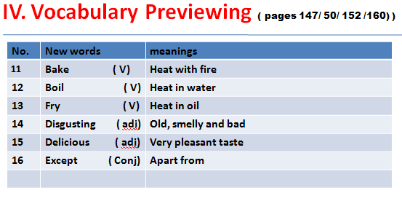
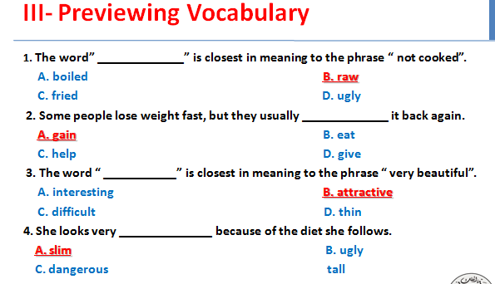
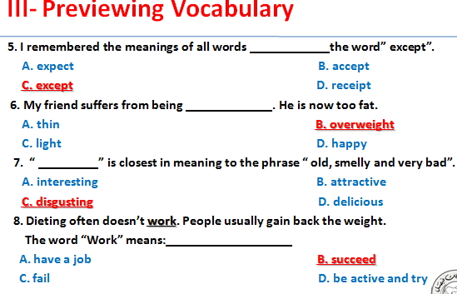
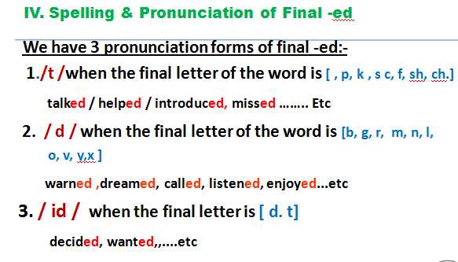
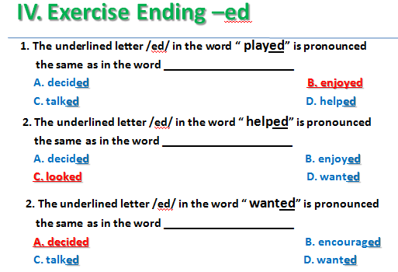

Lecture Eleven
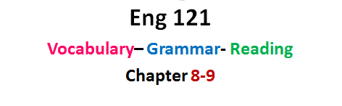
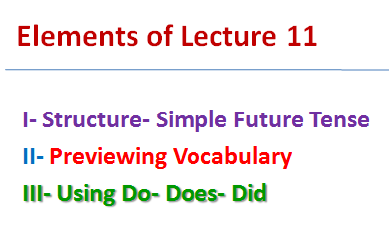
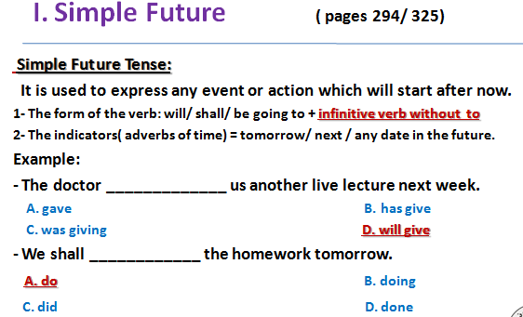
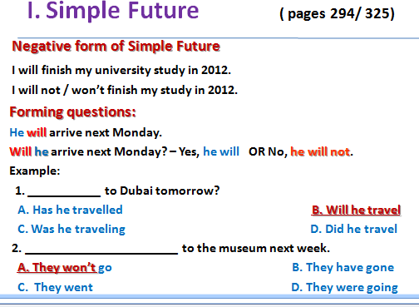
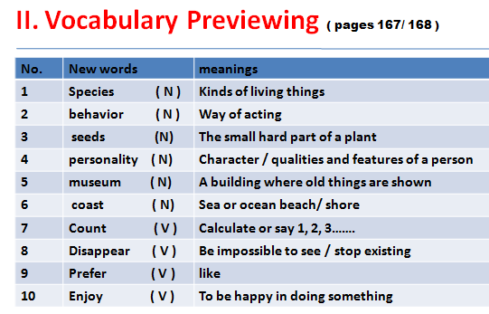
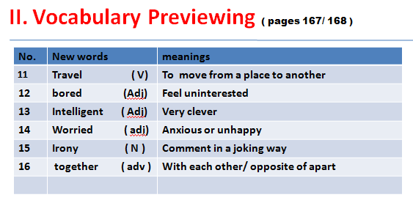
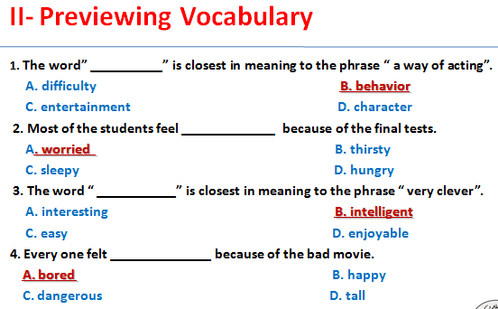
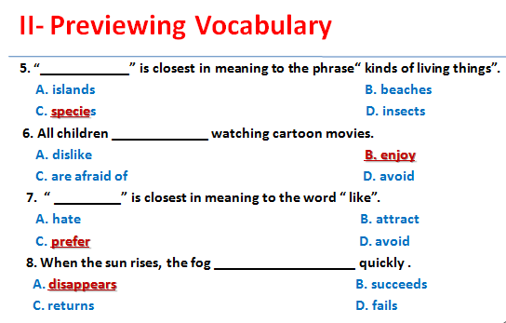
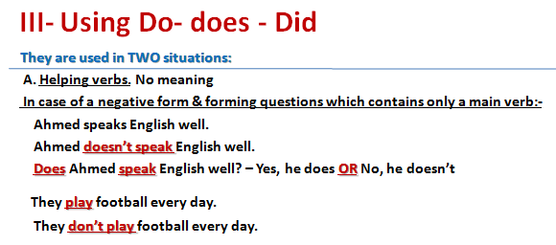
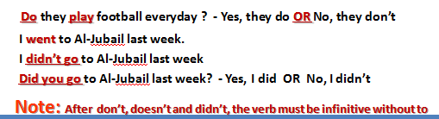
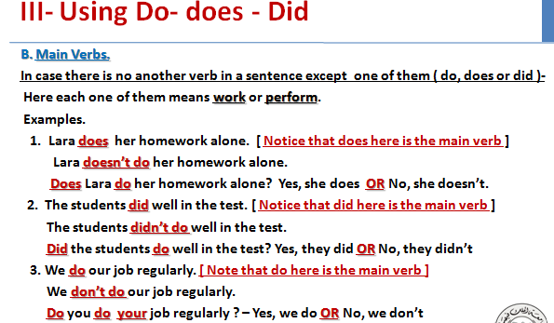
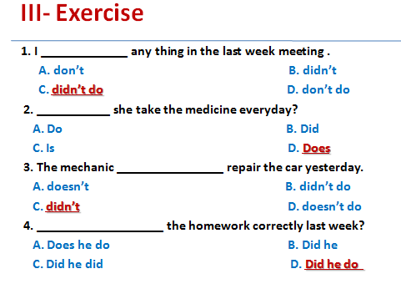
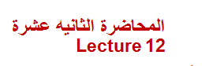
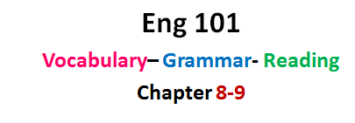
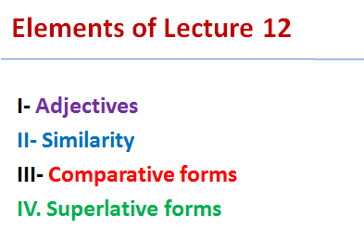
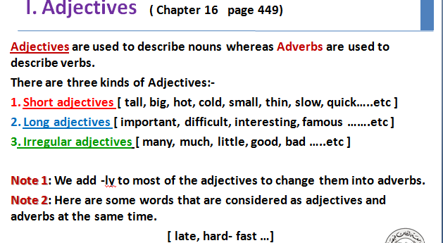
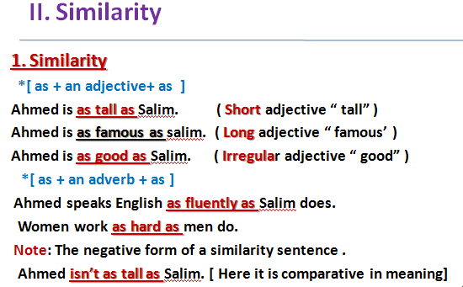
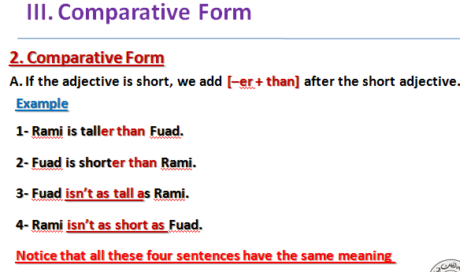
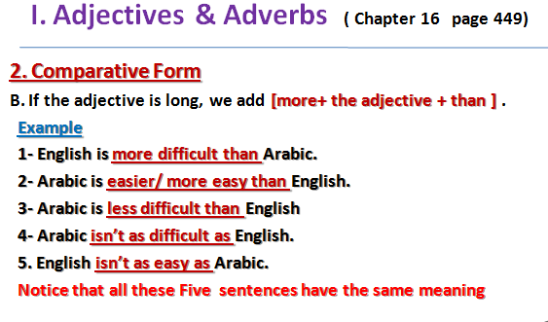
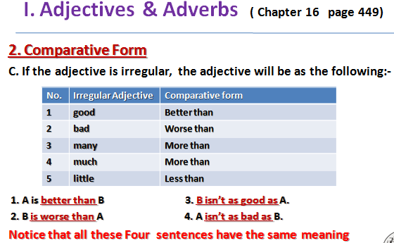
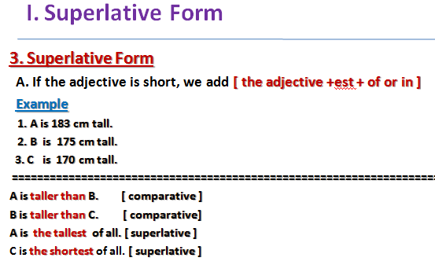
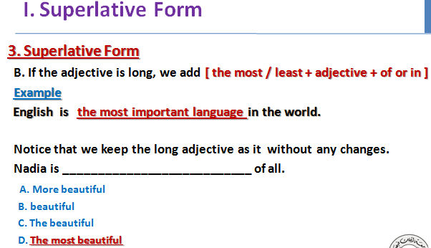
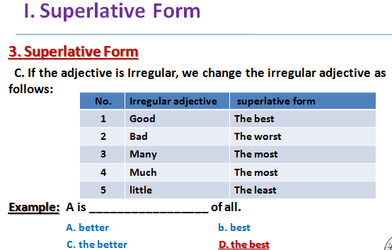
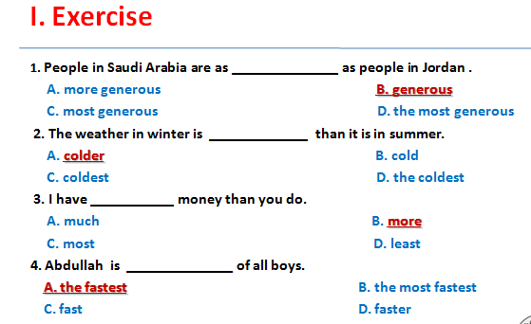



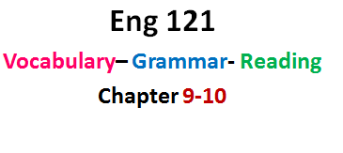
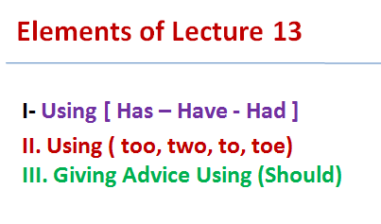
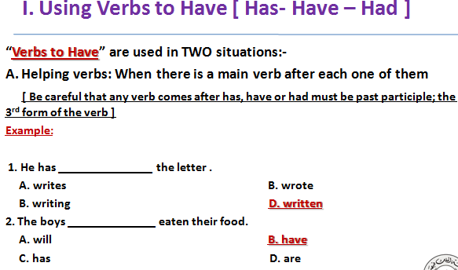
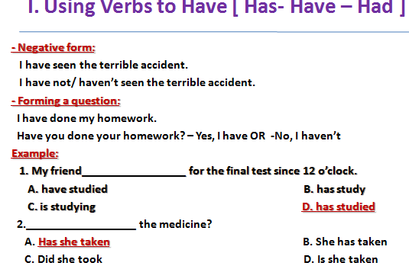
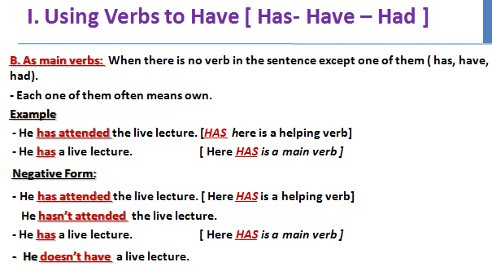
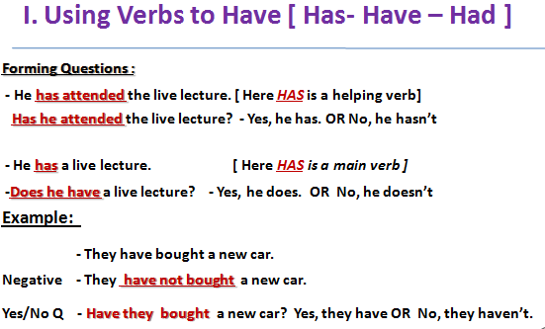
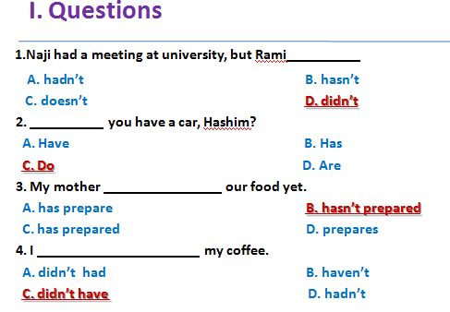
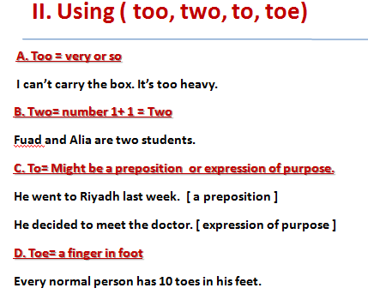
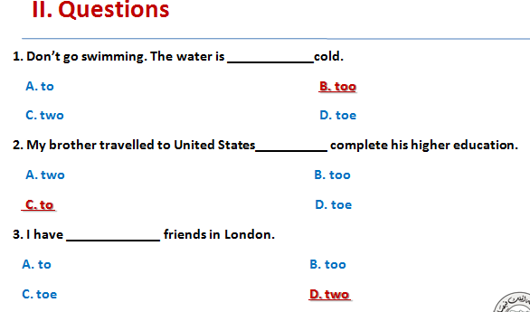
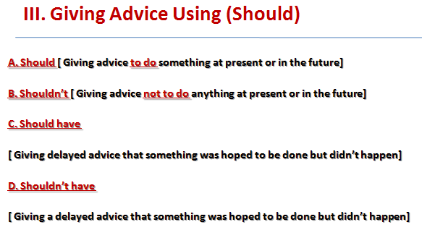
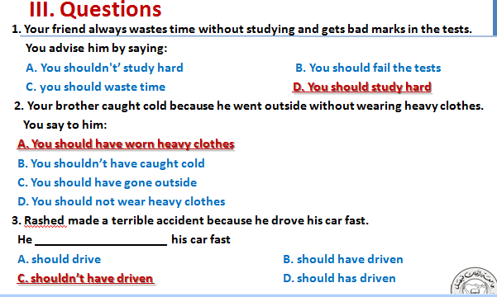

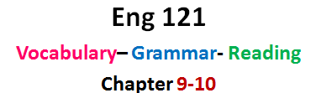
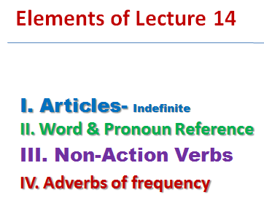
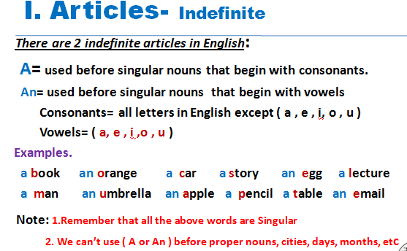
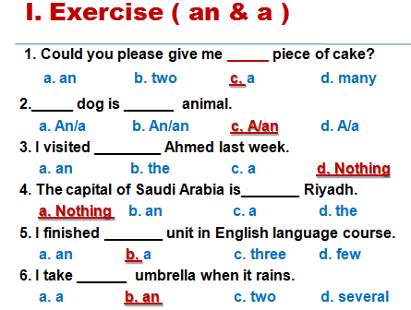
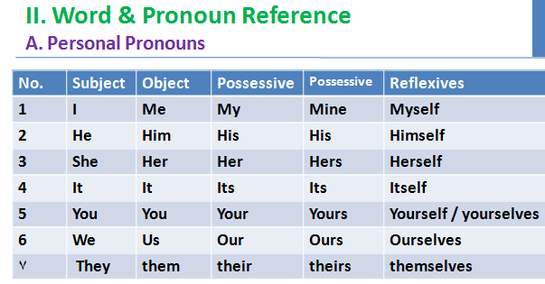
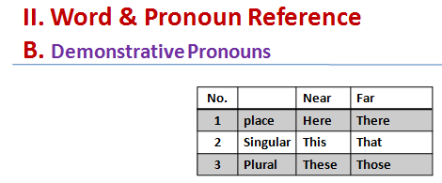
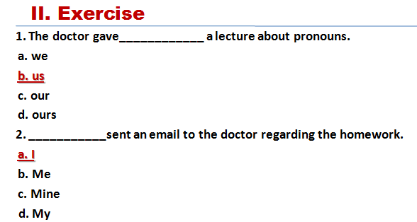
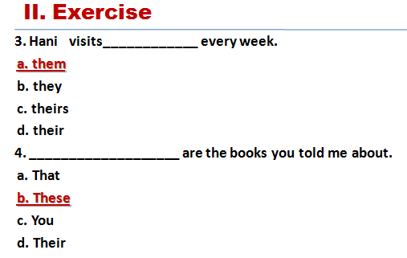
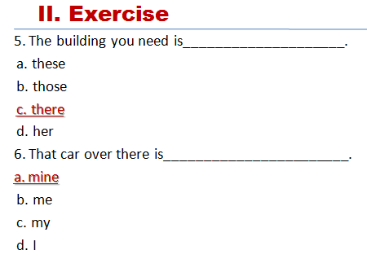
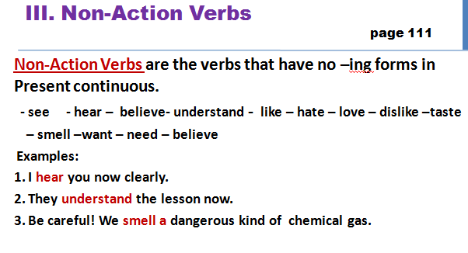
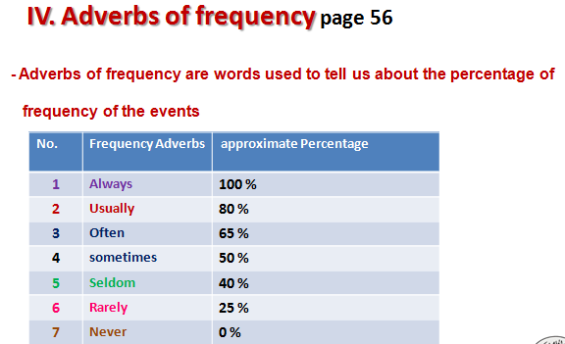
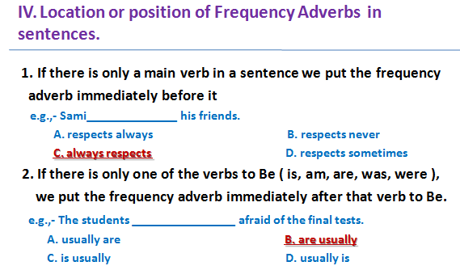
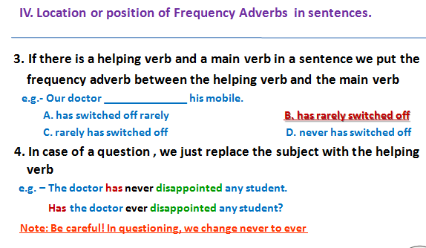
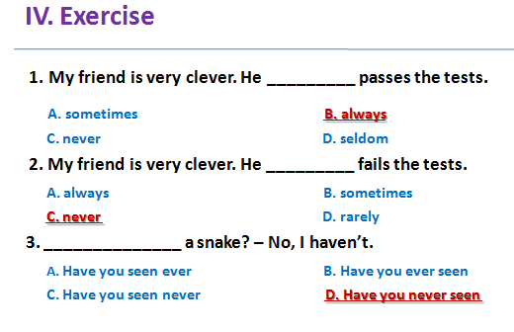
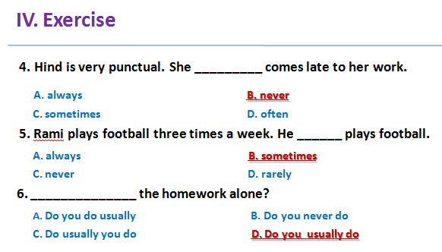
دعواتكم إخواني أخواتي لمحبتكم مها الزهراني
E طالبه جامعيه

