Lecture # 6
Write a Message
to a Friend
Lecture Components
Vocabulary
Days of the week
Free – time activities
Time expressions
Feelings and moods
Grammar
Simple past tense with regular verbs
Simple past tense with be and have
Writing:
Write a letter about last weekend
Days of the Week
Saturday
Sunday
Monday
Tuesday
Wednesday
Thursday
Friday
Francisco’s Schedule
Exercise B – page 82
What is Francisco doing at these times?
1) It’s 3:15 on Monday.
He’s studying with his math group.
2) It’s 7:00 on Thursday evening.
He’s practicing the guitar with Maria.
3) It’s 6:30 on Friday morning.
He’s working out.
4) It’s 8:45 on Saturday morning.
He’s playing basketball.
5) It’s 10:45 on Sunday morning.
He’s cleaning his room.
6) It’s 7:00 on Wednesday evening.
He’s calling grandma in San Diego.
Time Expressions
Time expressions tell WHEN something happens or HOW LONG something lasts:
WHEN:
in the morning, in the afternoon, in the evening
on Saturday, on January 3rd
at 12:oo p.m.
at noon, at night, at midnight
HOW LONG:
for two hours , for five days, for ten minutes
from 3:00 to 5:00

Time Expressions: Exercise C – page 82
1. How long does Francisco play basketball on Saturday? (for)
He plays basketball for two hours.
2. What time does Francisco call Grandma? (at)
He calls her at 7:00 p.m. on Wednesday evening.
3. What day does Francisco clean his room? (on)
He cleans his room on Sunday.

Time Expressions: Exercise C – page 82
4. When does Francisco work out? (in)
He works out in the morning.
5. How long does Francisco practice the guitar on Tuesday and Thursday? (from …to)
He practices the guitar from 6:30 p.m. to 8:00 p.m.

Adjectives: exercise D – page 83
These sentences are NOT true. Rewrite them using the correct adjective.
- Francisco is sad in Los Angeles.
Francisco is happy in Los Angeles.
2. Francisco was wide awake on Saturday morning.
Francisco was very sleepy on Saturday morning.
3. Maria didn’t play basketball because she was healthy.
Maria didn’t play basketball because she was sick.

Adjectives: exercise D – page 83
4. Francisco was full at noon.
Francisco was really hungry at noon.
5. Francisco was busy after lunch.
Francisco was bored after lunch.
6. Francisco was full of energy on Sunday evening.
Francisco was tired on Sunday evening

Simple Past Tense with regular verbs: affirmative
1. Francisco plays basketball every Saturday.
Francisco played basketball last Saturday.
2. Maria and Francisco study every Sunday afternoon.
Maria and Francisco studied last Sunday afternoon.
3. The Garcia family shop once a week.
The Garcia family shopped last week.
4. I visit my grandfather every month.
I visited my grandfather a month ago.

Simple Past Tense with regular verbs:
Negative
Affirmative NegativeContractions
workeddid not workdidn’t work
shoppeddid not shopdidn’t shop

Simple Past Tense with regular verbs:
Negative
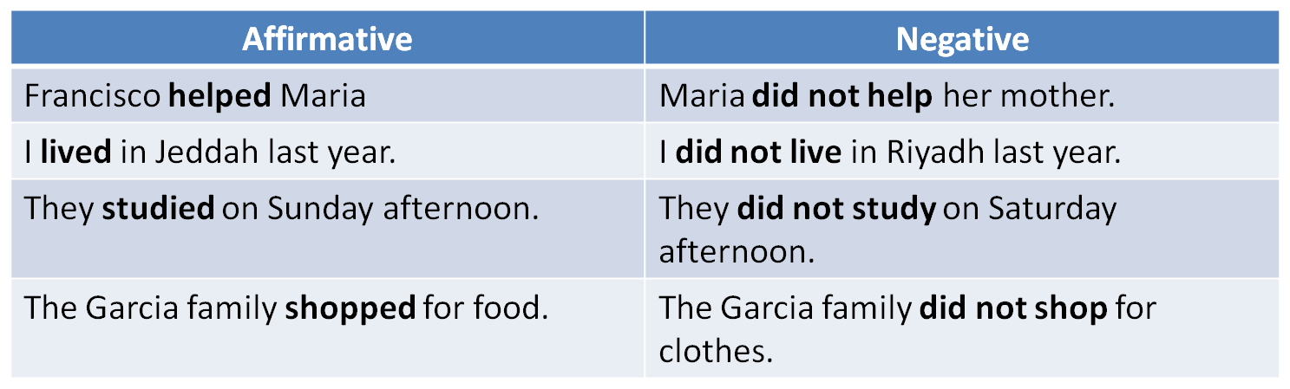
Simple Past Tense: Exercise A – page 83
Maria _________ basketball on Saturday morning. (play)
Francisco’s friend Rick __________ him on Saturday afternoon. (call)
Francisco and Rick ____________ to the mall in the morning. (walk)
Maria and Francisco ____________ on Saturday night. (watch TV)
didn’t play
didn’t walk
didn’t watch TV
didn’t call
Simple Past Tense: Exercise A – page 83
didn’t stay home
didn’t clean
didn’t work out
didn’t practice
didn’t relax
5. On Sunday, Maria and Francisco _______________all day. (stay home)
6. On Sunday morning, Francisco ___________clean his rooms for three hours. (clean)
7. On Sunday, Francisco _______________ and Maria ___________ the guitar. (work out/ practice)
8. On Sunday evening, Francisco _____________. (relax)

Simple Past Tense with be (was/were): affirmative & negative
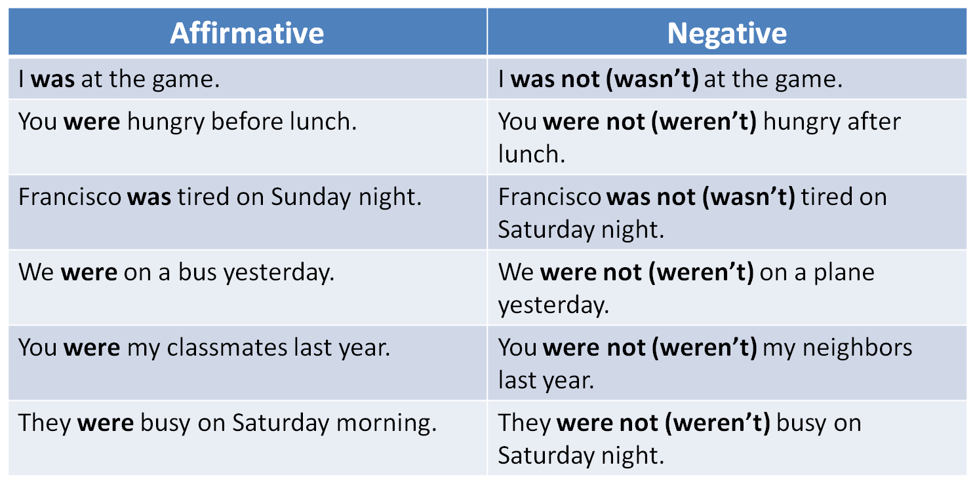
Simple Past Tense with have(had): affirmative & negative
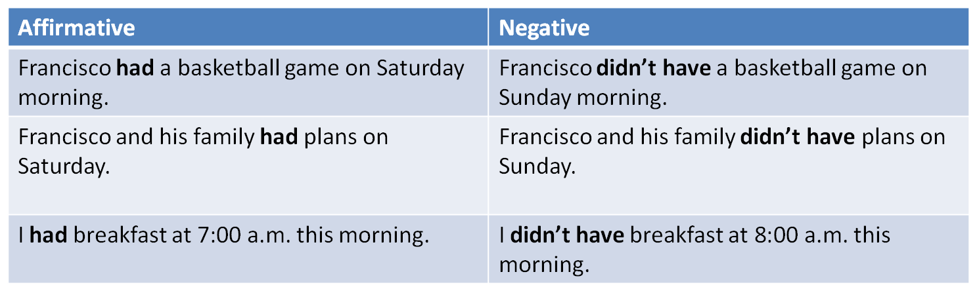
Parts of a Letter
There are usually five parts of a letter:
- The heading
- The greeting
- The body of the letter
- The closing
- The signature

Parts of a Letter
March 7, 2010
Dear Pedro,
My computer isn’t working, so I’m writing you a letter. How are you? I’m fine. Everything here in L.A. is great. School is going well. I have a lot of classes this year. I play sports in my free time, too. I’m really busy.
Last weekend was fun. On Saturday , I had a basketball game at 7:00 in the morning. I was very sleepy. Maria didn’t play because she was sick. After the game…………………..
Your cousin
Francisco
Heading: date
Greeting
Signature
Closing
Parts of a Letter
Label the parts of the following letter.
___Your friend,
___ How are you? I’m great. I’m sitting in the park right now. I’m relaxing with my friends. Last weekend was really exciting. I went to Jeddah with my family […] Did you do anything interesting? Write soon!
___ March 23, 2010
___ MAHER Al-HAMAD
___ Dear Abdullah,
Write a Letter to a Friend
First, tell the person how you are.
Then write about what you did last weekend.
Use time expressions to sequence events.
Finally, ask questions or make requests.
Example:
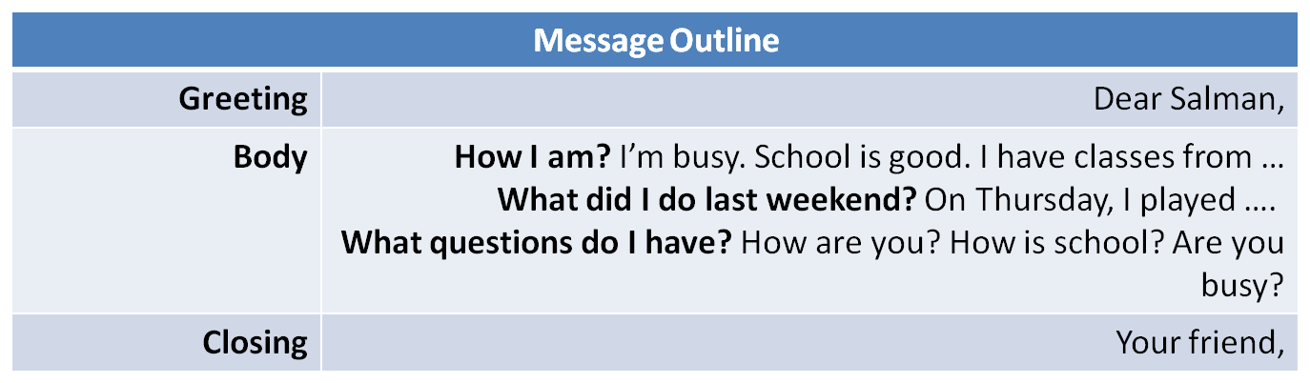

Practice
What’s the best way to combine the following two sentences?
- Then in the afternoon, I played football.
- My friend Ahmad played football too.
- Then in the afternoon, my friend and Ahmad played football.
- Then in the afternoon, my friend Ahmad played football.
- Then in the afternoon, my friend Ahmad and I played football.
Practice
What is the best order of the following sentences in a paragraph?
- I have classes Saturday to Friday from 7:00 a.m. to 2:00 p.m.
- My classes are interesting.
- Things here in Dammam are fine.
- I like my teachers, too.
- 1, 2, 3, 4
- 2, 3, 4, 1
- 4, 3, 2, 1
- 3, 1, 2, 4
Which sentence does not fit in the following paragraph?
- How are you? (2) How was your weekend? (3)Did you have fun? (4) I’m fine. (5) Please write soon.
- Sentence 1
- Sentence 2
- Sentence 3
- Sentence 4
What is a better word for “sleepy” in the following?
Then I had a big breakfast. I was sleepy.
- fine
- bored
- tired
- hungry
Choose the best substitute for the underlined words.
- I did my homework to three hours on Sunday.
- From
- At
- For
- Make no change
My sister practices the guitar in Monday afternoons.
- On
- At
- To
- Make no change
3. We watches movies last weekend.
- Are watching
- Watched
- Watch
- Make no change

