Lecture # 13
Building Sentences: Prepositional Phrases
Lecture Components :
Building a sentence
Prepositional Phrases
Building a Sentence:
بناء الجملة
Building a sentence
A sentence is a group of words which starts with a capital letter and ends with a full stop (.), question mark (?) or exclamation mark (!). A sentence contains or implies a predicate and a subject.
Building a Sentence
Sentences can contain subjects فاعلand objects مفعول به .
The subject in a sentence is generally the person or thing carrying out an action. The object in a sentence is involved in an action but does not carry it out, the object comes after the verbالفعل .
For example: The boy climbed a tree.

If you want to say more about the subject (the boy) or the object (the tree), you can add an adjective نعت، صفة .
For example: The young boy climbed a tall tree.

If you want to say more about how he climbed the tree you can use an adverb ظرف .
For example: The young boy quickly climbed a tall tree.

The sentence becomes more interesting as it gives the reader or listener more information.
You can add a prepositional phraseجار ومجرور
For example: The young boy quickly climbed a tall tree in the garden.

Prepositions:
A preposition is a part of speech that shows a relationship between two things.
  - Location (on, under, in) للمكان
  - Timing (before, after, during) للزمان
  - Direction (from, toward, to) للاتجاهات
The mouse is on the table.
Two things: mouse + table
Relationship: one is on the other
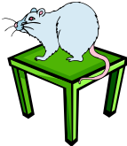
On is a preposition!

The mouse is under the table.
Two things: mouse + table
Relationship: one is under the other
Under is a preposition!
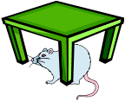
Here is a list of the most common prepositions:
aboard | along | behind | but(except) | from | off | past | until
about | amid | below | by | in | on | since | up
above | among | beneath | down | inside | onto | through | upon
across | around | beside | during | into | out | to | with
after | at | between | except | near | outside | toward | within
against | before | beyond | for | of | over | under | without

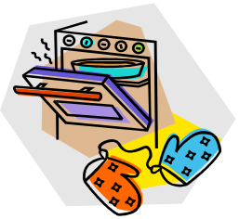
Which word is a preposition?
The pizza in the oven is mine.
pizza
oven
mine
in

Which word is a preposition?
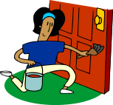
The girl by the door is my sister.
my
door
by
girl

Which word is a preposition?

The runners raced around the track.
around
runners
track
the

Prepositional Phrases:
Let’s look again at the sentences you practiced with.
The pizza in the oven is mine.
The girl by the door is my sister.
The runners raced around the track.
in the oven
by the door
around the track
These are prepositional phrases. Prepositional phrases start with a preposition and end with the object of a preposition.

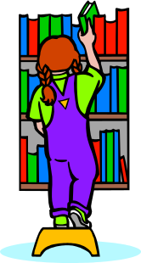
Identify the prepositional phrase.
I chose a book from the library.
chose a book

book from the library

from the library

Identify the prepositional phrase.
I sat with my mom.
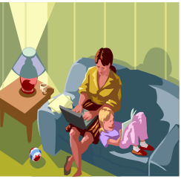
with my mom

with my

I sat with

Prepositional phrases :
We use prepositional phrases to write longer sentences.
The students bought a book.
The students in my class bought a book.
The students in my class bought a book about flowers.
Another example:
The questions were difficult.
The questions in the English exam were difficult.
The questions about prepositions in the English exam were difficult.
Prepositional phrases of place:
الجار والمجرور للدلالة على المكان
Prepositional phrases of place
The book on the desk is mine.
The room across from the bathroom is Mary’s bedroom.
I like to sit on the chair next to the window.
My clothes are in the bag under the bed.
Prepositional phrases of time
I saw my friends before the test.
We will play tennis after class.
I usually have a big breakfast in the morning.
My father came back from Mecca at midnight.
Prepositional Phrases :
Powerpoint presentation :
http://www.slideshare.net/diana.koscik/prepositional-phrases-powerpoint

